# Wheat Disease Detection Using Image Processing

## Details:

Detection of whether the wheat is healthy or not by detecting the rust in its leaf.

## Methods Used:

K-Means Clustering, canon A3500, 16 mega pixels

## Accuracy:

Neural Network 80.21

Support Vector Machine 89.23

## Link:

<https://sci-hub.do/https://ieeexplore.ieee.org/document/8122158>

# An IoT Based Weather Monitoring System Using Node MCU and Fuzzy Logic

## Details:

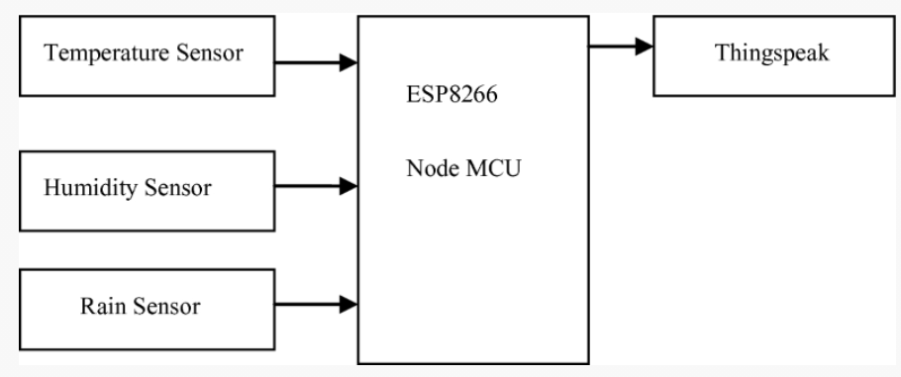They calculated the temperature, humidity and rain through Node MCU and sensors. They stored these data on an Iot online platform (Thingspeak), also they used the fuzzy rule to achieve better performance and more accuracy.

## Link:

<https://link.springer.com/chapter/10.1007/978-3-030-37051-0_14#Sec3>

# An IoT Environmental Data Collection System for Fungal Detection in Crop Fields

## Details:

This paper presents the design of an Internet of Things (IoT) system consisting of a device capable of sending real-time environmental data to cloud storage and a machine learning algorithm to predict environmental conditions for fungal detection and prevention. The stored environmental data on conditions such as air temperature, relative air humidity, wind speed, and rain fall is accessed and processed by a remote computer for analysis and management purposes.

## Method:

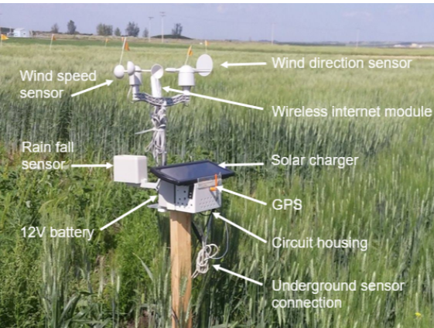A machine learning algorithm using Support Vector Machine regression (SVMr) was developed to process the raw data and predict short-term (day-to-day) air temperature, relative air humidity, and wind speed values to assist in predicting the presence and spread of harmful fungal diseases through the local crop field.

## Link:

<https://sci-hub.do/https://ieeexplore.ieee.org/document/7946787>