Devices connected like on circuit

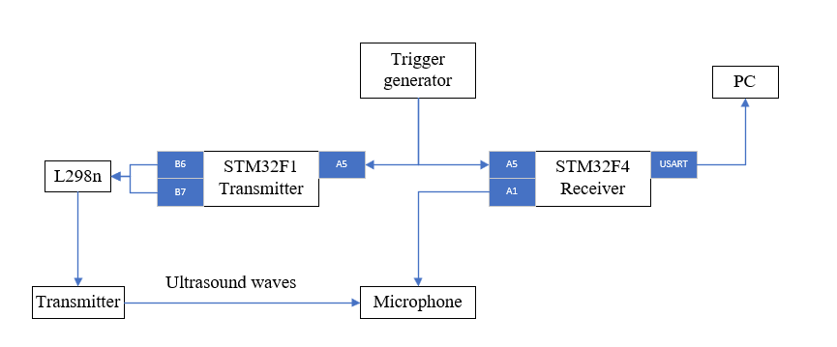

Trigger generate signal every 12 seconds. After receive synchro signal transmitted generate some ultrasound waves while receiver write signal from microphone. This signal using for calculate distance between transmitter and receiver.

Here is this signal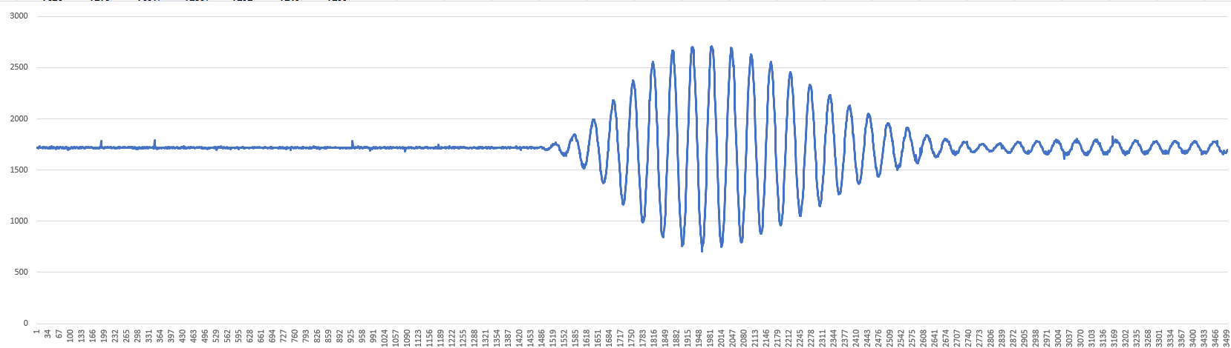

and another, in the same system condition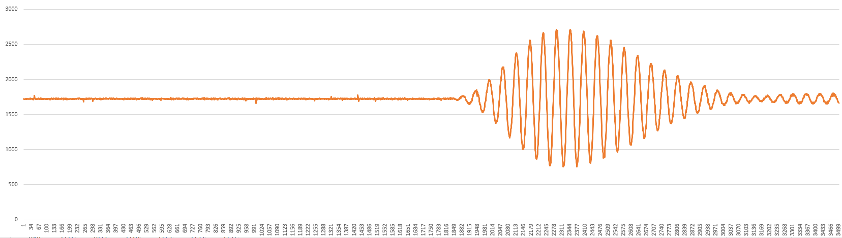

Question: Why signal comes with different times? although I don’t move receiver or transmitter.

Here is more signal with the same condition and distance between receiver and transmitter.

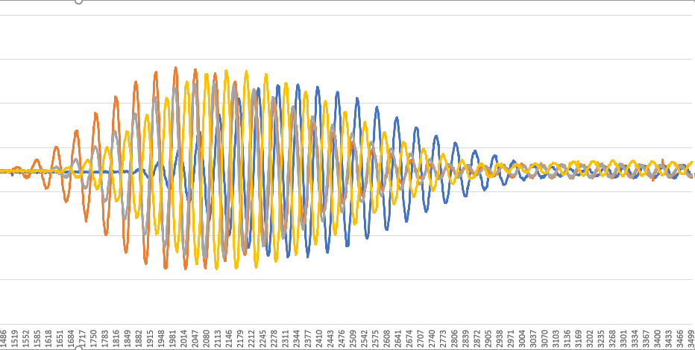

It's gives errors 50mm