**Development Part 2**

|  |  |
| --- | --- |
| **Date** | **26-10-2023** |
| **Team ID** | **499** |
| **Project Name** | **6112-AIR QUALITY ASSESSMENT IN TN** |

|  |  |
| --- | --- |
| 1 | Problem Statement |
| 2 | Data Visualization using Python |
| 3 | Data Visualization using IBM Cognos |
| 4 | Conclusion |

**AIR QUALITY ASSESSMENT IN TN**

**Problem Statement :**

Objective: Develop a comprehensive and localized air quality assessment system in Tennessee, leveraging advanced monitoring technologies and data analysis techniques.

Data: To conduct a comprehensive air quality assessment in Tennessee, critical data includes measurements of pollutants like PM2.5, PM10, NO2, SO2, CO, and O3 from monitoring stations. Meteorological data, encompassing temperature, humidity, wind patterns, and precipitation, is vital for understanding atmospheric conditions. Geographic information system (GIS) data aids in assessing how topography and land use influence air quality. Emission inventories offer insights into pollution sources, while population density and demographic data help identify vulnerable communities. Health records, historical data, and air quality modeling outputs provide additional context. Access to policy and regulatory information ensures evaluations align with existing guidelines, while remote sensing data offers a broader perspective on pollution patterns.

**Data Visualization 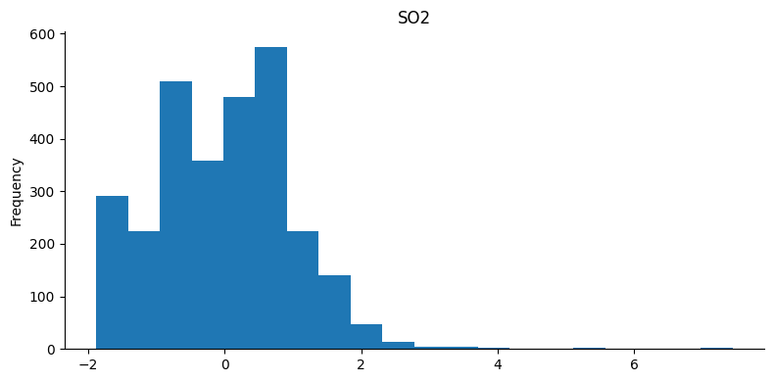using Python**

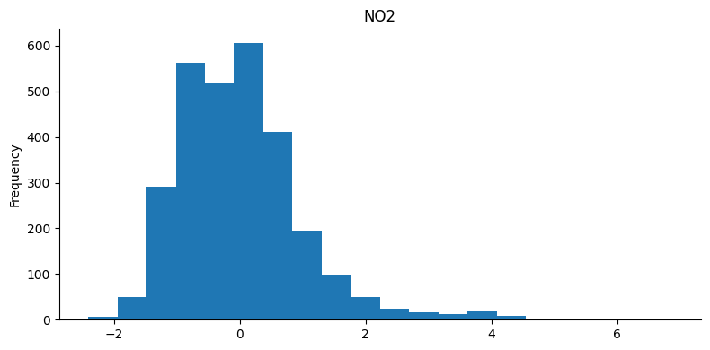

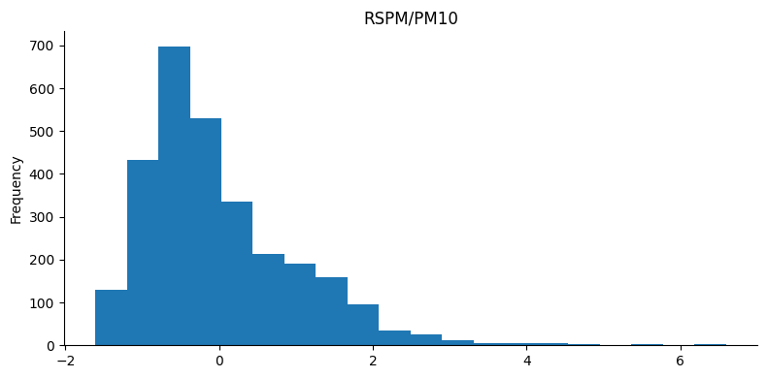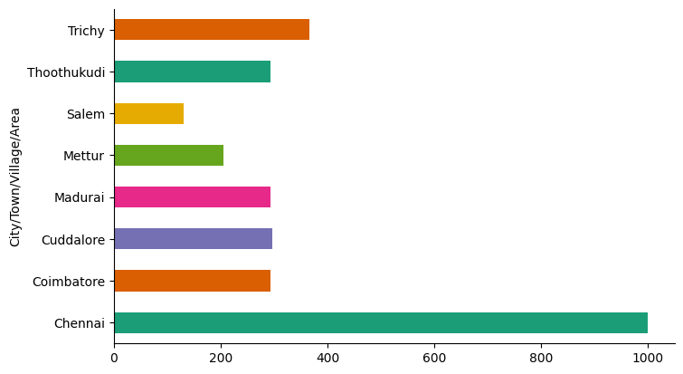

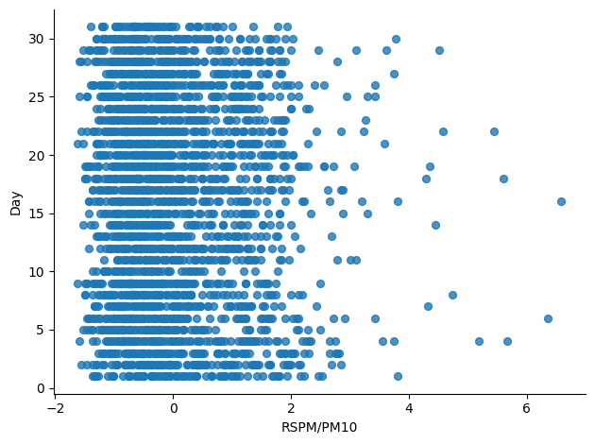

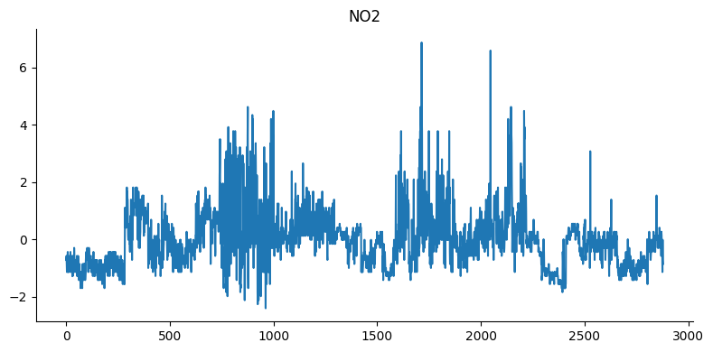

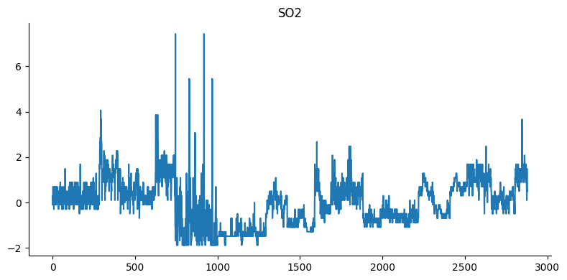

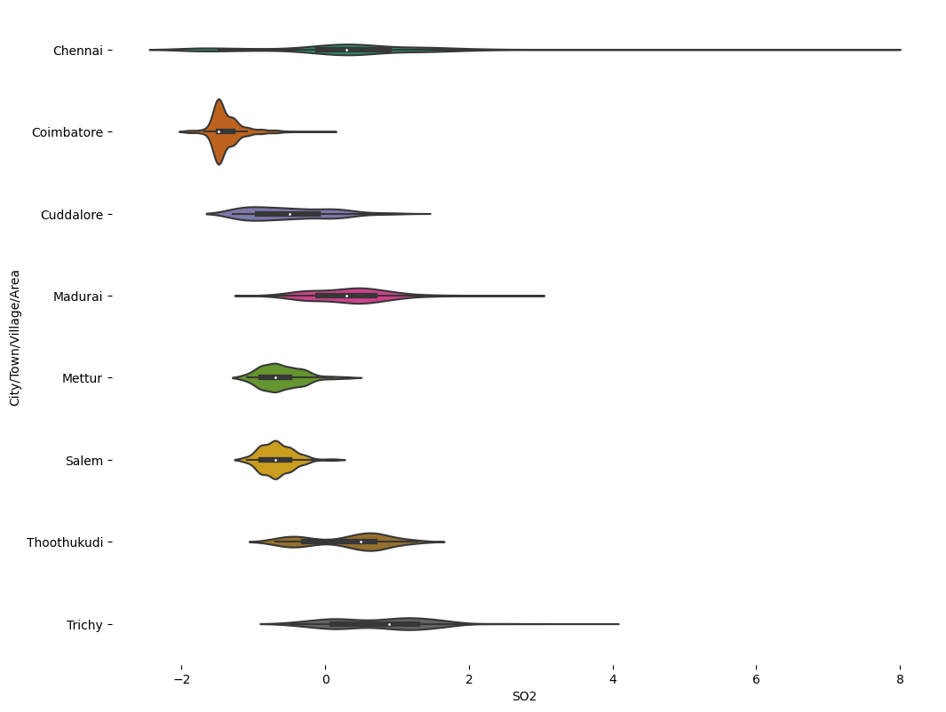

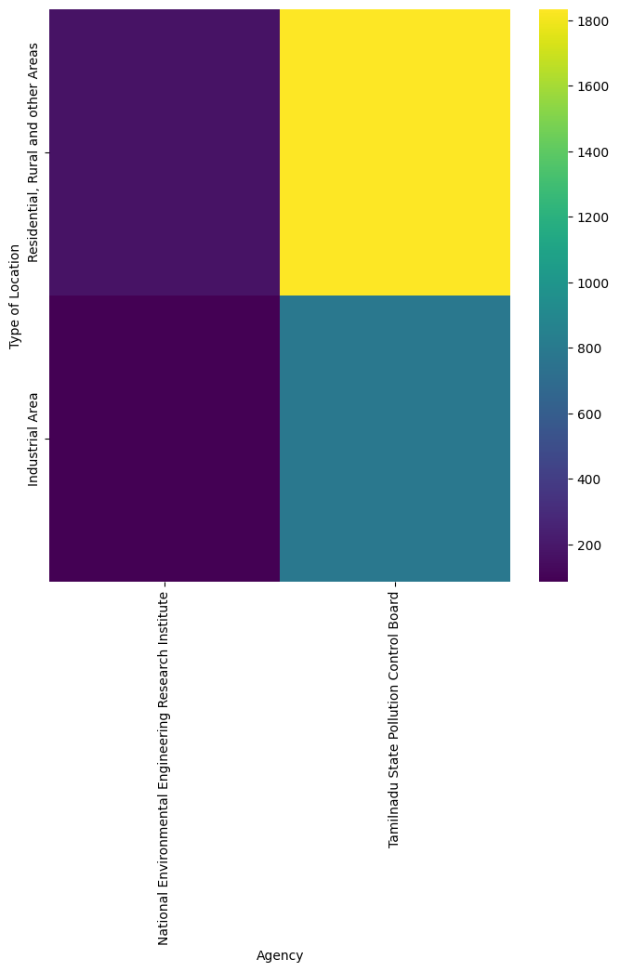

**Data Visualization using IBM Cognos**

* ­­­­**SO2 Analysis**

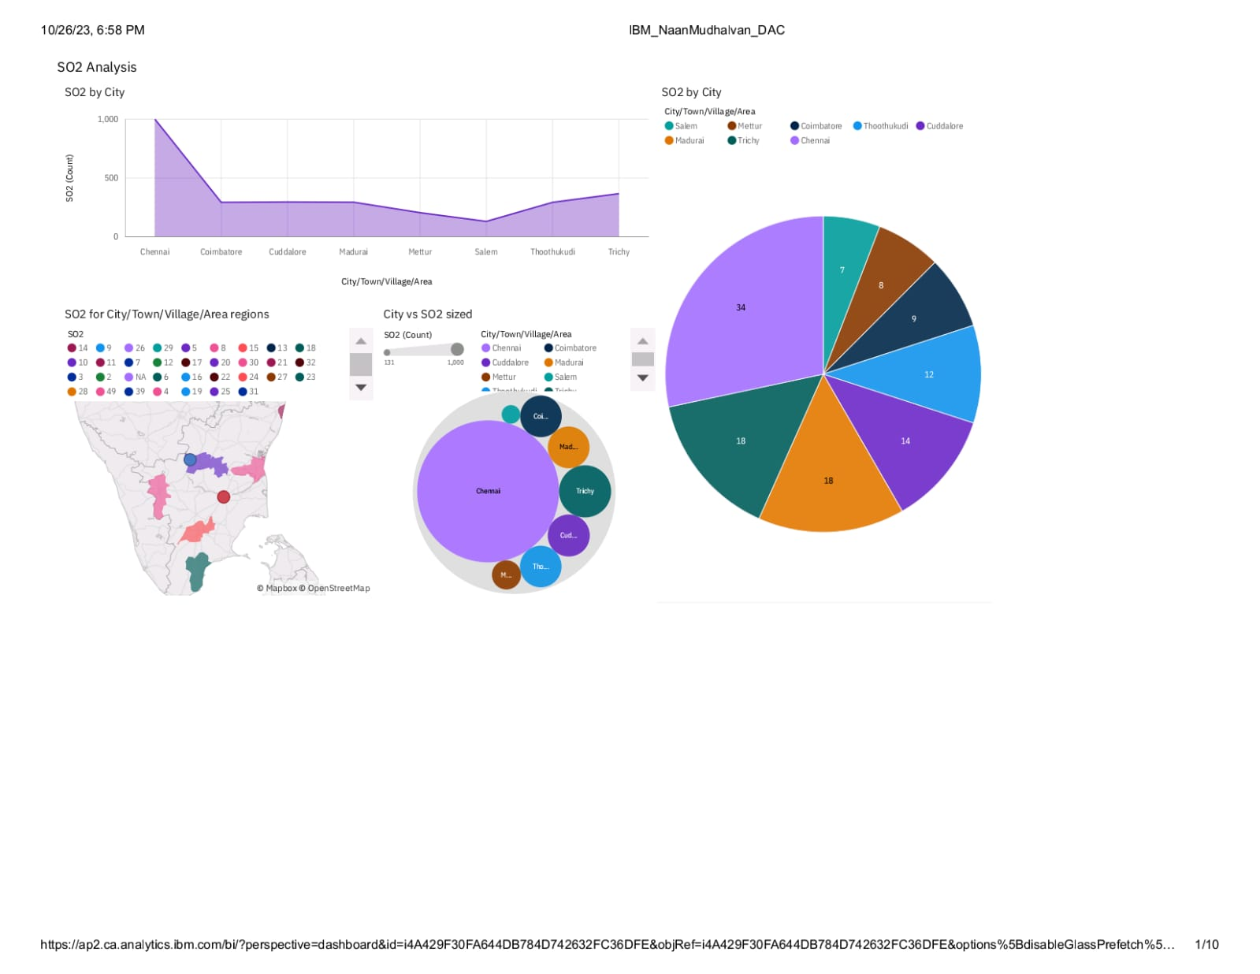

**Report :**

* The total number of results for SO2, across all City/Town/Village/Area, is nearly three thousand.
* The count is unusually high when the City/Town/Village/Area is Chennai.
* Salem has a SO2 of 131 for Stn Code 309
* Chennai is the most frequently occurring category of City/Town/Village/Area with a count of 1000 items with SO2 values (34.7 % of the total).
* The total number of results for SO2, across all City/Town/Village/Area, is nearly three thousand
* **NO2 Analysis**

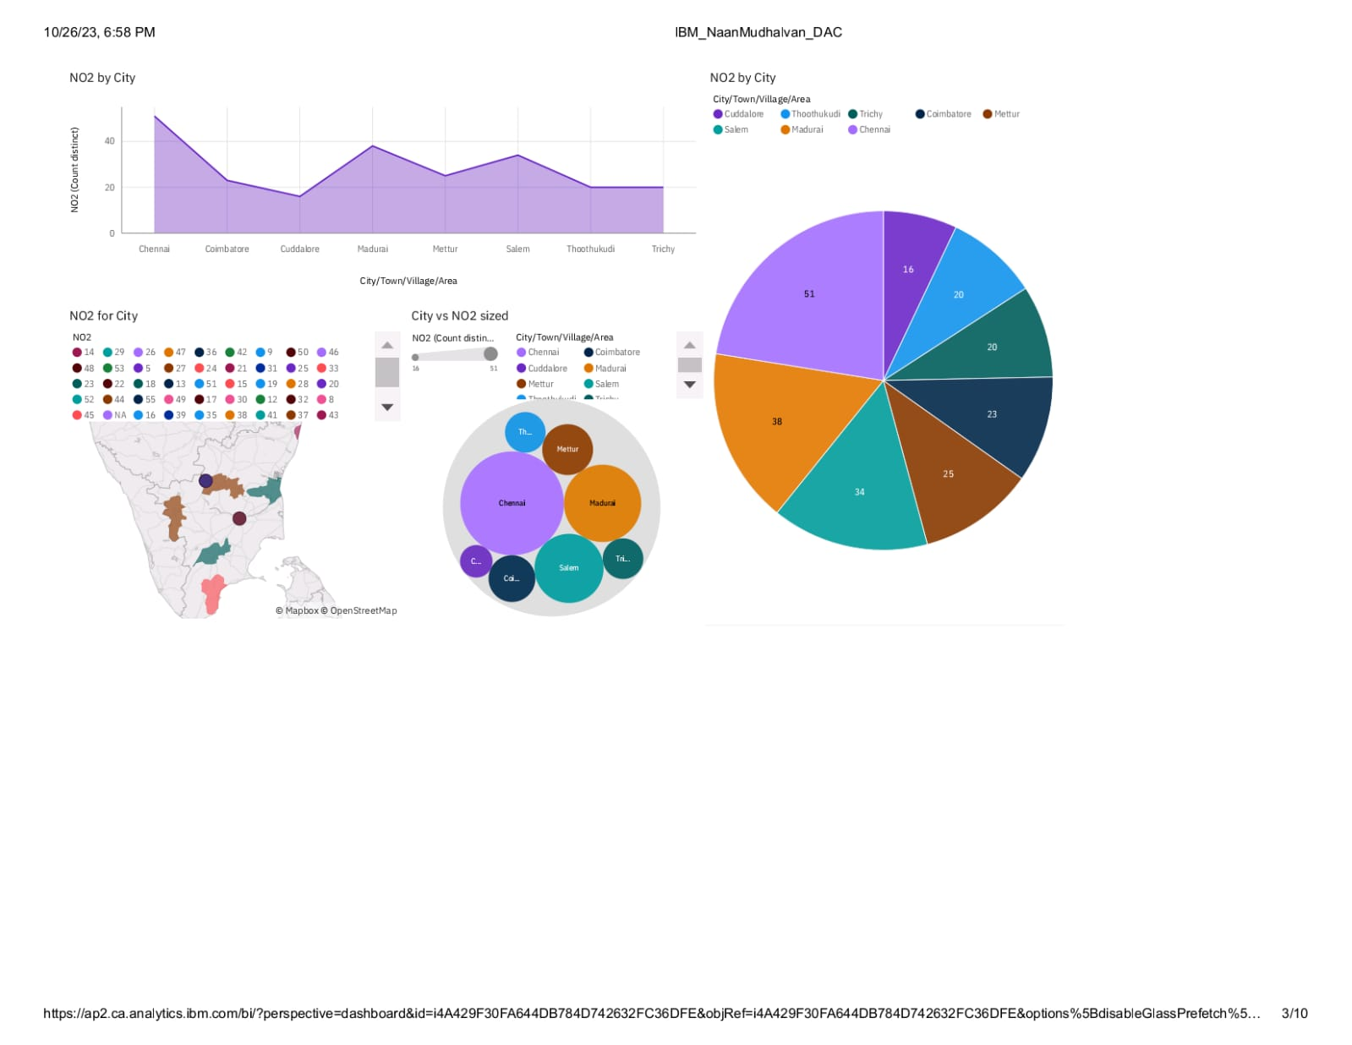

**Report:**

* City/Town/Village/Area Chennai has the highest NO2 Stn Code 161
* Chennai is the most frequently occurring category of City/Town/Village/Area with a count of 1000 items with NO2 values (34.7 % of the total).
* The total number of results for NO2, across all City/Town/Village/Area, is nearly three thousand
* The total number of results for NO2, across all City/Town/Village/Area, is nearly three thousand.
* **RSPM/PM10 Analysis**

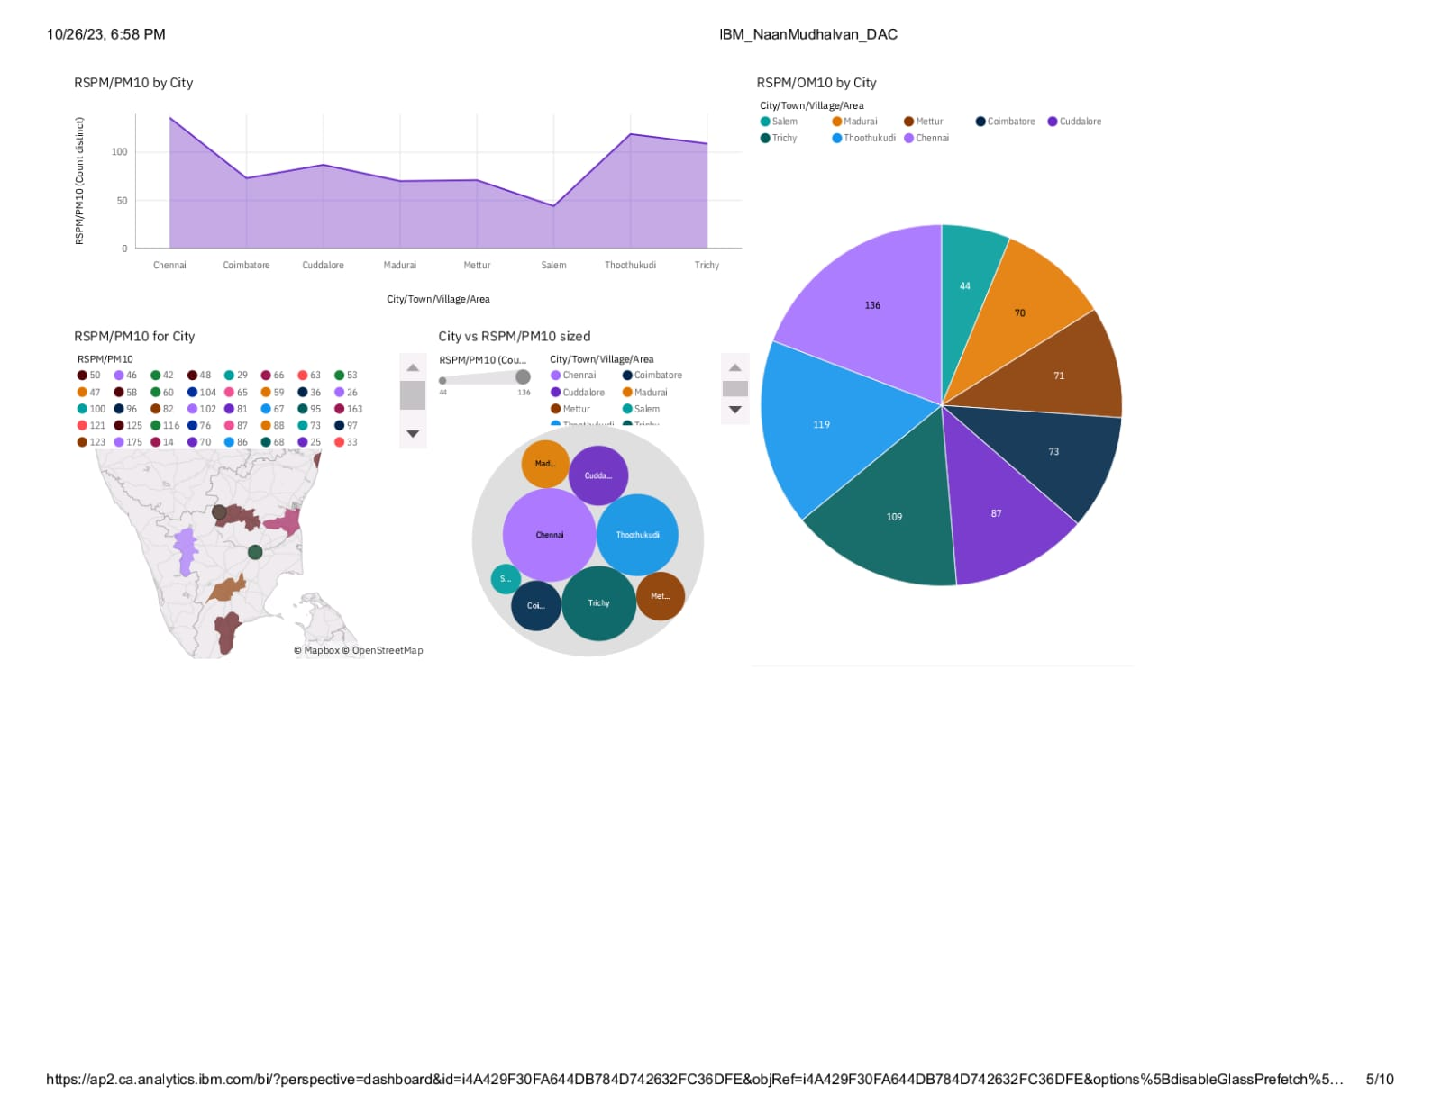

**Report:**

* City/Town/Village/Area Chennai has the highest RSPM/PM10 due to Stn Code 766.
* Thoothukudi has an RSPM/PM10 of 71 for Stn Code 239.
* RSPM/PM10, across all City/Town/Village/Area, is nearly three thousand.
* City/Town/Village/Area Chennai has the highest RSPM/PM10 due to Stn Code 766
* City/Town/Village/Area with a count of 1000 items with RSPM/PM10 values (34.7 % of the total).

**SO2 and NO2 Analysis**

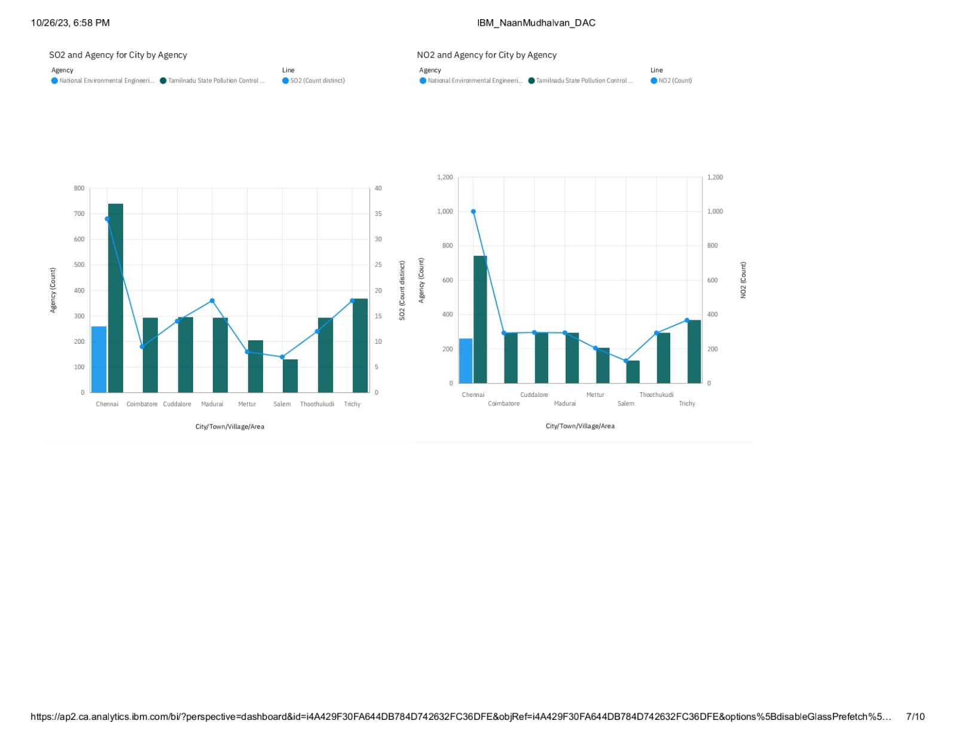

**Report:**

* Tamilnadu State Pollution Control Board is the most frequently occurring category of Agency with a count of 2619 items with Agency values (91 % of the total).
* City/Town/Village/Area Chennai has the highest NO2 due to Stn Code 764.
* Salem has a NO2 of 131 for Stn Code 309.
* Tamil Nadu State Pollution Control Board is the most frequently occurring category of Agency with a count of 2619 items with Agency values (91 % of the total).
* **City vs SO2 vs NO2**

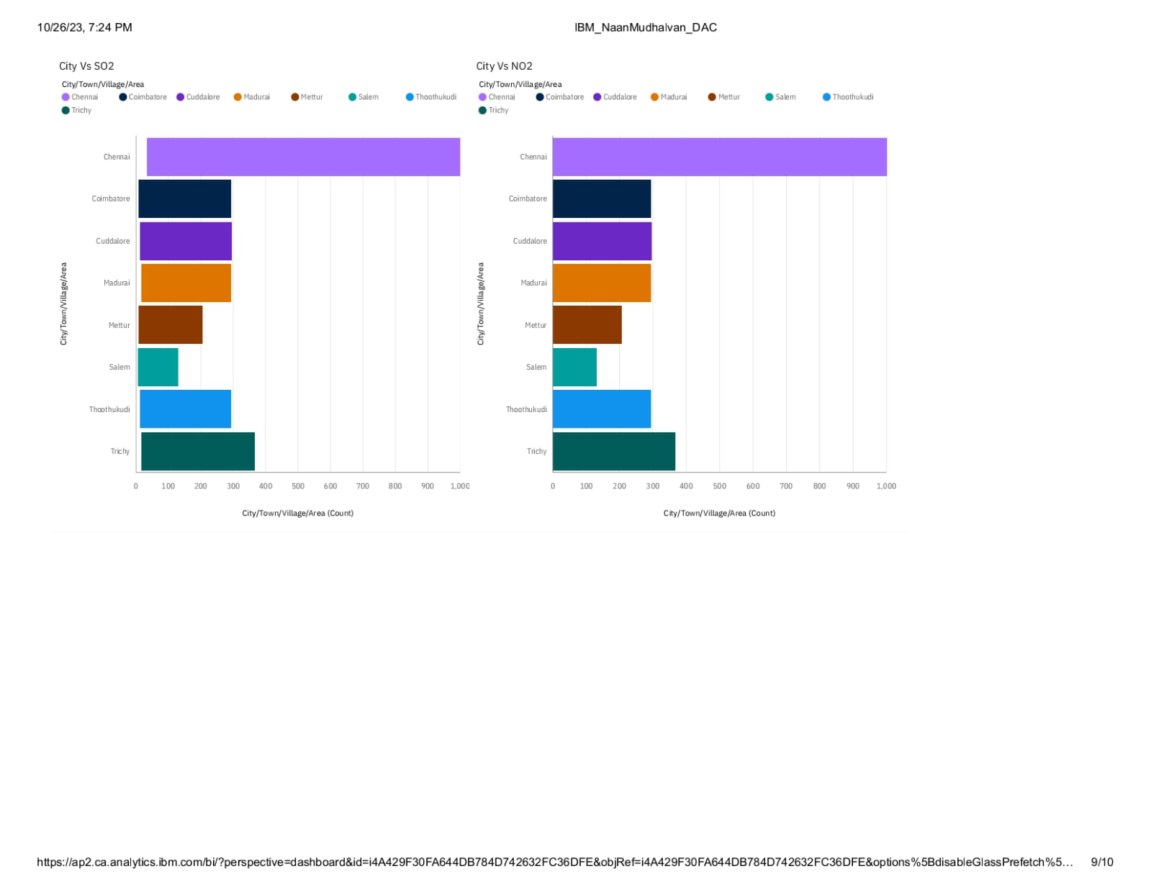

**Conclusion**

In conclusion, addressing air quality challenges in Tennessee demands a concerted and empathetic approach. The complexities, from limited monitoring infrastructure to diverse geographical influences, underscore the urgency of the issue. Through collaborative efforts, we can bridge gaps in data and technology, ensuring accurate assessments. Engaging communities and stakeholders, while prioritizing public health, will be pivotal in formulating effective policies. By empathizing with the concerns and experiences of affected individuals, we reaffirm our commitment to a cleaner, healthier Tennessee. Together, we can forge a path towards sustainable air quality improvements, safeguarding the well-being and vitality of our communities for generations to come.