

First name Last name

Title of the Thesis

Subtitle

Helsinki Metropolia University of Applied Sciences

Degree

Degree Programme

Thesis

Date

**Contents**

Introduction 2

The Music Industry 2

The Social Media 3

References 6

**Abstract**

Technology is changing how the world operates in a pace that is unimaginably hard to predict on either what will happen in the near future or when is the most trending fashion of today of any sort is going to vanish and the next easy to decease fashion is going to take place.  Through the process of those changes; a lot of small timer industries has come to life and became the giants of all and those who were giants once are leading a one foot in a graveyard role. The music industry is among one of those which had to reshape their forms and ways of reaching the audiences; which drastically changed the system of handing out products that was around for so many decades.

From the time of vinyl to the scorching new kid on block streaming music online, the industry was moving in a clearer path where an artist is owned by a record label and his creativity is controlled by the company owners to do whatever they have to do with it. Back in those days, the artist didn’t have much say on the process or how he wanted to reach his audiences which also gives him freedom to focus only on the innovative part of the production, but nowadays he have to use mediums of any kind to build himself a fan base and reach out to them on a daily basis with the help of social media.

Not be taken as a wild accusation; two factors can be held responsible for the rapid and unpredictable change that the music industry is showing; and for the new shape that the music industry is taking nowadays. One of them is the involvement of Internet in the commerce of music and the other one is the social media.  If one artist doesn’t exist in at least one of them, he or she doesn't exist at all.

What social media did to music has its own flaws in terms of hitting the intended target of the art and the artist especially for the already established labels and artists who are used to selling millions of copies per album few years ago, but it gave power to the new and upcoming artists by creating a platform, so that they can reach their audiences easily and get the opportunity that they have been striving for.

# Introduction

## The Music Industry

The music industry is a platform where artists and companies sell their music to the intended audience. The pre-production or creative part will be the responsibility of the artist, the producers, the sound engineers and if it is a bigger production, it will include instrumentalists who works hand in hand with the producer or the composer; and the after production portion will be done most by the record company executives, which includes designing the promotions and ways of how the artist’s work reaches its fans.

Figure 1.1 (Ian Dustry 1999) shows how the recording industry operates and gives a wider hint on who does what questions of the business in general. Although the bigger picture is clearer than ever, the form and shape of the whole architecture is overleaping the process of changing pace by pace and taking a different face.

Fig 1 Structure of Music Industry (Ian Dustry 1999)

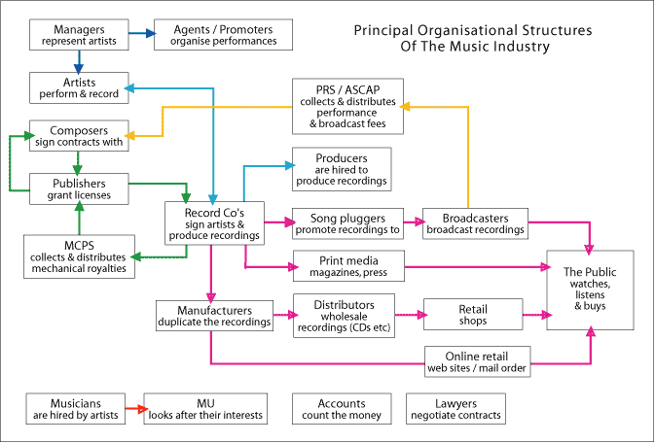

## The Social Media

The last century has been the century where that every inventions that were thought to be a theory and myths come to life, grow quickly and change the way we see things and understand the world. The social media emerged to be the saviour of the most anticipated social interaction, even though it has its own flaws on ruining the familiar traditions and social values.

Since the first ever email was sent between two computers situated next to each other in 1971, the importance of a social network is evolving rapidly and advancing to reach the point where the gap between a computer and a human being is diminished so it can help out on making every aspect of business simple and accessible.

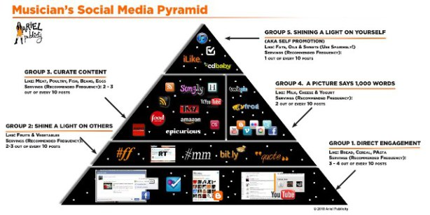

Fig 2 How the social media changed the music industry (uncategorized 2012)

The first site to start a music social media was MySpace, which created the platform for a lot of new music sites which then take everything that MySpace was and modified it to create something massive and enormous.

Electronic recommendation agents are also unique to the online diffusion process. These online sites are sources of discovery, connecting users to music that may be unfamiliar to them. These electronic recommendation agents suggest music that the user may like based on previous purchases or sampling history of the user. Individuals may turn to these sites specifically for new music recommendations, similarly to how others turn to opinion leaders during the diffusion process. [3, 45]

An artist must know how to make a great brand of his own by promoting it in radio, print, television and most necessary social media platforms. Ever since a commercial record selling came to replace the sheet music based music industry matters that looked impossible to achieve are done these days with the little effort from the artist side, but that could not be accomplished without an overly dedicated team from the artist's camp. This team of the artist takes care of the artist's do's and don'ts to keep him or her relevant by feeding the fan base of the artist rough details of the artist's current situation which also involves non music related activities such as charity donation involvements, speaking out about his political and social views when it's seen as a necessity, writing condolences,  doing his public relation matters, etc. Sometimes it doesn't even have to be the exact truth, as long it is entertaining and puts the artist on the most trending topics of the time list, the story can be fabricated too. Even on the emotional moments such as a disaster , a bombing in a civil war zone or a funeral of a national hero, etc, the artist must show his soft side by making a statement in his social media pages not only he wants to, but he also have to because his fan base wants to hear his or her opinions and give them words of encouragement.

The role of artist and repertoire used to be recruiting talented artists and song writers and bring them into the record company, but the recent changes on the process of how record labels are getting new artists, some artist and repertoire executives were forced to change their ways of recruiting while most lost their jobs.

Selling hundreds thousands of records is now a fantasy of the past, because a consumer can put his hands on the album that just came out right away on the Internet or some other music oriented social networks such as Spotify and YouTube.

The quick rise to fame of spotify and its similar music streaming sites or applications has made it easier for the fan of music,  but it has been a nightmare  for the artist and those who are involved in the process making any kind of music productions. Although,  there are artists who are swapping their business plans by investing millions to be a part of streaming music business and supporting the future of the whole industry, but the self-evident reality is that it is living so many loop holes for the artist and his creativity processes.

No matter how skillful and talented an artist is, no matter where he has done his apprenticeship or his music school status is and no matter who he knows, it is crucial that he has to put himself out there and promote his art personally; and the only feasible first step is to build his online profile as an artist and gets his music or any type of art out there.

YouTube sensations such as Charice Pompengo, Austin Mehon and Justin Bieber climbed to the top of the industry's ladder by just simply uploading videos themselves singing on YouTube. The concept of how many views made YouTube a site where people create a silent competition between artists, the Korean singer's PSY song Gangnam Style needs a noticeable mention in this section by setting an unbeatable record of having more than a billion views on YouTube, which made the song a worldwide hit.

# References

1. Dustry, Ian 1999, Structure of Music Industry, Accessed 3 February 2015.

[http://www.planetoftunes.com/music-industry/music-industry-structure.htm#.VQVm_46Uc1Y](http://www.planetoftunes.com/music-industry/music-industry-structure.htm#.VQVm_46Uc1Y )

1. Uncatagorized May 28 2012. How social media changed the music industry, Accessed 5 February 2015.

<https://bptruthmachine.wordpress.com/2012/05/28/how-social-media-changed-the-music-industry/>

1. Adam Joel Monk. The Diffusion of New Music through Online Social Networks. The Ohio State University: 2012.