Due: Friday 3/10/2014 11:59 PM

Name:

ID:

Email:

1)

a) Give an example of a syntax (compiler) error.

b) Give an example of a logic (runtime) error.

1. Consider the following code snapshot

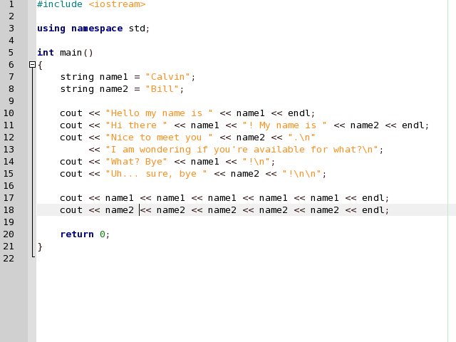

a) What is output? (make sure you're specific)

b) How many statements are there in the main() function?

c) Identify the code that are variable declaration and initialization statements

(Box these in the code snapshot).

d) Identify the code that is the program (Circle this in the code snapshot).  
  
  
  
e) Can you figure out one reason how variables are useful in this example?

1. Create a program that receives 12 total scores, four for each person, and calculates the average of scores for each quiz. The program should output all values as indicated below. The averages have only two data points, and all numbers are right justified to the center of the QUIZ 1 output.

name Quiz 1 Quiz 2 Quiz 3 Quiz 4

---- ------ ------ ------ ------

John 10 7 10 9

Mary 9 8 10 9

Matthew 8 7 9 10

Average 9.00 7.33 9.66 9.33

1. Write a program that plays the game of Mad Lib. Your program should prompt the user to enter the following strings: For simplicity, each input can only be a max of 10 characters.
   1. A name
   2. Another name
   3. A food
   4. A number between 100 and 120
   5. And Adjective
   6. A color
   7. An animal

After the strings are input, the should be substituted into the story below and output to the console.

Dear [Name],

I am sorry that I am unable to turn in my homework at this time. First, I ate a rotten [Food], which made me turn [Color] and extremely ill. I came down with a fever of [Number 100-200]. Next, my [Adjective] pet [Animal] must have smelled the remains of the [Food] on my homework because he ate it. I am currently rewriting my homework and hope you will accept it late.

Sincerely,

[Name]