PBL_LA Semantic Annotation Tool

DOCUMENTATION

# Split in two parts

In the old visual version of the application, both "Search learning objects" and "Annotate learning objects" were part of the same page.

Following the visual changes, they were separated into two parts and rendered as partial views. In the code below we can see the swap buttons and how partial pages are rendered.

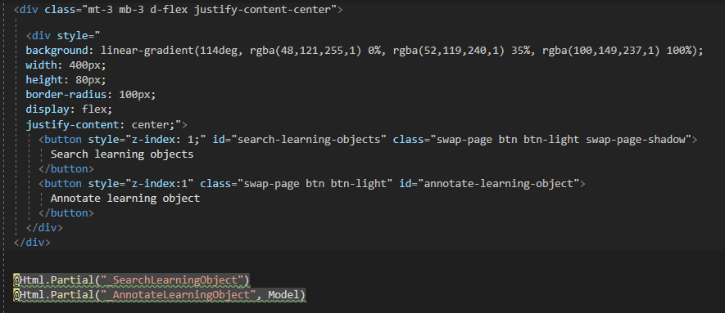

Second partial needs a model because now following values

public String ch_activity;

public String ch_lamethod;

public String technology;

public String data;

public String ch_step;

public int ch_act_id;

public int ch_lamethod_id;

public int technology_id;

public int data_id;

public int ch_step_id;

are properties in model and have their own getters and setters. This is a clean way to send data to the backend

For changing between the pages is used following jQuery code:

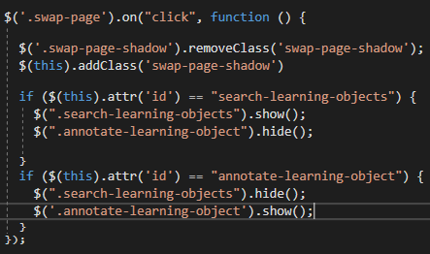

# Database

The Entity Framework was used to connect to the database, and because there is already a database, the Database First approach was used, which generates *DbSet* models for the required entities.

Dropdowns Activities and Tools get values from database through *ViewBags*.

In the following image the application is on debugging mode and through *QuickView* option we can see the values of *ViewBag.Technologies*:

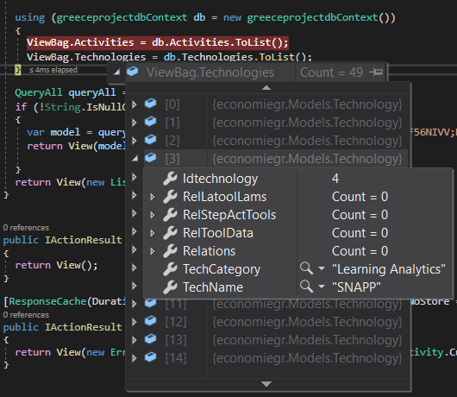

Each database table has their own DbSet in the Context and through those, all the linq methods are available (methods like inserd, update, delete, sort and more)

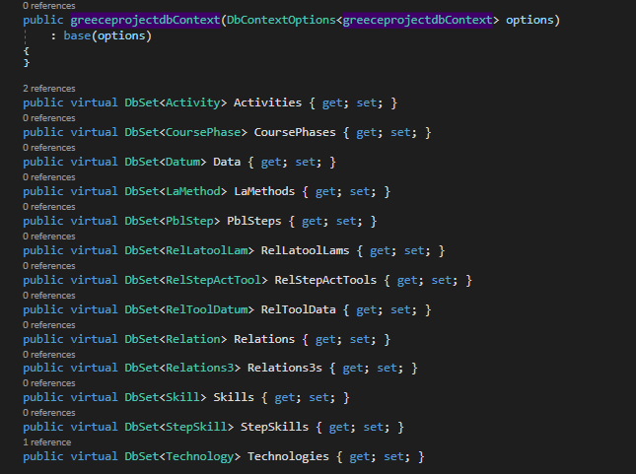

# Select2 Dropdowns

For integrating this library to the project there are included in header the following tags:

<link href="https://cdn.jsdelivr.net/npm/select2@4.1.0-rc.0/dist/css/select2.min.css" rel="stylesheet" />

<script src="https://cdn.jsdelivr.net/npm/select2@4.1.0-rc.0/dist/js/select2.min.js"></script>

First tag is used for getting the css of the library and the second one for getting the javascript of the library.

Select2 Dropdowns give a new style to dropdowns and also integrate functionality of search in dropdown. Simply, by adding the *js-basic-multiple* to a select tag and using this jQuery

$(document).ready(function () {

  $('.js-basic-multiple').select2();

});

Application load the code from the libraries to generate and create new dropdowns.