Techcrush NFT Assignment
Student: Harry Joseph Soronnadi | Network: Ethereum Sepolia | Symbol: TCRUSH
GitHub Repository | https://github.com/Bookofharry/techcrush-nft
Deployed Contract (Sepolia) | 0x62DEd3949ED5EF6af1784Cace3393e504B9656D9
Deployment Transaction | 0xf4b789bcd502abd2bc6793480e7cdb77bc5819d0938502485dd74e1f7eabe22d
Mint Transaction (Token #1) | 0xac5697902f1ff96f482a2388dc1f39f4adc864ab012ce42703ea46278877eb80
Token Recipient / Owner | 0xc5e058e6B8BeAC6EFa667e958D8cA0E3EE36a292

1. Smart Contract Compilation (forge build)
The contract compiles cleanly with Foundry's Solc 0.8.30 compiler. All 43 files, including OpenZeppelin contracts (ERC721URIStorage, Ownable), are compiled without warnings.

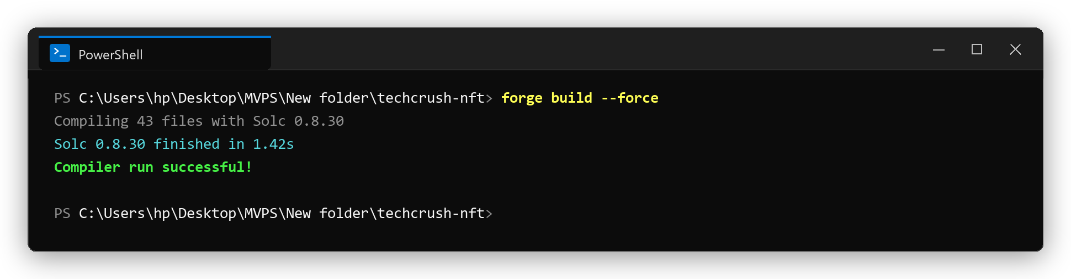

2. Automated Contract Testing (forge test -vv)
All 12 unit tests pass successfully, validating collection identity, safe minting, sequential token IDs, metadata URI persistence, access control (onlyOwner), and ERC-721 transfer permissions.

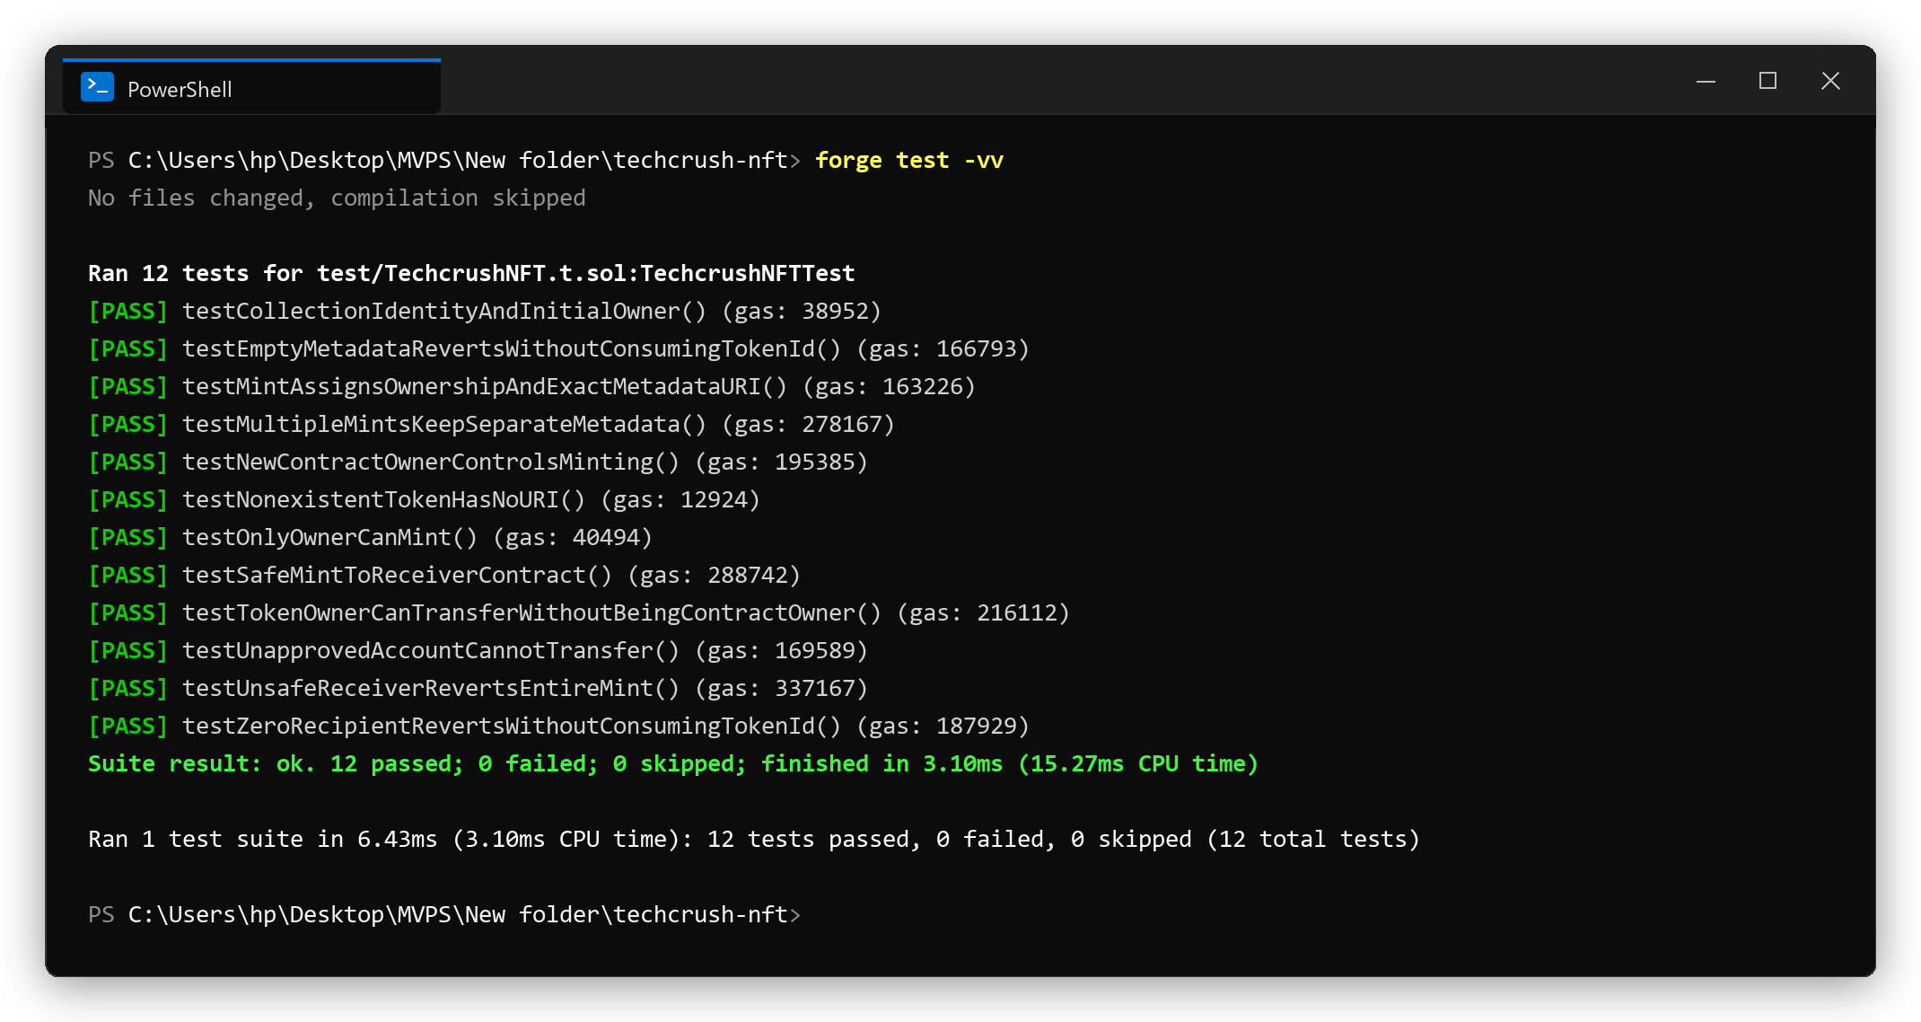

3. Sepolia Contract Deployment
The TechcrushNFT contract was successfully broadcast and verified on Ethereum Sepolia at address 0x62DEd3949ED5EF6af1784Cace3393e504B9656D9 with receipt status 0x1 (Success).

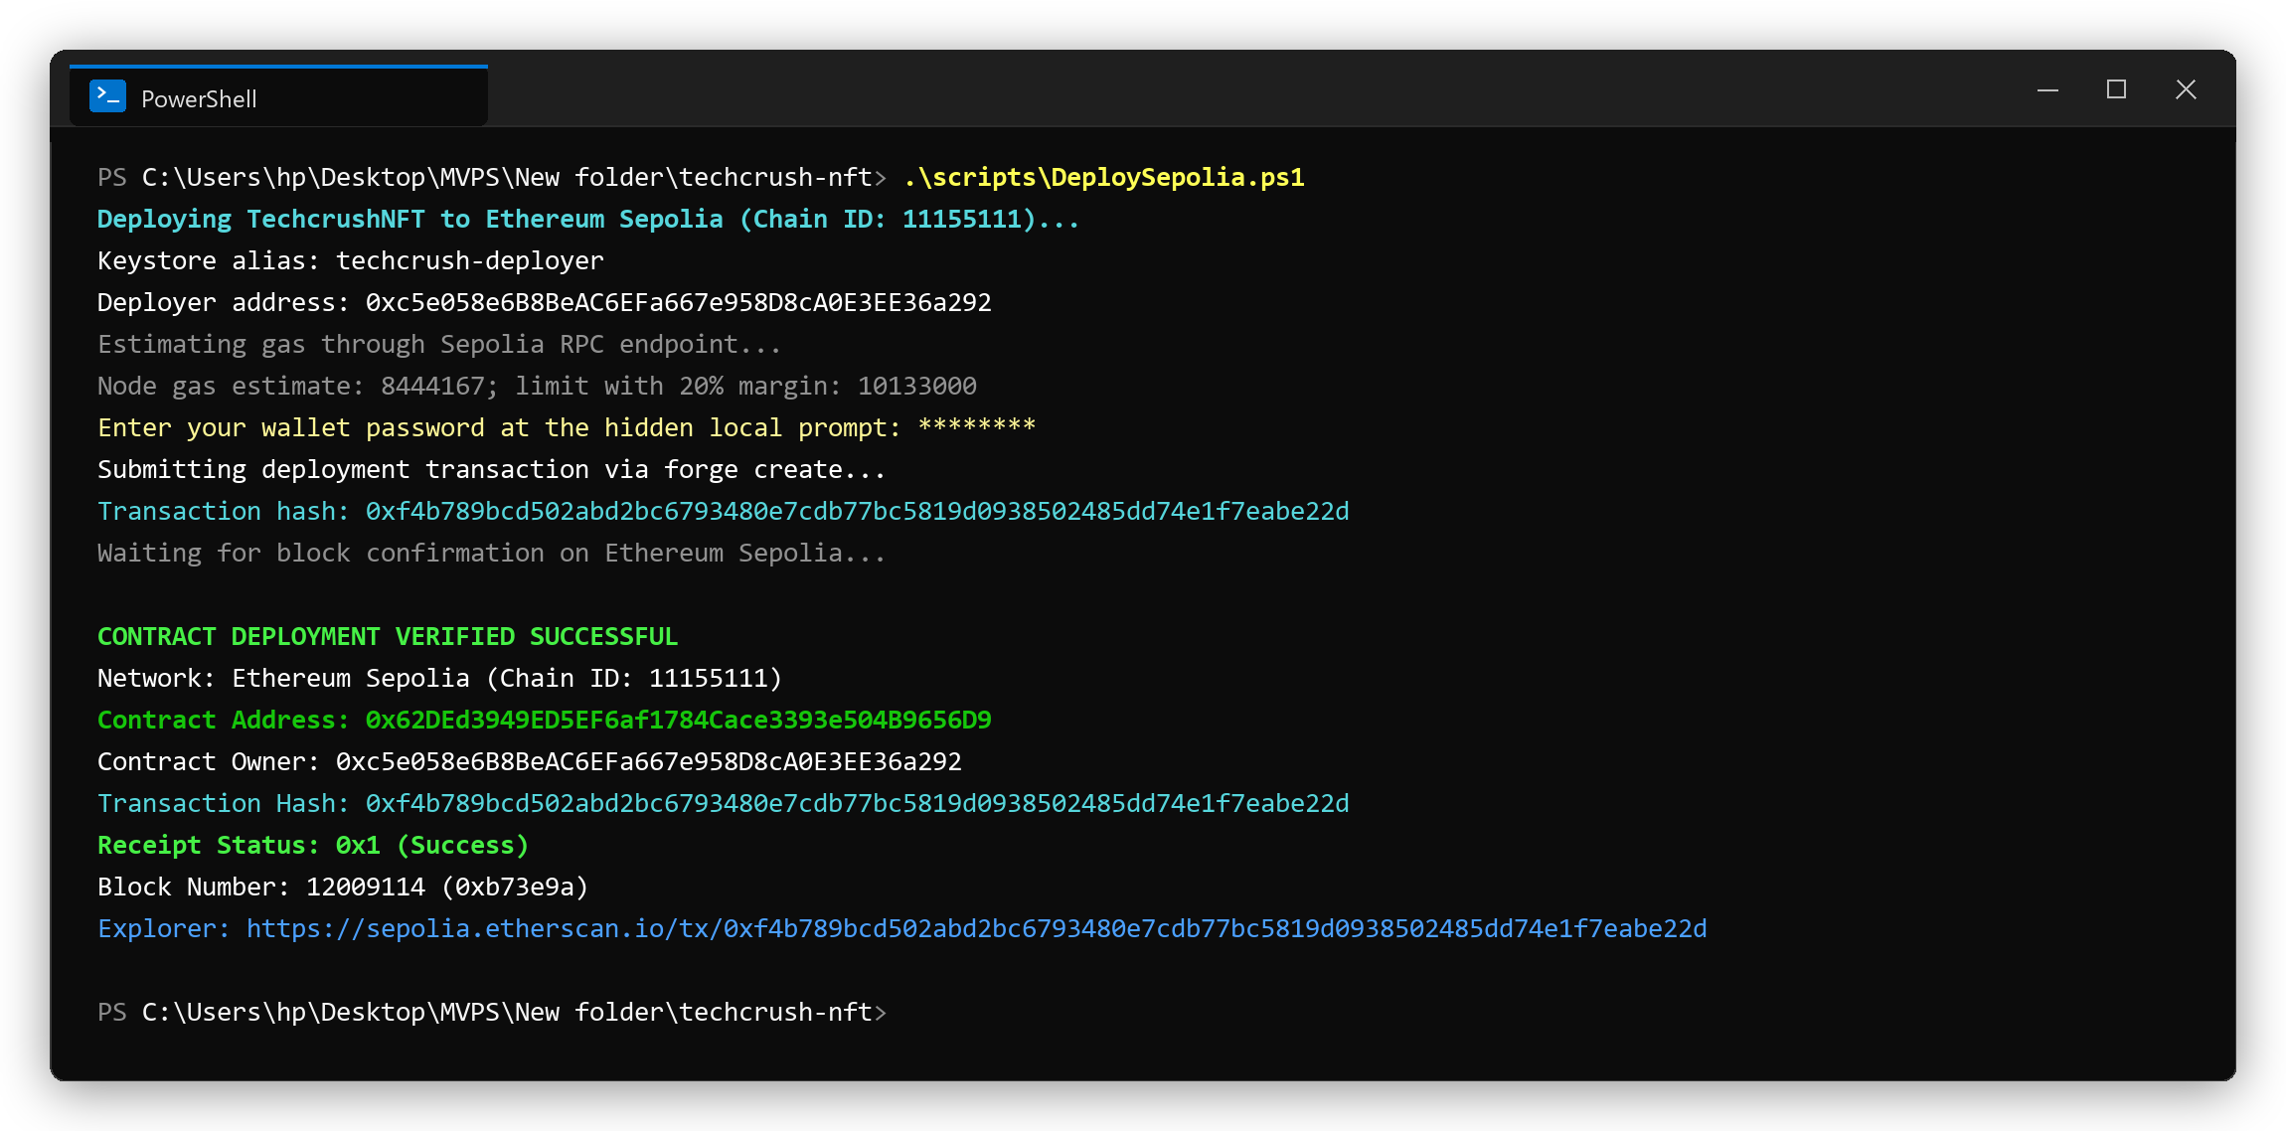

4. Sepolia Token Minting (Techcrush #1)
Token #1 was successfully minted to recipient 0xc5e058e6B8BeAC6EFa667e958D8cA0E3EE36a292. Both ownerOf(1) and tokenURI(1) were verified on Ethereum Sepolia.

