LinkedIn Profile Content Analysis

Benjamin Bowles, Gwenyth Krynski, Isabella Valdez, Maia Pacini, Trista Acker
TECM 4500: Content Analysis
October 4, 2025

Introduction
Technical communication majors have many career options after graduation. Students must decide what skills to prioritize learning to best aid them in the job search. Research has shown what job ads and recruiters want from technical communicators, but little is known about how professionals in the field present themselves on platforms like LinkedIn.

Purpose
The purpose of our report is to analyze how professionals in technical writing, editing, and training roles present themselves on LinkedIn and identify the skills and experiences they most often highlight to recommend how students should tailor their job materials to the field. Our study aims to answer the following research questions:
- RQ1: What skills, experiences, and competencies do technical writing professionals most often highlight in their LinkedIn profiles?
- RQ2: What skills should technical communication students aim to develop in their remaining coursework?
- RQ3: How should students structure their LinkedIn profiles to match what other professionals are doing?

Report Structure
This report begins by presenting the literature on competencies for technical writers requested by job ads and recruiters. Next, the methods used to gather and analyze LinkedIn profiles from technical writing professionals are described. The next section presents results from our collection and analysis. The paper concludes with our interpretation of the results and recommendations for students entering the field.

Literature Review
Past studies (Brumberger and Lauer, Stanton) describe different genres within technical communication job postings and what competencies are most often requested by those postings and by hiring manager. Our report focuses on skills for the technical writing/editing genre.

Job Ads
Brumberger and Lauer (2015) report that the most requested competencies for technical writing/editing roles is written communication (75%), followed by editing (51%), project planning/management (49%), visual communication (49%), and subject matter familiarity (45%). They also report the most requested personal characteristics/skills are collaboration (47%), time management (46%), independence/initiative (40%), detail oriented (39%), and analytical/critical thinking (33%).
Brumberger and Lauer also report the most requested information products and tools requested in the ads. User guides/tech docs were the most requested product (85%), and MS Office was the most common tool (59%). All other products and tools were mentioned in less than 20% of technical writing/editing posts.

Recruiters/Hiring Managers
Stanton (2017) interviewed recruiters and hiring managers to ask their top three top five skills sought out in candidates for technical writing roles. All interviewees mentioned a background in tech writing/strong writing skills as their top skill. All respondents also noted that soft skills are important when interviewing candidates. The skills mentioned as the most important were motivation to help others, strong interviewing skills, independence, strong interpersonal/communication skills, adaptability, problem-solving skills, and teamwork.
Stanton also reports that all respondents would require a portfolio demonstrating experience in writing for various audiences, editing, maintaining a consistent writing style, and using different applications. However, all but one respondent said they would interview a candidate with all skills except required software.

Methods
This section of our report describes the methods used to conduct our content analysis of LinkedIn profiles. We describe how our data was collected, what data was recorded, and how we analyzed the data.

Data Collection
Researchers independently collected LinkedIn profiles of individuals currently in a technical writing, editing, or training role. Each researcher collected 10 profiles, resulting in an initial total of 50. Group members used varying strategies to find their profiles.
Some used keyword searches or filters to restrict results by experience or location. Others relied on immediate connections or suggested profiles. Profiles were excluded if they lacked a headline, summary, or enough detail to analyze.
Researchers downloaded all profiles as PDFs. Their headlines and summaries were copied into individual text files. Files were labeled with the participant’s last name and sent to a shared drive.
To finalize the sample, profiles were reviewed for duplicates and insufficient data. We also identified examples to use for our codebook. Four duplicate profiles were removed resulting in a final sample size of 46 profiles. Two summaries were excluded due to missing or insufficient data. Three headlines and four summaries were used as examples for our codebook and removed from the sample.

Metadata
Metadata for all profiles was compiled into a shared spreadsheet. The following information was documented from each profile:
- First and last name
- Current position and company
- Highest degree level obtained
- Profile headline

Coding Scheme
After consolidating our data, we coded the headlines for structure and the summaries for their main theme. Headlines were coded as either single phrase, list/separated phrases, or narrative structure. Summaries were coded as career history, skills/tools, job duties, or achievements/values focused. Further descriptions of each code are included in Appendix A.
To create the codebook, we independently read the samples before an agreed meeting and took note of recurring themes. During the meeting, we discussed these patterns to develop our codes. Minor edits were made based on feedback from our professor.
One researcher randomly selected nine headlines and nine summaries for the group to test and refine the codebook. Researchers independently coded the pilot samples, recording their codes, supporting quotes, and notes for cases they were uncertain about. Supporting quotes from the headlines were not provided due to their brevity. Samples were coded for their primary focus to ensure mutual exclusivity.

Reliability
The group met to discuss after coding the pilot. Inter-rater-reliability (IRR) was calculated as the average percent agreement across raters using pairwise comparisons. Our agreement was 89% for headlines, indicating sufficient reliability. Our agreement was not sufficient for our summaries. Raters discussed discrepancies in our initial coding results and agreed to re-code using a disagreement log. We independently recorded codes, supporting quotes, and justifications for our decisions to retain or revise our codes. Raters chose not to revise our codebook before re-coding.
After our re-code, raters reached an agreement of 83%, indicating sufficient reliability. We then evenly split up the remaining profiles to finish coding. After coding all profiles, researchers used pivot tables to analyze the variables in the context of our research questions.

Results
There were three major results that we chose to focus on for this analysis: the frequency of summary codes, the frequency of heading codes, and the frequency of skills mentioned.
We focused on these results because we believed they would provide the most beneficial insight to our research questions. The frequency of both summary and headline codes, as well as the frequency of skills, would address the first question regarding which skills, experiences, and competencies are most often highlighted. Once the first question was answered, we could then begin to construct the answers for questions two and three.

Table 1: Number of Summaries in Each Code
Codes | Number of Summaries
Career History | 5
Skills/Tools/Qualifications Focused | 10
Job Duties | 7
Professional Achievements and Values | 21

Table 1 displays the number of summaries that were assigned to each code category. The chart shows that most of the summaries were coded under Professional Achievements and Values (21), followed by Skills/Tools/Qualifications Focused (10), Job Duties (7), and Career History (5).

Table 2: Number of Headlines in Each Code
Codes | Number of Headlines
Single Phrase | 28
List/Separated Phrases | 17
Narrative/Sentence | 2

Table 2 presents the headline amounts we input for each code category. Starting with Single Phrase (28) being the majority, followed by List/Separated Phrases (17), and Narrative/Sentence (2).
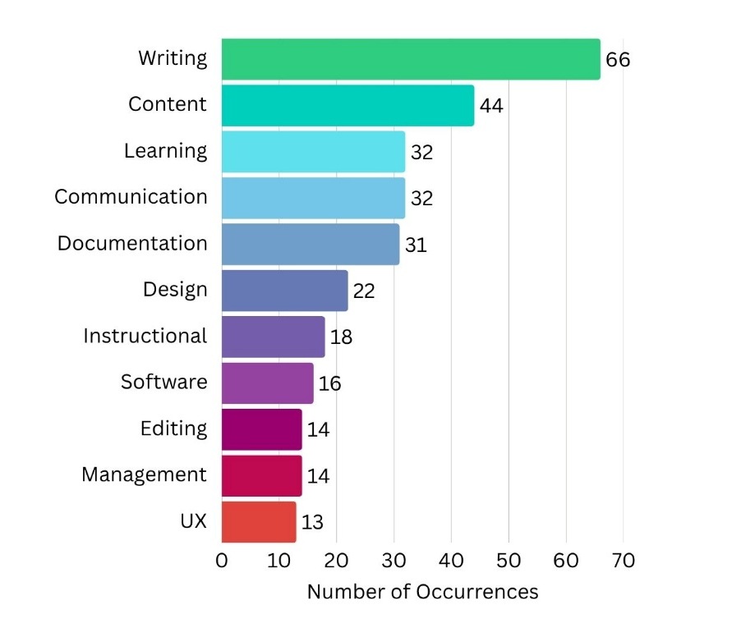
Figure 1: Most Common Skills Listed in Profile Summaries
Figure 1 illustrates the most common skills, as well as the frequency with which they appeared across the samples. In relation to RQ2, we see that the most frequent skill was “writing” with 66 occurrences. Following in descending order were:
Content (44), Learning (32), Communication (32), Documentation (31), Design (22), Instructional (18), Software (16), Editing (14), Management (14), and UX (13).

Discussion
Figure 1 shows the most common skills listed in our LinkedIn summaries. The frequent presence of these terms suggests they carry weight within the field and signal alignment with industry expectations. To capitalize on that, students should weave these same terms into their résumés, LinkedIn profiles, and other job materials—but not as isolated buzzwords. In practice, that means pairing the skill term with context (e.g. project experience, outcomes, statistics, and experience) rather than just listing it. Doing so can help job materials pass through recruiter filters and resonate with hiring managers who look for evidence, not just claims.
Looking at the format of the LinkedIn profiles for Technical Writers and Editors, we found that a majority would use an achievements/values approach for their summaries. While including the important feats they had accomplished in their professional lives, most profiles would incorporate their more personal values that helped drive them professionally throughout their journey.
Personalizing their summaries with both their professional achievements and the personal values that drive them makes their profiles stand out to employers, highlighting them as both professionals and unique people. Students can apply this to their profile by pairing each listed skill with evidence such as project outcomes, statistics, or results. Doing so can increase engagement with recruiters and better communicate professional authenticity.
Overall, our findings highlight clear pathways for students preparing to enter the field of technical writing. The data suggests that success in this profession depends less on earning an advanced degree and more on developing practical skills in writing, editing, and document/information design. By emphasizing these competencies in both coursework and job materials, students can more effectively align themselves with industry trends.
Additionally, structuring LinkedIn profiles or resumes around achievements, values, and specific evidence of expertise can help students present themselves as capable and authentic professionals. Together, these insights offer a realistic and encouraging outlook for future graduates pursuing careers in technical communication.

References
Brumberger, E., & Lauer, C. (2015). The Evolution of Technical Communication: An Analysis of Industry Job Postings.

Stanton, R. (2017). Do Technical/Professional Writing (TPW) Programs Offer What Students Need for Their Start in the Workplace? A Comparison of Requirements in Program Curricula and Job Ads in Industry.

Appendix A

Headline Codebook

Variable: Style

Definition: The headline’s main structure and focus
Code | Definition | Example
Single phrase | Consists of a single title, skillset, or phrase | “Technical Editor at Bosch” (P. 31)
List/separated phrases | Consists of two or more titles, skillsets, or phrases that do NOT show a narrative. May or may not contain visual separators such as pipes, bullets/interpuncts, dashes, or emojis | “BA in English. MA in Professional and Technical Communications.  Technical Writer. Editor. UX Designer. Content Manager” (P. 11)
Narrative/sentence | Consists of complete sentence(s) and/or narrative(s). First and third person phrasing is acceptable. Must mention professional goals or values | “Blindness has taught me to see differently ... The insight I've gained would be a valuable component of your design research team. Give me a shot. You’ll see.” (P. 12)

Summary Codebook

Variable: Theme/focus

Definition: The aspect of an individual’s career the summary most emphasizes
Code | Definition | Example
Career history | Individual describes how they got to their current role/place in life | “My journey as a technical writer started with reading the job description on the Bureau of Labor Statistics website to find a job that focused on writing.”  (P. 11)
Skills/tools/qualifications focused | Individual lists specific skills, tools, or qualifications relevant to their current or desired role | “Software: Microsoft Word, FrameMaker, Arbortext, Ventura,  Adobe InDesign, Robohelp, Madcap Flare, Confluence, Acrobat,  CorelDraw, Adobe Illustrator, Photoshop.  Technologies: Internet (TCP/IP), Wi-Fi, 3G and 4G wireless data,  Android devices.” (P. 42)
Job duties | Individual discusses routine job duties, tasks, or projects they work on. May list skills in the context of specific job tasks | “Dedicated, organized, and adaptable professional with extensive experience editing a wide range of material including peer-reviewed journals, academic and professional books, conference papers, business correspondence, magazines, newsletters, procedural manuals/guidelines, marketing copy, and online content.” (P. 31)
Professional achievements and values | Individual describes achievements, values or goals that are important to them. May include specific accomplishments, principles they value, or goals they are working on or hope to achieve in the future. May also focus on information that makes the individual unique as a person rather than as a professional | “As a technical communicator, I value effective communication  through clear and concise language.” (P.19)

Coding Rules
- Always refer to the codebook definitions and categories when coding
- Only code based on what is written in the headline and summary. Don’t infer meaning beyond what is stated
- Code each sample into only one category. If a sample appears to meet multiple categories, make note of a “secondary” code to discuss at meetings
- Do not reference other coders’ results until after the pilot samples are coded to maintain validity
- If agreement is below 70% for the pilot samples, coders will revise definitions and re-code the samples

Handling Fringe Cases
If an excerpt contains two or more codes, code the sample according to the dominant code. The dominant code is determined by the excerpt’s overall intent (i.e., does it mainly list information, or does it aim to tell a story?). Coders should note any fringe cases so they can be discussed during meetings.
- Example: “Tech Writer at Blackbaud | Creating accessible documentation for all”
- Possible codes: List/separated phrases, Narrative/sentence
- Code/reasoning: The headline is visibly separated, but the content focuses on a professional goal

