*Project Proposal*

*For*

*Restaurant Management System*

BCIS Department

Apex College

**POKHARA UNIVERSITY**

By

Sarishma Neupane (16080050)

Nisha Pathak (16080028)

Prakash Majhi (16080033)

Saurav Pokharel (16080053)

Sijan Shrestha (16080060)

Kathmandu, Nepal

2018

To,

Research and Extension Centre

Apex College

Pokhara University

Kathmandu, Nepal

From:

Sarishma Neupane (16080050)

Nisha Pathak (16080028)

Prakash Majhi (16080033)

Saurav Pokharel (16080053)

Sijan Shrestha (16080060)

Subject: Proposal for “Restaurant Management System”

In partial fulfillment of the requirement for

The degree of

*BACHELOR IN COMPUTER INFORMATION SYSTEM*

Kathmandu, Nepal

March, 2018

# ACKNOWLEDGEMENT

This project provided by APEX College has indeed been a fruitful for us. For the topic we choose we have been able to prepare this report. Beside our continual efforts, we got support from different people and parties for which we are extremely grateful and by their support while completing the report. Firstly, we would like to give special thanks to our Principal, and my friends for their encouragement and support during our project study period and at the time of preparation of this report. A special gratitude we give to our sir Mr. Tara Shrestha whose contribution in stimulating right from the time of selection of the topic and throughout the course of the research. We had tried our best to minimize errors to extent possible way by consulting our supervisor, colleague, personnel, organization, books and Internet.

We would like to appreciate to all of those who had helped us in making this report possible and guiding us in every step of the way. Furthermore we would also like to acknowledge with much appreciation the crucial role of the staff of Employee, who gave the permission to use all required equipment and the necessary materials to complete the task. I have to appreciate the guidance given by other supervisor as well as the panels especially in our project presentation that has improved our presentation skills thanks to their comment and advices.

Date: 2018/03/22

# ABSTRACT

This project titled as "Restaurant Management System" is developed in HTML, CSS, Laravel and VEU.JS as front end and SQL Developer and DBMS Server as back end. The main aim of the project is to control the management activities of the restaurant through this project. It helps in the easy access for storing the data and retrieving the data by restaurant at the time of needed. This system helps the restaurant to operate their operation more systematically. Here, in this system the admin can login and store the food menu item, their price list and get the inventory, sales details as well as employee details from the system. This system is developed to provide service facility to restaurant and also to the customer. This restaurant management system can be used by employees in a restaurant to handle the clients, their orders and can help them easily find free tables or places orders.

# List of Figures:

Figure 1. Context Flow Diagram 2

Figure 2 Project Summary 6

Figure 3 Summary Task 6

# List of Abbreviation:

* HTML: Hyper Text Markup Language
* CSS: Cascading Style Sheet
* SQL: Structured Query Language
* DBMS: Database Management System
* PHP: PHP Hypertext Preprocessor

**Table of Contents**

ACKNOWLEDGEMENT i

ABSTRACT ii

List of Figures: iii

List of Abbreviation: iv

CHAPTER 1 1

1.1 Introduction: 1

1.2 Objectives: 1

1.2.1 Academic Objectives: 1

1.2.2 Specific Objectives: 2

1.3 Theoretical Background and Working Summary 2

1.3.1 Theoretical Knowledge Required for the Project: 2

1.3.2 Context Flow Diagram: 2

1.3.3 Working Principle of the Project: 3

CHAPTER 2 4

2.1 Literature Review: 4

CHAPTER 3 5

3.1 Hardware and Software Requirements: 5

CHAPTER 4 6

4.1 Proposed Schedule: 6

CHAPTER 5 7

5.1 Cost Benefit Analysis: 7

Benefits: 8

CHAPTER 6 9

6.1 Application of the Project in Real World: 9

6.2 Limitations: 9

CHAPTER 7 10

7.1 Group Organization: 10

# CHAPTER 1

## Introduction:

Restaurant Management System is a web application. This system is developed to automate day to day activity of a restaurant. Restaurant is a kind of business that serves people all over the world with ready-made food. This system is developed to provide service facility to restaurant and also to the customer. This restaurant management system can be used by employees in a restaurant to handle the clients, their orders and can help them easily find free tables or places orders. The Restaurant Management System helps the restaurant manager to manage the restaurant more effectively and efficiently by computerizing meal ordering, billing, inventory control, sell management, employee management, and report generator.

Many restaurant have a lot of difficult to manage the business such as customer ordering and reservation table. By using manual customer ordering it is difficult for the employee to keep the correct customer information and may lose the customer information. This restaurant management system will have contain a higher level of security which is known as cross site request forgery.

The best way to optimize these activities is growing the business online as well. Today’s generation encourages high-tech services especially over the internet. Hence, the project is developed proficiently to help restaurant owners automate their business operations. This project serves the best way of maintaining customer’s information and caters their needs.

## Objectives:

### Academic Objectives:

* To complete the minor-project we mentioned by the university in a specified time.
* To learn about time management and explore more on group work with environment.
* To be able to generate ideas about the different projects.

### Specific Objectives:

* To learn about the real time working of web development fundamental concept.
* To create a platform for the Nepalese people to
* To develop a viewable platform on any devices with 100% responsiveness.

## Theoretical Background and Working Summary

### Theoretical Knowledge Required for the Project:

In order to complete this project we required some theoretical knowledge about the internet technology and about its components and networking like HTML, LARAVEL, GIT BASH, VUE JS, and CSS. For the storage management of the data of the proposed system we also have knowledge about database management like MYSQL.

### Context Flow Diagram:

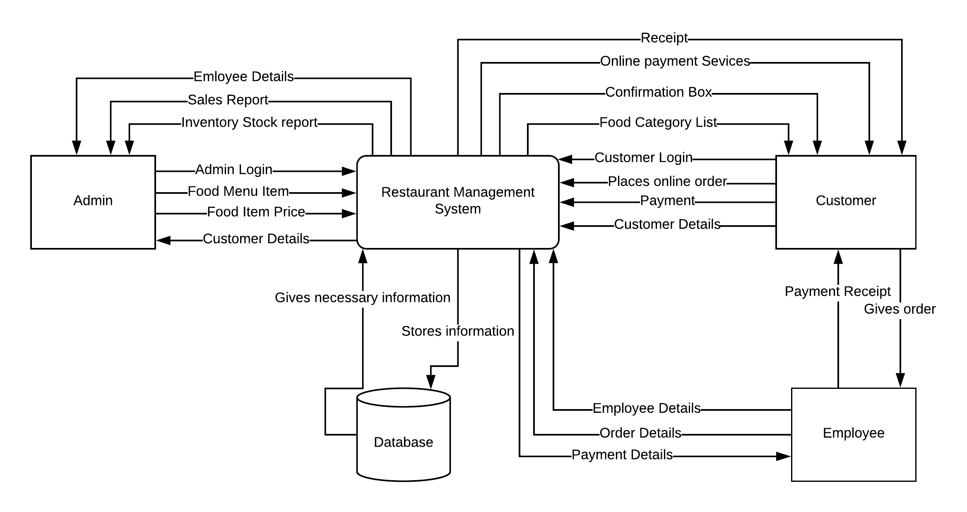

Figure 1. Context Flow Diagram

## 1.3.3 Working Principle of the Project:

The proposed project will be useful mainly for the restaurant businesses and customer who love to prefer the readymade food, organizing seminars and events. Nowadays, people prefer the home delivery services for the food products as well as restaurant businesses use the manual system for booking of hall, customer orders. But, with the help of this management system it provide dedicated services to restaurant business as well as customer too. In this system, restaurant can manage their inventory, sales, account, billing as well as food item and employees of their work place. Besides these, there are other more function that restaurant operator will interact.

# CHAPTER 2

## 2.1 Literature Review:

Restaurant Management System, a proper and systematic system which deals with the management activities of the restaurants in this competitive 21st century. We came to know about this project from visiting the renowned restaurant and café Red Mud Café of Jhamsikhel. We visited there for our refreshment and we got to know that they have digital way of taking order from the customer and digital billing view for the customers.

By seeing the management service at the Red Mud Café we were inspired and decided to do this project and implement in real time for the restaurant those who are seeking for the systematic and ease way of providing their services to the people within their business place as well as out of their business area like home based order. We want to develop this system to make the restaurant business to operate smoothly and customer to get enough satisfaction as well as help the restaurant to operate in the competitive market and sustain for a long period of time. This system gives its user an easy way to perform their tasks effectively.

For making this project, we surveyed many restaurant and café to know whether any of them has used this system. But we got to know that only few renowned restaurant are using these kind of system but they lack the online order system in their used system. In development of this project, we need to know all the components that are attached to restaurant in order to include in the new system so that user can feel easy to operate with this system.

For the further enhancement, we are searching for more features and conducting more research in order to build this system effectively with more features.

# CHAPTER 3

## 3.1 Hardware and Software Requirements:

|  |  |
| --- | --- |
| Hardware Requirement | 1.6 GHz or faster processor, 2gb RAM, 50MB of available hard disk |
| OS Requirement | Windows XP and above |
| Framework | Laravel and Composer |
| Backend | Web Server |
| Web Browser | Mozilla Firefox, Google Chrome, Internet Explorer |
| Design Software | Adobe Photoshop |
| Documentation Software | Microsoft Word |
| Diagramming Software | Microsoft Visio |
| Scheduling Software | Microsoft Project |
| Version Controller | Git Hub |

# CHAPTER 4

## 4.1 Proposed Schedule:

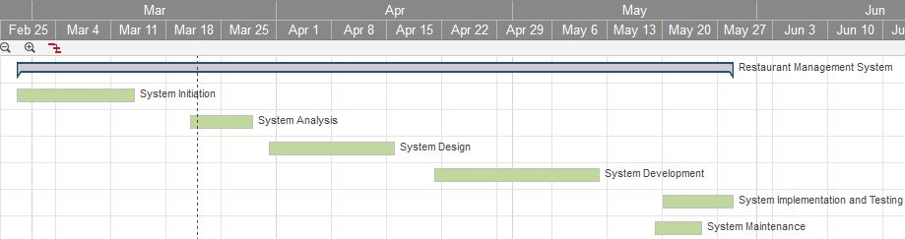

Figure 2 Summary Task

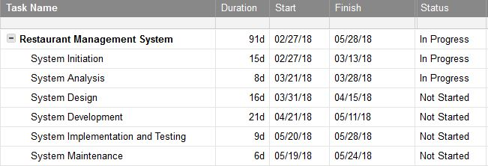

Figure 3 Project Summary

A Gantt chart, commonly used in project management, is one of the most popular and useful ways of showing activities (tasks or events) displayed against time. On the left of the chart is a list of the activities and along the top is a suitable time scale. Each activity is represented by a bar; the position and length of the bar reflects the start date, duration and end date of the activity. Gantt charts illustrate the start and finish dates of the terminal elements and summary elements of a project. Terminal elements and summary elements constitute the work breakdown structure of the project. Modern Gantt charts also show the dependency (i.e., precedence network) relationships between activities.

# CHAPTER 5

## 5.1 Cost Benefit Analysis:

|  |  |  |
| --- | --- | --- |
| **S.N** | **TANGIBLE COSTS** | **ESTIMATED COSTS** |
| 1. | **Software Costs**   * Microsoft Project 2013 * Microsoft Visio 2007 * Adobe Photoshop * MYSQL Database * Apache Server | Rs. 12000- Rs.15000 |
| **2**. | **Transportation Costs** | Rs. 120 per day |
| **3.** | **Utilities**   * Electricity * Internet * Food | Rs. 2000 – Rs. 2500 per day |
| **4** | **Domain Registration** | Rs. 1000 |
| **5** | **Web Hosting** | Rs. 10000 |
| **6** | **Rent** | Rs. 20000 |
| **7** | **Database Server** | Rs. 6500 |
| **8** | **Desktop** | Rs. 120000(6*20000) |
| **Total Costs** | | **Rs. 310000-400000** |

## Benefits:

* Easy to operate.
* No deep knowledge about computers required for operating it.
* Maintenance is also cheaper.
* Secured and CSRF protection.
* Easy to track the necessary information required by the restaurant.
* Easy for customer to order the food they wish to desire in a click.

# CHAPTER 6

## 6.1 Application of the Project in Real World:

* The proposed system will be used in the restaurant and café business sectors
* For managing the inventory, sales, account as well as employees management.
* Providing online ordering facilities to their customers.
* To provide customer easy to access from any devices at any time.
* Customer can point out their view at any particular item and rate it.

## 6.2 Limitations:

* The development of this system will be limited to fully back end (admin) side.
* Customers cannot cancel the order after it has been submitted.
* Navigation bar won’t be a dynamic.
* Test Driven Development will not be implemented.
* Slug will not be implemented.

# CHAPTER 7

## 7.1 Group Organization:

|  |  |
| --- | --- |
| **Member Name** | **Work** |
| Sarishma Neupane (Leader) | Project Designing and Coding |
| Nisha Pathak | Project Research, Requirement Analysis |
| Prakash Majhi | Project Research |
| Saurav Pokharel | Coding and Implementation, Maintenance |
| Sijan Shrestha | Coding and Implementation, Testing and Maintenance |