CLACELL: Robust cell type classifier for immune cells
Julian Kraus¹, David B. Blumenthal¹, Anne Hartebrodt¹
¹Biomedical Network Science Lab, Department Artificial Intelligence in Biomedical Engineering, Friedrich-Alexander-Universität Erlangen-Nürnberg (FAU)
Single-cell RNA sequencing (scRNA-seq) has transformed genomic research by uncovering cellular heterogeneity, however robust cell type classification remains a significant analytical bottleneck. While manual marker-based annotation is subjective and scale-limited, existing computational classifiers frequently struggle when deployed on complex immune tissues. State-of-the-art models often suffer from high performance variance, sensitivity to gene dropout, and overfitting. To address these challenges, we introduce CLACELL, an open-source Python framework engineered for the robust and deterministic classification of immune cells.
Methods: CLACELL uses a feature-subsampling ensemble paired with a Linear SVM. The framework was benchmarked against CellTypist, scGPT, and SingleR using in-distribution (ID) and out-of-distribution (OOD) scRNA-seq datasets. Performance and robustness were measured via robustness tests, including classification report, random feature dropout, prediction stability, and progressive feature importance dropout (removal of up to 2% of key marker genes).
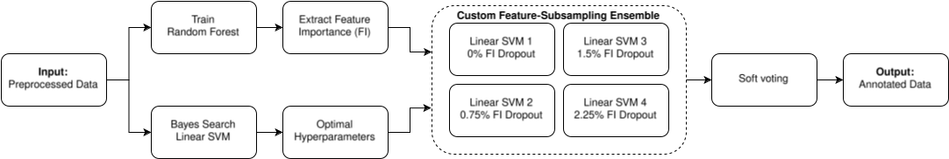Figure 1: Overview of the CLACELL Annotation Pipeline
Results: CLACELL consistently outperforms CellTypist across most metrics and achieves superior generalization on OOD data compared to SingleR, which showed a strong tendency to overfit on the training distribution. While the deep learning model scGPT outperformed CLACELL on OOD data, CLACELL demonstrated superior performance on ID data. Overall, performance was evenly balanced across all test scenarios, however, scGPT exhibited higher variance, non-deterministic outputs, and required GPU acceleration. Therefore CLACELL provides an optimal balance of predictive accuracy, operational robustness, and strict reproducibility.

