Celestial Mechanics Toolkit
Want to create realistic orbital simulations, but don't want to bother with complicated physics calculations? This is the toolkit for you! By putting together a few easy-to-use components, you can make complex orbital simulations that follow Kepler's Laws of Planetary Motion. On top of all this, the toolkit has been designed for quick procedural generation of orbits and orbital systems.

GameObjects can move in circular, elliptical, parabolic, or hyperbolic paths, as well as rotate about an axis. Orbiting objects can be nested to create complicated orbital systems. The toolkit also includes components for generating ring meshes, simulating orbital decay and precession, and drawing orbital paths.

Orbit Shape and Size
There are two basic types of orbits: Closed and Open. Closed orbits repeat, and are used to show planets and satellites. Open orbits do not repeat, and are used to show slingshot or flyby maneuvers. The most common type of orbits are closed elliptical orbits.

The shape of an orbit is defined with the eccentricity parameter. An eccentricity between 0 and 1 defines a closed orbit, and an eccentricity of 1 or greater defines an open orbit. 0 and 1 are special values, and denote perfectly circular and perfectly parabolic orbits, respectively.

The size of an orbit is defined with the periapsis parameter. This indicates the closest distance the orbital body will get to its focus. In an open orbit, the periapsis is usually called the focal length.

Orbit Orientation
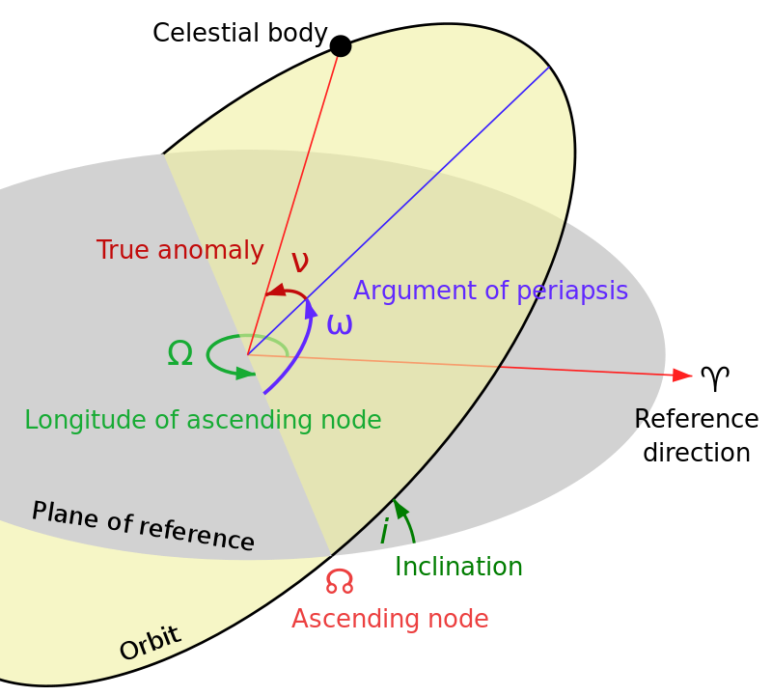Wikimedia CC BY-SA 3.0
Instead of rotating an orbit using the X, Y, and Z axes, orbital orientations are specified by three other angles: Longitude of the Ascending Node, Inclination, and Argument of the Periapsis.

The longitude is applied first, and indicates the direction of the periapsis within the parent's orbital plane. The inclination is applied second, and indicates the rotation of the orbit about the periapsis. The argument is applied last, and indicates a final rotation of the periapsis within the orbital plane.

Orbital Motion
The starting position of the orbital body along the orbital path is known as the mean anomaly. Anomaly is an angular measurement that indicates the current orbital position. An anomaly of 0° is at the periapsis, an anomaly of 180° is at the far end of the orbit. This parameter is used to calculate the true anomaly, which is the angle between the periapsis and the current orbital position.

Open orbits have limits, which indicate the lowest and highest anomaly values. Open orbits can theoretically move to infinity, so the limits define a stopping point for the simulation. When an open orbit is simulated, it is automatically stopped and reset when it reaches either limit.

Closed orbits have an epoch parameter, which is used to adjust the starting time of the simulation. This is useful when simulating real-life orbital systems, which typically record orbital parameters for a single given time. The epoch can adjust this forward or backward to any point in time.

The period is the amount of time it takes for a body to complete one orbit, in seconds. A lower period results in a faster orbital speed. For open orbits, the period is the amount of time to move from the lower limit to the upper limit. The orbital rate can also be adjusted at runtime with the time scale parameter. If an orbit needs to be paused without stopping the simulation, the time scale can be reduced to 0.

Events
When an orbit starts, stops, and updates, it will invoke UnityEvents. The On Update event includes a parameter for the current true anomaly. The On Start and On Stop events are called when the simulate parameter is changed.

Properties
The toolkit exposes read-only properties that are used when calculating orbital positions. These properties can be used by custom scripts to perform more detailed calculations.

