Homework 1
Question 1: From the network structure perspective, what are the key components in Internet? (5 points)
1) computing devices: hosts or end systems.
2) communication links: fiber, copper, radio, satellite.
3) packet switches: routers and switches.

Question 2: Please specify three typical types of access networks. (5 points)
1) Digital Subscriber Line (DSL)
2) Cable
3) Fiber

Question 3: Regarding the hierarchical structure of Internet, please provide your solutions to the following two questions. (10 points)
(a) In Internet, what is the difference between Tier-I ISP and Tier-II ISP.
1) Tier-I ISP (Global): e.g. Sprint, AT&T, China Telecom
  - National-level Internet coverage
  - Sufficient traffic volume (i.e. the number of users)
  - Tier-I ISPs are peered with each other
2) Tier-II ISP (Region): e.g. China Unicom, CTM Macao
- Region-level coverage (e.g., access networks)
- Use Tier-I ISP to reach a global access
- Tier-2 ISPs could also be peered with each other
(b) How do two different Tier-I ISPs exchange data?
Global ISPs are connected with each other via Internet exchange point (IXP) to exchange data, which can significantly reduce the cost for connecting all access networks directly.

Question 4: Regarding the circuit switching and packet switching, please provide your solutions to the following two questions. (30 points)
(a) What are the key differences between the circuit switching and packet switching? (10 points)
The differences between the circuit switching and packet are shown below:
Attribute | Circuit Switching | Packet Switching
Resource reservation | Yes | No (on-demand manner)
Call setup and tear up | Yes | No (very simple)
Number of served users | Limited due to limited link capacity | Multiplexing gain
Performance | Guaranteed performance | Packet delay, loss, and network congestion
Application | Telephone networks | Internet and computer networks

(b) What are the advantages and disadvantages of the circuit switching? (10 points)
Advantage:
- Reliable performance of delivering data from source host to destination host
  - Guaranteed predetermined trans bandwidth and router capacity
  - Guaranteed latency for the data from source to destination
Disadvantage:
- Resource is idle if not used by the owning call (no sharing): a low-efficient utilization of network resources
(c) What are the advantages and disadvantages of the packet switching? (10 points)
Advantage:
- Given the number of users, save the bandwidth
- Given the bandwidth capacity, more users can be served
Disadvantage:
If arrival rate (in bits) to link exceeds transmission rate of link for a period of time:
- Queueing delay: Packets will queue, wait to be transmitted on link
- Packet loss: Packets can be dropped (lost) if memory (buffer) fills up
  - Link in buffer has finite capacity
  - Packet dropped if the buffer is full

Question 5: We consider the following scenario in Figure 1. There is an access link with bandwidth of 1Mbit per second (i.e., 1Mbps) to serve several hosts (i.e., end-system) in a local area network. Each host requires a bandwidth of 100kbps for sending its data when its active, and each host’s active probability is 0.2. Please provide your solutions for the following two questions (20 points)
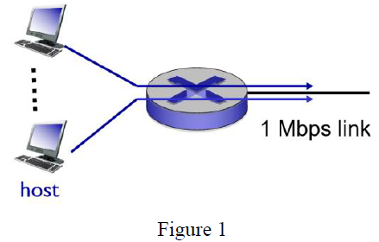
(a) Suppose that circuit switching is adopted, how many hosts can be admitted by this access link?
1 Mbps ÷ 100 kbps = 10 hosts.
(b) Suppose that packet switching is adopted and that there are 25 hosts admitted by this access link. In this case, what is the probability that an admitted host cannot obtain its required bandwidth (i.e., 100kbps) when it is active?
Link supports 10 active hosts. Congestion occurs if >10 active. So the probability of congestion occurs is P(X>10) ≈0.0056, X∼Binomial(n=25,p=0.2).
(c) Compared to the solution in (b), if there are 40 hosts are admitted, how will the above probability change (i.e., increase, decrease or keep the same)? Please give your explanation.
The probability will be increased, because probability of exceeding 10 increases will cause congestion probability rises.
(d) Compared to the solution in (b), if each host’s active probability becomes 0.1, how will the above probability change? Please give your explanation.
Congestion probability will decrease significantly, because lower activity probability will reduce congestion.
(e) Based on the solution in (d), if each host’s active probability becomes 0.1, will the benefit of from the statistical multiplexing gain be more significant or not? Please give your explanation.
More significant, since fewer hosts are active simultaneously, resources are better utilized.

Question 6: Suppose that we consider the store-forward-delay in packet switching. As shown in Figure 2, a source host send three packets to a destination host via one router. The size of each packet is L bits, and the bandwidth of each link is R bps. The source host sends the three packets in sequence. Assume that only the transmission delay in considered in this scenario. What is the overall latency for the destination host to receive ALL THE THREE packets? (20 points)
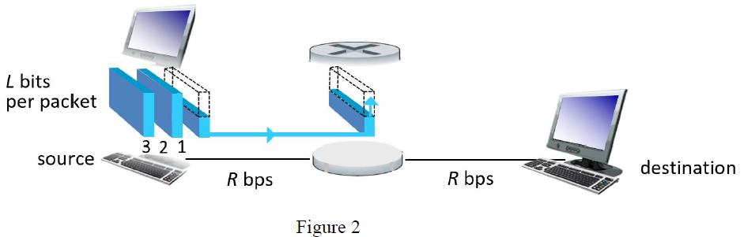
- First packet arrives at destination after 2 × (L/R).
- Second packet after 3 × (L/R).
- Third packet after 4 × (L/R).
Therefore, the overall latency to receive all the three packets is 4 × (L/R).

Homework 2
Question 1 (15 points): Regarding the delay in packet switching systems,
(i) please specify four types of delay in packet switching.
1) nodal processing delay
2) queueing delay
3) transmission delay
4) propagation delay
(ii) Please explain the difference between the queueing delay and transmission delay.
Queueing delay is the time a packet waits in a buffer before being transmitted. Transmission delay is the time required to push all bits of a packet onto the link.
(iii) Please explain the reason for the packet loss.
Physical condition: routers have limited storage, i.e., the buffer space of an output link is limited. When the buffer of the output link is fully used, the newly coming packet has to be dropped. As a result, the packet is lost.

Question 2 (15 points): Consider a packet delivery shown in Figure 1 below. A sending-host sends a packet to a receiving-host via two routers. The packet size is of L. The distance between two different routers and the distance between host and router are denoted by d. The link bandwidth is denoted by R. The signal propagation in each link is denoted by v. For each individual router, its total node processing delay and queuing delay is denoted by T. Please calculate the overall delay for the whole packet is received by the receiving host.
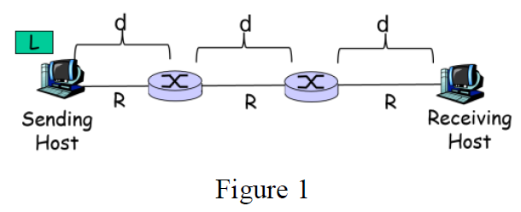

Total delay =
- 3 × transmission delay = $3⋅\frac{L}{R}$
- 3 × propagation delay = $3⋅\frac{d}{v}$
- 2 × node and queuing delay = $2⋅T$
So,
$$\text{Total Delay}=3⋅\frac{L}{R}+3⋅\frac{d}{v}+2⋅T$$

Question 3 (5 points): Please specify the difference between the Client/Server (CS) service model and Peer-to-Peer (P2P) service model.
Client/Server (CS):
server:
- always-on host
- permanent address
- server farms for scaling
clients:
- communicate with server
- may be intermittently connected
- may have dynamic addresses
- do not communicate directly with each other
Peer-to-Peer (P2P):
- no always-on server
- arbitrary end systems can directly communicate with each other as the “peers”
- A temporary requesting peer can obtain content (service) from a temporary providing peer
- peers are intermittently connected and change addresses
- Highly scalable but difficult to manage

Question 4: (35 points) Suppose that we have a file of size F=20MBits and we need to distribute this file from one server to a group of peers. The number of the peers is N. Assume that the server’s uploading bandwidth $u_{s}$=40MHz, and each peer has an equal uploading bandwidth $u_{i}$=5 MHz and equal downloading bandwidth $d_{i}$=10MHz. Then, please provide your solution to the following four questions:
(a): Suppose that we use Client/Server service model to distribute the file. How long does it for the case N=5, N=10, N=20, N=40, and N=60, respectively? (10 points)
The time to distribute F to N clients is $d_{cs}=max⁡\{\frac{NF}{u_{s}}, \frac{F}{d_{i}}\}$.
When N=5, 10, 20, 40, and 60, the $d_{cs}$=2.5, 5, 10, 20, and 30, respectively.

(b): Suppose that we use Peer-to-Peer service model to distribute the file. How long does it for the case N=5, N=10, N=20, N=40, and N=60, respectively? (10 points)
The time to distribute F to N clients is $d_{p2p}=max⁡\{\frac{F}{u_{s}}, \frac{F}{d_{i}},NF/(u_{s}+\sum{u_{i}})\}$.
When N=5, 10, 20, 40, and 60, the $d_{p2p}$=2, 2.22, 2.85, 3.33, and 3.53, respectively.
(c): What can you find by comparing the solutions from (a) with the solutions from (b)? (5 points)
CS time increases linearly with N; P2P time grows much slower due to peer contribution.
(d): Suppose that there are infinite number of the peers in the system, i.e., N= , how long does the Client/Server model to distribute the file, and how long does the Peer-to-Peer model to distribute the file? (10 points)
CS: Distribution time → ∞ (server bottleneck).
P2P: $d_{p2p}=max⁡\{\frac{F}{u_{s}}, \frac{F}{d_{i}}\}$

Question 5 (10 points): Regarding the layered protocol in Internet,
(i) please specify the names of the five layers in the TCP/IP reference model. (5 points)
Application, transport, network, link, physical
(ii) Please specify the names of the seven layers in the ISO/OSI reference model. (5 points)
Application, presentation, session, transport, network, link physical

Question 6 (10 points): Please specify three types of network attacks.
Denial of Service (DoS), Packet “sniffing”, IP spoofing.
Question 7 (10 points): Regarding the data-link layer service,
(i) what is the key functionality of the data-link layer service? (4 points)
Data-link layer has responsibility of transferring datagram from one node to physically adjacent node over a link.
(ii) Consider the packet delivery in Figure 2. Suppose that host A sends a packet to Host F. How many times will the encapsulation operations between the data-link layer and the network layer be invoked, and how many times will the de-capsulation operations invoked accordingly? (6 points)
Encapsulation occurs at each hop when a frame is created; decapsulation occurs at each receiving node. For host A → F via multiple hops, encapsulation and decapsulation happen at each link.

Homework 3
Question 1: (20 points)
(a) Please specify three examples of MAC which are based on the rationale of “random access”. (5points)
- slotted ALOHA
- ALOHA
- CSMA, CSMA/CD, CSMA/CA
(b) Can CSMA completely avoid collisions? Please explain your solution. (5 points)
No, collisions can still occur since that propagation delay means two nodes may not hear each other’s transmission.
(c) What are the differences between CSMA/CD and CSMA/CA? (10 points)
CSMA/CD: Used in wired Ethernet. Detects collisions during transmission and aborts immediately.
CSMA/CA: Used in Wi-Fi (802.11). Cannot detect collisions; instead, avoids them using random backoff and timers.

Question 2: (20 points)
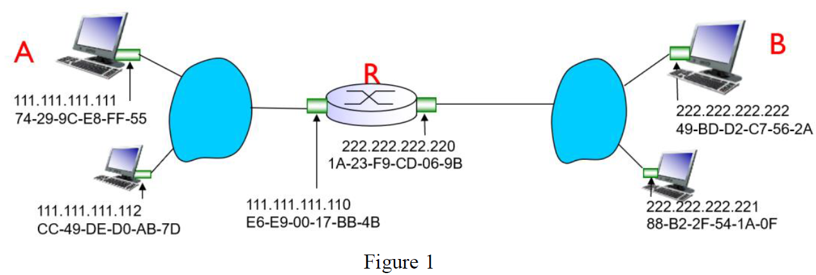
(a) As shown in Figure 1, suppose that host A sends a datagram to host B. Will the source/destination IP addresses be changed when the datagram traverses through the router R?
No, source and destination IP addresses remain unchanged.

(b) As shown in Figure 1, suppose that host A sends a datagram to host B. Will the source/destination MAC addresses be changed when the frame traverses through the router R?
Yes, source and destination MAC addresses change at each hop.

Question 3: (20 points)
(a) What are the differences between the function of the network layer and the function of the data link layer? (10 points)
Network: routing of datagrams from source to destination
forwarding: move packets from router’s input to appropriate router output
routing: determine route taken by packets from source to destination.
- IP, routing protocols
Link: data transfer between neighboring network elements
Data-link layer has responsibility of transferring datagram from one node to physically adjacent node over a link
- Ethernet, 802.11 (WiFi), PPP
(b) What the difference between the MAC address and IP address? (10 points)
MAC address: Physical identifier, fixed per device, used at link layer.
IP address: Logical identifier, hierarchical, can change, used at network layer.

Question 4: (20 points) Please explain the difference between the Link-State based routing algorithm and the Distance-Vector based algorithm.
Message complexity:
LS: with n nodes, E links, O(nE) massages sent
DV: exchange between neighbors only (convergence time varies)
Speed of convergence:
LS: O(n²) algorithm requires, O(nE) massages (may have oscillations)
DV: convergence time varies (maybe routing loops, and count-to-infinity problem)
Robustness: what happens if router malfunctions?
LS:
- Node can advertise incorrect link cost
- Each node computes only its own table
DV:
- DV node can advertise incorrect path cost
- Each node’s table used by others
- Error propagates through network

Question 5: (20 points)
(a) Consider the network topology shown in Figure 2. Suppose that the distance vector based algorithm is used for routing. Please specify convergence process as shown in the following Figure 3. (10 points)
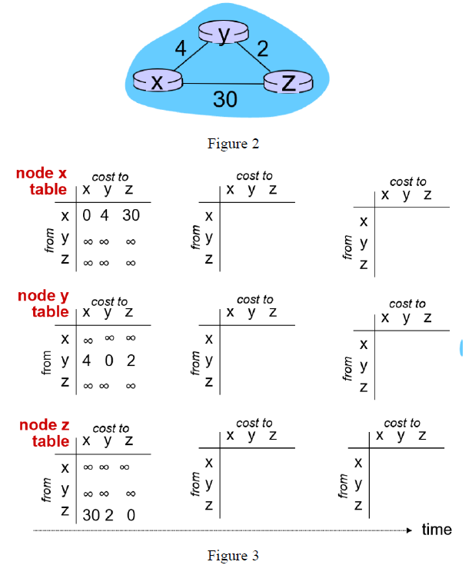
0 4 6
4 0 2
6 2 0
0 4 6
4 0 2
6 2 0
0 4 6
4 0 2
6 2 0
0 4 30
4 0 2
6 2 0
0 4 30
4 0 2
30 2 0
0 4 6
4 0 2
30 2 0

(b) After convergence of the distance vector based algorithm in the above Question 3(a), if the link cost between router x and router y is increased to 60 as shown in Figure 4 below, will the distance vector based algorithm converge quickly after this increased link cost? Please explain your reasons. (10 points)
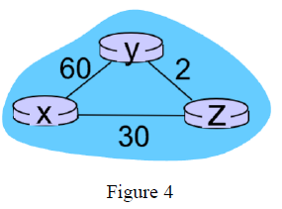
No, convergence will be slow because DV relies on iterative neighbor updates and may suffer from count-to-infinity.

Homework 4
Question 1: (10 points)
Regarding the IP fragmentation, suppose that there is a datagram of 5000 bytes, and the MTU of the link is 1000 bytes. How many datagrams will be generated after the IP fragmentation, and why?
Total 6 datagrams.
Original datagram: length=5000, fragflag=0, there are 4980 bytes in data field.
1st datagram: length=1000, fragflag=1, there are 980 bytes in data field.
2nd datagram: length=1000, fragflag=1, there are 980 bytes in data field.
3rd datagram: length=1000, fragflag=1, there are 980 bytes in data field.
4th datagram: length=1000, fragflag=1, there are 980 bytes in data field.
5th datagram: length=1000, fragflag=1, there are 980 bytes in data field.
6th datagram: length=100, fragflag=0, there are 80 bytes in data field.
Because of that 5 fragments of 1000 bytes each (980 bytes data + 20 bytes header), all with “more fragments” flag = 1. 1 final fragment of 100 bytes (80 bytes data + 20 bytes header), “more fragments” flag = 0.

Question 2: (10 points)
- What does "CIDR" refer to? (5 points)
Classless Inter-Domain Routing. Subnet portion of address of arbitrary length. Address format a.b.c.d/x, where x is subnet prefix length.
(b) What does "DHCP" refer to? (5 points)
Dynamic Host Configuration Protocol. Automatically assigns IP addresses to hosts.

Question 3: (10 points)
Regarding the shortage of the IPv4 addresses, please specify two ways to address this issue of the shortage of the IPv4 addresses.
Use NAT (Network Address Translation).
Upgrade to IPv6.

Question 4: (20 points)
(a) To identify a TCP socket, what are the 4-tuple information required? (5 points)
Source IP address, destination IP address, source port number, and destination port number.
(b) To identify a UDP socket, what are the 2-tuple information required? (5 points)
Destination IP address and destination port number.
(c) What are the differences between TCP and UDP? (10 points)
TCP | UDP
- Connection management  - Connection-oriented  - Send and receive buffers exist  - Full duplex data  - Reliable data transfer  - Flow controlled  - Congestion controlled | - No connection establishment (which can add delay)  - Simple: no connection state at sender, receiver  - Small header size  - No congestion control: UDP can blast away as fast as desired

Question 5: (5 points) What are the three mechanisms to realize the reliable data transfer protocols?
Feedback (control messages (ACK, NAK) from receiver to sender), sequence number, and timer.

Question 6: (15 points)
Consider the situation of reliable data transfer. Each packet size is 5000bits. The link bandwidth is 5Mbits/ sec. The single-trip signal propagation delay is 0.005sec.
(a) What is the utilization ratio of this link if the stop-and-wait based reliable data transfer protocol is adopt? (5 points)
Round Trip Time (𝑅𝑇𝑇)=2∗0.005=0.01 𝑠𝑒𝑐
L/R=5000/5000000=0.001 sec
$$U=\frac{L/R}{RTT+L/R}=\frac{0.001}{0.01+0.001}=0.0909$$
(b) How to improve the utilization ratio of this link? To make a full utilization of the link, what is the maximum number of packets which can be sent without requiring acknowledgement? (5 points)
Use pipelined protocols (Go-Back-N or Selective Repeat). Maximum packets in flight = RTT/(L/R) + 1 = 11.
(c) What are the differences between the GBN protocol and selective repeater protocol?
Go-back-N | Selective Repeat
- Sender can have up to N unacked packets in pipeline  - Receiver only sends cumulative ack: doesn’t ack packet if there’s a gap  - Sender has timer for oldest unacked packet: when timer expires, retransmit all unacked packets | - Sender can have up to N unacked packets in pipeline  - Receiver sends individual ack for eack packet  - Sender maintains timer for each unacked packet: when timer expires, retransmit only that unacked packet

Question 7: (20 points)
(a) What are the differences between TCP congestion control and TCP flow control? (5 points)
Flow control: Avoid the sender overflowing receiver’s buffer by transmitting too much, too fast.
Congestion control: Avoid too many sources sending too much data too fast for network to handle.
(b) What are the three mechanisms used for TCP congestion control? (10 points)
AIMD (Additive Increase, Multiplicative Decrease), slow start, and conservative after timeout events.
(c) Please explain why TCP needs to perform the fast-transmission mechanism after receiving three duplicated ACKs? (5 points)
After the sender receives 3 duplicate ACKs, it assumes that the packet is lost and retransmit that packet without waiting for a retransmission timer to expire.

Question 8: (10 points)
(a) What does DNS refer to? (5 points)
DNS: Domain Name System.
(b) What are the two query-schemes used by DNS? (5 points)
Two query schemes: Iterative query and Recursive query.

