题型：
- 选择（不多，应该5道左右）
参考https://gaia.cs.umass.edu/kurose_ross/knowledgechecks/index.php
二、名词全称（5道），注意作业题中的那些
三、大题：主要参考作业题以及该链接中的课后习题
Interactive Problems, Computer Networking: A Top Down Approach
重点：
- 作业题中标黄的几道题
- 算路由延迟
3、如下
Question 5 (10 points): Regarding the layered protocol in Internet,
(i) please specify the names of the five layers in the TCP/IP reference model. (5 points)
Application, transport, network, link, physical
(ii) Please specify the names of the seven layers in the ISO/OSI reference model. (5 points)
Application, presentation, session, transport, network, link, physical

4、Question 5: (20 points)
(a) Consider the network topology shown in Figure 2. Suppose that the distance vector based algorithm is used for routing. Please specify convergence process as shown in the following Figure 3. (10 points)
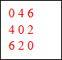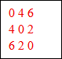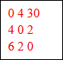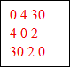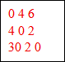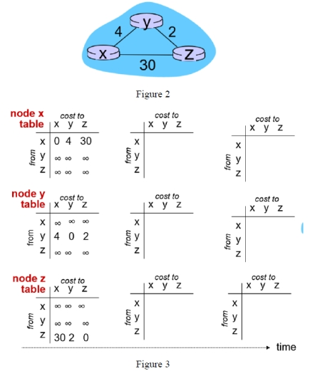

(b) After convergence of the distance vector based algorithm in the above Question 3(a), if the link cost between router x and router y is increased to 60 as shown in Figure 4 below, will the distance vector based algorithm converge quickly after this increased link cost? Please explain your reasons. (10 points)
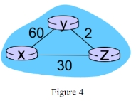
No, convergence will be slow because DV relies on iterative neighbor updates and may suffer from count-to-infinity.

5、DNS: Interactive Problems, Computer Networking: A Top Down Approach中C2的DNS相关
6、TCP拥塞：Interactive Problems, Computer Networking: A Top Down Approach
7、CDMA：Interactive Problems, Computer Networking: A Top Down Approach中C7.1,7.2
8、HTTP：Interactive Problems, Computer Networking: A Top Down Approach中C2的HTTP相关，但是考的很简单，大概就问了HTTP版本类似这种：
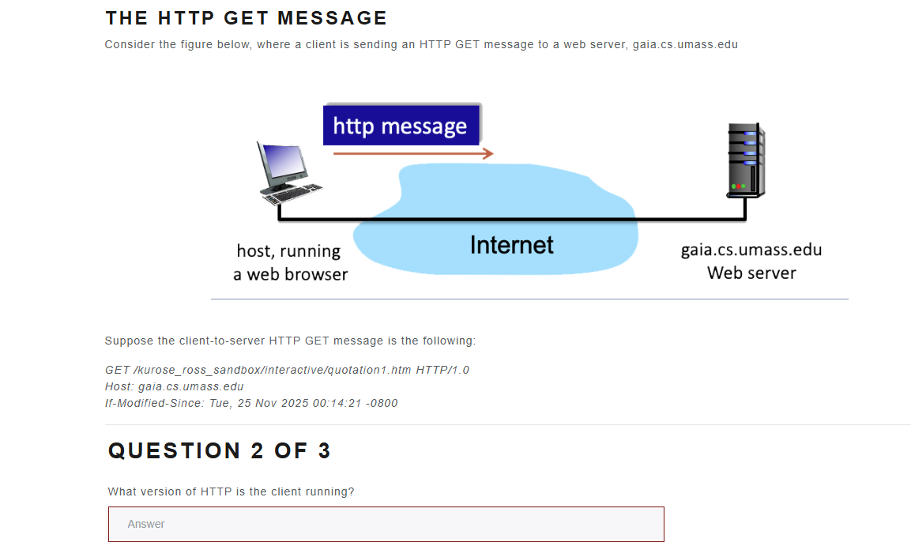
9、计算题：第一章的各种电路交换、包交换的计算、延迟等

