

***Punjab University College of Information Technology***

Pick and Drop Services

For Female Students

**SUBMITTED TO**

Ma’am Amina Mirza

**SUBMITTED BY**

BSEF19M006 – Muhammad Adil

BSEF19M043 – Abubakar Dar

BSEF19M053 – Haris Amir

**Deliverable 2**

**Domain Model**

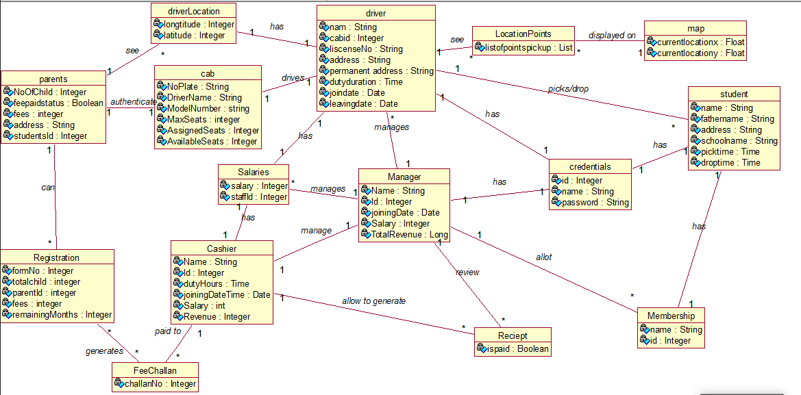

**Design Class Diagram**

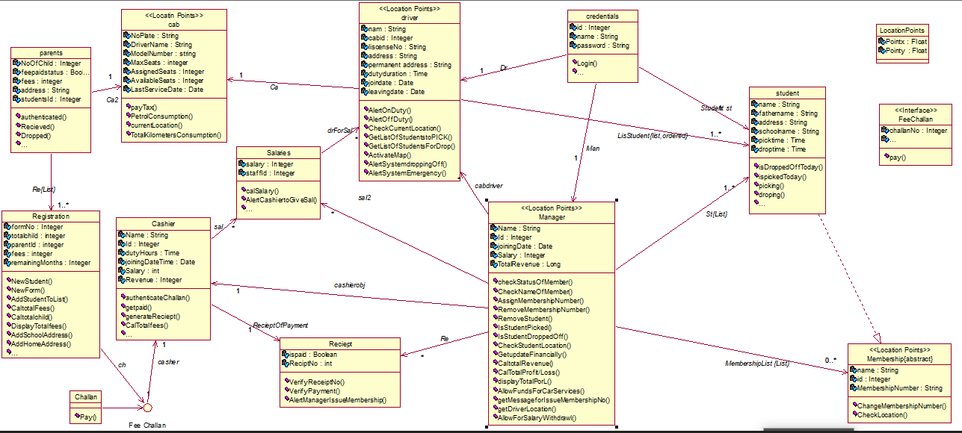

**System Sequence Diagrams**

**Parent SSD**

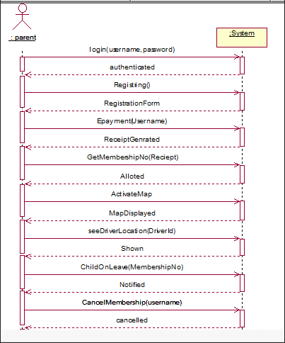

**Cashier SSD**

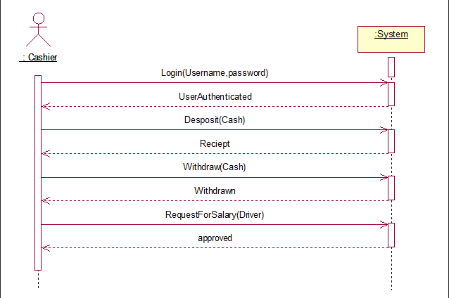

**Driver SSD**

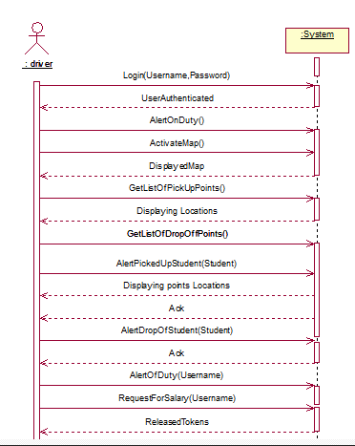

**Sequence Diagram**

**Registering a Student**

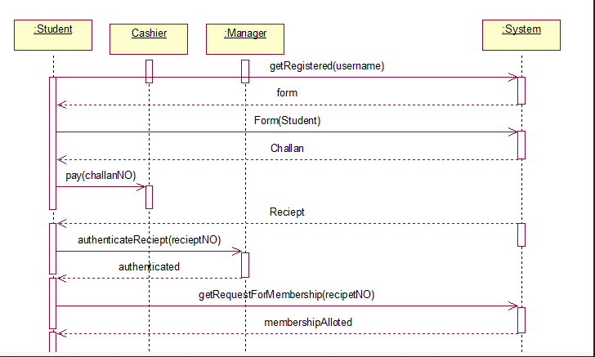

**Picking a Student**

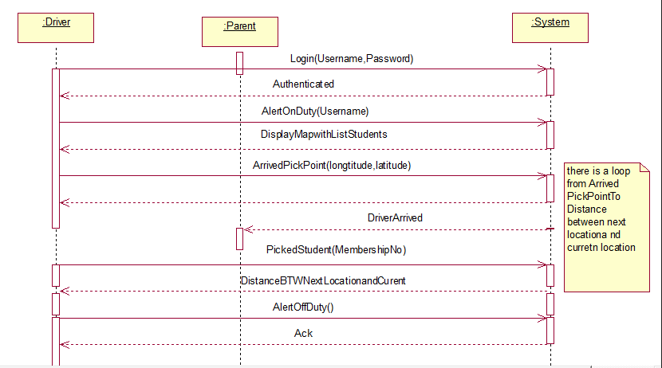

**Dropping a Student**

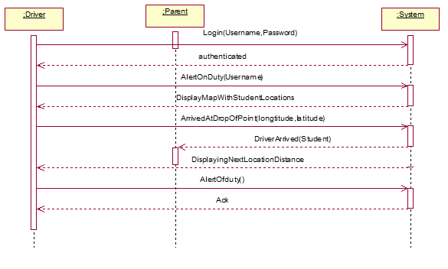

**Collaboration Diagram**

**Registering a Student**

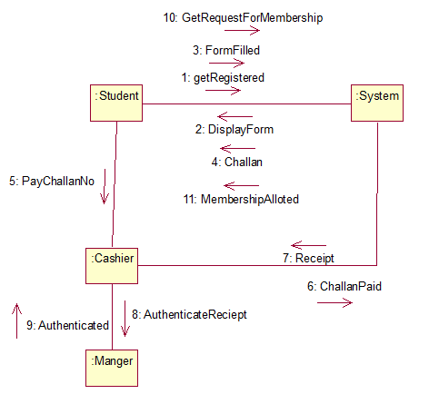

**Picking a Student**

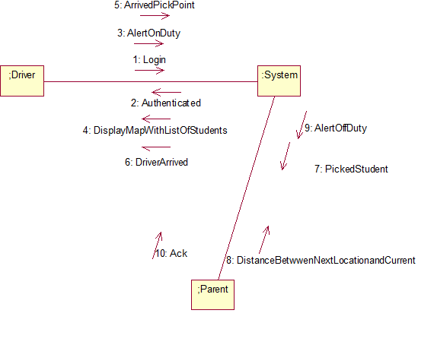

**Dropping a Student**

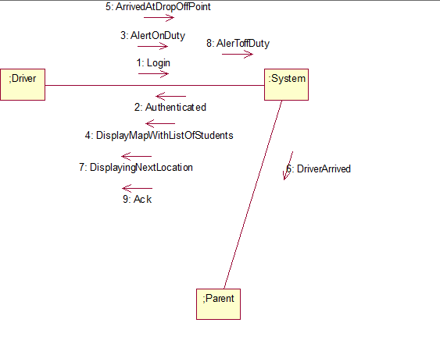

**Use Case Contract**

**Operation:**

Registering()

**Cross Reference:**

Use Case: Registering a Student

**Precondition:**

A parent wants to register their child for our service.

**Post condition:**

* Registration form is given to manager.
* All the entered information is valid.
* Service is available in their residential area.

**Wire Frames**

**Home Page**

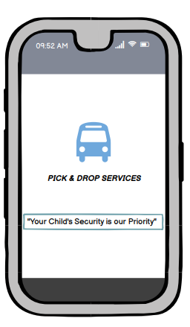

**Sign in/Sign up**

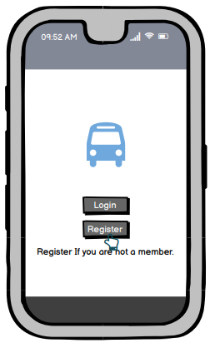

**Registration Selection Page**

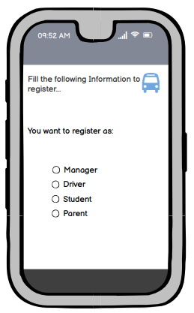

**Registration Form Page 1**

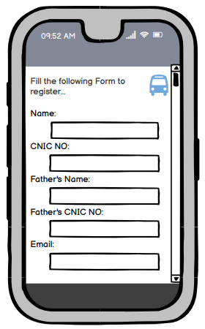

**Registration Form Page 2**

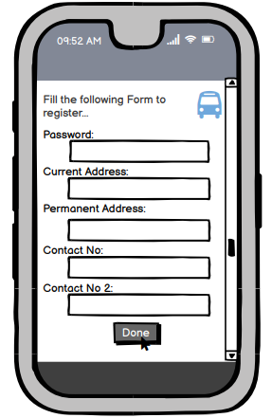

**Login Page**

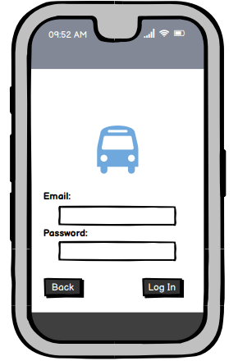

**Driver Activity Page**

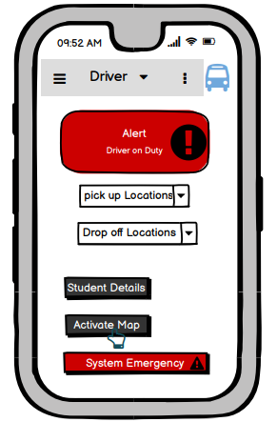

**Driver Map Page**

**Parent Activity Page**

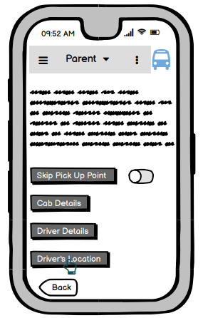

**Parent MAP Page**

**Student Activity Page**

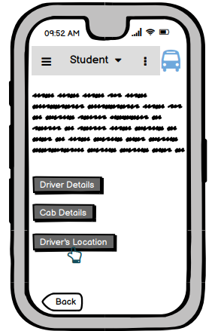

**Student Map Page**

