Network Analysis of the 2004 Madrid Train Bombing

Jered Sanchez

February 5, 2019

## Madrid Terrorist Relationship Network

The analysis begins with transforming the data from the files provided into a graph object consisting of nodes and ties, in this case nodes represent terrorists in the network and ties the relationship strenghts between them.

Showing the basic attributes of the network below, we see there are 64 nodes and 243 relationships between them:

# Explore the set of nodes  
V(g)

## + 64/64 vertices, named, from f10ac29:  
## [1] Jamal Zougam Mohamed Bekkali   
## [3] Mohamed Chaoui Vinay Kholy   
## [5] Suresh Kumar Mohamed Chedadi   
## [7] Imad Eddin Barakat Abdelaziz Benyaich   
## [9] Abu Abderrahame Omar Dhegayes   
## [11] Amer Azizi Abu Musad Alsakaoui   
## [13] Mohamed Atta Ramzi Binalshibh   
## [15] Mohamed Belfatmi Said Bahaji   
## [17] Galeb Kalaje Abderrahim Zbakh   
## [19] Farid Oulad Ali José Emilio Suárez   
## + ... omitted several vertices

# Print the number of nodes  
  
vcount(g)

## [1] 64

# Explore the set of ties  
E(g)

## + 243/243 edges from f10ac29 (vertex names):  
## [1] Jamal Zougam--Mohamed Bekkali   
## [2] Jamal Zougam--Mohamed Chaoui   
## [3] Jamal Zougam--Vinay Kholy   
## [4] Jamal Zougam--Suresh Kumar   
## [5] Jamal Zougam--Mohamed Chedadi   
## [6] Jamal Zougam--Imad Eddin Barakat   
## [7] Jamal Zougam--Abdelaziz Benyaich   
## [8] Jamal Zougam--Abu Abderrahame   
## [9] Jamal Zougam--Amer Azizi   
## [10] Jamal Zougam--Abu Musad Alsakaoui   
## + ... omitted several edges

# Print the number of ties  
ecount(g)

## [1] 243

## Initial Data Visualization

Once we have a general idea of the data and structure of the graph, we can begin to visualize the network. This network has a typical core-periphery structure, with a densely knitted center and a sparser periphery around it.

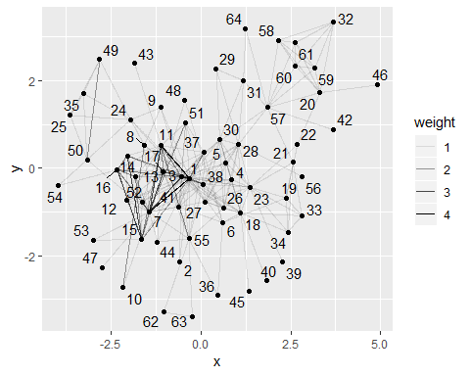

Circular network layout

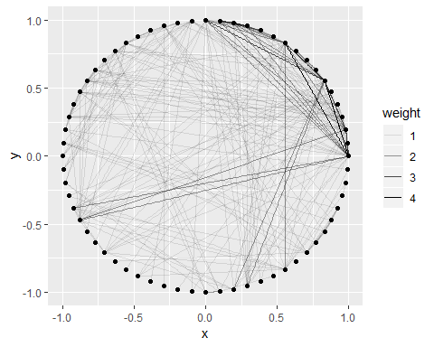

Grid network layout

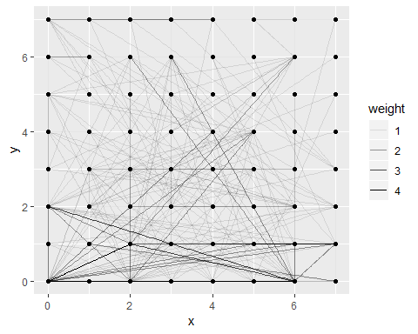

## Network Centrality Measures

We can look for the most connected terrorists of the train bombing network using degree centrality. The ranking leader, Jamal Zougam, was in fact directly involved in the bombings and was one of the first to be arrested.

## # A tibble: 64 x 3  
## id name degree  
## <dbl> <chr> <dbl>  
## 1 1 Jamal Zougam 29  
## 2 3 Mohamed Chaoui 27  
## 3 7 Imad Eddin Barakat 22  
## 4 11 Amer Azizi 18  
## 5 38 Said Berrak 17  
## 6 17 Galeb Kalaje 16  
## 7 23 Naima Oulad Akcha 16  
## 8 18 Abderrahim Zbakh 15  
## 9 28 Jamal Ahmidan 14  
## 10 55 Mohamed El Egipcio 13  
## # ... with 54 more rows

Several other measures of network centrality can be helpful for analysis. In the following table tie strength, betweenness, and closeness are included.

### Tie Betweenness

Ties with high betweenness may have considerable influence within a network by virtue of their control over information passing between nodes. Removing them will most disrupt communication between nodes.

## # A tibble: 64 x 6  
## id name degree strength betweenness closeness  
## <dbl> <chr> <dbl> <dbl> <dbl> <dbl>  
## 1 3 Mohamed Chaoui 27 34 374. 0.00820  
## 2 1 Jamal Zougam 29 43 264. 0.00813  
## 3 38 Said Berrak 17 19 109. 0.00769  
## 4 28 Jamal Ahmidan 14 14 260. 0.00752  
## 5 27 S B Abdelmajid Fakhet 12 12 56.9 0.00746  
## 6 37 Abdeluahid Berrak 11 12 267. 0.00746  
## 7 23 Naima Oulad Akcha 16 16 234. 0.00730  
## 8 18 Abderrahim Zbakh 15 15 178. 0.00725  
## 9 30 Hamid Ahmidan 12 12 53.2 0.00725  
## 10 55 Mohamed El Egipcio 13 14 171. 0.00709  
## # ... with 54 more rows

## Final Data Visualization

Once we have an idea of how the network behaves, and the key targets within the network, we can search and visualize the data interactively. This feature allows us to single out a target by selecting the node itself or by the dropdown selector box. You can scoll up and down to zoom on the graph, and see the node names.