Personal Portfolio Website Plan

# Your Name: Randall Shockley

# Ideas for your website

Determine how you will use your personal portfolio website to showcase your skills.

Idea 1: (Journey) Create a timeline of my previous work experience including what certifications and degrees I have obtained along the way.

Idea 2: (Portfolio) Create a photo album to display what I have accomplished and created thus far.

Idea 3: (Resume) Create a page for my personal resume and skills.

Idea 4: (About Me) Create a biography about myself and what I love to do, to potentially relate to others.

Idea 5: (Contact) Create a contact page with links to my certifications and LinkedIn Profile.

# Website Plan

|  |  |  |
| --- | --- | --- |
| Topic | Questions | Answers |
| Purpose of Website | What is the purpose and goal of the website? | To showcase my skills and show professionalism to potential employers. |
| Target Audience | Describe the target audience (age, gender, demographics) | The target audience would be for potential employers or contractors relating to the IT field, it will not be gender specific, and the age range will be around 30-45 years old. |
| Graphics | What graphics will you use on the website? | I will use slideshows, photographs, timelines, icons, and backgrounds. |
| Color | What colors will you use within the site to enhance the purpose and brand? | I will mainly stay neutral with light blue or grey but increasing color and variety among the things I value or want to showcase the most. |
| Accessibility | How will the website accommodate people with disabilities? | If any videos are inserted, captions will be included. Contrast between the text and the background. Provide navigation for easier browsing. Offer text alternatives for photographs. |
| Project Timeline | Identify the project timeline | (First to Last) Work on gathering information and photographs, create the outline of the website including headers and navigation, upload the information gathered at the beginning and adjust the background colors so that everything looks and feels smoothly to the audience, create accessibility features for the website, and finally make sure that no links or pictures are broken by testing each feature and fix any bugs before launching the website.  Time frame: One to two months. |

What do you want this website to accomplish? I want this website to showcase my skills and love for the advancement of technology and video game industry. It should be very professional and explain what I want to accomplish in life.

# Wireframe

Sketch the wireframe for your home page below.







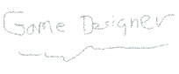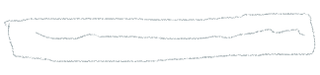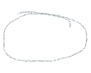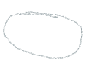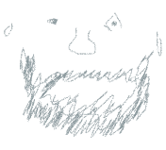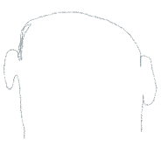

# Site map

Create a site map for the website below.

