Student Clubs and Events Website Planning Document

# Names of Team Members:

1. Randy – Project Leader – Stays focused on implementation and has great attention to detail.

2. Amber – Content Manager – Always looking for new creative ideas and great with organizing.

3. Drew – Web Developer – The techy guy, loves to code.

4. Rebecca – Web Designer – Very creative and loves to design.

Exchange contact information and determine that best days and time(s) of the week to meet.

# Discussion About Student Clubs and Events

As a group, discuss what various clubs, events, and/or activities you would like to showcase at your school to help increase awareness.

Idea 1: Darts Club

Idea 2: Gaming Club

Idea 3: Board Games

Idea 4: Scavenger Hunt Event

Idea 5: Graphic Design

# Website Plan

|  |  |  |
| --- | --- | --- |
| Topic | Questions | Answers |
| Purpose of Website | What is the purpose and goal of the website? | To give students a place to web browse and explore new activities, clubs and events happening throughout the year at college. |
| Target Audience | Describe the target audience (age, gender, demographics) | The target audience is not gender specific, but the age range is between 17-34. The target audience is mainly for those interested in technology, but not completely. |
| Graphics | What graphics will you use on the website? | Videos, GIFS, Photographs, Charts and Logos |
| Color | What colors will you use within the site to enhance the purpose and brand? | Bright and Vibrant colors to instill excitement and enjoyment. |
| Accessibility | How will the website accommodate people with disabilities? | Text to Speech, Contrast settings, Text Zoom, and Closed Captioning. |
| Project Timeline | Identify the project timeline | (First to Last) Gather Information and Graphics, Create the layout, Add the content to the website, Get peer reviews, Bug check and finalize content, Deploy Website.  Time Frame: One Month |

# Wireframe

Sketch the wireframe for the home page below.







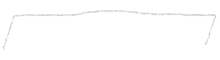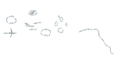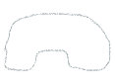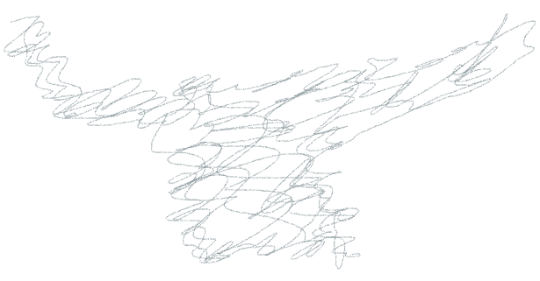

# Site map

Create a site map for the website below.

