FTP
Step 1: Make all the connections:
PC0 -> Switch
FTP Server -> Switch

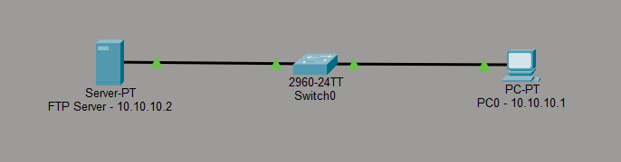

Step 2: Set the IP addresses: Subnet Mask – 255.0.0.0
PC0: 10.10.10.1
FTP Server: 10.10.10.2

Step 3: Configure the FTP Server:
(Click on the FTP Server -> Go to Services -> Turn FTP Service ON -> Under User Setup -> Create username and password -> Tick all the checkboxes -> Click Add button). The FTP account will now appear in the list.
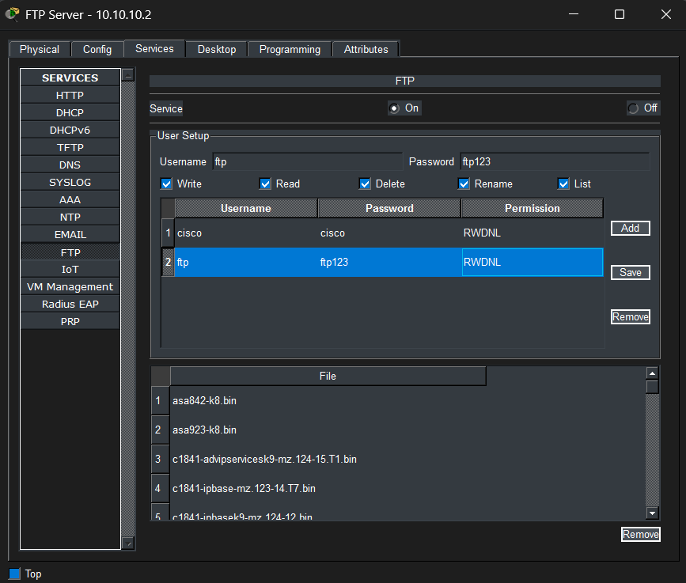
Step 4: Verify Connectivity:
(Click on the PC -> Go to Desktop -> Command prompt)
Type: ping 10.10.10.2

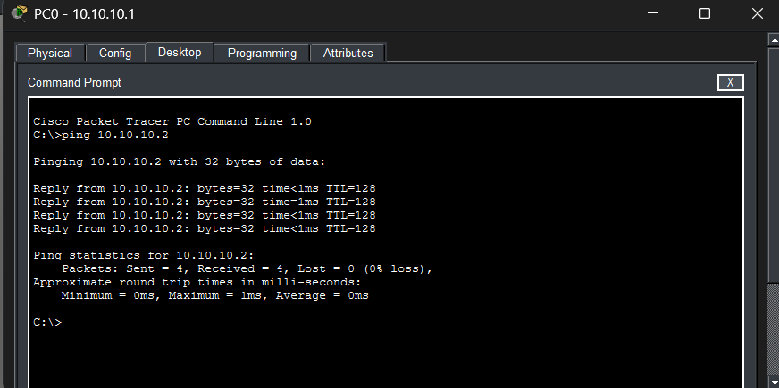

Step 5: Create a file in the text editor:
(Click on the PC -> Go to Desktop -> Text Editor -> Save the file).
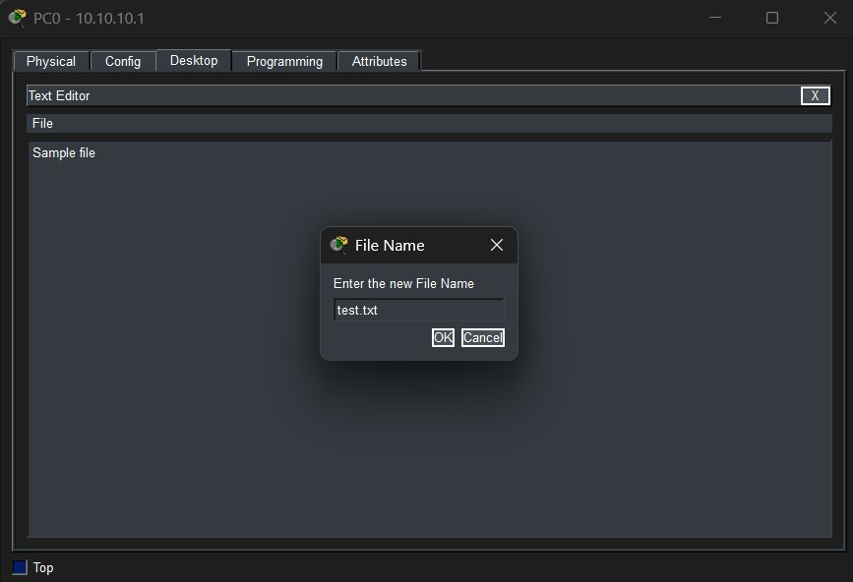

Step 6: Login to the FTP Server:
(Click on the PC -> Go to Desktop -> Command prompt)
- Type: ftp 10.10.10.3
- Enter Username and password
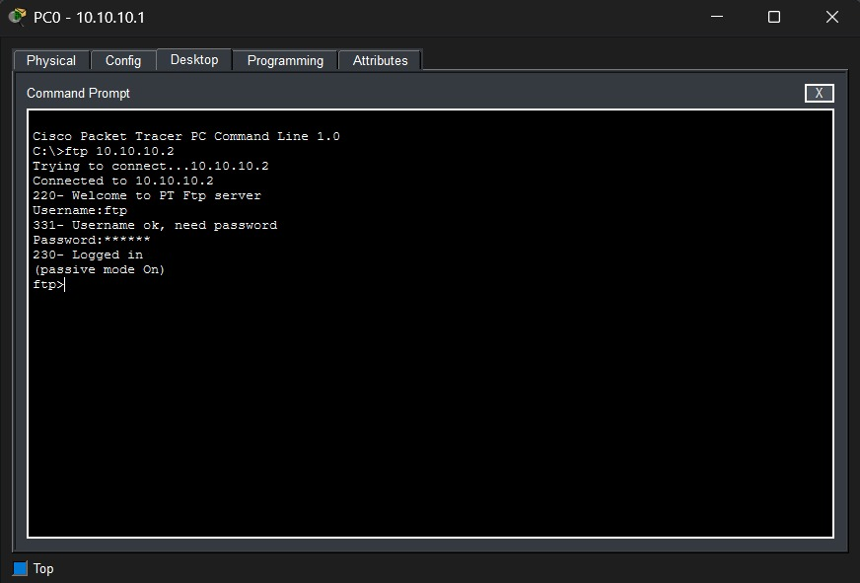
Commands:
- dir – To view the files on the server
- put filename.txt – To upload a file
- get filename.txt – To download a file
- delete filename.txt – To remove a file from the server
- quit – To exit FTP

Step 7: Try uploading and deleting the previously created text file (test.txt) : See the changes using the dir command.

