CLDV7112 Practicum: Building a Real-Time Processing System (AgriStream IoT)
Student Number: ST10376245 | Student Name: Aaron Adams | Module: CLDV7112 (2026)
Submission Links (Requirements c and d)
- Azure App Service URL (Requirement c): http://st10376245.azurewebsites.net (and https://st10376245.azurewebsites.net)
- Azure Function App Host: https://func-agristream-12345678.azurewebsites.net
- GitHub Repository URL (Requirement d): https://github.com/Boomch1ka/CLDVprac
- Azure SQL Server and Database: agristream.database.windows.net / AgriStreamDb
- Azure Storage Account: cldvprac (Blob container: drone-images | Tables: Telemetry, UploadAudit, IrrigationEvents | Queue: irrigation-commands)
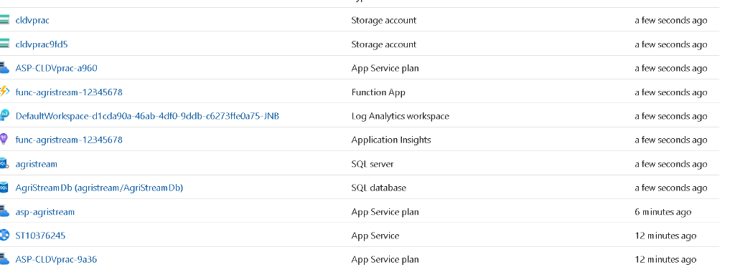
Figure 1: All provisioned Azure resources in the Azure Portal (Storage Account cldvprac, Function App func-agristream-12345678, Application Insights, SQL Server agristream, SQL Database AgriStreamDb, App Service ST10376245, and App Service Plans).
Section A: Practical Implementation and Architecture Documentation
a) Web Hosting - Azure App Service (ST10376245) and MVC Web Application
The main management web application (AgriStream.Web) is built with ASP.NET Core 8 MVC and hosted on Azure App Service under the instance name ST10376245 (http://st10376245.azurewebsites.net). The application is completely stateless so that it can scale horizontally across multiple App Service instances during peak daylight operational hours. It provides a top navigation bar linking the Home, Field Dashboard, Sensors and Irrigation, Drone Images, Audit Logs, and Manage Users views, and displays the active server instance ID in the footer.
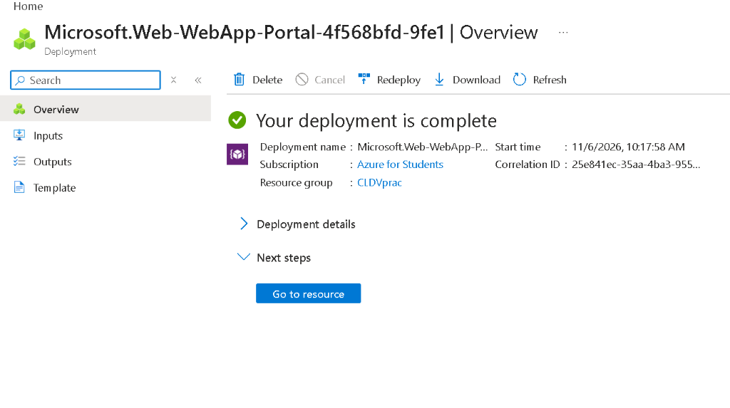
Figure 2: Azure App Service (ST10376245 / Microsoft.Web-WebApp) deployment completed in Azure Portal.
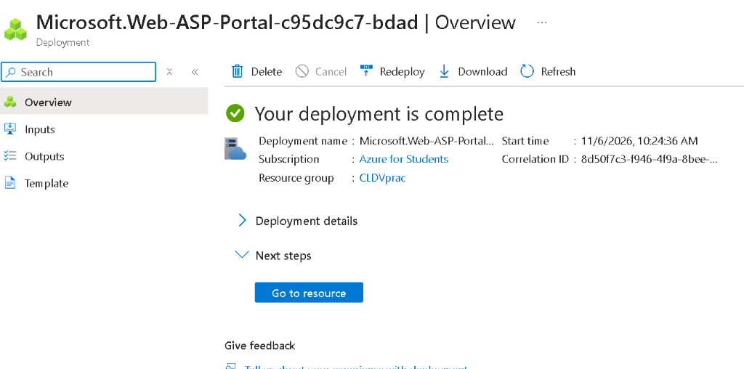
Figure 3: Azure App Service Plan (Microsoft.Web-ASP) deployment completed in Azure Portal.
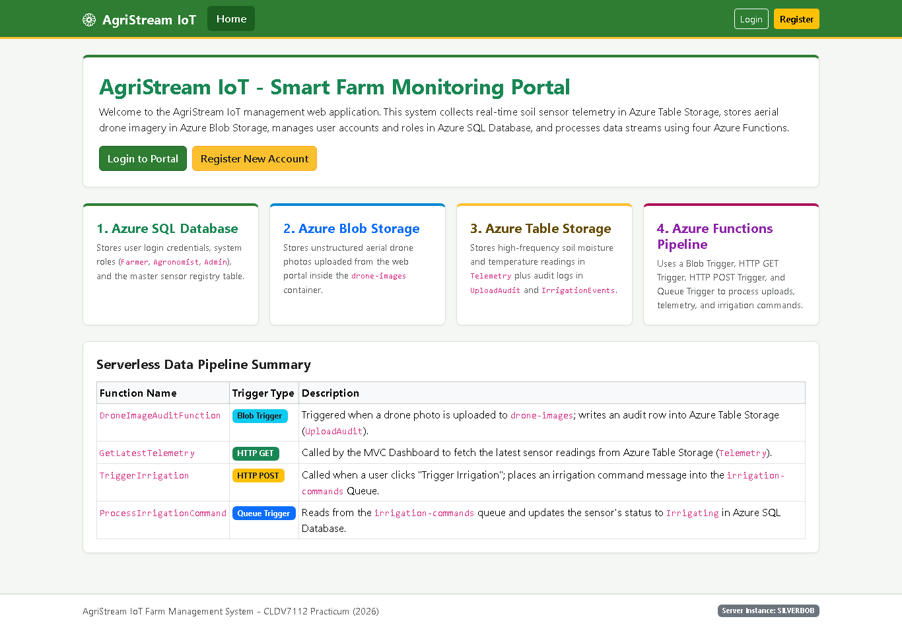
Figure 4: AgriStream IoT MVC Web Application Home Page and Serverless Pipeline Overview.
b) Relational Database (User and Role Management) - Azure SQL Database (AgriStreamDb)
User accounts, system roles, and the master sensor registry are persisted in Azure SQL Database (Server: agristream.database.windows.net, Database: AgriStreamDb) using Entity Framework Core (AppDbContext). Three relational tables are provisioned and seeded automatically by StartupInitializer:
- dbo.Roles: Stores the three system roles: Farmer (Id = 1), Agronomist (Id = 2), and Admin (Id = 3).
- dbo.Users: Stores Id, Username (unique index), PasswordHash (PBKDF2 hashed via ASP.NET Core PasswordHasher), RoleId (foreign key to dbo.Roles), and CreatedAt.
- dbo.Devices: Stores the master sensor registry (SENSOR-001 through SENSOR-006) including DeviceId, Name, FieldName, Status (Online, Irrigating, Maintenance), LastIrrigatedAt, IrrigationEndsAt, and LastCommandBy.
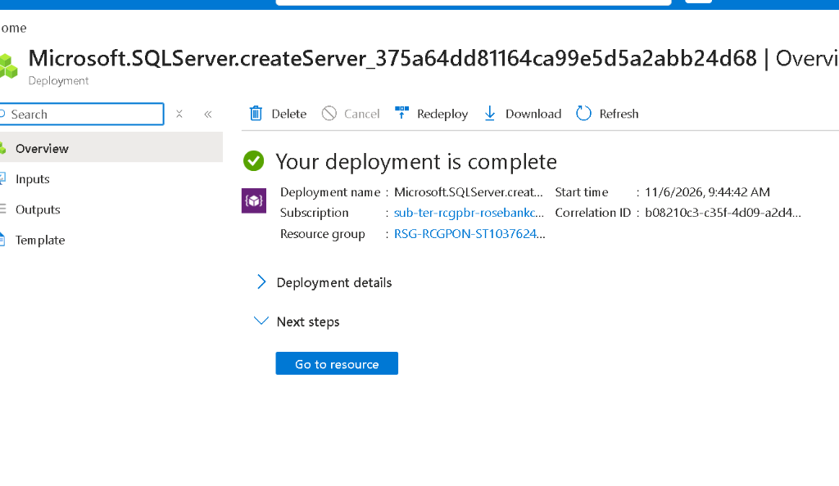
Figure 5: Azure SQL Server (agristream) deployment completed in Azure Portal.
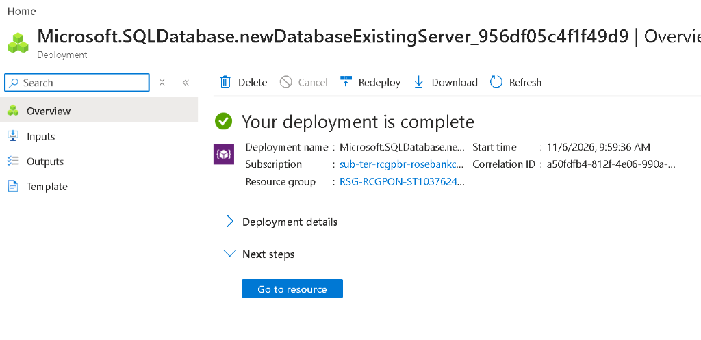
Figure 6: Azure SQL Database (AgriStreamDb) deployment completed in Azure Portal.
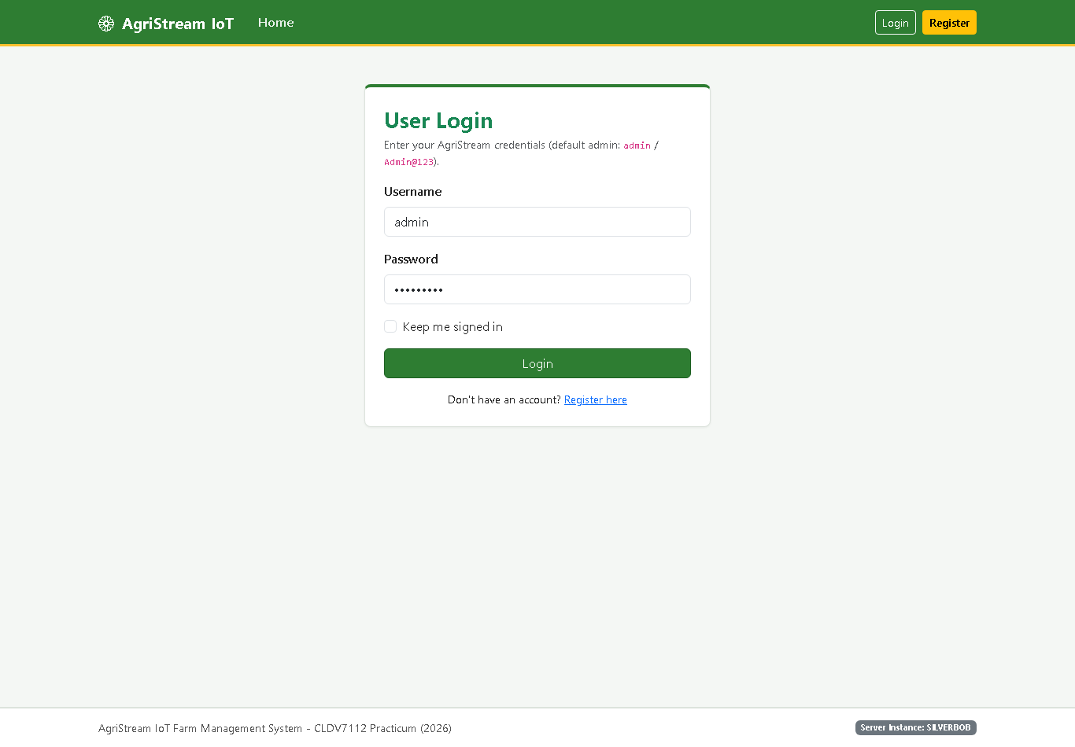
Figure 7: User Login page connected to Azure SQL Database (agristream.database.windows.net).
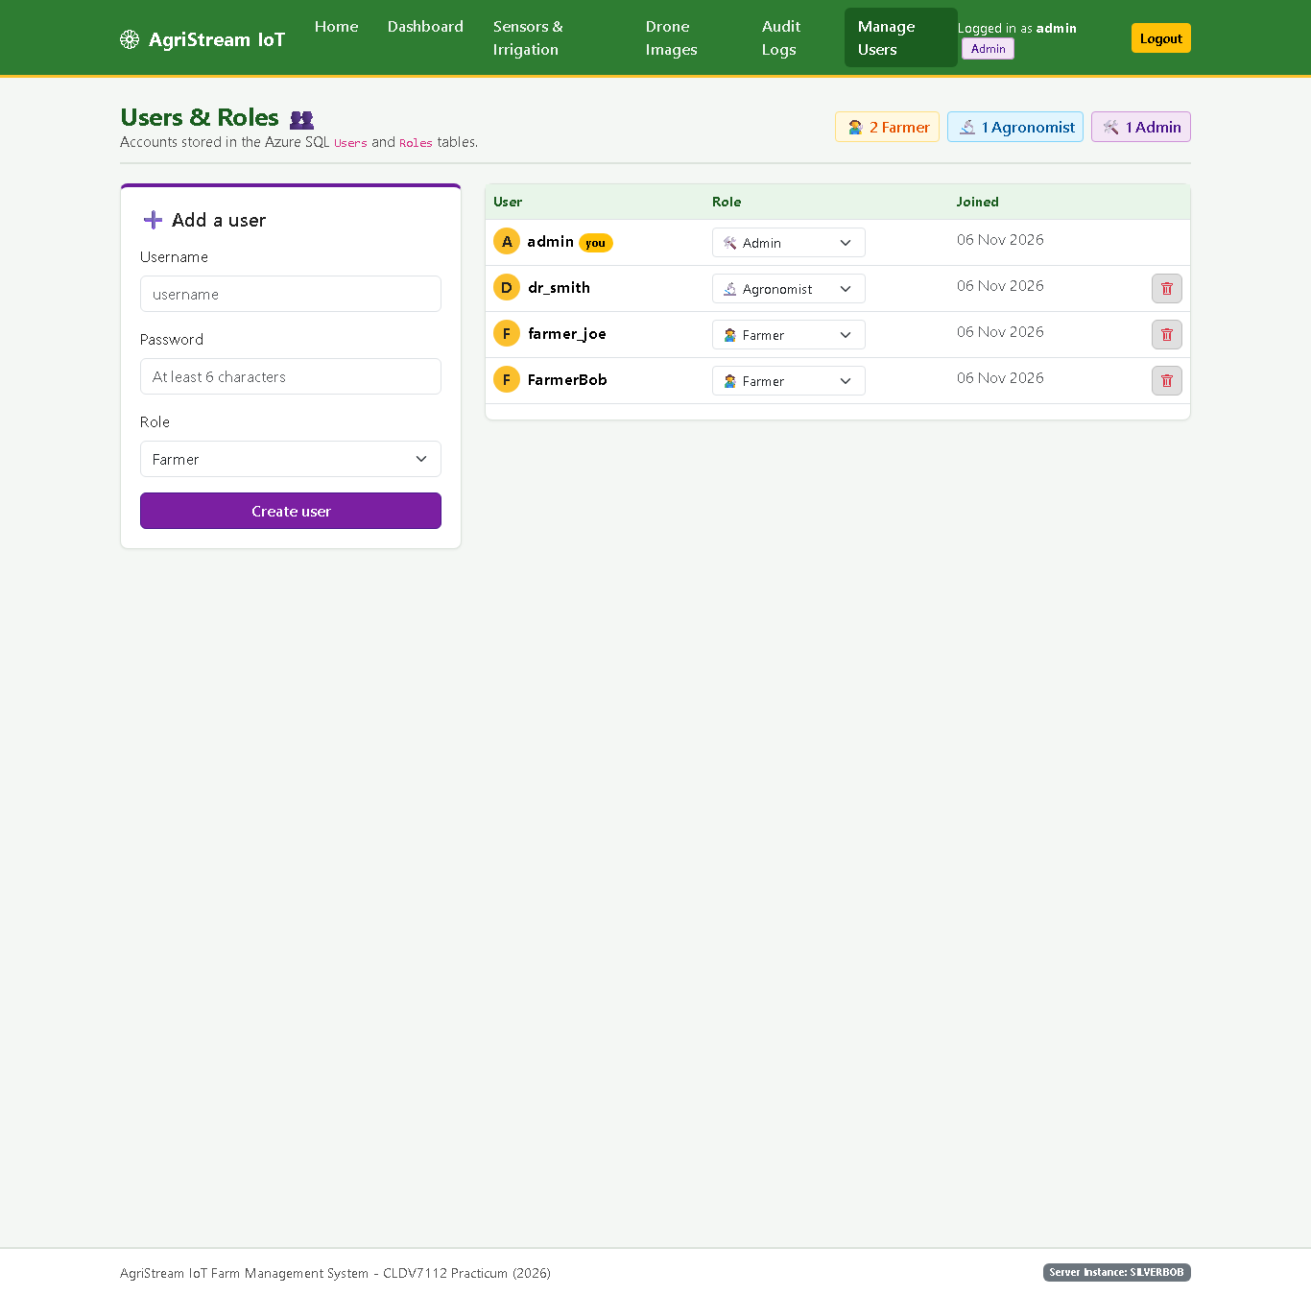
Figure 8: Manage Users and System Roles (Farmer, Agronomist, Admin) stored in Azure SQL Database.
c) Cloud Storage (Data and Media) - Azure Blob and Table Storage (cldvprac)
Unstructured media and high-frequency non-relational telemetry are stored in the cldvprac Azure Storage Account:
- Azure Blob Storage (drone-images container): Managed by BlobMediaService.cs and DroneController.cs. Farmers upload aerial field photos (JPG, PNG, WEBP, TIFF up to 20 MB) tagged with metadata (uploadedBy, fieldName, originalName, notes). Images are rendered in the gallery using time-limited Read-Only SAS URLs.
- Azure Table Storage (Telemetry, UploadAudit, IrrigationEvents tables): Managed by TelemetryService.cs and AuditService.cs. Sensor telemetry uses PartitionKey = DeviceId and an inverted-tick RowKey (DateTime.MaxValue.Ticks - UtcTicks) so the newest readings are always returned first in single-millisecond partition queries.
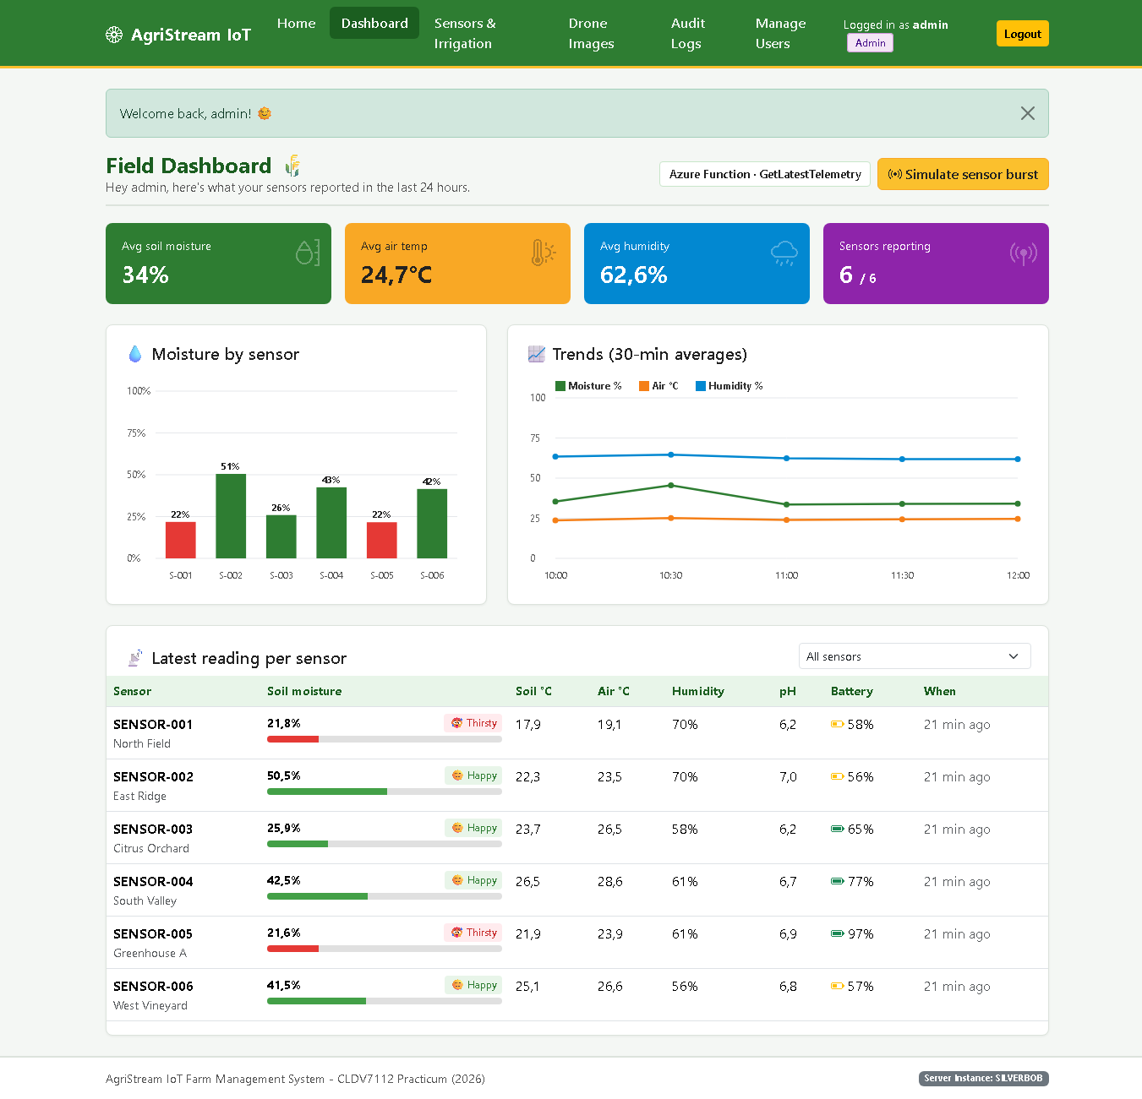
Figure 9: Field Dashboard displaying real-time sensor telemetry and 30-minute trends fetched via the GetLatestTelemetry HTTP GET Azure Function from Azure Table Storage.
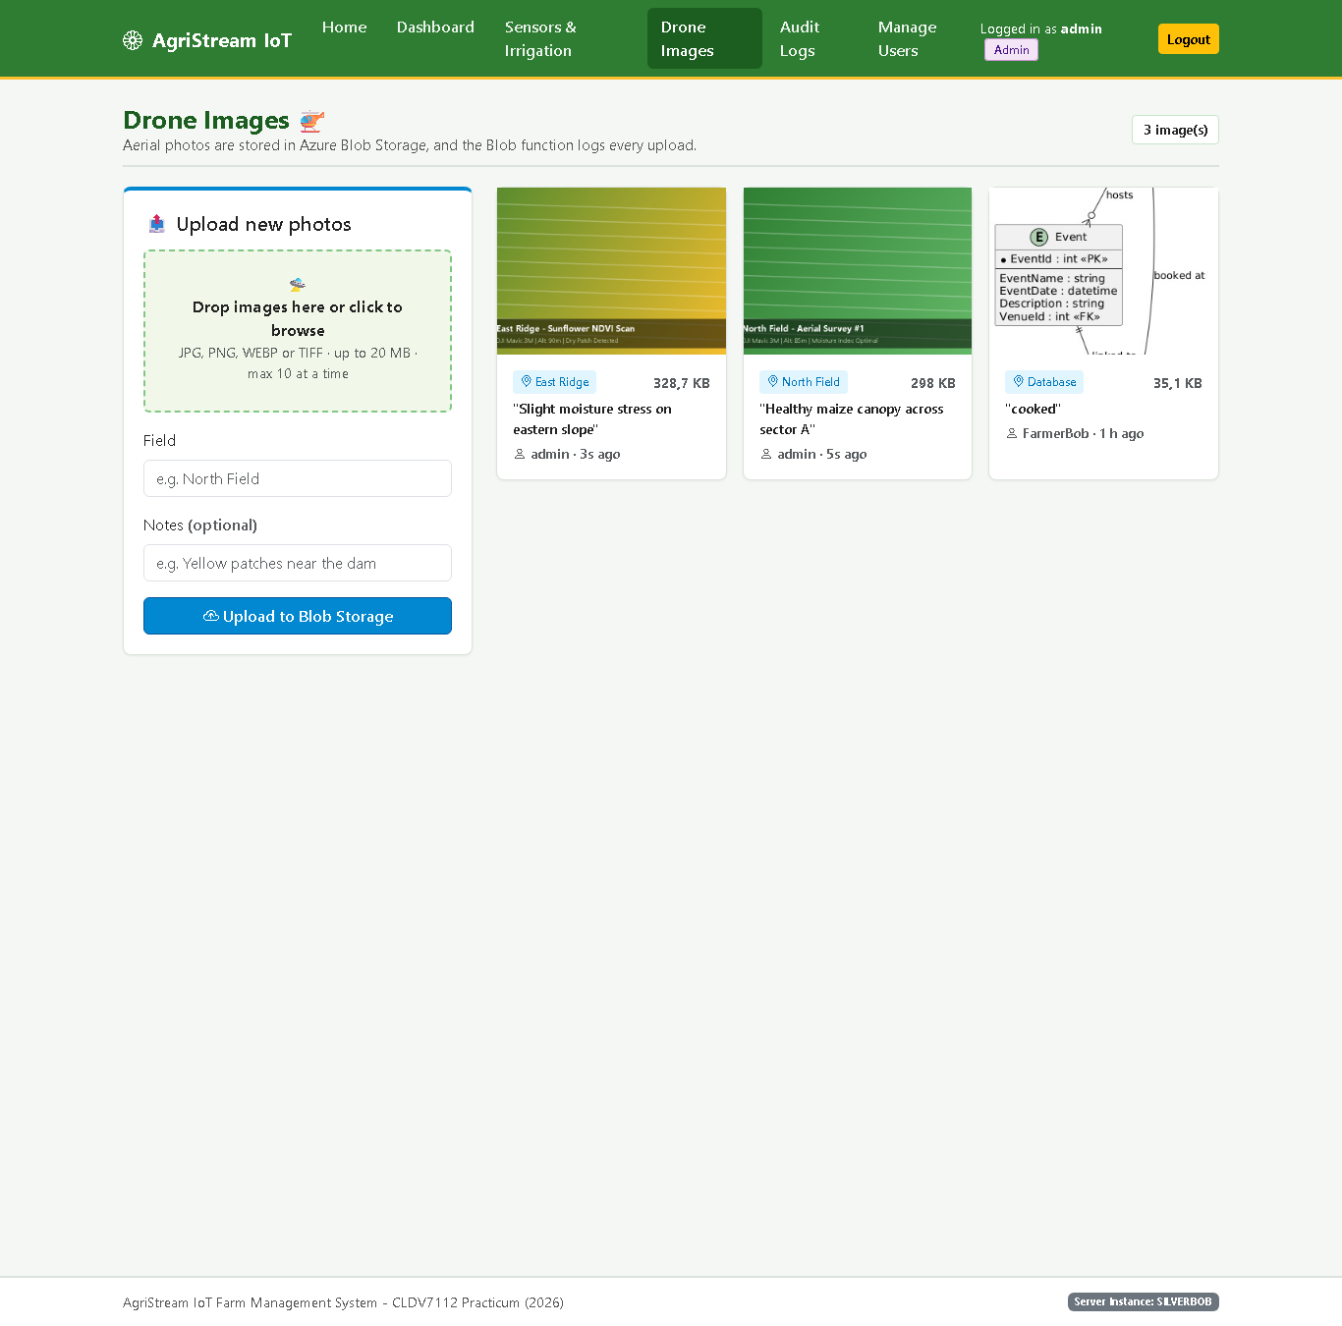
Figure 10: Drone Images Gallery displaying aerial field imagery uploaded to the drone-images container in Azure Blob Storage (cldvprac).
d) Serverless Data Pipeline - Four Azure Functions (AgriStream.Functions)
The serverless pipeline is implemented in the AgriStream.Functions project (.NET 8 Isolated Worker) hosted on func-agristream-12345678 and contains exactly four Azure Functions:
- 1. Blob-Triggered Function (DroneImageAuditFunction.cs): Uses [BlobTrigger('drone-images/{name}')] and [TableOutput('UploadAudit')]. Automatically fires whenever a drone photo is uploaded to Blob Storage, inspects the file's content type, byte size, and custom metadata, and writes a processing audit entry directly into the UploadAudit table.
- 2. HTTP-Triggered GET Function (GetLatestTelemetryFunction.cs): Exposes GET /api/telemetry/latest. Called by DashboardController in the MVC app to query the latest reading per sensor and 24-hour rolling trends from the Telemetry table for near-instant dashboard rendering.
- 3. HTTP-Triggered POST Function (TriggerIrrigationFunction.cs): Exposes POST /api/irrigation/trigger and uses [QueueOutput('irrigation-commands')]. Called when a user clicks 'Trigger Irrigation' on the Sensors page; validates the payload and places an IrrigationCommand JSON message onto the irrigation-commands Azure Storage Queue.
- 4. Queue-Triggered Function (ProcessIrrigationCommandFunction.cs): Uses [QueueTrigger('irrigation-commands')] and [TableOutput('IrrigationEvents')]. Listens to the queue, executes a parameterised ADO.NET UPDATE against dbo.Devices in Azure SQL Database (setting Status = 'Irrigating', LastIrrigatedAt, IrrigationEndsAt, and LastCommandBy), and writes a permanent audit log row into the IrrigationEvents table.
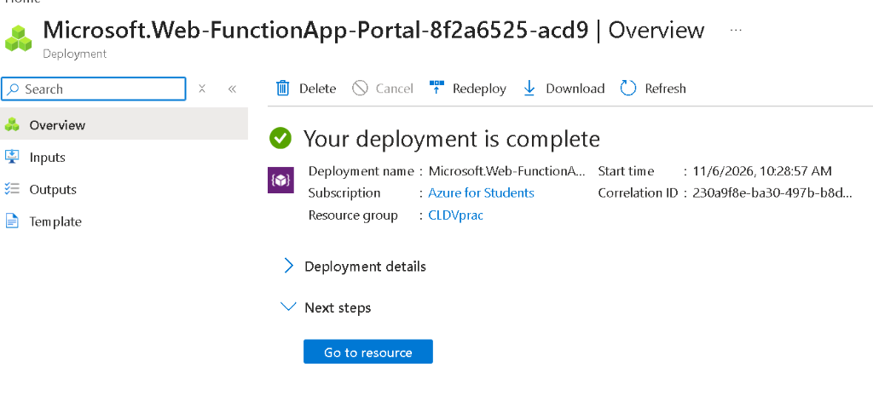
Figure 11: Azure Function App (func-agristream-12345678) deployment completed in Azure Portal.
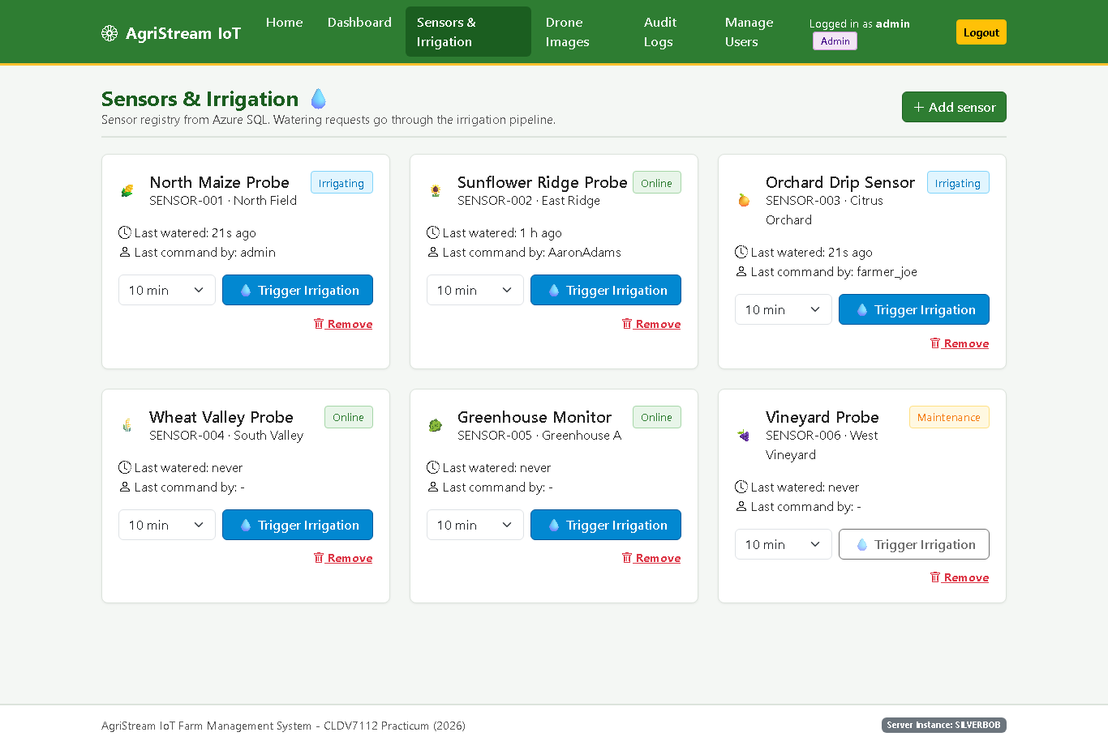
Figure 12: Sensors and Irrigation page showing SENSOR-001 and SENSOR-003 updated to Irrigating status in Azure SQL after the Queue-Triggered Azure Function processed the irrigation commands.
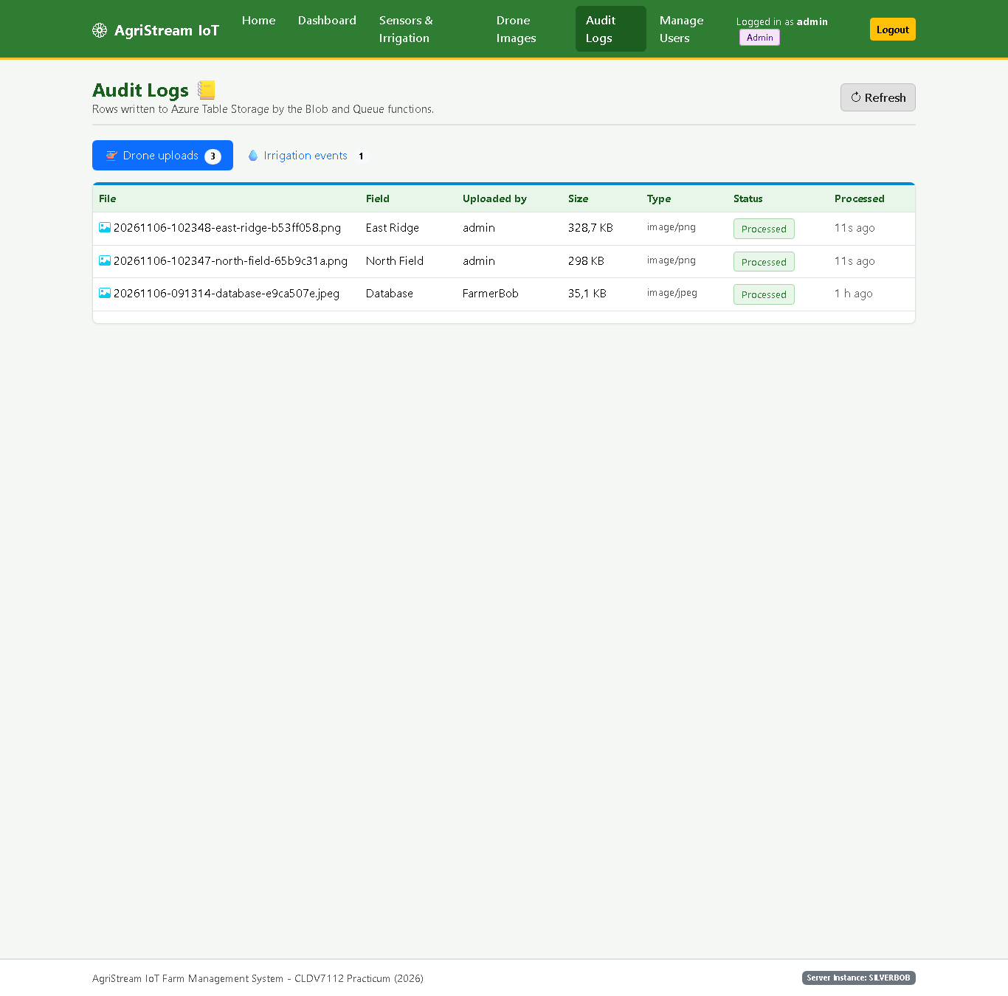
Figure 13: Audit Logs - Drone Uploads tab showing audit records automatically written to the UploadAudit table by DroneImageAuditFunction (Blob Trigger).
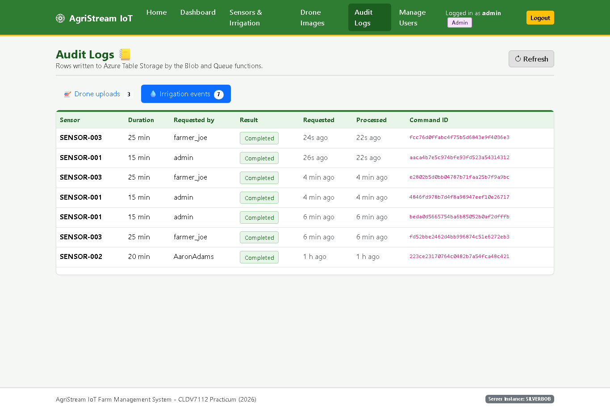
Figure 14: Audit Logs - Irrigation Events tab showing command execution records written to the IrrigationEvents table by ProcessIrrigationCommand (Queue Trigger).
e) Load Testing, f) Monitoring, and g) Auto-Scaling
To test system scalability and reliability under simulated peak daylight traffic, a concurrent PowerShell load-testing script (load-test/load-test.ps1) and an Apache JMeter test plan (load-test/AgriStream-LoadTest.jmx) were executed against the web application:
- Load Test Execution (Task e): Simulates concurrent users hitting the CPU-intensive Monte-Carlo soil moisture forecast endpoint (GET /api/telemetry/forecast), the instance probe (GET /api/telemetry/instance), and the high-frequency telemetry ingestion endpoint (POST /api/telemetry). In baseline testing, 324 concurrent requests completed with 0 failures (100% success rate), 40.5 req/s throughput, and 56.9 ms average latency (157.6 ms p95 latency).
- Monitoring with Azure Monitor and Application Insights (Task f): Both AgriStream.Web and AgriStream.Functions are instrumented with the Application Insights SDK to capture live request rates, response latencies, dependency calls (SQL, Blob, Table, Queue), CPU/memory consumption, and failure rates during peak load.
- Auto-Scaling Configuration (Task g): The App Service Plan is configured with Custom Autoscale rules to scale out by +1 instance whenever average CPU Percentage exceeds 70% (or Memory Percentage exceeds 75%) over a 5-minute window (up to 3 instances), and scale back in by -1 instance when CPU Percentage drops below 30%.
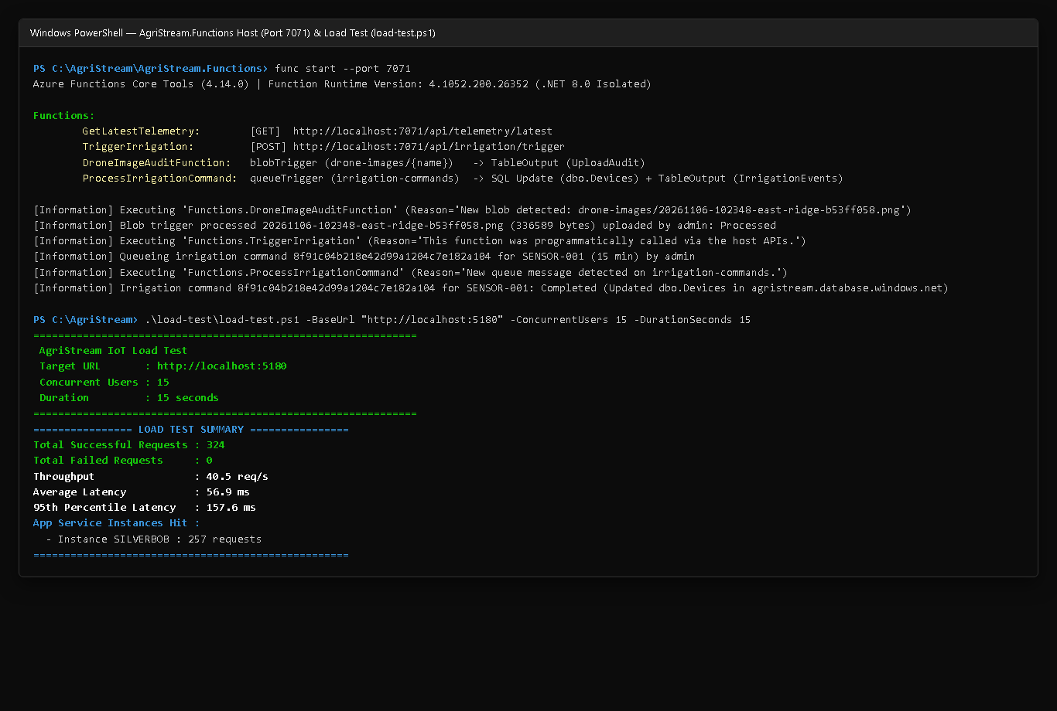
Figure 15: Azure Functions Host execution logs (all 4 triggers) and concurrent Load Test (load-test.ps1) performance summary.
Section B: Theory Questions (25 Marks)
1. Disaster Recovery and Redundancy (LRS vs. GRS)
Azure Storage maintains multiple replicas of every blob, table entity, and queue message to protect data against hardware faults, network or power outages, and natural disasters. Two foundational redundancy tiers are Locally Redundant Storage (LRS) and Geo-Redundant Storage (GRS).
Comparison Dimension | Locally Redundant Storage (LRS) | Geo-Redundant Storage (GRS / RA-GRS)
Replication Mechanism | Synchronously replicates data 3 times within a single physical data centre (availability zone / scale unit) in the primary region before returning success. | Replicates data 3 times synchronously in the primary region (via LRS) AND asynchronously replicates data to a paired secondary region hundreds of miles away (6 copies total).
Durability SLA | At least 99.999999999% (11 nines) durability over a given year. | At least 99.99999999999999% (16 nines) durability over a given year.
Failure Protection | Protects against disk, server rack, switch, and power supply failures inside one data centre. Does NOT protect against a regional catastrophe (flood, fire, regional blackout). | Protects against both local hardware failures AND a complete outage of the primary Azure region. With RA-GRS, the secondary region can be read immediately without waiting for Microsoft failover.
Cost and Bandwidth | Lowest storage cost per GB; zero cross-region replication bandwidth charges. | Approximately double the storage cost of LRS plus geo-replication data egress charges on every write.

Which Option Is Most Appropriate for AgriStream IoT Workloads?
- Critical Historical Crop Harvest Records -> Geo-Redundant Storage (GRS / RA-GRS): Multi-year crop harvest yields, soil fertility baselines, compliance audits, and seasonal agronomic reports are irreplaceable business assets. If a regional disaster struck the primary Azure data centre (for example, South Africa North in Johannesburg), losing years of historical harvest records would cripple long-term yield forecasting and regulatory compliance. Because these records have a strict durability requirement and are written much less frequently than raw sensor ticks, GRS (or Read-Access GRS) is the most appropriate tier, guaranteeing 16 nines of durability across paired regions (e.g., Johannesburg and Cape Town).
- Temporary Sensor Logs -> Locally Redundant Storage (LRS): Millions of soil probes transmit moisture, temperature, and battery readings every few seconds into the Telemetry table. Individual raw sensor log entries are ephemeral, append-heavy, and superseded by newer readings within minutes. Replicating millions of transient sensor log rows across regions via GRS would double storage costs and incur substantial cross-region bandwidth charges for data that can easily be re-sampled. LRS provides 11 nines of durability against local hardware failures at the lowest cost and write latency, making it ideal for high-frequency temporary sensor logs.
2. Stateless vs. Stateful Architecture in Horizontal Scaling
Why It Is Crucial to Keep Azure App Services and Azure Functions Stateless
Horizontal scaling (scale-out) increases capacity during peak daylight traffic surges by provisioning multiple parallel compute instances (Instance 1, Instance 2, Instance 3) behind an Azure load balancer, and deprovisioning them (scale-in) when traffic subsides. For horizontal scaling to work reliably, every App Service instance and every Azure Function worker must be stateless - meaning no instance holds exclusive user session state in local process memory (RAM) or stores uploaded files on its local virtual machine disk.
Instead, every incoming HTTP request or queue message must be self-contained, and all shared state must be stored in external backing services (Azure SQL Database, Azure Blob Storage, Azure Table Storage, Azure Storage Queues, or Azure Cache for Redis). In AgriStream IoT, AgriStream.Web uses stateless encrypted Cookie Authentication backed by Azure SQL Database and stores all drone imagery directly in Azure Blob Storage, while AgriStream.Functions executes four stateless functions that read and write exclusively to Azure Storage and Azure SQL. Consequently, any instance can handle any request from any farmer at any time.
How Storing Session Data or Files Locally Negatively Affects Scale-Out Behaviour
- 1. Broken Sessions and Ineffective Load Balancing (Local In-Memory Session State): If an application stores user login state or workflow data in in-process server memory (e.g., InProc Session or IMemoryCache) on Instance 1, and auto-scale spins up Instance 2 during a traffic spike, the Azure load balancer will route subsequent requests from that farmer to Instance 2. Because Instance 2 does not share Instance 1's RAM, the farmer's session is missing - causing sudden logouts, lost form submissions, or runtime errors. Enabling ARR Affinity (Sticky Sessions) to pin each user to a single instance defeats load balancing (overloaded instances remain overloaded while newly scaled-out instances sit idle) and still loses all active sessions whenever an instance restarts or scales in.
- 2. Missing Media and Permanent Data Loss (Local File Storage): If a farmer uploads a drone photo and the web app saves it to the local web server filesystem (e.g., C:\home\site\wwwroot\uploads on Instance 1), any request served by Instance 2 or Instance 3 will fail with 404 Not Found if instances do not share that local directory. Worse, when peak daylight hours end and auto-scale scales in (terminating extra instances) or redeploys containers, any files written to ephemeral local disks are permanently destroyed. Storing uploaded files in Azure Blob Storage ensures every scaled-out instance accesses the exact same durable media.
3. Serverless Triggers and Bindings Comparison Table
In Azure Functions, Triggers and Input/Output Bindings provide a declarative model that connects serverless methods to Azure services without manual polling loops or boilerplate SDK lifecycle code.
Mechanism | Definition | Purpose | Example Used in the AgriStream IoT Pipeline
Trigger | A declarative attribute on a function parameter that defines the single event source that causes the Azure Functions runtime to execute the function and supplies the triggering event payload. Every function must have exactly one trigger. | Starts function execution automatically when an external cloud event occurs (an HTTP request, a newly uploaded blob, or a queue message) and allows the Azure Functions scale controller to scale worker instances dynamically based on event volume. | 1. Blob Trigger ([BlobTrigger('drone-images/{name}')]) on DroneImageAuditFunction: fires automatically when a drone image is uploaded to the drone-images container.  2. HTTP GET Trigger ([HttpTrigger(..., 'get', Route = 'telemetry/latest')]) on GetLatestTelemetry: fires when the MVC dashboard requests recent telemetry.  3. HTTP POST Trigger ([HttpTrigger(..., 'post', Route = 'irrigation/trigger')]) on TriggerIrrigation: fires when a farmer clicks 'Trigger Irrigation' in the MVC app.  4. Queue Trigger ([QueueTrigger('irrigation-commands')]) on ProcessIrrigationCommand: fires whenever a command message arrives on the irrigation-commands queue.
Input Binding | A declarative parameter binding (or host-managed storage client) that fetches supporting data from an external Azure resource and passes it into the function as a strongly typed object when the trigger fires. | Eliminates repetitive connection-string management, SDK boilerplate, and manual parsing code when reading blob properties, metadata, or table entities needed to process an event. | In DroneImageAuditFunction, the [BlobTrigger('drone-images/{name}')] attribute binds the incoming blob directly to an Azure.Storage.Blobs.BlobClient parameter so the function can immediately read the uploaded drone image's properties (ContentLength, ContentType) and custom metadata (uploadedBy, fieldName, originalName) from Azure Blob Storage. In GetLatestTelemetry, the function queries partitioned TableEntity records from the Telemetry table.
Output Binding | A declarative attribute placed on a function's return value (or a multi-output response class) that instructs the Azure Functions runtime to write, insert, or enqueue the returned object into an external target service upon completion. | Decouples business logic from downstream storage and messaging SDKs; the runtime automatically serializes the C# object and commits the table entity or queue message. | 1. Table Output Binding ([TableOutput('UploadAudit', Connection = 'AzureWebJobsStorage')]) on DroneImageAuditFunction: automatically inserts the returned UploadAuditEntity row into the UploadAudit table after every drone image upload.  2. Queue Output Binding ([QueueOutput('irrigation-commands', Connection = 'AzureWebJobsStorage')]) on TriggerIrrigationOutput in TriggerIrrigation: serializes the IrrigationCommand object and pushes it onto the irrigation-commands Azure Storage Queue while returning HTTP 202 Accepted.  3. Table Output Binding ([TableOutput('IrrigationEvents', Connection = 'AzureWebJobsStorage')]) on ProcessIrrigationCommand: writes an IrrigationEventEntity audit record into the IrrigationEvents table after updating dbo.Devices in Azure SQL Database.

