Course: 26S_CST8279_450 Intro to Comp. Prog. using Python
Assignment: Lab 5 – Debugging
Student Name: Ange Gbocho
Student ID: 041277826
Date: June 12, 2026

Finding the Error in the Code
In this assignment, I examined the Python function provided and used debugging techniques to determine why it does not always find the minimum value in a list.
The original code is shown below:
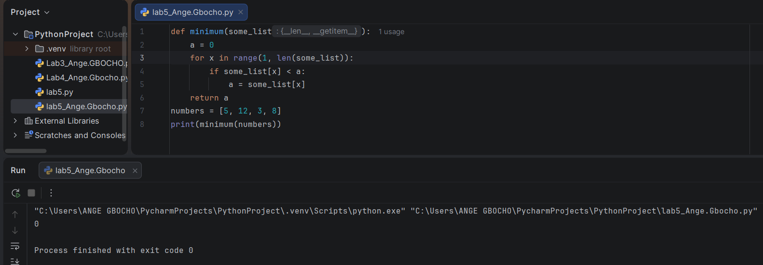
Figure 1: Original program returning an incorrect result
The main issue is that the variable “a” is set to 0 at the beginning of the function. This means the program assumes that 0 is the smallest value before it even starts checking the list.
This creates a problem when the list contains only positive numbers.
For example:
numbers = [5, 12, 3, 8]
The minimum value in this list is 3. However, the function returns 0 because none of the values in the list are smaller than 0. Since the condition is never true, the value of a never changes.
While debugging the program, I could follow the value of “a” during each iteration of the loop. This helped me see that the variable stayed at 0 for the entire execution, which made the bug easier to identify.
Another issue is that the loop starts at index 1. This is not a problem if the first element of the list is already being used as the starting minimum value. However, since a is initialized to 0, the first element is never used as the initial comparison value.

Corrected Code
A better solution is to initialize a with the first element of the list.
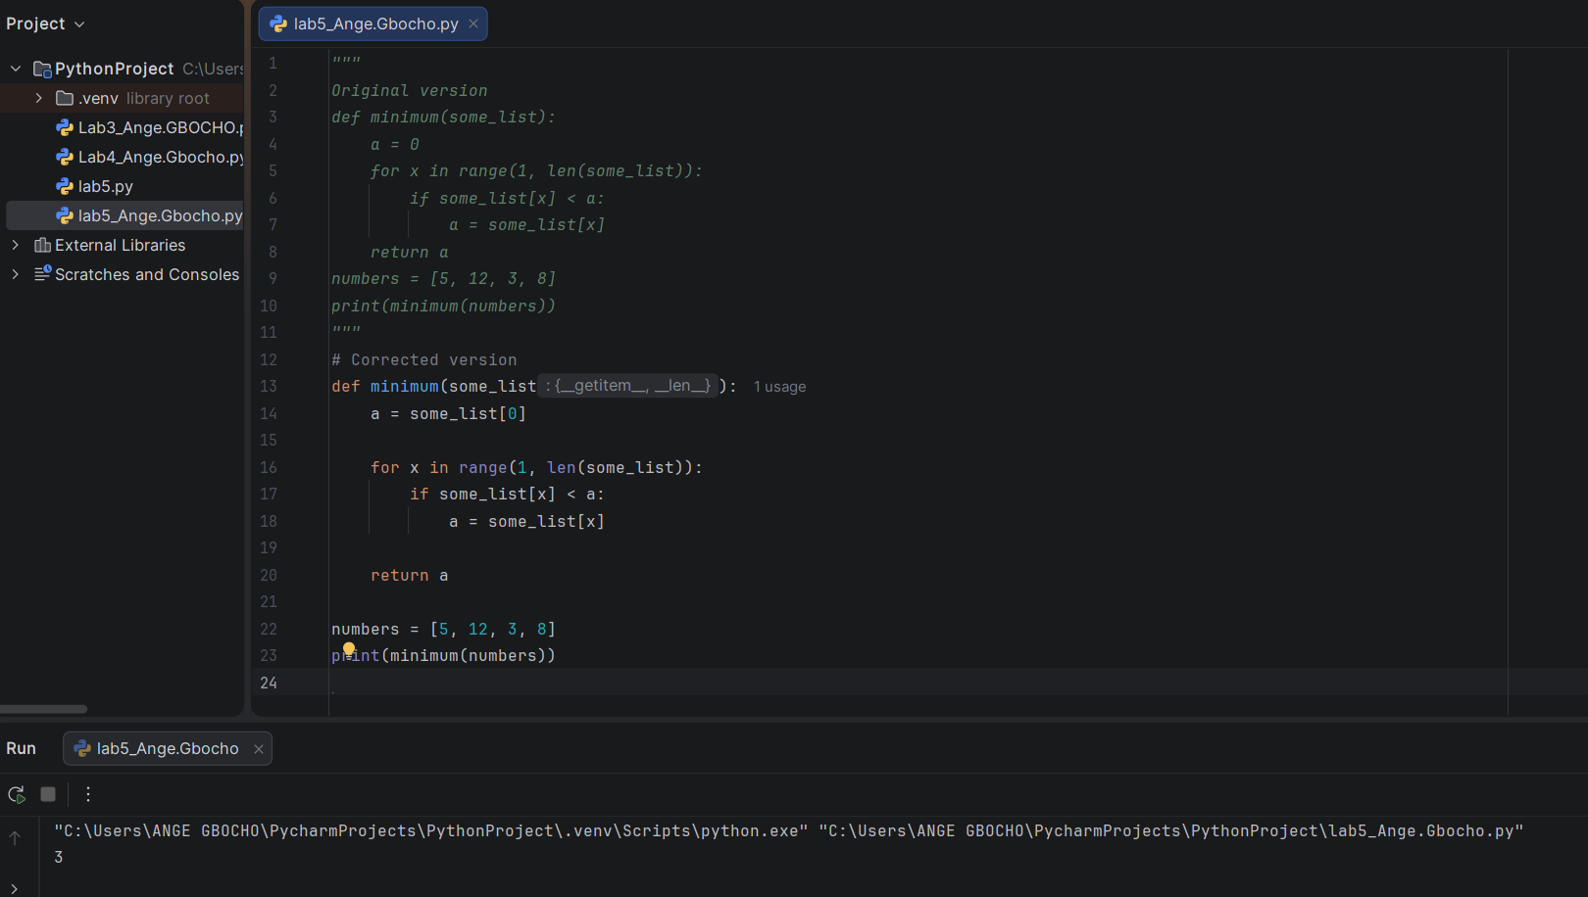
Figure 2. Corrected program returning the correct minimum value.
This version starts with the first value in the list and then compares the remaining values to it. Because of this, the function can correctly find the minimum value in both positive and negative number lists.
The corrected version returns the correct minimum value without using Python's built-in min() function.

Conclusion
The teammate's mistake was setting the variable a to 0 instead of using the first element of the list. By using debugging techniques to monitor the variable values during execution, I was able to identify the problem and understand why the function was not working correctly. After correcting the initialization of “a”, the function works as expected and returns the smallest value in the list.

References
Algonquin College. (2026). Module 5: Debugging and testing Python programs. Course materials.
Python Software Foundation. (2026). The Python tutorial. Retrieved from https://docs.python.org/3/tutorial/
W3Schools. (2026). Python functions. Retrieved from https://www.w3schools.com/python/python_functions.asp

