Lab 10 – Using Tuples in Python
Student Name: Ange Gbocho
Course: CST8279 – Introduction to Computer Programming using Python
Assignment: Lab 10 – Using Tuples in Python

Question 1: How do you access an element from a tuple?
You can access an element from a tuple by using its index number inside square brackets [ ]. Tuple indexing starts at 0, so the first element is at index 0, the second at index 1, and so on.
Example code:
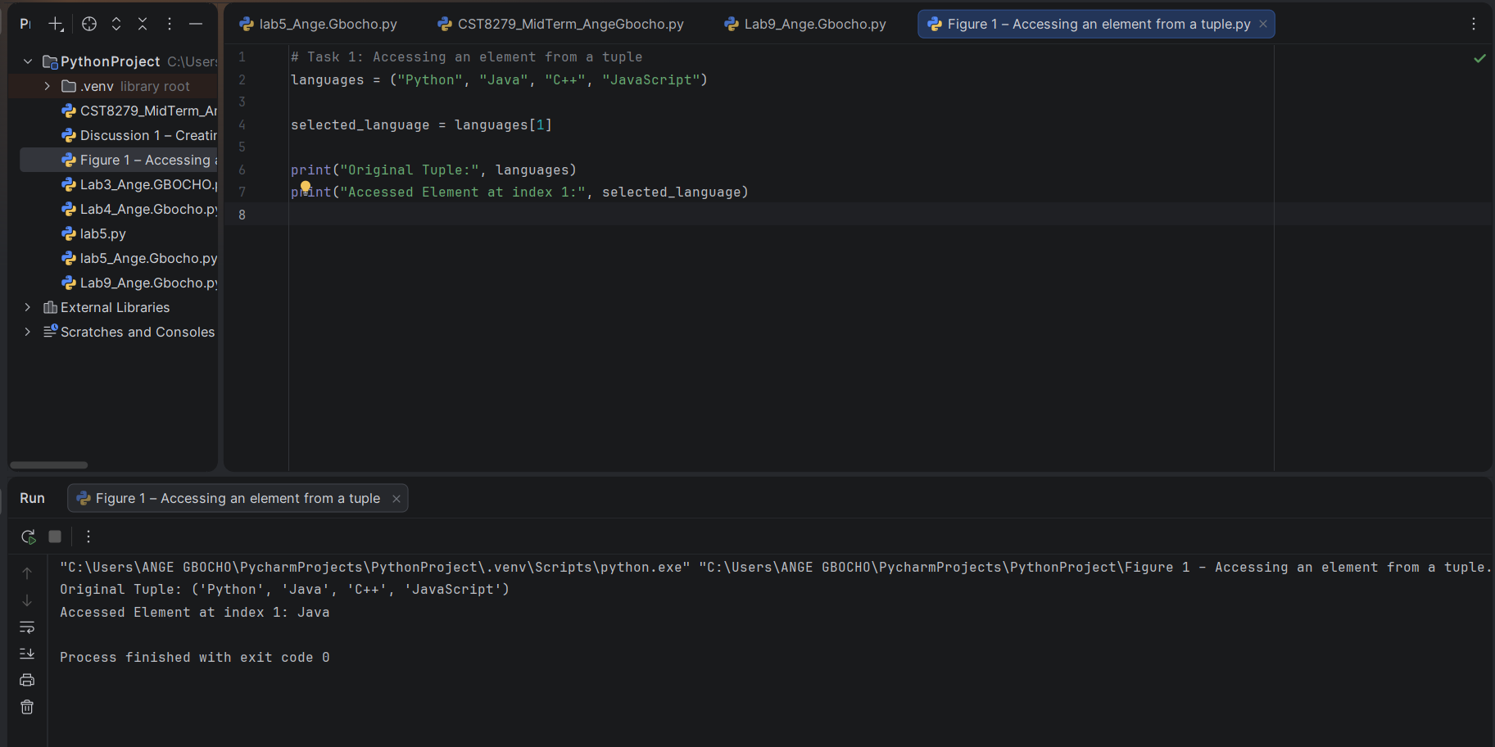
Figure 1. Output showing how to access an element from a tuple.

Question 2: Does a tuple allow negative indexing? How?
Yes. Tuples support negative indexing. Negative indexes count from the end of the tuple. For example, -1 refers to the last element and -2 refers to the second-to-last element.
Example code:
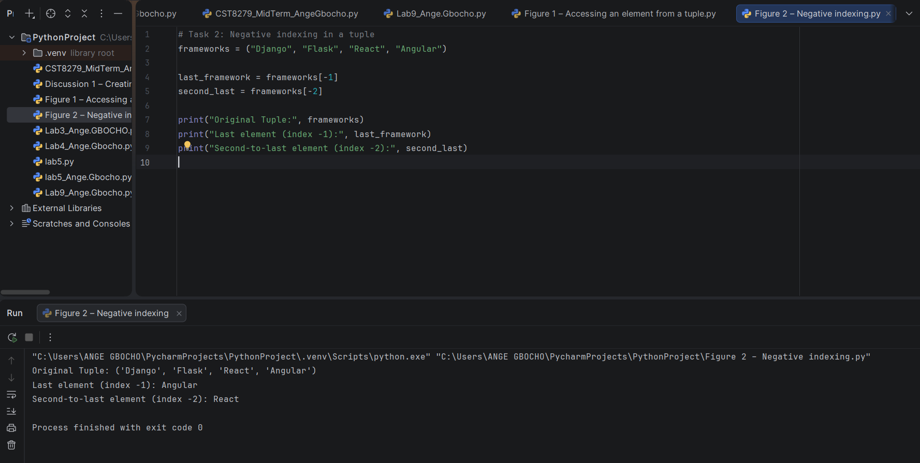
Figure 2. Output showing how negative indexing is used to access elements from the end of a tuple.

Question 3: How does deleting work in a tuple?
Tuples are immutable, which means individual elements cannot be deleted or modified. Attempting to delete a single element raises a TypeError. However, the entire tuple variable can be deleted using the del statement. Accessing the variable afterwards raises a NameError.
Example code:
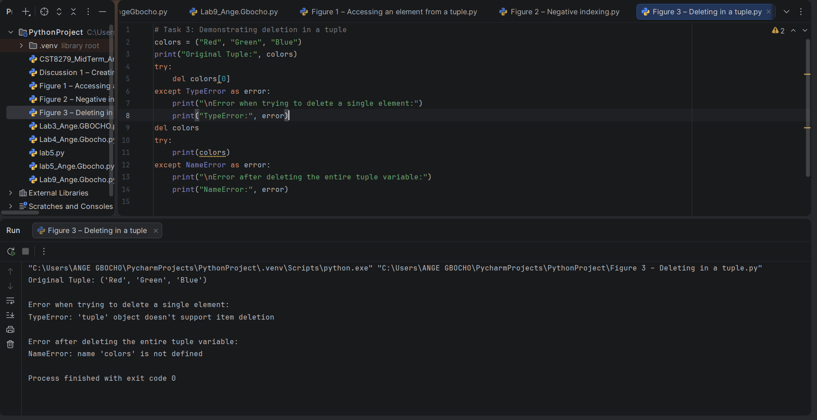
Figure 3. Output demonstrating that individual tuple elements cannot be deleted because tuples are immutable, while the entire tuple variable can be deleted using the del statement.

References
Python Software Foundation. (2026). Python documentation. https://docs.python.org/3/
W3Schools. (2026). Python Tuples. https://www.w3schools.com/python/python_tuples.asp

