SAP to Snowflake: Building a Data Warehouse with Boomi
  - Hands-on Lab Guide

Products: Boomi for SAP, Boomi Data Integration
Duration: ~75 minutes
Level: Beginner-friendly
Exercises: 3

ℹ️ This lab uses two Boomi products in sequence: Boomi for SAP to expose SAP data as a clean feed, and Boomi Data Integration to land and transform that data in Snowflake.

Prerequisites

- Boomi for SAP UI access — Log in at https://boomiforsap.demo.boomi.com:44300/zbx/home. Credentials provided by your trainer.
- Boomi Data Integration account — Log in at https://console.rivery.io. Credentials provided by your trainer.
- Snowflake trial account — Free 30-day trial at https://signup.snowflake.com. Exercise 2 walks you through setup.
- No prior SAP or Snowflake experience required — all steps are explained from scratch.

What You'll Build

This lab builds a full end-to-end pipeline from SAP S/4HANA to a Snowflake data warehouse:

- SAP S/4HANA (VBAK / VBAP tables) → Boomi for SAP Table Service (OData endpoint)
- Boomi for SAP Table Service → Boomi Data Integration Source-to-Target Flow
- BDI Flow → Snowflake RAW schema (SAP_SALES_ORDERS_RAW)
- BDI SQL Transformation → Snowflake DW schema (FACT_SALES + DIM_CUSTOMER)

Pre-Lab Setup: Create Your Snowflake Trial Account
Time required: ~10 minutes | Complete before starting Exercise 2

ℹ️ The Snowflake trial is completely free — no credit card required. It includes $400 in credits valid for 30 days. Complete these steps before (or during a break between) Exercises 1 and 2.

Step 1: Navigate to the Signup Page and Enter Your Details (3 min)
- 1. Open a browser (Chrome recommended) and go to https://signup.snowflake.com
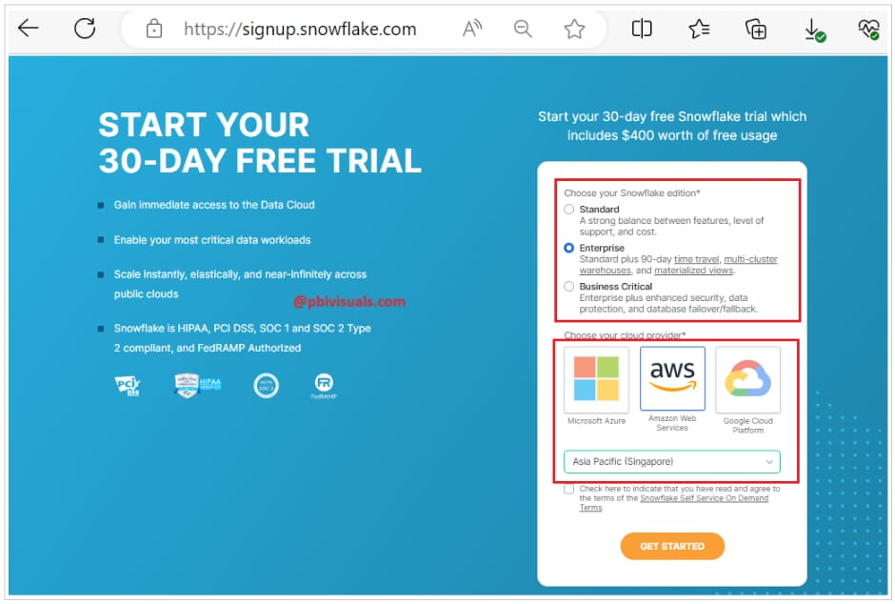
Snowflake free trial signup page

- 2. Fill in the registration form:

Field | Value
First & Last Name | Your name
Email | Work or personal email — used for login and activation
Company | Your organization name (or "Self" for personal use)
Country | Your country (may be auto-detected)

✅ No mobile number is required.

Step 2: Choose Cloud Provider, Region, and Edition (3 min)
- 1. Select your cloud provider. For this lab, choose AWS (Amazon Web Services).
- 2. Select the cloud region closest to your physical location for best performance.
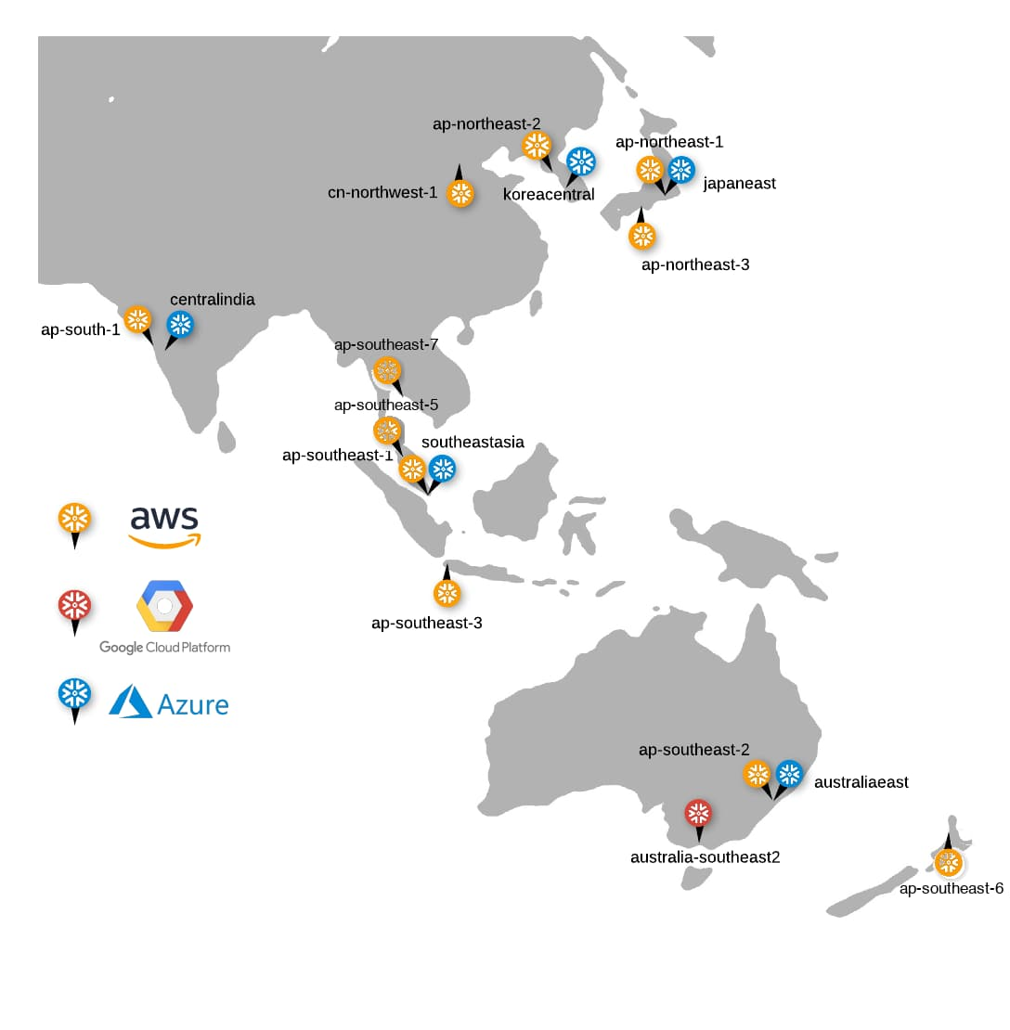
Select AWS as cloud provider and choose your nearest region

⚠️ Cloud provider and region cannot be changed after account creation. If you need a different provider, you must create a new trial account.

- 3. Select Enterprise as your Snowflake edition. Enterprise includes multi-cluster warehouses, Time Travel up to 90 days, and column-level security — all features used in this lab.

Field | Description
Standard | Core features, Time Travel up to 1 day
Enterprise ✅ | Multi-cluster warehouses, materialized views, Time Travel up to 90 days
Business Critical | Highest security/compliance, HIPAA support

Step 3: Accept Terms and Activate Your Account (4 min)
- 1. Check the box to accept Snowflake's Terms of Service, then click Get Started.
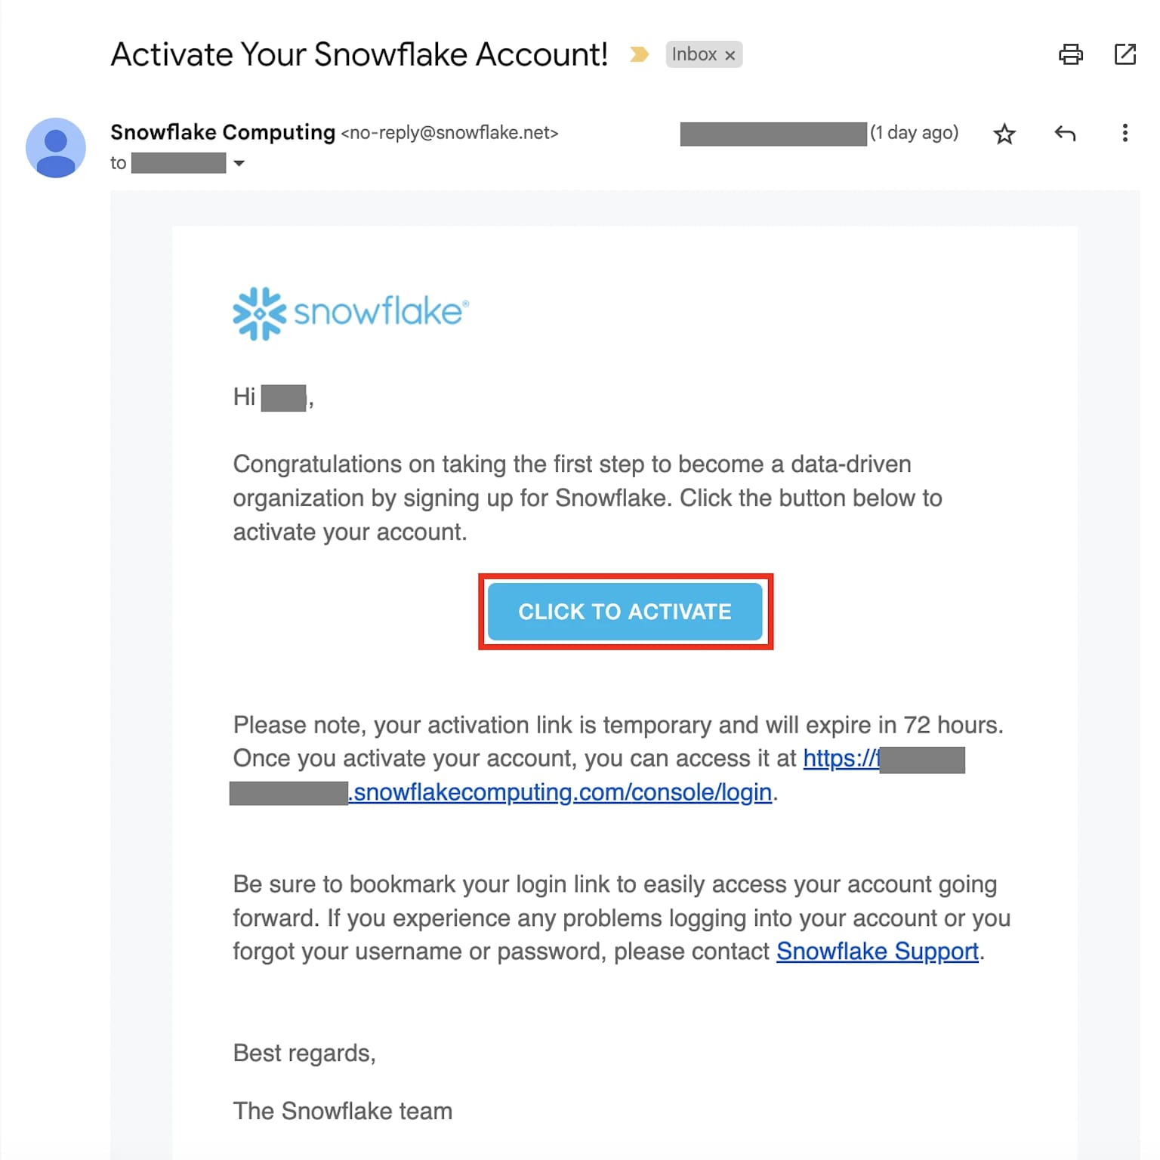
Accept Terms of Service and click Get Started to submit

- 2. Within a few minutes you will receive an activation email from Snowflake. Check your inbox (and spam folder). Click the Click to Activate button in the email.
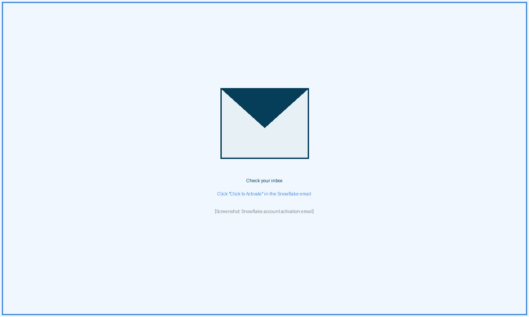
Snowflake activation email — click "Click to Activate"

⚠️ If you don't receive the activation email within 5 minutes, check your spam folder. Corporate email filters may block Snowflake emails - ask your IT team to whitelist Snowflake email domains if needed.

- 3. After clicking the activation link, choose a username and a strong password. Click Get Started to complete setup.
- 4. You are automatically logged into Snowsight, Snowflake's web-based UI. Bookmark your account URL (format: https://<org>-<account>.snowflakecomputing.com) for easy future access.
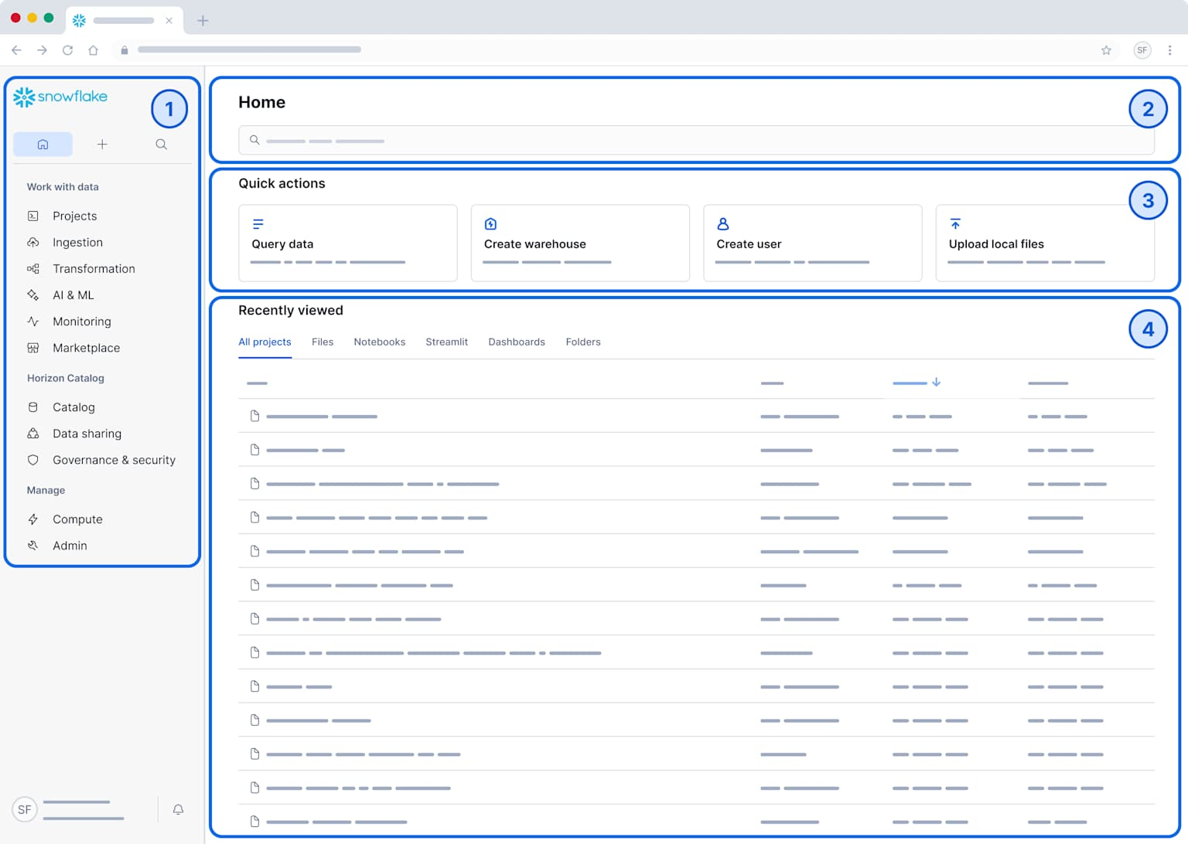
Snowsight home screen — your trial environment is ready

✅ Your Snowflake trial is ready! You will use this account in Exercise 2. Keep the browser tab open.

Quick Reference

Field | Value
Signup URL | https://signup.snowflake.com
Login URL | https://app.snowflake.com
Trial duration | 30 days from signup
Free credits | $400 included
Credit card required? | No
Recommended edition | Enterprise
Recommended cloud | AWS

Exercise 1: Connect to SAP and Create a Table Service
Duration: ~25 minutes | Steps: 5

Overview
SAP stores sales orders across two related tables: VBAK (Sales Document Header — one row per order) and VBAP (Sales Document Items — one row per line item). In this exercise you will use the Boomi for SAP drag-and-drop UI to join those tables and publish a Table Service — a managed OData endpoint that Boomi Data Integration can query in Exercise 2.

ℹ️ What you'll learn: navigate the Boomi for SAP UI; join SAP tables on the Table Service canvas; select only the fields your data warehouse needs; publish a Table Service so it is queryable from Boomi Data Integration.

Step 1: Log In to Boomi for SAP (5 min)
Open a new browser tab and navigate to the Boomi for SAP UI. Log in with the credentials below.

Field | Value
URL | https://boomiforsap.demo.boomi.com:44300/zbx/home
User | BOOMI_WRKSHP
Password | Welcome1

- 1. After logging in you will land on the Boomi for SAP home screen. In the left navigation, click Table Services.
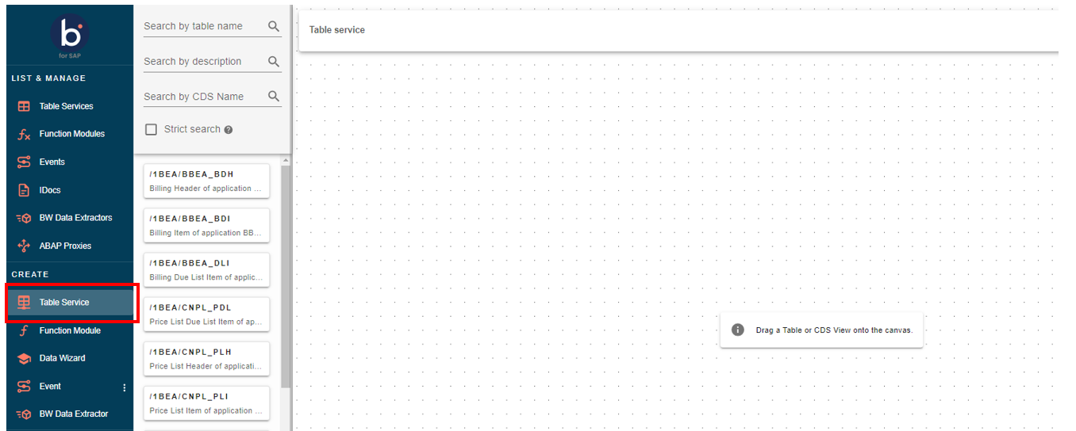
Navigate to Table Services in the left sidebar

- 2. Click the + Create button in the top-right corner to open the Table Service canvas.
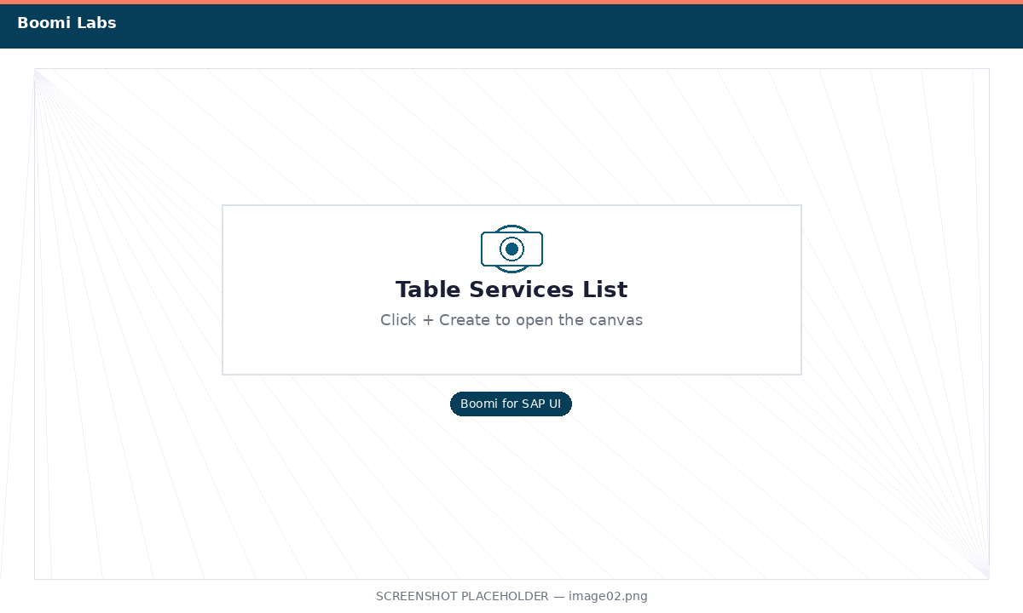
Click + Create to open a new Table Service canvas

Step 2: Add VBAK and VBAP to the Canvas (5 min)
Search for the two SAP sales order tables and drag them onto the canvas.

ℹ️ VBAK: Sales Document Header — one row per order. VBAP: Sales Document Items — one row per line item.

- 1. In the Table Search box on the left panel, type VBAK. Find "Sales Document: Header Data" and drag it onto the canvas.
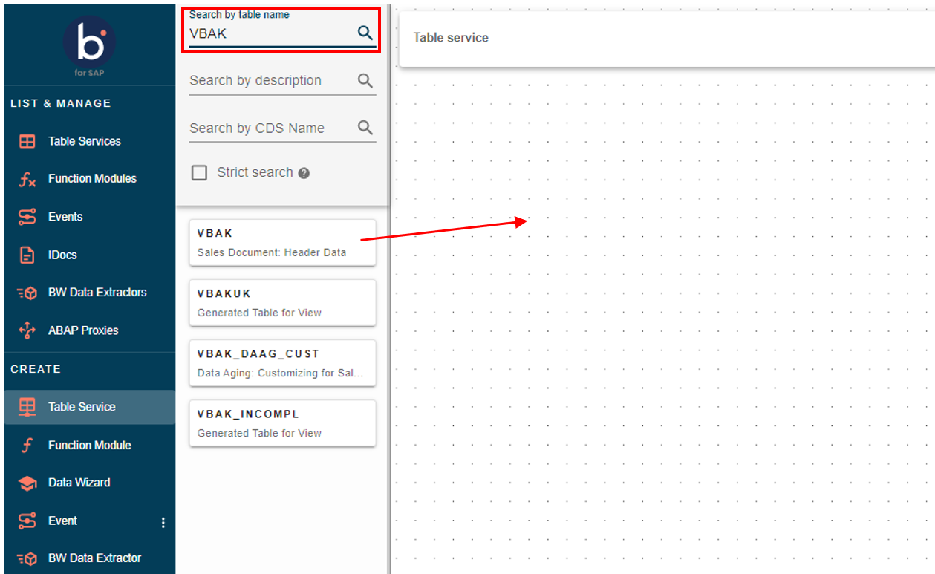
Search for VBAK and add it to the canvas

- 2. Clear the search box, type VBAP, find "Sales Document: Item Data" and drag it onto the canvas to the right of VBAK.
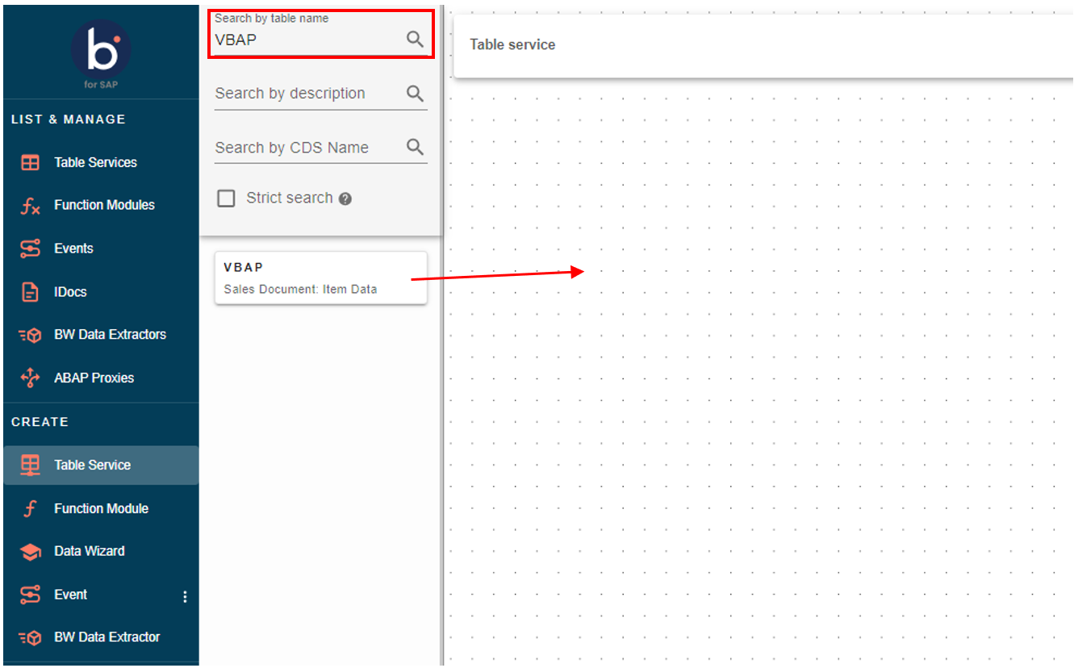
Both VBAK and VBAP tables are now on the canvas

Step 3: Join VBAK and VBAP on VBELN (5 min)
- 1. On the VBAK table card, locate the field VBELN (Sales Document Number). Hover over it — a connector dot appears on the right edge.
- 2. Click and drag from the VBAK VBELN connector dot to the VBELN field on VBAP. Release to create the join line.
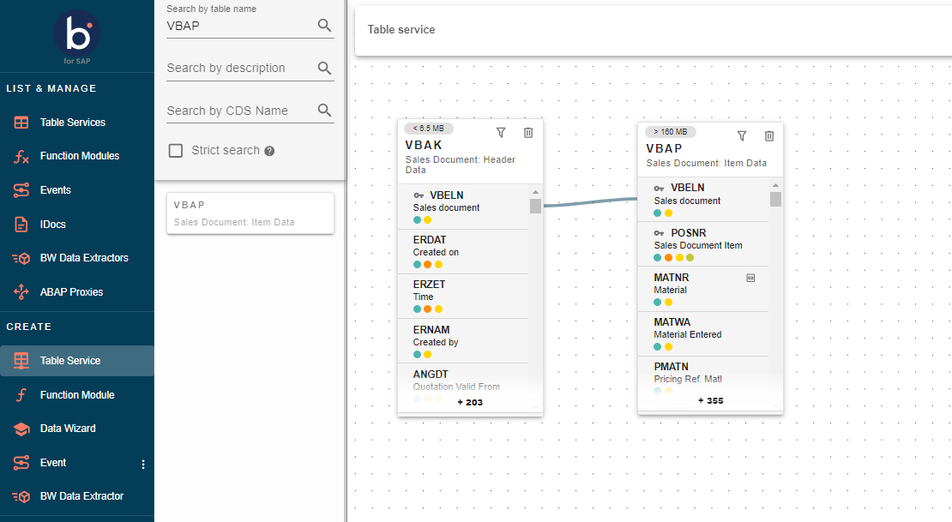
Join line connecting VBELN on VBAK to VBELN on VBAP

- 3. Click the join line to confirm it is an Inner Join — only orders with at least one line item are returned.
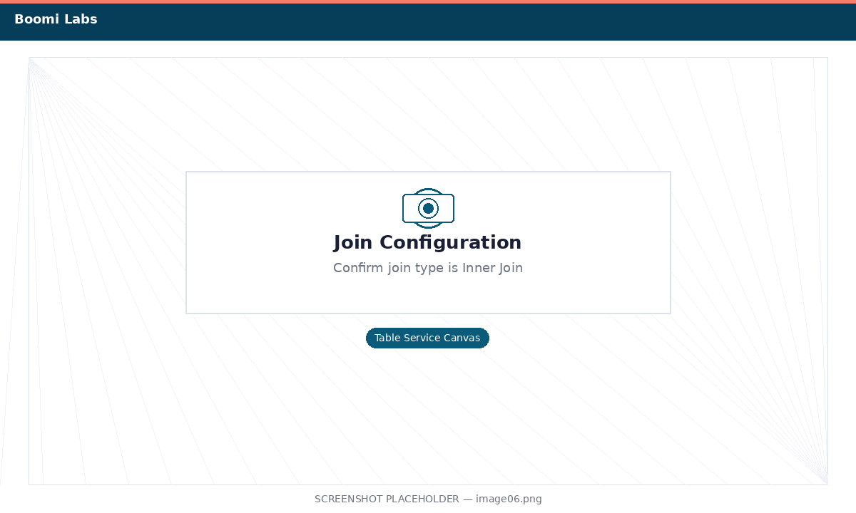
Join configuration — confirm the join type is Inner Join

Step 4: Select the Fields for Your Data Warehouse (7 min)
⚠️ SAP tables can have hundreds of fields. Select only what your data warehouse needs — this keeps loads fast and the Snowflake schema clean.

- 1. On VBAK, click the filter fields icon. Deselect all, then re-select only:

Field | Description
VBELN | Sales Document Number
ERDAT | Created On (date)
KUNNR | Sold-to Party (Customer ID)
NETWR | Net Value of Sales Order
WAERK | Currency
VKORG | Sales Organization
VTWEG | Distribution Channel
SPART | Division

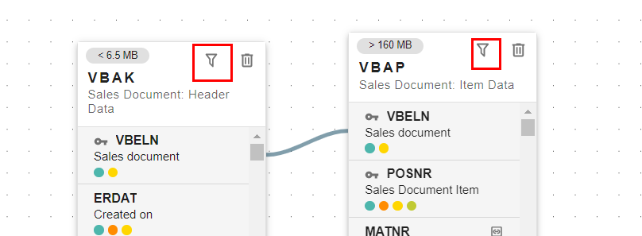
VBAK field filter — 8 fields selected

- 2. On VBAP, click the filter fields icon. Deselect all, then re-select only:

Field | Description
VBELN | Sales Document Number
POSNR | Item Number
MATNR | Material Number
ARKTX | Short Description of Item
KWMENG | Cumulative Order Quantity
KMEIN | Unit of Measure

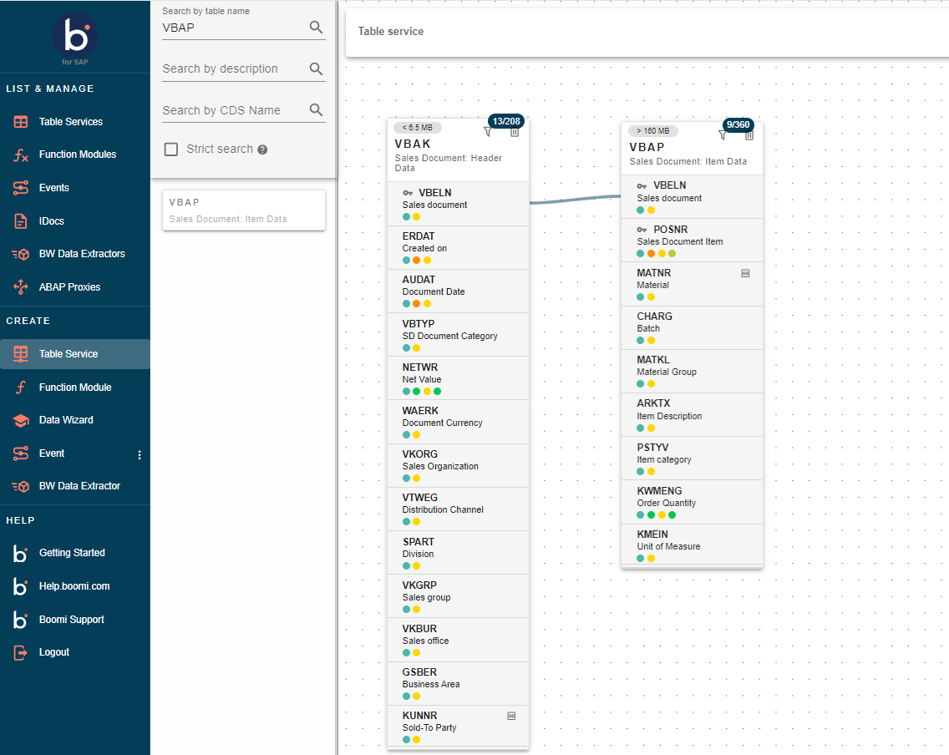
VBAP field filter — 6 fields selected

Step 5: Name and Publish the Table Service (3 min)
- 1. Click the Settings tab at the top of the canvas. Set the Service Name to SALES_ORDER_DW_XX (replace XX with your assigned user number).
- 2. Click Save, then click Publish. The service status changes from Draft to Active.
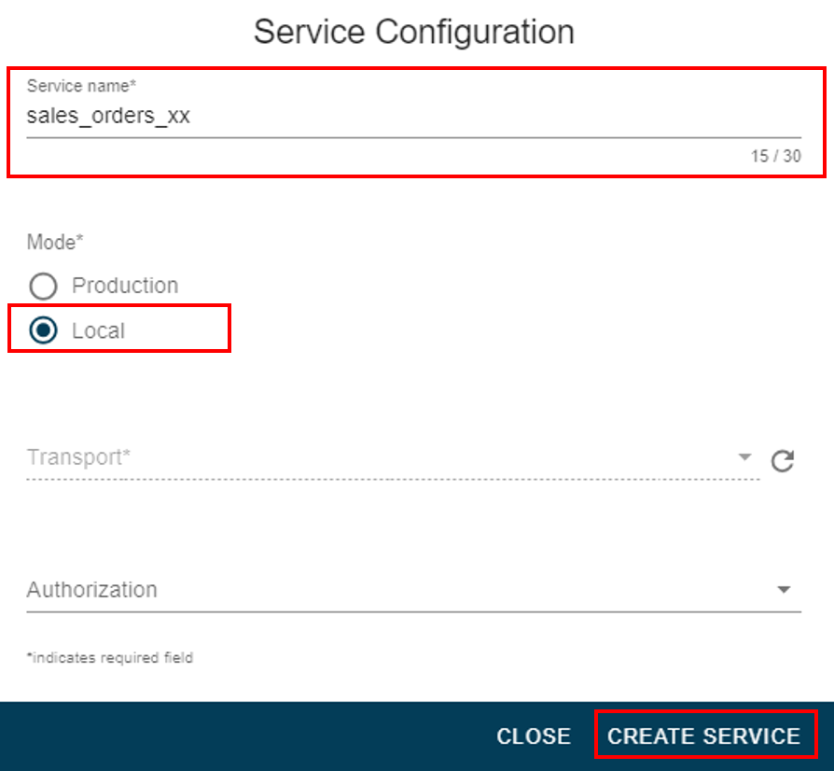
A green Active badge confirms the Table Service is live

- 3. Copy the OData URL shown in the service details panel — you will need it in Exercise 2.
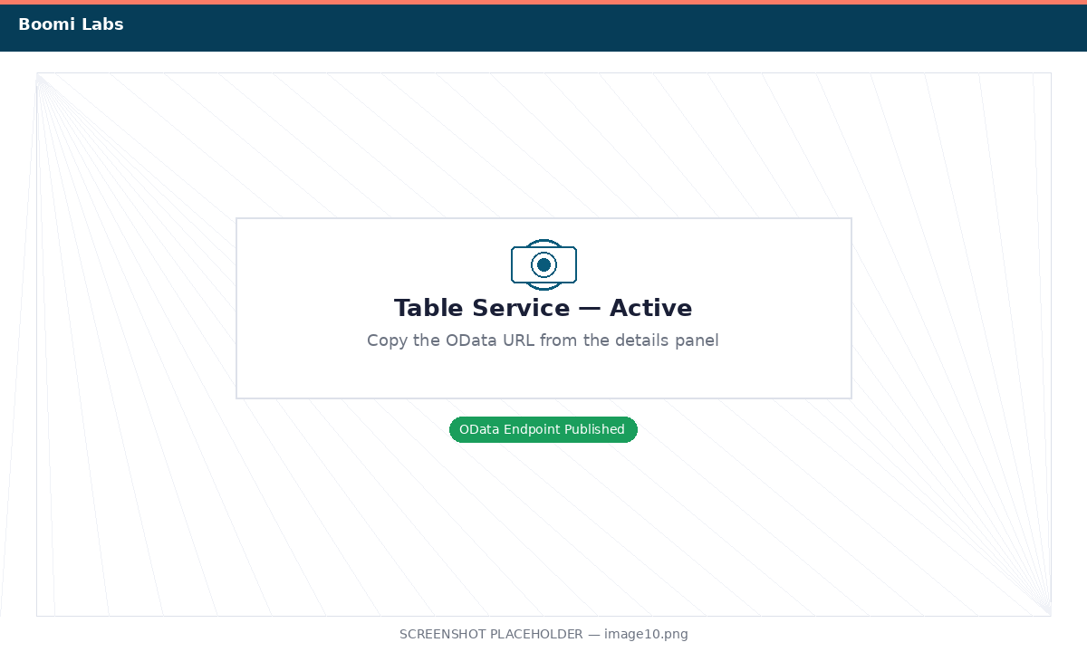
Copy the OData URL from the service details panel

✅ Exercise 1 complete! Your SAP Table Service is published and ready. In Exercise 2 you'll connect Boomi Data Integration to this service and load the data into Snowflake.

Exercise 2: Extract SAP Data into Snowflake
Duration: ~30 minutes | Steps: 5

Overview
In Exercise 1 you created a Table Service that exposes SAP sales orders as a clean, queryable feed. Now you'll connect Boomi Data Integration (BDI) to that feed as a source, point it at a new Snowflake database as a target, and run an initial full load. BDI automatically creates the target table in Snowflake — no DDL required.

ℹ️ What you'll learn: provision a Snowflake trial; create a Snowflake connection in BDI; connect BDI to the SAP Table Service as an OData source; configure and run a BDI Source-to-Target flow; verify loaded data in Snowflake.

Step 1: Set Up Your Snowflake Target (7 min)
ℹ️ If your trainer has pre-provisioned a Snowflake environment, skip sub-steps 1–2 and use the provided credentials.

- 1. Go to https://signup.snowflake.com and create a free 30-day trial. Choose Standard tier and AWS as the cloud provider.
- 2. Log in to your Snowflake account. Open a Worksheet and run the SQL below to create the database and schemas.

-- Create the lab database
CREATE DATABASE SAP_DW_LAB;

-- RAW schema: landing zone for data from SAP
CREATE SCHEMA SAP_DW_LAB.RAW;

-- DW schema: transformed, analytics-ready tables (used in Exercise 3)
CREATE SCHEMA SAP_DW_LAB.DW;

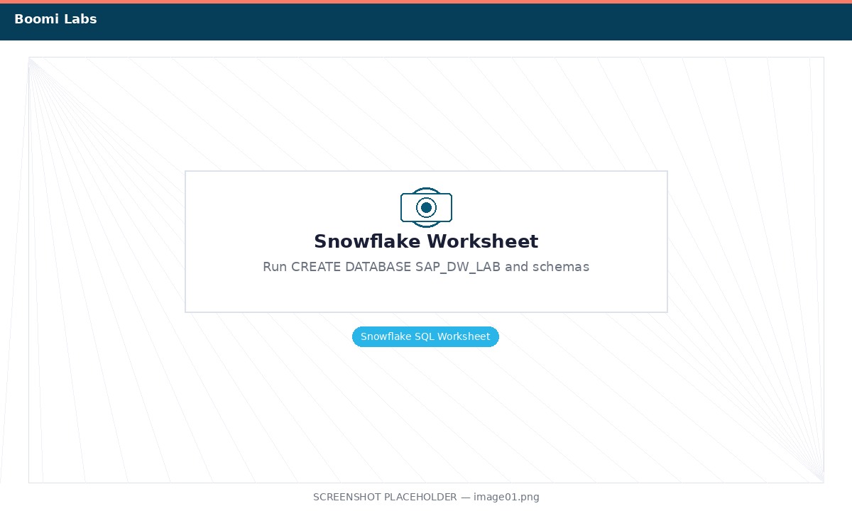
Run all three statements in Snowflake — each should return "Statement executed successfully"

- 3. Note your Snowflake Account Identifier — visible in Admin > Accounts or in your browser URL as <org>-<account>.snowflakecomputing.com.

Step 2: Connect Boomi Data Integration to Snowflake (5 min)
- 1. Log in to Boomi Data Integration at https://console.rivery.io using the credentials provided by your trainer.
- 2. In the left sidebar, go to Connections and click + New Connection.
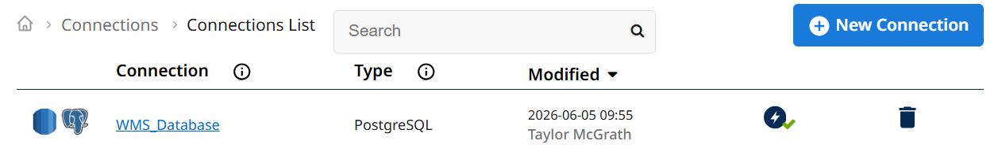
BDI Connections page — click + New Connection

- 3. Search for Snowflake and select it. Fill in the table below, then click Test Connection.

Field | Value
Connection Name | Snowflake_SAP_DW
Account | Your account identifier (e.g., myorg-myaccount)
Username | Your Snowflake username
Password | Your Snowflake password
Warehouse | COMPUTE_WH
Database | SAP_DW_LAB

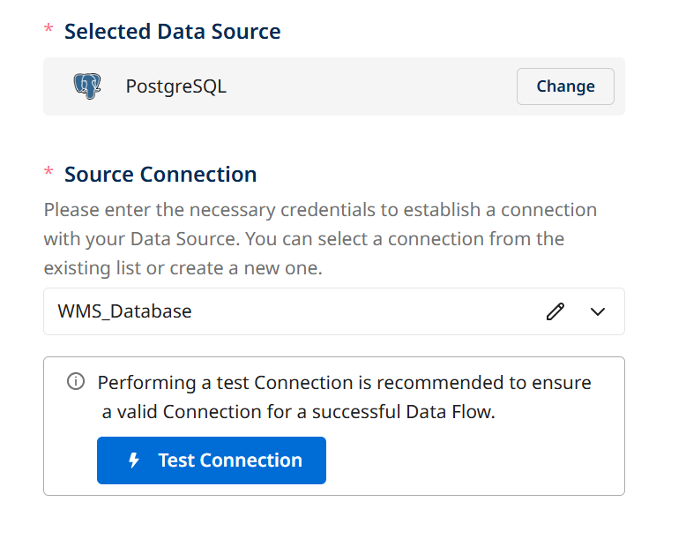
Snowflake connection form — fill in your account details and click Test Connection

- 4. When the test returns a green Connection Successful message, click Save.

Step 3: Add the SAP Table Service as a Source (5 min)
- 1. In BDI, go to Connections > + New Connection. Search for OData and select it.
- 2. Fill in the connection details using the OData URL you copied at the end of Exercise 1.

Field | Value
Connection Name | SAP_Table_Service_XX (replace XX)
Base URL | The OData URL from Exercise 1
Authentication | Basic Auth
Username | BOOMI_WRKSHP
Password | Welcome1

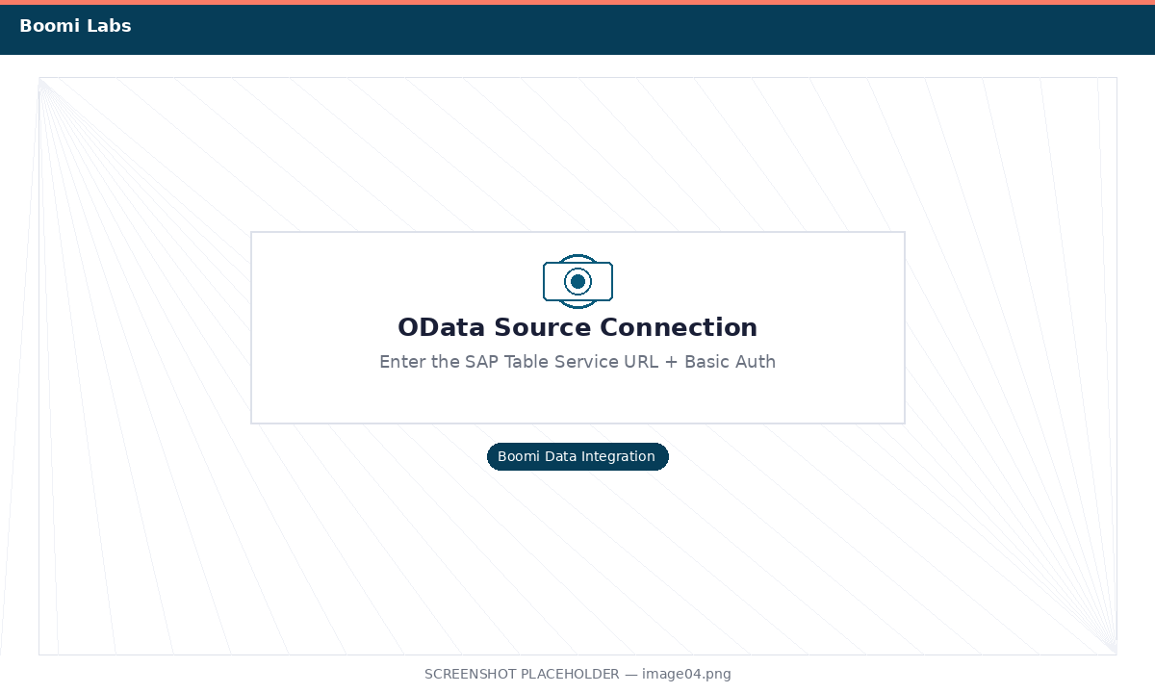
OData source connection form — enter SAP Table Service URL and Basic Auth credentials

- 3. Click Test Connection. A successful test confirms BDI can reach your SAP Table Service. Click Save.

Step 4: Create the Source-to-Target Flow (8 min)
- 1. In BDI, click Create and choose Source to Target Flow.
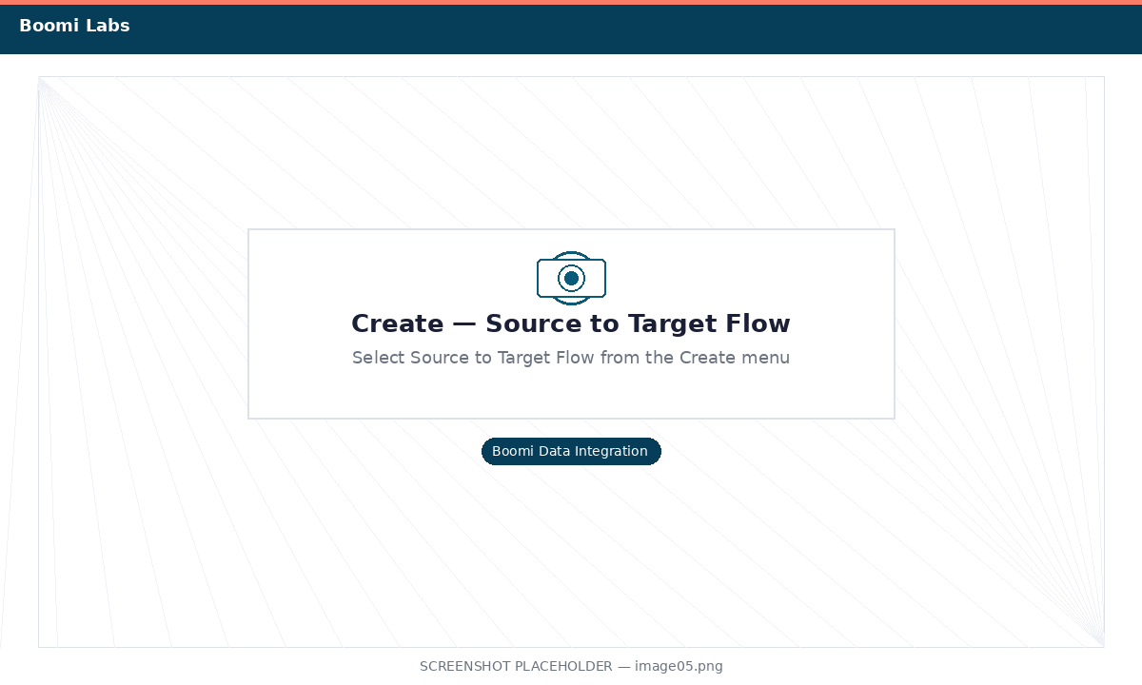
Select Source to Target Flow from the Create menu

- 2. On the Source tab, select the SAP_Table_Service_XX connection, then select the SALES_ORDER_DW_XX entity.
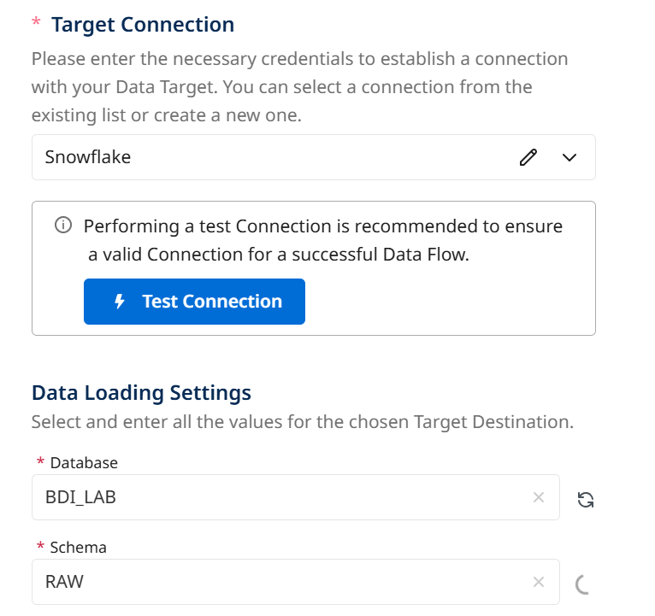
Source tab — select the SALES_ORDER_DW_XX entity

- 3. Switch to the Target tab. Select Snowflake_SAP_DW. Set Database = SAP_DW_LAB, Schema = RAW, Table Name = SAP_SALES_ORDERS_RAW.
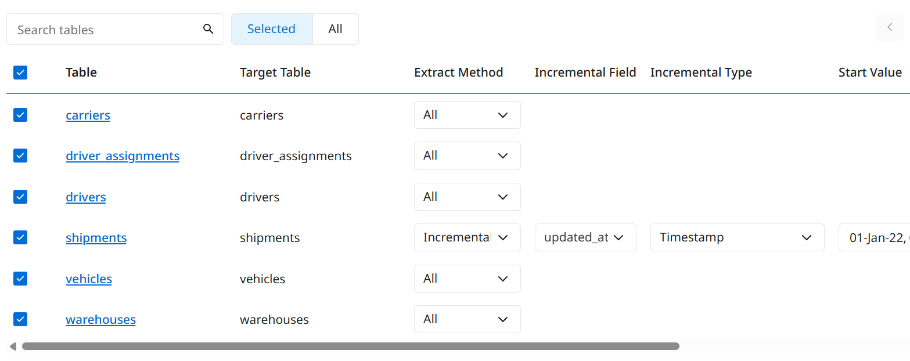
Target tab — Snowflake SAP_DW_LAB.RAW.SAP_SALES_ORDERS_RAW

- 4. Go to Schedule & Settings. Set Schedule to OFF, name the flow sap-to-snowflake-raw-XX, and click Save.

Step 5: Run the Flow and Verify in Snowflake (5 min)
- 1. Click Activate in the bottom-right corner of the flow editor.
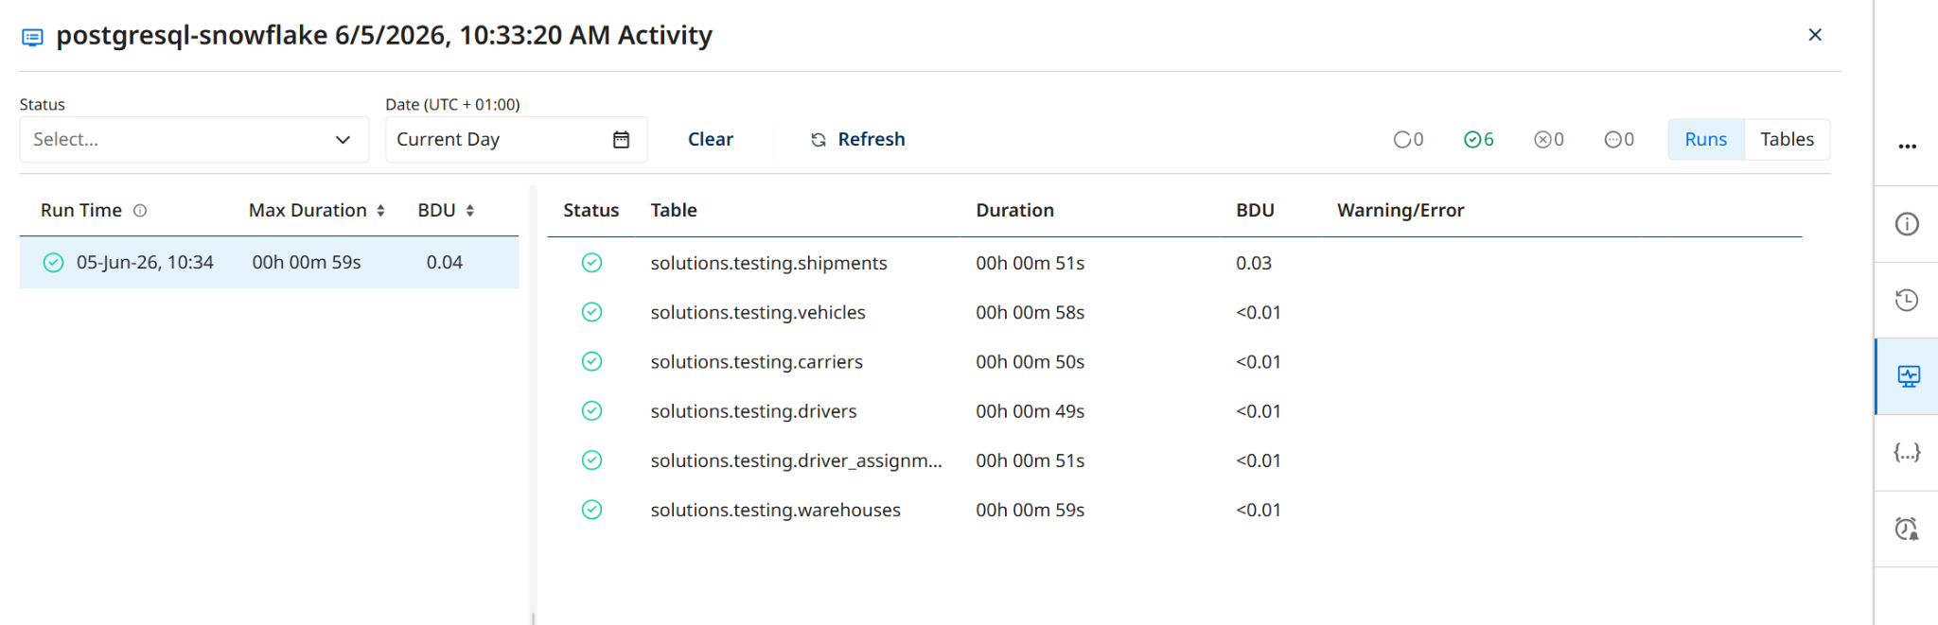
Click Activate to enable the flow

- 2. Click Run Data Flow. Open the live run tree (monitor icon). When you see a green checkmark and row count, the load is complete.
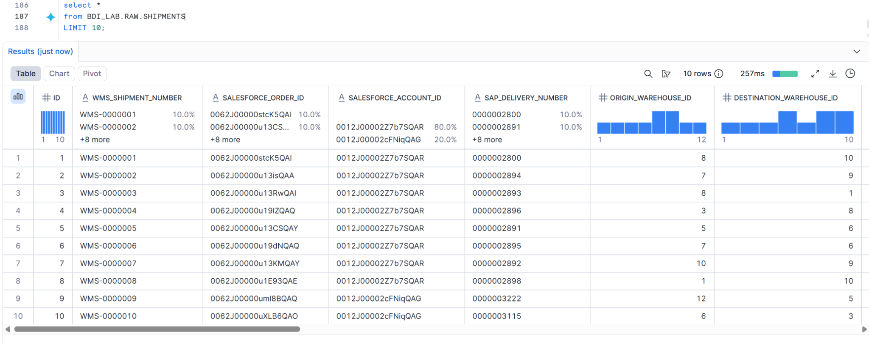
Run tree — green checkmark confirms the SAP data landed in Snowflake

- 3. In Snowflake, open a Worksheet and run the query below to verify the data.

SELECT
VBELN AS order_number,
ERDAT AS order_date,
KUNNR AS customer_id,
NETWR AS net_value,
WAERK AS currency,
MATNR AS material_number,
ARKTX AS item_description,
KWMENG AS quantity,
KMEIN AS unit
FROM SAP_DW_LAB.RAW.SAP_SALES_ORDERS_RAW
LIMIT 20;

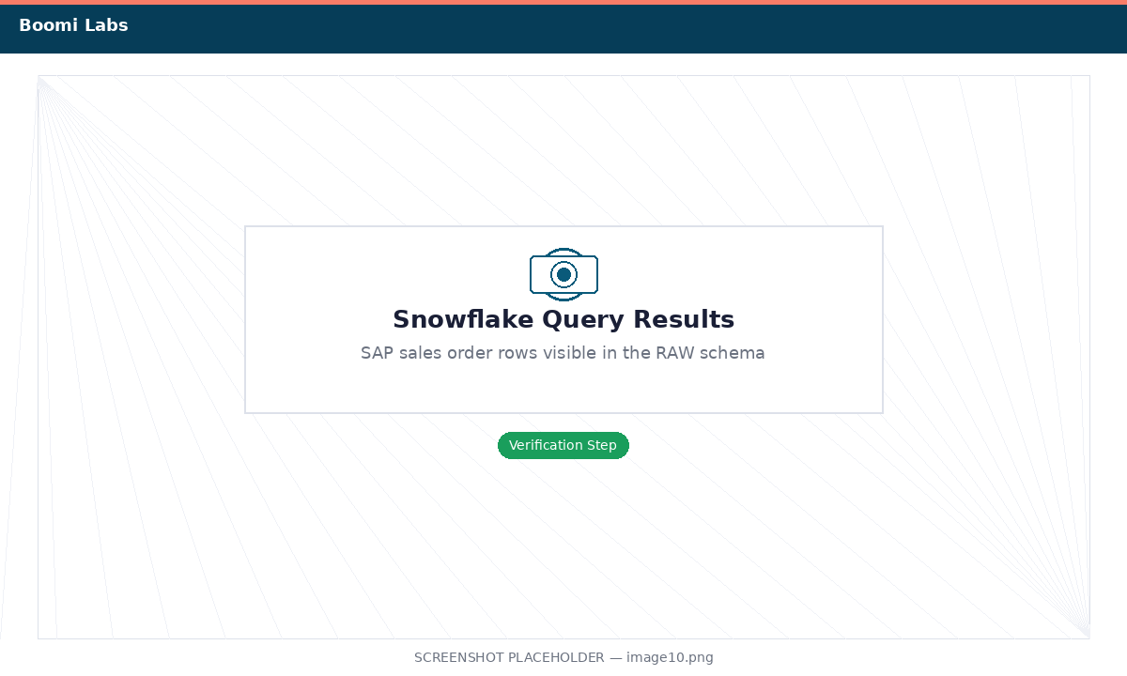
Snowflake query results — SAP sales order rows in the RAW schema

✅ Exercise 2 complete! SAP sales order data is now in Snowflake. In Exercise 3 you'll transform it into structured fact and dimension tables.

Exercise 3: Transform SAP Data into a Data Warehouse
Duration: ~20 minutes | Steps: 4

Overview
The raw table from Exercise 2 is a flat, denormalized dump — great for landing data quickly, but not ideal for analytics. In this exercise you'll add a SQL Transformation step to your BDI pipeline that runs push-down SQL directly inside Snowflake to build two proper data warehouse tables:

- DW.FACT_SALES — one row per sales order line item with all measurable facts
- DW.DIM_CUSTOMER — one row per unique customer with descriptive attributes

Finally, you'll use Snowflake Cortex AI to ask natural-language questions about the data.

ℹ️ Push-down SQL means BDI sends the SQL to Snowflake for execution — the data stays inside the warehouse, keeping loads fast and cost-efficient.

Step 1: Add a SQL Transformation to the Pipeline (3 min)
- 1. In BDI, open the sap-to-snowflake-raw-XX flow from Exercise 2 and click Edit.
- 2. At the bottom of the flow editor, click + Add Step and choose SQL Transformation.
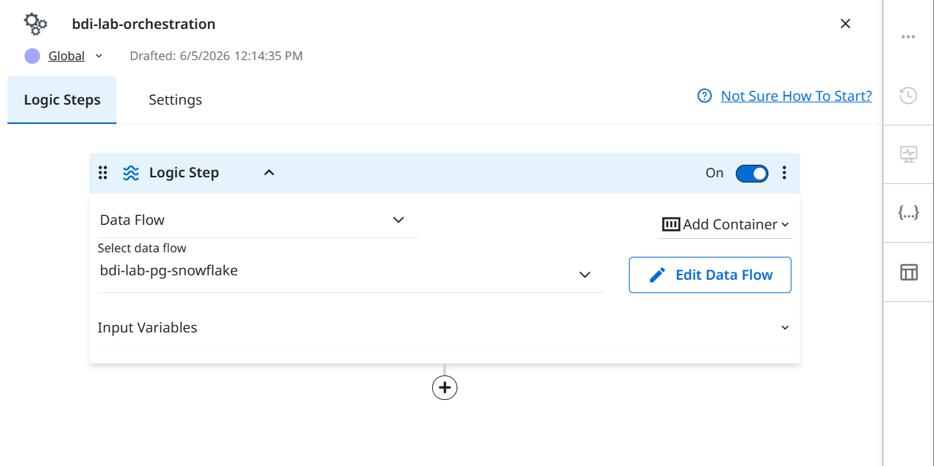
Click + Add Step → SQL Transformation in the BDI flow editor

- 3. In the SQL Transformation settings, confirm the Connection is set to Snowflake_SAP_DW. Name the step Build DW Tables.
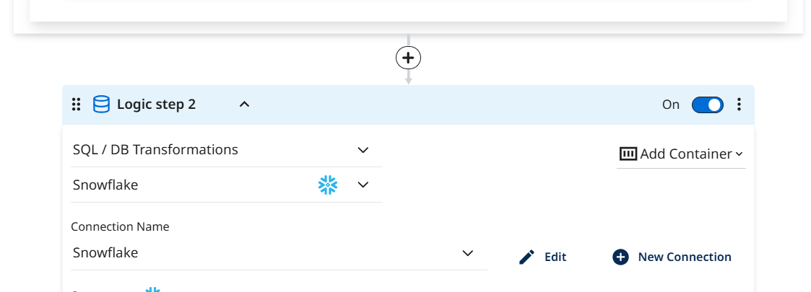
SQL Transformation settings — Snowflake_SAP_DW connection selected for push-down execution

Step 2: Write the SQL for Fact and Dimension Tables (8 min)
ℹ️ BDI's SQL Transformation accepts multiple statements separated by semicolons. Both tables are created in one step execution.

- 1. Paste the FACT_SALES statement into the SQL editor:

-- Fact table: one row per order line item
CREATE OR REPLACE TABLE SAP_DW_LAB.DW.FACT_SALES AS
SELECT
VBELN AS order_id,
POSNR AS line_item_id,
KUNNR AS customer_id,
MATNR AS material_id,
TO_DATE(ERDAT, 'YYYYMMDD') AS order_date,
TRY_CAST(KWMENG AS FLOAT) AS quantity,
KMEIN AS unit_of_measure,
TRY_CAST(NETWR AS FLOAT) AS net_order_value,
WAERK AS currency,
VKORG AS sales_org,
VTWEG AS distribution_channel,
SPART AS division,
ARKTX AS item_description
FROM SAP_DW_LAB.RAW.SAP_SALES_ORDERS_RAW
WHERE VBELN IS NOT NULL;

- 2. Add the DIM_CUSTOMER statement after a semicolon:

-- Dimension table: one row per unique customer
CREATE OR REPLACE TABLE SAP_DW_LAB.DW.DIM_CUSTOMER AS
SELECT DISTINCT
KUNNR AS customer_id,
VKORG AS sales_org,
VTWEG AS distribution_channel,
SPART AS division
FROM SAP_DW_LAB.RAW.SAP_SALES_ORDERS_RAW
WHERE KUNNR IS NOT NULL;

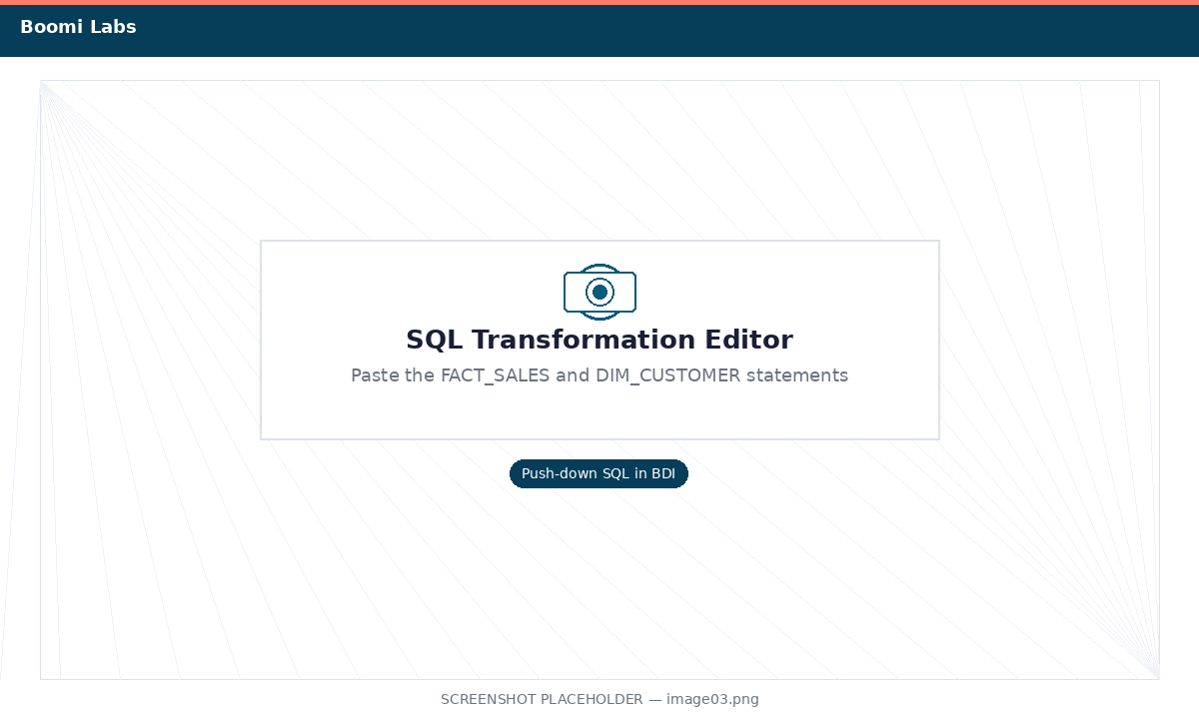
BDI SQL editor — both CREATE OR REPLACE TABLE statements

- 3. Click Validate SQL. Confirm there are no syntax errors, then click Save.

Step 3: Run the Full Pipeline and Verify (5 min)
- 1. Click Run Data Flow. Open the live run tree and wait for both steps to show a green checkmark: the SAP load step and the Build DW Tables SQL step.
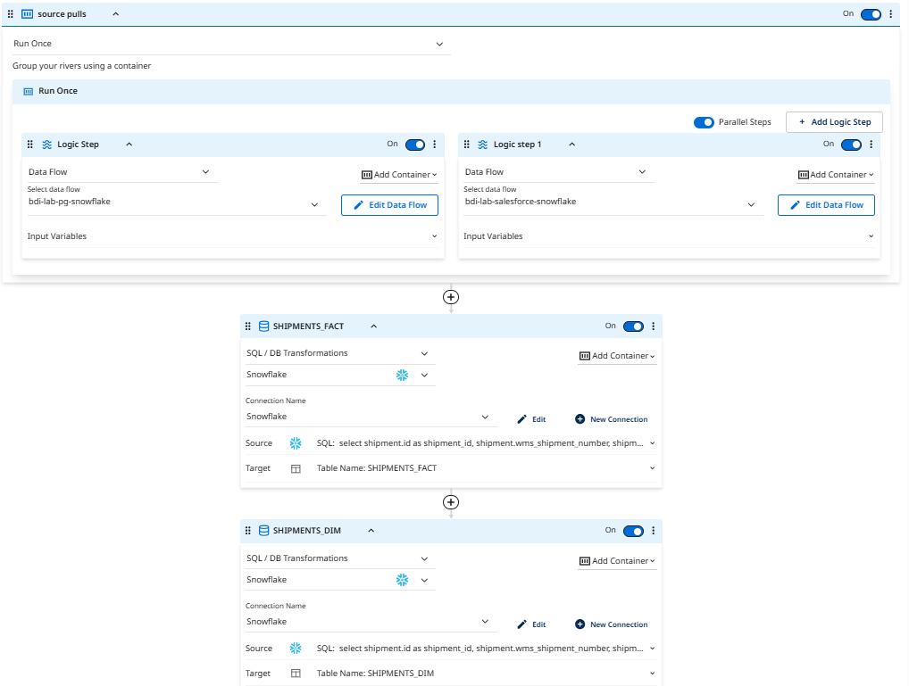
Run tree — both pipeline steps complete with green checkmarks

- 2. In Snowflake, run the verification queries below.

-- Check the fact table
SELECT COUNT(*) AS total_line_items FROM SAP_DW_LAB.DW.FACT_SALES;

-- Check the dimension table
SELECT COUNT(*) AS unique_customers FROM SAP_DW_LAB.DW.DIM_CUSTOMER;

-- Top 5 customers by total order value
SELECT customer_id, SUM(net_order_value) AS total_value, currency
FROM SAP_DW_LAB.DW.FACT_SALES
GROUP BY customer_id, currency
ORDER BY total_value DESC LIMIT 5;

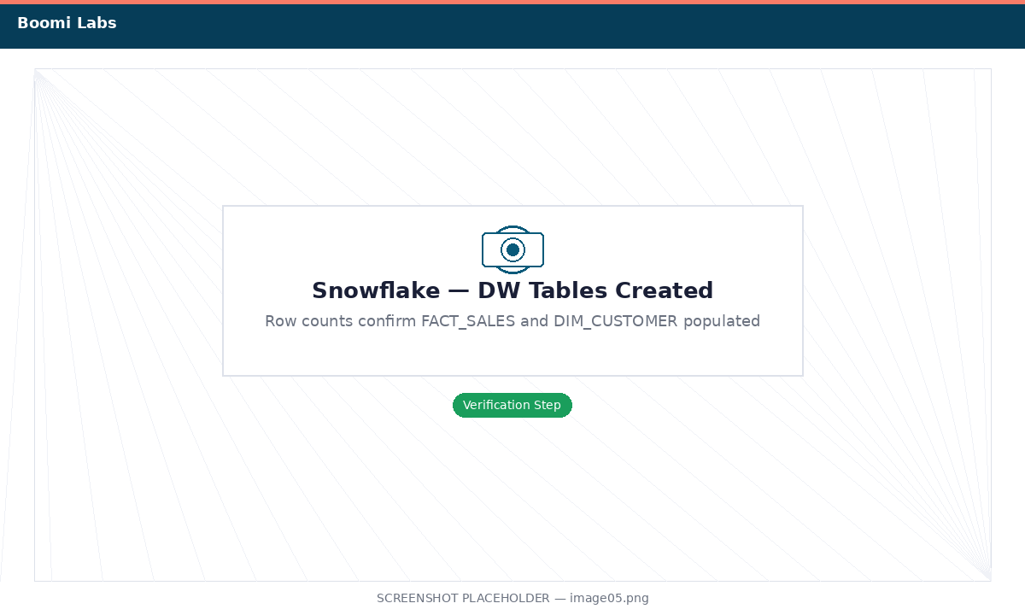
Snowflake — row counts confirm FACT_SALES and DIM_CUSTOMER were created and populated

Step 4: Explore with Snowflake Cortex AI (4 min)
- 1. In the Snowflake UI, click the Cortex AI icon in the left navigation, or go to AI & ML > Cortex Analyst. Point Cortex at the SAP_DW_LAB.DW schema.
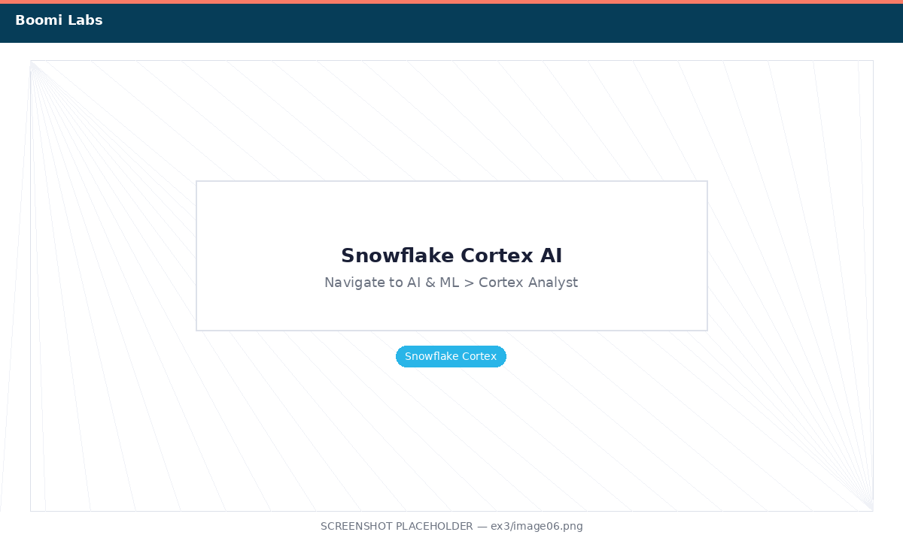
Navigate to Snowflake Cortex AI from the left sidebar

- 2. Try these natural-language questions:

- "What are the top 10 customers by total sales value?"
- "Show me monthly sales totals for this year."
- "Which materials have the highest order quantities?"

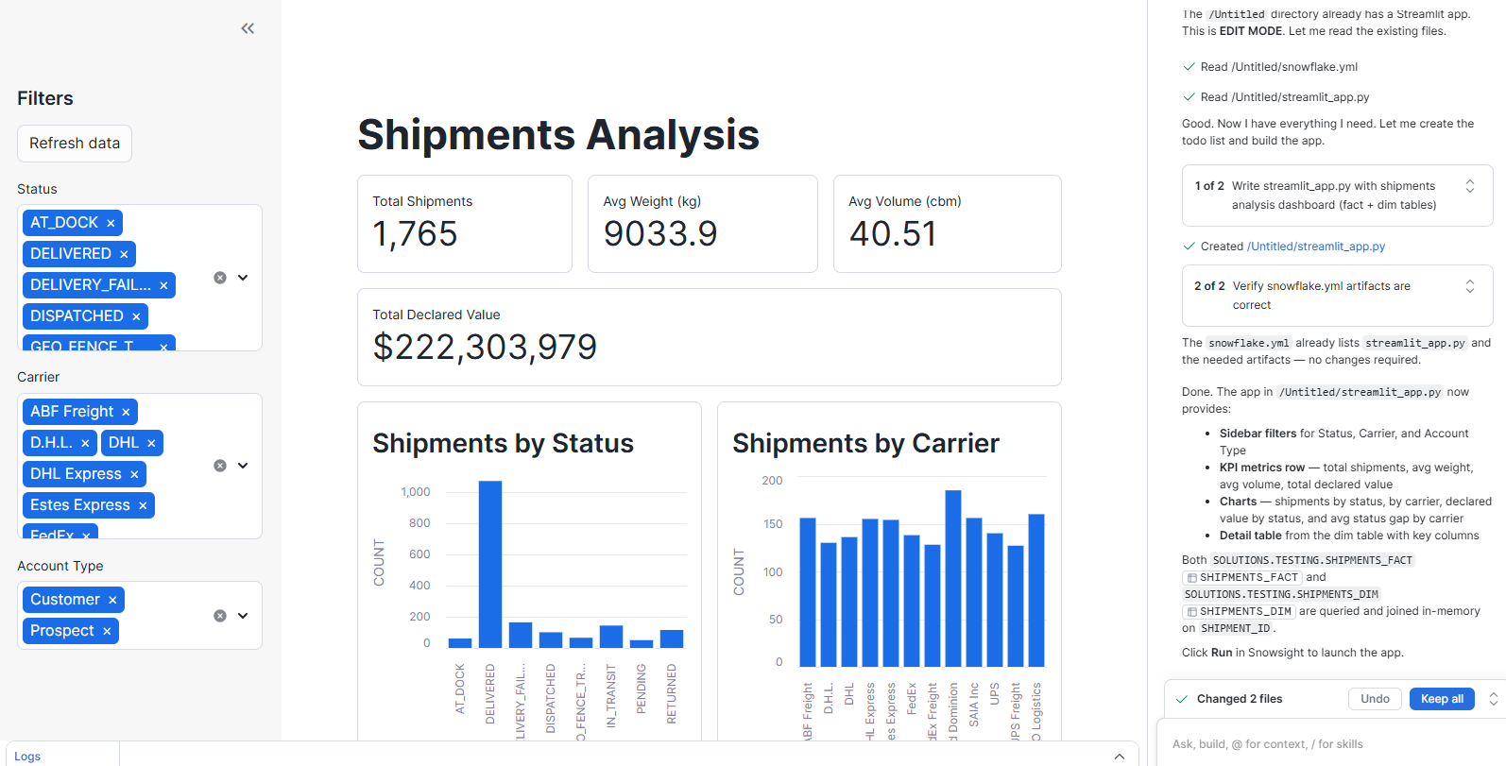
Snowflake Cortex AI — natural language query results rendered as charts

✅ Lab complete! You've published a SAP Table Service, loaded SAP data into Snowflake, built FACT_SALES and DIM_CUSTOMER tables with push-down SQL, and explored results with Cortex AI.

Next Steps
- Schedule the BDI flow to run nightly for incremental SAP loads.
- Add more SAP Table Services (e.g., customer master KNA1) to enrich DIM_CUSTOMER.
- Connect Tableau or Power BI to SAP_DW_LAB.DW for dashboarding.
- Explore the Boomi for SAP Lab to learn BAPI invocations and real-time events.

