1. INTRODUCTION
1.1 PROBLEM DEFINITION
This project targets to develop software for Educational Institutions in order to handle the time table formation for the pupil as well as staff. Making a timetable for students is essential for every institution before starting every academic year this task may sound simple, but it is way too challenging. This software resolves the problem by permitting the pupil and other employees to see their assigned subject and Timetable.
This software helps to handle the particulars of the timetable of pupil and staff. Visual Basic.Net is employed as front end which is used to craft the user interface and SQL database is employed as back end and used to craft the database and save the data. If anybody with a little computer knowledge can approach and deal with the software with ease hence it can be termed user-friendly. It also offers security to the users by offering perfect login.
Timetable Management is a crucial aspect of organizing and optimizing schedules in various domains such as education, business, and event planning. It involves the efficient allocation of resources, such as time, rooms, and personnel, to create structured and balanced schedules that meet the needs of individuals or groups.
The primary goal of Timetable Management is to eliminate conflicts, avoid overlapping activities, and ensure the best utilization of available resources. It plays a significant role in enhancing productivity, reducing confusion, and improving overall efficiency. Whether you are a school administrator, a project manager, or an event organizer, an effective timetable management system can streamline operations and lead to better outcomes.
Timetable Management allows you to allocate resources, such as classrooms, teachers, and equipment, in a way that minimizes conflicts and optimizes utilization. By intelligently scheduling activities and avoiding clashes, timetable management helps prevent conflicts and ensures that individuals or groups can participate in all required events.
A well-organized timetable helps in planning and preparing for various activities in advance, leading to smoother execution and reduced last-minute adjustments. Timetable management identifies gaps and unused time slots, enabling you to make the most of your available time and improve productivity.
Timetable Management systems often allow for easy adjustments and modifications, accommodating unforeseen changes or preferences. Timetable data can provide insights into attendance, resource usage, and activity trends, helping with future decision-making and optimization.
Timetable Management software helps design timetables and mark attendance for teachers and students. It helps to regulate proper schedules and allocate faculty according to their availability by outlining the classes sections and other details fed into the system.
Modern Timetable Management often involves software applications that combine database management, user interfaces, and scheduling algorithms. These applications can be customized to meet specific requirements and integrated with other systems to provide a comprehensive solution for managing schedules effectively.
In this context, using technologies like MySQL for database management and VB.NET for user interface development can facilitate the creation of a powerful and user-friendly timetable management system. Such a system can simplify the process of creating, modifying, and viewing schedules, leading to improved organization and enhanced outcomes across various domains.
Adopting a digital system for Timetable Management enhances the authenticity of data as it would be sensitive towards manipulations and boosts efficiency due to workflow automation.

1.2. ORGANIZATION PROFILE
Vivekananda Educational Institution with 20 colleges are run by Angammal Educational Trust. Vidhya Rathna, Kongu Nattu Sathanaiyalar prof. Dr. M. KARUNANITHI, B.Pharm., M.S., Ph.D., D.Litt., formed the trust in the year 1987 motivated the ideas of service into the people with the focus on promoting technical and professional education for women of our country. Twenty-three thousand girls from rural as well as urban areas from all over India have been provided with ample opportunities to pursue education at all levels in all disciplines. Vivekananda Educational Institution is the only one its kind in the whole of Asia.
Vivekananda College of Arts and Sciences for Women (Autonomous) was established and hailed into women's educational service in the year 1995. Angammal Educational trust chaired by the great educationalist Vidhya Rathna prof. Dr. M. KARUNANITHI, B.Pharm., M.S., Ph.D., D.Litt., sponsors this college and other institutions under the name of the great Saint Vivekanandha. Our institutions are situated on either side of Tiruchengode, Namakkal main Road at Elayampalayam. 6 kms away from Tiruchengode. This is biggest women’s college in India with more than 7500 girl students and more than 19 departments. The strength of the college was just 65 at the time of its establishment. With the dedication, work, sacrifice and long vision of the chairman, this institution has grown in to a Himalaya stage. Autonomous status is given to the college for its successful performance.

2. SYSTEM CONFIGURATION
2.1 HARDWARE CONFIGURATION
This section gives the details and specification of minimum hardware on which the system is expected to work.
- System : Intel Dual Core 2.42 GHz

- Hard Disk : 300 GB

- Monitor : 15” VGA Color

- Mouse : Optical

- RAM : 2 GB

2.2 SOFTWARE CONFIGURATION
This section gives the details of minimum software that are used for the development.
- Operating system : Windows/Linux

- Coding Language : VB.NET

- Data Base : SQL SERVER

2.3 SOFTWARE DESCRIPTION
What is .NET?
Many people reckon that it's Microsoft's way of controlling the Internet, which is false. NET is Microsoft's strategy of software that provides services to people any time, any place, on any device. An accurate definition of .NET is, it's an XML Web Services platform which allows us to build rich .NET applications, which allows users to interact with the Internet using wide range of smart devices (tablet devices, pocket PC's, web phones etc). which allows to build and integrate Web Services and which comes with many rich set of tools like Visual Studio to fully develop and build those applications.
.NET Framework
.NET is a "Software Platform". It is a language-neutral environment for developing rich .NET experiences and building applications that can easily and securely operate within it. When developed applications are deployed, those applications will target .NET and will execute wherever .NET is implemented instead of targeting a particular Hardware/OS combination. The components that make up the .NET platform are collectively called the .NET Framework. The .NET Framework is a managed, type-safe environment for developing and executing applications. The .NET Framework manages all aspects of program execution, like. allocation of memory for the storage of data and instructions, granting and denying permissions to the application, managing execution of the application and reallocation of memory for resources that are not needed.
The .NET Framework is designed for cross-language compatibility. Cross-language compatibility means, an application written in Visual Basic .NET may reference a DLL file written in C# (C-Sharp). A Visual Basic .NET class might be derived from a C# class or vice versa.
The .NET Framework consists of two main components:
- Common Language Runtime (CLR)
- Class Libraries

Common Language Runtime (CLR)
The CLR is described as the "execution engine of NET. It provides the environment within which the programs run. It's this CLR that manages the execution of programs and provides core services, such as code compilation, memory allocation, thread management, and garbage collection. Through the Common Type System (CTS), it enforces strict type safety, and it ensures that the code is executed in a safe environment by enforcing code access security. The software version of NET is actually the CLR version.
Working of the CLR
When the .NET program is compiled, the output of the compiler is not an executable file but a file that contains a special type of code called the Microsoft Intermediate Language (MSI), which is a low-level set of instructions understood by the common language run time. This MSIL. defines a set of portable instructions that are independent of any specific CPU). It's the job of the CLR to translate this Intermediate code into a executable code when the program is executed making the program to run in any environment for which the CLR is implemented. And that's how the NET Framework achieves Portability. This MSIL is turned into executable code using a JIT (Just In Time) complier. The process goes like this. when NET programs are executed the CLR activates the JIT complier. The JIT complier converts MSII. into native code on a demand basis as each part of the program is needed. Thus, the program executes as a native code even though it is compiled into MSIL making the program to run as fast as it would if it is compiled to native code but achieves the portability benefits of MSIL.
Class Libraries
Class library is the second major entity of the NET Framework which is designed to integrate with the common language runtime. This library gives the program access to runtime environment. The class library consists of lots of prewritten code that all the applications created in VB .NET and Visual Studio .NET will use. The code for all the elements like forms, controls and the rest in VB .NET applications actually comes from the class library.

ASP.NET Application Services
ACTIVE SERVER PAGES
COMMON LANGUAGE RUNTIME
WINDOWS FORMS
Common Type System
Life Cycle Monitoring
Memory Management
Controls
Drawing
Windows Application Services
Diagnostics
XML
Net
Threading
IO
Security
ADO.NET
Web Services
Web Forms
Etc
.NET FRAMEWORK BASE CLASSES
Security
ADO.NET
Controls
.NET FRAMEWORK
Common Language Specification (CLS)
If we want the code which we write in a language to be used by programs in other languages then it should adhere to the Common Language Specification (CLS). The CLS describes a set of features that different languages have in common. The CLS defines the minimum standards that .NET language compilers must conform to, and ensures that any source code compiled by a .NET compiler can interoperate with the .NET Framework
Some reasons why developers are building applications using the .NET Framework

- Improved Reliability
- Increased Performance
- Developer Productivity
- Powerful Security
- Integration with existing Systems
- Ease of Deployment
- Mobility Support
- XML Web service Support
- Support for over 20 Programming Languages
- Flexible Data Access
VB.NET
Visual Basic .Net is much more than new version of VB; it is the most exciting and empowering system of development around. The world wanted a generic language that would enable portability to different operating system and a specification was created. This specification became known as the common language specification (cols).
Visual Basic .Net has revolutionized windows programming and with an object based, event driven approach to software designs. Visual basic.Net applications act a as front end to the database. Visual basic .Net application provides the interface between the user and the database.
PROGRAMMING TOOLS
First, we must look at the different tools that we have to work with. When you are creating a program, you must interact with four main windows. They are the Tool bar, Tool box, Project box, and the Properties window.
TOOL BAR
The tool bar is the bar is at the very top of the editing window. It consists of the dropdown menus: File, Edit, View, Project, Build, Debug. Data, Tools, Window, and Help. Below those options are the "quick buttons". These buttons, reading from left to right are: New Project, New Form, Open File, Save File, Save All, Cut, Copy, Paste, Undo, Redo, Navigate Backward, Navigate Forward, Solution Configurations, Find, Solution Explorer, Properties, Toolbox, and Class View.
TOOL BOX
The Tool box contains the tools you use to place various controls on your forms. It displays all the standard Visual Basic controls plus any custom controls and objects you have added to your project with the Custom Controls dialog box.
There are 47 basic tools in the Toolbox
Pointer: This is the only item in the Toolbox that doesn't draw a control. It is used to resizeor move a control after it's been drawn on a form.
Label: Used for text that you don't want the user to change, such as a caption graphic.
Link Label: A Hyperlink label
Command Button: Used to create a button that the user can choose to carry out a command.
Text Box: Used to hold text that the user can either enter or change
Main Menu: Adds menus under the titles bar of the form. ie. File, Edit,
Check Box: Used to create a box that the user can easily choose to indicate if something is true or false, or to display multiple choices when the user can choose more than one.
Radio Button: Used in a group of option buttons to display multiple choices from which the user can choose only one.
Group Box: Typically used to serve as a border for control with similar needs
Picture Box: Used to display graphical images (either decorative or active), as a container that receives output from graphics methods, or as a container for other controls.
Panel: Used to host or hold other controls that belong to the same group.
Datagrid: Allows users see and edit multiple rows of data simultaneously, also useful for rapid entry of large amounts of data.
List Box: Used to display a list of items from which the user can choose one. The list can be scrolled if it has more items than can be displayed at one time.
Checked List Box: Allows the user to select multiple items in a list by providing a check box for each item.

Combo Box: Used to draw a combination list box and text box. The user can either choose an item from the list or enter a value in the text box.
List View: Displays a list of items with icons, similar to Windows explorer.
Tree View: Displays a hierarchy of nodes, like files and folders.
Tab Control: Allows the user to add multiple tabs to a form, like dividers in a notebook.
Date Time Picker: Allows the user to select a single item from a list of dates or times.
Month Calendar: Displays a calendar that allows the user to change months and select date
Horizontal Scroll Bar: Used to provide a graphical tool for quickly navigating through a long list of items or a large amount of information, for indicating the current position on a scale, or as an input device or indicator of speed or quantity.
Vertical Scroll Bar: Used to provide a graphical tool for quickly navigating through a long list of items or a large amount of information, for indicating the current position on a scale, or as an input device or indicator of speed or quantity.
Timer: Used to generate timer events at set intervals. This control is invisible at run time.
Splitter: To resize docked controls at runtime
Domain Up Down: Basically, a textbox with two buttons for moving up and down in a list
Numeric Up Down: Same as Domain Up Down, except the list is composed of numbers and the up and down arrows adjust the value of the control.
Track Bar: Also called a slider. Used to move through vast amounts of data, or visually adjust a number.

Progress Bar: Set to indicate the progress of a process by displaying the status in the form of small rectangles in a long rectangle.
Rich Text Box: A textbox that uses .rtf format.
Image List: Just like it sounds, a list of images. The list can be navigated by a button that scrolls through the images
Help Provider: Brings up the help window.
Tool Tip: Used to display text when the user moves the mouse over a control.
Context Menu: Displays a menu of frequently used commands associated with the selected item
Tool Bar: Allows the programmer to add a toolbar to his form
Status Bar: Used to allow an application to display various information about its status
Notify Icon: Used for processes that run in the background, and most of the time don't need interface with the user. A good example would be virus protection software.
Open File Dialog: Brings up the window that allows the user to select a file for opening
Save File Dialog: Opens the window that lets the user select the location and name of the current open file
Font Dialog: Brings up the font selection window
Color Dialog: Allows the user to choose the current font color

Print Preview Dialog: Opens the menu window for Print Preview settings
Print Dialog: Brings up the typical Windows print menu
Print Preview Control: Opens print preview with the default settings
Error Provider: Provides a non-intrusive way of showing that there is an error with the input or in a data set. An exclamation mark in a red square is displayed next to the error
Print Document: Prints the current document with the default printer settings
Page Setup Dialog: Opens the window that allows the user to adjust page margins, headers and footers, and orientation.

IMPORTANT FEATURES
The application is a graphical user interface.
- Client-Server architecture benefits picture and image box can be easily handled using bit mapped files and icons.

- Bit mapped files and icons are used as simple debugging tools.

- With the advent of .NET, Microsoft has introduced many new technologies that make writing component based distributed systems easier, more flexible, and more powerful than ever before.

- It is now easier than it has ever been to write components in any programming language that can interoperate with components on other machines, which may not be Windows-based at all.

MS-SQL SERVER 2005

MS SQL Server is a powerful database management system and the user can create application that requires little or no programming. It supports GUI features and an entire programming language, Visual Studio Application which can be used to develop richer and more developed application.
There are quite a few reasons, the first being that SQL is a feature rich program that can handle any database related task you have. You can create places to store your data build tools that make it easy to read and modify your database contents, and ask questions of your data. SQL is a relational database, a database that stores information about related objects. In MS SQL that database means a collection of tables that hold data. It collectively stores all the other related objects such as queries, forms and reports that are used to implement function effectively.
The MS SQL database can act as a back-end database for .NET as a front end, MS SQL supports the user with its powerful database management functions. A beginner can create his/her own database very simply by some mouse clicks. Another good reason to use SQL as backend tool is that it is a component of the overwhelmingly popular Microsoft office software suite.
MS SQL however is a relational database, which means that you can define relationships among the data it contains. Relational database, are superior to flat file databases because you can store discrete information.
Microsoft SQL Server 2005 is a full-featured relational database management system (RDBMS) that offers a variety of administrative tools to ease the burdens of database development, maintenance and administration. In this article, we'll cover six of the more frequently used tools: Enterprise Manager, Query Analyzer, SQL Profiler, Service Manager, Data Transformation Services and Books Online.

Let's take a brief look at each:
Enterprise Manager is the main administrative console for SQL Server installations. It provides you with a graphical "birds-eye" view of all of the SQL Server installations on your network.
Query Analyzer offers a quick and dirty method for performing queries against any of your SQL Server databases.
It's a great way to quickly pull information out of a database in response to a user request, fest queries before implementing them in other applications, create/modify stored procedures and execute administrative tasks.
SQL Profiler provides a window into the inner workings of your database. You can monitor many different event types and observe database performance in real time.
SQL Profiler allows you to capture and replay system "traces" that log various activities. It's a great tool for optimizing databases with performance issues or troubleshooting particular problems.

Service Manager is used to control the MS-SQL Server (the main SQL Server process), MSDTC (Microsoft Distributed Transaction Coordinator) and SQL Server Agent processes.
An icon for this service normally resides in the system tray of machines running SQL Server. You can use Service Manager to start, stop or pause any one of these services.

Data Transformation Services (DTS) provide an extremely flexible method for importing and exporting data between a Microsoft SQL Server installation and a large variety of other formats.
Books Online is an often-overlooked resource provided with SQL Server that contains answers to a variety of administrative, development and installation issues. It's a great resource to consult before turning to the Internet or technical support.
Hopefully, this article has provided you with a brief introduction to the various tools available to Microsoft SQL Server users. Now get out there and give them a whirl!

SQL Server Architecture
Microsoft SQL Server data is stored in databases. The data in a database is organized into the logical components visible to users. A database is also physically implemented as two or more files on disk.
When using a database, you work primarily with the logical components such as tables, views, procedures, and users. The physical implementation of files is largely transparent. Typically, only the database administrator needs to work with the physical implementation.
Each instance of SQL Server has four system databases (master, model, tempdb, and msdb) and one or more user databases. Some organizations have only one user database. containing all the data for their organization.
It is not necessary to run multiple copies of the SQL Server database engine to allow multiple users to access the databases on a server. An instance of the SQL Server is capable of handling thousands of users working in multiple databases at the same time.
When connecting to an instance of SQL Server, your connection is associated with a particular database on the server. This database is called the current database. You are usually connected to a database defined as your default database by the system administrator.
SQL Server allows you to detach databases from an instance of SQL Server, then reattach them to another instance, or even attach the database back to the same instance. If you have a SQL Server database file, you can tell SQL Server when you connect to attach that database file with a specific database name.

3. SYSTEM STUDY
3.1 EXISTING SYSTEM
The existing Timetable Management System is a manual process commonly used by academic institutions to create and manage class schedules. This system typically relies on spreadsheets and paper-based schedules. The current Timetable Management System used in colleges and schools is like a big puzzle. People put class schedules together by hand, and these schedules are written down or stored in computer files.
In this system, timetables are created and updated manually, often involving significant effort and time. Various stakeholders, including faculties, students, and administrators, rely on these schedules for class allocation. Communication regarding schedule changes can be fragmented, leading to miscommunication and delays. However, the process is prone to errors due to manual data entry, and real-time updates are challenging to schedule. If there is a change in the schedule it can take a while to update everything. It's like changing a plan in a board game, and everyone needs to know about it. And also, there is a risk of data loss due to damage to physical documents or accidental deletions in spreadsheets. And in this manual timetable system, multiple copies of schedules are maintained, leading to inconsistencies and data redundancy. Real-time updates to schedules are not readily available, leading to confusion among students and faculties. Furthermore, the system lacks scalability, making it increasingly difficult to manage timetable as institutions grow or change. So, the way we do schedules now like an old and complicated. We can make it much easier and better with a new system uses computers. This new system will avoid mistakes, let everyone see the schedule easily and adopt when things change. Transitioning to an automated and integrated system can help overcome the problems in manual timetable system and improve scheduling and resource management.
DISADVANTAGES
The main problem in the existing Timetable Management System is heavy reliance on manual processes. This manual process approach leads to various issues, but at its core, the primary problem is the inefficiency and potential for errors that arise when people have to manually input, update, and manage class schedules. This inefficiency can lead to scheduling conflicts, mistakes and difficulties in adopting to changes quickly. Therefore, automating and streamlining these processes is a key solution to solve the problem of inefficiency in the existing system.
3.2 PROPOSED SYSTEM
The proposed Timetable Management System is designed to revolutionize the way schedules are created and managed in educational institutions. We have designed this timetable management system to efficiently handle scheduling and allocation tasks within an educational institutions or organization. It encompasses various modules, including user authentication, course management, subject management, class management, staff management, subject allotment, and timetable generation. This timetable management system aims to optimize the management of courses, subject, class, staff and subject allotment for providing a conflict-free Automated Timetable. This project can be measured as a valuable system as it helps the academic to improve their procedure of preparing the timetable. It empowers administrators, teachers and staff with the tools they need to create, manage and access timetable, ensuring a well-organized and conflict-free scheduling process. This system aims to streamline the scheduling process, prevent conflicts, and provide easy access to timetables for staff and students.
ADVANTAGES
- Unlike the manual timetabling system, this system offers flexibility.
- It exploits minimal processing/computing power.
- Prevent scheduling conflicts and optimize resource utilization.
- It greatly diminishes the time needed to generate maximum error free timetables.
- This system allows user for easy adjustment and rescheduling if needed.
- Allows you to easily create a unique timetable for each class and staff.
- It enhances the communication and accessibility of timetables for administrators, teachers and students.
- This system automates the scheduling process, saving time and effort compared to manual scheduling methods.

3.3 PROJECT DESCRIPTION
This Timetable Management System simplifies the process of Timetable generation which may otherwise needed to done using spreadsheets manually. It leads to constraints problem that are difficult to determine when timetable is generated manually. The intention of the system is to generate the timetable automatically. This project is created by utilizing Vb.Net as frontend and SQL as backend. It encompasses a user-friendly login page with authentication and authorization features the main menu includes options for adding, updating and deleting courses, subject, classes and staff records. These functionalities are linked to an SQL database to ensure data persistence. The system also offers a subject allocated feature, ensuring that staff members are assigned subject without schedule clashes. Additionally, it generates staff and class timetable which can be viewed in a report format. We have designed a user-friendly interface for teachers and staff. With this system users can easily access and view their schedules which can reduce the communication barriers between administrators, teachers and students. It enhances productivity and we can reduce the scheduling conflicts with this automated system. This project can be measured as a valuable system as it helps the academic to improve their procedure of preparing the timetable.
MODULES
This Timetable Management System is divided into various modules, each serving a specific purpose which is described below.
- User Authentication Module
- Course Module
- Subject Module
- Class Module
- Staff Module
- Subject Allotment Module
- Timetable Generation Module
- Report Module

MODULES DESCRIPTION
REGISTRATION MODULE
This module is designed for staff admin who works on this project. The new user has to be registered. This system wanted proper authentication and the user definition for accessing the features behind this system. For getting the features and to access the problems users have to register to this system. Once registered, the system will provide the access rights to the users to work in this system.
ADMIN LOGIN
This module is the first module. From this page, only the admin can navigate to the project. The admin has to be login with the username and password after the registration. If the username and password does not match then the admin can’t able to move on to the project. This authentication module concentrates on the security of the system from unauthorized users.
COURSE MODULE
This is the main module which initialize the timetable management system. In this module, the details about the departments are added. The programmae and course details of various departments are inserted in the table for further needs.
SUBJECT MODULE
This module is to enter the subject details according to the courses selected. After adding, we can update, delete and also search which will be easy for updating further information in future. The subjects are inserted with year, semester, section, subject code and number of hours. These details are stored in a table and viewed in the form by using datagrid view.
CLASS MODULE
This module inserts the information about class details for the courses selected with year and section. Class module is important for generating timetable for both staff and class. This module also stores in a table and viewed in data grid view. By selecting the row in datagrid view we can easily delete if not needed.

STAFF MODULE
In this module, necessary information about the staff is maintained. Staff details such as Name, ID Number, Gender, department, qualification, and mobile number with validation are inserted and stored in a table and viewed in data grid view. Also, we can easily search, update and delete using the unique value ID Number.
SUBJECT ALLOTMENT MODULE
This is the main module which allots the subjects to the staff with class, without repetitions. It detects the conflict in allocation of classes at the same time, alert the users through an error message. This module provides the flexibility to edit and using this module the timetable is generated. This module prevents the scheduling conflicts and ensures a smooth and user-friendly environment.
STAFF TIMETABLE MODULE
This is the final timetable generation module. In this module, timetable can be viewed for staff. This module is based on the subject allotment module. Based on number of hours with respect to the ID Number, the timetable is generated in this module from the subject allotment.
CLASS TIMETABLE MODULE
This module generates the timetable for class based on the selection of programmae, course, year, semester and section. Based on this selection the subjects are generated in the table with the help of subject allotment module. After the timetable is generated in the table it can be viewed in the form using data grid view.
REPORT MODULE
In this module, admin can collect all the needed information that will be entered with the application. For each staff and class, the timetable can be submitted as report by taking a printout. This module also, reduce the communication barriers between administrators, teachers and students.

4.SYSTEM ANALYSIS AND DESIGN
4.1 DATA FLOW DIAGRAM

LOGIN

NO YES

GENERATE
ADD RECORD
REPORTS

STAFF REPORTS
CLASS REPORTS
TIMETABLE
SUBJECT ALOTTMENT
COURSE
SUBJECT
CLASS
STAFF
CLASS TIMETABLE
STAFF TIMETABLE

4.2 INPUT DESIGN
Input design serves as a guide for implementing the user interface and helps maintain consistency across the system. It involves designing forms, field, and controls that enable users to enter, select, and submit data accurately and easily. By following the input design guidelines and capturing the required information for each entity, the Timetable Management system can effectively manage courses, classes, staff and subjects, facilitating the generation of comprehensive and accurate timetable. The primary purpose of input design in this system is to facilitate efficient data entry and management while ensuring data integrity and user-friend lines.
INPUT DESIGN FOR THIS PROJECT
- Login page serves as a secure gateway, allowing authorized users to access the system.
- The add record page streamlines the process of adding, updating, searching and deleting courses, subjects, classes and staff.
- Subject allotment prevents conflicts when assigning subjects to staff.
- The timetable page presents schedules in an organized manner.
- Report page displays the timetable and it allows users to print the timetables generated.
In this project, the input design provides a structured and efficient way to manage records, allocate subjects and present timetable and reports within the system. Overall, this system provides a structured and user-friendly interface for users to interact with the system efficiently and effectively.

4.3 DATABASE DESIGN
TABLE STRUCTURE
USER REGISTRATION
S.NO | FIELD NAME | TYPE | SIZE
1 | USER NAME | VARCHAR | 50
2 | PASSWORD | VARCHAR | 50

PROGRAMMAE DETAILS
S.NO | FIELD NAME | TYPE | SIZE
1 | SELECT PROGRAMMAE | VARCHAR | 50
2 | COURSE | VARCHAR | 50

SUBJECT DETAILS
S.NO | FIELD NAME | TYPE | SIZE
1 | PROGRAMMAE | VARCHAR | 50
2 | COURSE | VARCHAR | 50
3 | YEARS | VARCHAR | 50
4 | SEMESTER | VARCHAR | 50
5 | SUBJECT | VARCHAR | 50
6 | SUBJECT CODE | VARCHAR | 50
7 | NUMBER OF HOURS | VARCHAR | 50

CLASS DETAILS
S.NO | FIELD NAME | TYPE | SIZE
1 | PROGRAMMAE | VARCHAR | 50
2 | COURSE | VARCHAR | 50
3 | YEARS | VARCHAR | 50
4 | SECTION | VARCHAR | 50

STAFF DETAILS
S.NO | FIELD NAME | TYPE | SIZE
1 | NAME | VARCHAR | 50
2 | ID NUMBER | VARCHAR | 50
3 | GENDER | VARCHAR | 50
4 | DEPARTMENT | VARCHAR | 50
5 | QUALIFICATION | VARCHAR | 50
6 | MOBILE NUMBER | VARCHAR | 10

SUBJECT ALLOTMENT
S.NO | FIELD NAME | TYPE | SIZE
1 | PROGRAMMAE | VARCHAR | 50
2 | COURSE | VARCHAR | 50
3 | YEARS | VARCHAR | 50
4 | SEMESTER | VARCHAR | 50
5 | SECTION | VARCHAR | 50
6 | ID NUMBER | VARCHAR | 50
7 | STAFF NAME | VARCHAR | 50
8 | SUBJECT NAME | VARCHAR | 50
9 | SUBJECT CODE | VARCHAR | 50
10 | NUMBER OF HOURS | VARCHAR | 50

TIMETABLE
S.NO | FIELD NAME | TYPE | SIZE
1 | ID NUMBER | VARCHAR | 50
2 | DAY ORDER | VARCHAR | 50
3 | HOUR 1 | VARCHAR | 50
4 | HOUR 2 | VARCHAR | 50
5 | HOUR 3 | VARCHAR | 50
6 | HOUR 4 | VARCHAR | 50
7 | HOUR 5 | VARCHAR | 50
8 | HOUR 6 | VARCHAR | 50
9 | HOUR 7 | VARCHAR | 50

4.4 OUTPUT DESIGN
The primary purpose of the output design in the Timetable Management System is to present information in a manner that is easily understandable, visually appealing, and efficient for users. It serves as a bridge between the system’s data and the users, ensuring that schedules and reports are clear and accessible. The output design of this system is structured to ensure clarity, usability and efficient information presentation to users.
OUTPUT FORMS PRESENT IN THIS PROJECT
- After logging in, users are directed to a user-friendly dashboard through a message box with key functionalities.
- When performing record-related actions such as adding courses, subjects, classes or staff, users receive clear confirmation messages upon successful operations or error and validation issues.
- The use of grid view, to display data form the connected SQL database enhances data accessibility.
- Subject allotment operations provide confirmation and showing error message if there is scheduling classes, allowing users to make necessary adjustments.
- After generating timetable, it can be viewed in data grid view.
- The report generation feature displays the timetable and users can make a copy through print option.
The output designs enhance the user experience, making it effortless for users to manage timetables and gather relevant information from the system with ease and efficiency. This output design aims to streamline Timetable Management and enhance user productivity within the system.

5. SYSTEM TESTING AND IMPLEMENTATION
5.1 SYSTEM TESTING
Testing is a series of different tests that whose primary purpose is to fully exercise the computer-based system. Although each test has a different purpose, all work should verify that all system element, have been properly integrated and performed allocated function. Testing is the process of checking whether the developed system works according to the actual requirement and objectives of the system.
The philosophy behind testing is to find the errors. A good test is one that has a high probability of finding an undiscovered error. A successful test is one that uncovers the undiscovered error. Test cases are devised with this purpose in mind. A test case is a set of data that the system will process as an input. However, the data are created with the intent of determining whether the system will process them correctly without any errors to produce the required output.
TYPES OF TESTING:
- Unit testing
- Integration testing
- Functional testing
- Validation testing
- Output testing
UNIT TESTING
All modules were tested and individually as soon as they were completed and were checked for their correct functionality.
INTEGRATION TESTING
The entire project was split into small program; each of these single programs gives a frame as an output. These programs were tested individually; at last, all these programs were combined together by creating another program where all these constructors were used.

FUNCTIONAL TESTING
This type of testing focuses on verifying that the system’s features and functionalities work as intended. It involves testing different function such as adding, updating, deleting, searching in forms and generating reports. The goal of functional testing is to verify that each function of the timetable management system operates as intended and produces the expected results.
VALIDATION TESTING
At the culmination of the black box testing software is completely assembled as a package. Interfacing errors have been uncovered and corrected and a final series of test i.e., Validation succeeds when the software function in a manner that can be reasonably accepted the customer.
OUTPUT TESTING
After performing the validation testing the next step is output testing of the proposed system. Since the system cannot be useful if it does not produce the required output. Asking the user about the format in which the system is required tests the output displayed or generated by the system under consideration.
Here the output format is considered in two ways, one is on screen and another one is printed format. The output format on the screen is Round to be corrected as the format was designed in the system phase according to the user needs. And for the hardcopy the output comes according to the specifications requested by the user.

5.2 SYSTEM IMPLEMENTATION
The implementation of a Timetable Management System project involves several crucial steps to ensure its successful operation and functionality. This system is designed to efficiently organize and manage schedules, making it an essential tool in various settings such as educational institutions, business and event management. System implementation in the context of a Timetable Management System project is a critical phase where the planned system transitions from a conceptual idea to a functional reality. This phase involves translating the design and requirements into actual software that users can interact with. System implementation include database design where the structure for storing schedule data is established, followed by the backend logic responsible for scheduling, user authentication and data integration. Simultaneously, frontend development focuses on creating the user interface, ensuring it is intuitive and responsive. Rigorous testing is carried out to identify and rectify any issues or bugs before deployment.
System implementation is the pivotal stage that transforms a concept into a functional tool for efficient Timetable Management.
The Main Stages in the Implementation are as follows:
- Planning
- Designing
- Coding
- Training
- System Testing
- Changeover Planning
The holistic implementation plan for the Timetable Management System encompasses multiple phases to ensure the seamless development and deployment of a robust scheduling solution.
In the planning phase, we will engage in detailed requirement gathering, charting out the specific needs of educational institutions and end-users. This will serve as the foundation for designing a structured database schema to efficiently manage data related to courses, subjects, classes, staff, and timetables.

The designing phase will focus on creating an intuitive and user-friendly user interface (UI) that enables the insertion, updating, and deletion of records through grid views, while back-end development will encompass complex coding for user authentication, authorization, and intelligent subject allotment algorithms designed to prevent scheduling clashes.
Moving to the training phase, we will develop a comprehensive training program and thorough documentation, ensuring that users and administrators are equipped to utilize the system to its fullest potential. System testing will be conducted rigorously, encompassing unit testing, integration testing, and specialized subject allotment testing, to verify the system's reliability and functionality.
This phase will be followed by changeover planning, involving the creation of a seamless transition strategy that minimizes disruptions, identifies key stakeholders and end-users, and ensures data migration from existing systems.
Together, these phases will guarantee the successful implementation of the Timetable Management System, offering an efficient tool for scheduling, subject allocation, and reporting while maintaining data security and user satisfaction.
Here, are the key points summarizing the Roles for the System Implementation of this Timetable Management System. The following Roles are involved in carrying out the processes of this phase.
- Project Manager
- System Analysts
- Database Administrators
- UI/UX Designers
- Software Developers
- Quality Assurance Testers
- Technical Support Specialists
- Change Management Specialists
- Documentation Specialists
- Security Analysts
- Subject Matter Experts
- End-Users
The Purpose of System Implementation:
The purpose of system implementation is multifaceted, serving as the crucial phase where conceptual plans and designs are translated into practical, operational systems. The overarching purpose of the Timetable Management System's full system implementation is to transform a conceptual scheduling solution into a practical, efficient, and user-friendly tool. This phase serves as the critical bridge between idea and execution, aiming to deliver a comprehensive system that streamlines the scheduling and subject allotment processes within educational institutions and organizations.
- The implementation process encompasses the development of a login page and various forms for adding and managing essential records like courses, subjects, classes, and staff. These forms enable users to seamlessly insert, update, and delete data through user-friendly grid views, all while being intricately connected to an SQL database for data storage and retrieval.
- Beyond this, the system implementation involves coding sophisticated algorithms to prevent scheduling conflicts during subject allotment, ensuring that staff members receive subject assignments without clashes. Furthermore, the creation of staff and class timetables, along with the capability to generate detailed reports, serves to enhance the overall functionality of the system.
- The implementation also involves intricate backend coding, addressing user authentication, authorization, and the critical task of subject allotment while preventing scheduling conflicts. Robust data integration and security measures ensure data consistency and protection.
- Rigorous testing procedures, including subject allotment tests, validate system reliability. Additionally, training and comprehensive documentation empower users and administrators to utilize the system optimally.
Overall, the system implementation ensures the Timetable Management System delivers on its promise of efficient scheduling, subject allocation, and reporting, benefiting educational institutions. The system implementation ensures that the Timetable Management System not only meets its project objectives but also becomes a valuable and reliable tool for efficient scheduling, subject allocation, and reporting in educational institutions and organizations alike.

6.CONCLUSION AND FUTURE ENHANCEMENT
CONCLUSION
Timetable Management System project stands as a significant achievement in the realtime of educational and organizational efficiency. From the initial stage of conceptualization to the meticulous planning and dedicated teamwork during implementation, this project has exemplified a commitment to delivering a practical, user-friendly, and dependable scheduling solution. With the successful implementation of this system, we have realized our goal of translating abstract ideas into a tangible product that simplifies and streamlines scheduling, subject allotment, and reporting processes. This project underscores the immense value of technology in optimizing operational workflows and empowering users to manage their tasks more efficiently. As we look ahead, the Timetable Management System is poised to make a meaningful impact by simplifying complex scheduling tasks, preventing subject allotment conflicts, and providing insightful timetables and reports. It signifies a significant stride towards achieving operational excellence and enhanced productivity.
FUTURE ENHANCEMENT
First and foremost, we will prioritize reinforcing security measures and access control, ensuring the utmost protection of user data and system integrity. We plan to elevate the system's analytical prowess by extending its reporting capabilities, offering comprehensive insights into class and lab schedules, staff workloads, and resource allocation. To enhance communication, we will introduce a proactive notification system that will promptly alert users to any modifications in their schedules or other critical updates. These concerted efforts will collectively position our Timetable Management System as a robust, efficient, and adaptable solution for the future. With its current capabilities and potential for future enhancements, this system stands as a valuable asset in the real time of educational resource management.
We eagerly anticipate the continued success and evolution of this system as it continues to contribute to the success and efficiency of our Educational Institutions and organizations.

BIBLIOGRAPHY
[1] Learning Visual Basic.Net Through Applications by Clayton Crooks II.
[2] Belmamoun, Abdelhakim. "VB.NET 2005 + SQL Server: Technologie de gestion et de programmation des bases de données." Editions ENI, 2007.
[3] Marques, C. S., & Rodrigues, J. F. (2015). "A Web-Based System for School Timetable Scheduling." In 2015 IEEE/RSJ International Conference on Intelligent Robots and Systems (IROS) (pp. 1431-1436).
[4] College Timetable Using Time Scheduling Algorithm, International Journal of Engineering Research and Technology(IJERT) Vol-10, Issue-08, 2022 ISSN: 2278-0181.
[5] Visual Basic .NET Database Programming" by Jeffrey P. McManus.
[6] Mehrotra, D., & Yadav, D. (2010). "An Efficient Approach to Automated Timetable Generation." In 2010 IEEE/RSJ International Conference on Intelligent Robots and Systems (pp. 4367-4372).
[7] Tony Martin, “Visual Basic.Net and SQL Server 2000: Building a Effective Data Layer” Apress, 2002.
[8] Bill Evjen and Jason Beres, Visual Basic.Net Programming Bible, Willey Publishing-2006.
[9] Dusan Petkovic, “Microsoft SQL Server 2019: A Beginner Guide”, MCGraw Hill Education, 2019
[10] Evangeles Petroutsos, “Visual Basic.Net Database Programming”, willey, 2002.
[11] David Chappell understanding .Net, Pearson education, 2002.
[12] “System Testing for Timetable Management System” by ChatGPT, OpenAI.

8. APPENDIX
8.1 SAMPLE CODING
LOGIN FORM
Imports System.Data
Imports System.Data.SqlClient
Public Class Login
Dim con As SqlConnection
Dim cmd As SqlCommand
Dim rdr As SqlDataReader
Private Sub Form1_Load(ByVal sender As System.Object, ByVal e As System.EventArgs) Handles MyBase.Load
txtUsername.Text = "Username"
txtUsername.ForeColor = Color.DarkGray
txtPassword.Text = "Password"
txtPassword.ForeColor = Color.DarkGray
End Sub
Private Sub txtUsername_GotFocus(ByVal sender As Object, ByVal e As System.EventArgs) Handles txtUsername.GotFocus
If txtUsername.Text = "Username" Then
txtUsername.Text = ""
txtUsername.ForeColor = Color.Black
End If
End Sub

Private Sub txtUsername_LostFocus(ByVal sender As Object, ByVal e As System.EventArgs) Handles txtUsername.LostFocus
If txtUsername.Text = "" Then
txtUsername.Text = "Username"
txtUsername.ForeColor = Color.DarkGray
End If
End Sub
Private Sub txtPassword_GotFocus(ByVal sender As Object, ByVal e As System.EventArgs) Handles txtPassword.GotFocus
If txtPassword.Text = "Password" Then
txtPassword.Text = ""
txtPassword.PasswordChar = "•"
txtPassword.ForeColor = Color.Black
End If
End Sub
Private Sub txtPassword_LostFocus(ByVal sender As Object, ByVal e As System.EventArgs) Handles txtPassword.LostFocus
If txtPassword.Text = "" Then
txtPassword.Text = "Password"
txtPassword.PasswordChar = ""
txtPassword.ForeColor = Color.DarkGray
End If
End Sub

Private Sub btnLogin_Click(ByVal sender As System.Object, ByVal e As System.EventArgs) Handles btnLogin.Click
If (txtUsername.Text = "") Then
MsgBox("Enter the Username")
txtUsername.Focus()
Exit Sub
End If
If (txtPassword.Text = "") Then
MsgBox("Enter the Password")
txtPassword.Focus()
Exit Sub
End If
Try
con= New SqlConnection("Data Source=LAPTOP-SHSHMKK1\SQLEXPRESS01;Initial Catalog=Login;Integrated Security=True")
con.Open()
cmd = New SqlCommand("select*from New_Register where username='" & txtUsername.Text & "' and password='" & txtPassword.Text & "'")
cmd.Connection = con
rdr = cmd.ExecuteReader()
If (rdr.Read()) Then
framemenu.Show()
Me.Hide()

Else
MessageBox.Show("Invalid Username And Password", "Error message", MessageBoxButtons.RetryCancel,MessageBoxIcon.Exclamation, MessageBoxDefaultButton.Button1)
txtUsername.Clear()
txtPassword.Clear()
End If
Catch ex As Exception
End Try
End Sub
Private Sub btnCancel_Click(ByVal sender As System.Object, ByVal e As System.EventArgs) Handles btnCancel.Click
End
End Sub
Private Sub LinkLabel1_LinkClicked(ByVal sender As System.Object, ByVal e As System.Windows.Forms.LinkLabelLinkClickedEventArgs) Handles LinkLabel1.LinkClicked
Register.Show()
End Sub
End Class

NEW USER REGISTRATION
Imports System.Data.SqlClient
Public Class Register
Dim conn1 As New SqlConnection("Data Source=LAPTOP SHSHMKK1\SQLEXPRESS01;initial catalog=Login;integrated security=true;")
Private Sub btnSubmit_Click(ByVal sender As System.Object, ByVal e As System.EventArgs) Handles btnSubmit.Click
conn1.Open()
Dim cmd As New SqlCommand("Select Username,Password from New_register where Username=@Username", conn1)
cmd.Parameters.AddWithValue("Username", txtUser.Text)
Dim myreader As SqlDataReader
myreader = cmd.ExecuteReader()
If (myreader.Read()) Then
conn1.Close()
MessageBox.Show("Username Already Exists", "Error Message",MessageBoxButtons.RetryCancel, MessageBoxIcon.Exclamation, MessageBoxDefaultButton.Button1)
txtUser.Clear()
txtPass.Clear()
conn1.Close()
Else
conn1.Close()
Dim con As New SqlCommand("insert into New_Register(Username,Password) values('" & txtUser.Text & "','" & txtPass.Text & "')", conn1)
If txtUser.Text = "" Then
MessageBox.Show("Enter the Username And Password", "Information",
MessageBoxButtons.OKCancel, MessageBoxIcon.Exclamation, MessageBoxDefaultButton.Button1)

ElseIf txtPass.Text = "" Then
MessageBox.Show("Enter the Username And Password", "Information", MessageBoxButtons.OKCancel, MessageBoxIcon.Exclamation, MessageBoxDefaultButton.Button1)
Else
conn1.Open()
con.ExecuteNonQuery()
conn1.Close()
MessageBox.Show("Added Successfully!", "Information", MessageBoxButtons.OKCancel, MessageBoxIcon.Information, MessageBoxDefaultButton.Button1)
Login.Show()
Me.Hide()
End If
End If
End Sub
Private Sub btnCancel_Click(ByVal sender As System.Object, ByVal e As System.EventArgs) Handles btnCancel.Click
Me.Close()
End Sub
End Class

SUBJECT ALLOTMENT
Imports System.Data
Imports System.Data.SqlClient
Private connection As String = "Data Source=LAPTOP-SHSHMKK1\SQLEXPRESS01;Initial Catalog=Alotment;Integrated Security=True"
Private Sub btnAlot_Click(ByVal sender As System.Object, ByVal e As System.EventArgs) Handles btnAlot.Click
If cmbProgrammae.Text = "" Then
MessageBox.Show("Enter the Details", "Information", MessageBoxButtons.OK, MessageBoxIcon.Exclamation, MessageBoxDefaultButton.Button1)
ElseIf cmbCourse.Text = "" Then
MessageBox.Show("Enter the Details", "Information", MessageBoxButtons.OK, MessageBoxIcon.Exclamation, MessageBoxDefaultButton.Button1)
ElseIf cmbYear.Text = "" Then
MessageBox.Show("Enter the Details", "Information", MessageBoxButtons.OK, MessageBoxIcon.Exclamation, MessageBoxDefaultButton.Button1)
ElseIf cmbSemester.Text = "" Then
MessageBox.Show("Enter the Details", "Information", MessageBoxButtons.OK, MessageBoxIcon.Exclamation, MessageBoxDefaultButton.Button1)
ElseIf cmbSection.Text = "" Then
MessageBox.Show("Enter the Details", "Information", MessageBoxButtons.OK, MessageBoxIcon.Exclamation, MessageBoxDefaultButton.Button1)
ElseIf cmbIDNumber.Text = "" Then
MessageBox.Show("Enter the Details", "Information", MessageBoxButtons.OK, MessageBoxIcon.Exclamation, MessageBoxDefaultButton.Button1)
ElseIf cmbStaffName.Text = "" Then
MessageBox.Show("Enter the Details", "Information", MessageBoxButtons.OK, MessageBoxIcon.Exclamation, MessageBoxDefaultButton.Button1)
ElseIf cmbSubjectName.Text = "" Then
MessageBox.Show("Enter the Details", "Information", MessageBoxButtons.OK, MessageBoxIcon.Exclamation, MessageBoxDefaultButton.Button1)
ElseIf cmbSubjectCode.Text = "" Then
MessageBox.Show("Enter the Details", "Information", MessageBoxButtons.OK, MessageBoxIcon.Exclamation, MessageBoxDefaultButton.Button1)
ElseIf cmbNumberofHours.Text = "" Then
MessageBox.Show("Enter the Details", "Information", MessageBoxButtons.OK, MessageBoxIcon.Exclamation, MessageBoxDefaultButton.Button1)
Else
Dim query As String = "SELECT COUNT(*) FROM Subject_Alotment WHERE Programmae=@Programmae AND Course=@Course AND Years=@Years AND Semester=@Semester AND Section=@Section AND Staff_Name=@Staff_Name AND Subject_Name=@Subject_Name AND Number_of_Hours=@Number_of_Hours AND (ID_Number=@ID_Number OR Subject_Code=@Subject_Code)"
Dim SubjectCodeExistsQuery As String = "SELECT COUNT(*) FROM Subject_Alotment WHERE Programmae=@Programmae AND Course=@Course AND Years=@Years AND Semester=@Semester AND Section=@Section AND Subject_Code=@Subject_Code AND ID_Number<>@ID_Number"
Using con As New SqlConnection(connection)
con.Open()
Using cmd As New SqlCommand(query, con)
cmd.Parameters.AddWithValue("@Programmae", cmbProgrammae.Text)
cmd.Parameters.AddWithValue("@Course", cmbCourse.Text)
cmd.Parameters.AddWithValue("@Years", cmbYear.Text)
cmd.Parameters.AddWithValue("@Semester", cmbSemester.Text)
cmd.Parameters.AddWithValue("@Section", cmbSection.Text)
cmd.Parameters.AddWithValue("@ID_Number", cmbIDNumber.Text)
cmd.Parameters.AddWithValue("@Staff_Name", cmbStaffName.Text)
cmd.Parameters.AddWithValue("@Subject_Name", cmbSubjectName.Text)
cmd.Parameters.AddWithValue("@Subject_Code", cmbSubjectCode.Text)
cmd.Parameters.AddWithValue("@Number_of_Hours", cmbNumberofHours.Text)
Dim count As Integer = CInt(cmd.ExecuteScalar())
If count > 0 Then
MessageBox.Show("This Subject Alotment Already Exists", "Information", MessageBoxButtons.OK, MessageBoxIcon.Warning, MessageBoxDefaultButton.Button1)
Else
Using Subjectcodecommand As New SqlCommand(SubjectCodeExistsQuery, con)
Subjectcodecommand.Parameters.AddWithValue("@Programmae", cmbProgrammae.Text)
Subjectcodecommand.Parameters.AddWithValue("@Course", cmbCourse.Text)
Subjectcodecommand.Parameters.AddWithValue("@Years", cmbYear.Text)
Subjectcodecommand.Parameters.AddWithValue("@Semester", cmbSemester.Text)
Subjectcodecommand.Parameters.AddWithValue("@Section", cmbSection.Text)
Subjectcodecommand.Parameters.AddWithValue("@Subject_Code", cmbSubjectCode.Text)
Subjectcodecommand.Parameters.AddWithValue("@ID_Number", cmbIDNumber.Text)
Dim SubjectCodeRecordCount As Integer = Convert.ToInt32(Subjectcodecommand.ExecuteScalar())
If SubjectCodeRecordCount > 0 Then
MessageBox.Show("Can't Insert! This Subject is Already Allotted for Another Staff", "Information", MessageBoxButtons.RetryCancel, MessageBoxIcon.Warning, MessageBoxDefaultButton.Button1)
Else
Dim insertQuery As String = "INSERT INTO Subject_Alotment(Programmae,Course,Years,Semester,Section,ID_Number,Staff_Name,Subject_Name,Subject_Code,Number_of_Hours)" & "VALUES(@Programmae,@Course,@Years,@Semester,@Section,@ID_Number,@Staff_Name,@Subject_Name,@Subject_Code,@Number_of_Hours)"
Dim insertcommand As New SqlCommand(insertQuery, con)
insertcommand.Parameters.AddWithValue("@Programmae", cmbProgrammae.Text)
insertcommand.Parameters.AddWithValue("@Course", cmbCourse.Text)
insertcommand.Parameters.AddWithValue("@Years", cmbYear.Text)
insertcommand.Parameters.AddWithValue("@Semester", cmbSemester.Text)
insertcommand.Parameters.AddWithValue("@Section", cmbSection.Text)
insertcommand.Parameters.AddWithValue("@ID_Number", cmbIDNumber.Text)
insertcommand.Parameters.AddWithValue("@Staff_Name", cmbStaffName.Text)
insertcommand.Parameters.AddWithValue("@Subject_Name", cmbSubjectName.Text)
insertcommand.Parameters.AddWithValue("@Subject_Code", cmbSubjectCode.Text)
insertcommand.Parameters.AddWithValue("@Number_of_Hours", cmbNumberofHours.Text)
insertcommand.ExecuteNonQuery()
MessageBox.Show("Subject Alotted Successfully", "Information", MessageBoxButtons.OK, MessageBoxIcon.Information, MessageBoxDefaultButton.Button1)
BindData()
cmbProgrammae.SelectedIndex = -1
cmbCourse.SelectedIndex = -1
cmbYear.SelectedIndex = -1
cmbSemester.SelectedIndex = -1
cmbSection.SelectedIndex = -1
cmbIDNumber.SelectedIndex = -1
cmbStaffName.SelectedIndex = -1
cmbSubjectCode.SelectedIndex = -1
cmbSubjectName.SelectedIndex = -1
cmbNumberofHours.SelectedIndex = -1
End If
End Using
End If
End Using
End If
End Sub
End Class
TIMETABLE GENERATION
Imports System.Data
Imports System.Data.SqlClient
Public Class Staff_Timetable
Dim conn As New SqlConnection("DataSource=LAPTOP-SHSHMKK1\SQLEXPRESS01;Initial Catalog=Record;Integrated Security=True")
Dim connection string As String ="DataSource=LAPTOP-SHSHMKK1\SQLEXPRESS01;Initial Catalog=Alotment;Integrated Security=True"
Private Sub cancelbtn_Click(ByVal sender As System.Object, ByVal e As System.EventArgs) Handles btncancel.Click
Me.Close()
End Sub
Private Sub Staff_Timetable_Load(ByVal sender As System.Object, ByVal e As System.EventArgs) Handles MyBase.Load
GridStafftimetable.ColumnHeadersDefaultCellStyle.Font = New Font("Arial", 10, FontStyle.Bold)
GridStafftimetable.RowsDefaultCellStyle.Font = New Font("Arial", 9, FontStyle.Bold)
GridStafftimetable.RowTemplate.Height = 40
GridStafftimetable.ColumnHeadersHeight = 40
Dim newRow As DataGridViewRow = New DataGridViewRow()
newRow.CreateCells(GridStafftimetable, "I")
GridStafftimetable.Rows.Add(newRow)
Dim newRow2 As DataGridViewRow = New DataGridViewRow()
newRow2.CreateCells(GridStafftimetable, "II")
GridStafftimetable.Rows.Add(newRow2)
Dim newRow3 As DataGridViewRow = New DataGridViewRow()
newRow3.CreateCells(GridStafftimetable, "III")
GridStafftimetable.Rows.Add(newRow3)

Dim newRow4 As DataGridViewRow = New DataGridViewRow()
newRow4.CreateCells(GridStafftimetable, "IV")
GridStafftimetable.Rows.Add(newRow4)
Dim newRow5 As DataGridViewRow = New DataGridViewRow()
newRow5.CreateCells(GridStafftimetable, "V")
GridStafftimetable.Rows.Add(newRow5)
conn.Open()
Dim strsql As New SqlCommand("select distinct IDNumber from Staff_Details", conn)
Dim myreader As SqlDataReader = strsql.ExecuteReader
cmbSelectIDNumber.Items.Clear()
While myreader.Read()
cmbSelectIDNumber.Items.Add(myreader("IDNumber"))
End While
conn.Close()
conn.Open()
Dim strsql2 As New SqlCommand("select distinct Name from Staff_Details", conn)
Dim myreader2 As SqlDataReader = strsql2.ExecuteReader
cmbSelectStaff.Items.Clear()
While myreader2.Read()
cmbSelectStaff.Items.Add(myreader2("Name"))
End While
conn.Close()
End Sub

Private Sub cmbSelectIDNumber_SelectedIndexChanged(ByVal sender As Object, ByVal e As System.EventArgs) Handles cmbSelectIDNumber.SelectedIndexChanged
conn.Open()
Dim strsql As New SqlCommand("select Name from Staff_Details where IDNumber='" + cmbSelectIDNumber.Text + "'", conn)
Dim myreader As SqlDataReader = strsql.ExecuteReader
cmbSelectStaff.Text = ""
cmbSelectStaff.Items.Clear()
While myreader.Read()
cmbSelectStaff.Items.Add(myreader("Name"))
End While
conn.Close()
End Sub
Private Sub btnview_Click(ByVal sender As System.Object, ByVal e As System.EventArgs) Handles btnview.Click
If cmbSelectIDNumber.SelectedItem IsNot Nothing Then
Dim IDNumber As Integer = cmbSelectIDNumber.Text
Dim DayOrders() As String = {"I", "II", "III", "IV", "V"}
Dim connection As String = "Data Source=LAPTOP-SHSHMKK1\SQLEXPRESS01;Initial Catalog=Timetable;Integrated Security=True"
Using con As New SqlConnection(connection)
con.Open()
For Each DayOrder As String In DayOrders
Dim checkquery As String = "SELECT COUNT(*) FROM Timetable WHERE IDNumber=@IDNumber AND DayOrder=@DayOrder"
Using checkcommand As New SqlCommand(checkquery, con)
checkcommand.Parameters.AddWithValue("@IDNumber", IDNumber)

checkcommand.Parameters.AddWithValue("@DayOrder", DayOrder)
Dim count As Integer = CInt(checkcommand.ExecuteScalar())
If count = 0 Then
Dim query As String = "INSERT INTO Timetable (IDNumber, DayOrder) VALUES (@IDNumber, @DayOrder)"
Using cmd As New SqlCommand(query, con)
cmd.Parameters.AddWithValue("@IDNumber", IDNumber)
cmd.Parameters.AddWithValue("@DayOrder", DayOrder)
cmd.ExecuteNonQuery()
End Using
End If
End Using
Next
Dim subjectQuery As String = "SELECT Subject_Name, Number_of_Hours FROM Subject_Alotment WHERE ID_Number = @IDNumber"
Using subjectCmd As New SqlCommand(subjectQuery, con)
subjectCmd.Parameters.AddWithValue("@IDNumber", IDNumber)
Using reader As SqlDataReader = subjectCmd.ExecuteReader()
While reader.Read()
Dim subjectName As String = reader("Subject_Name").ToString()
Dim numberOfHours As Integer = CInt(reader("Number_of_Hours"))
For i As Integer = 1 To numberOfHours
Dim insertQuery As String = "INSERT INTO Timetable (IDNumber, DayOrder, subjectname) VALUES (@IDNumber, @DayOrder, @subjectName)"
Using insertCmd As New SqlCommand(insertQuery, con)

insertCmd.Parameters.AddWithValue("@IDNumber", IDNumber)
insertCmd.Parameters.AddWithValue("@Subject_Name", subjectName)
insertCmd.ExecuteNonQuery()
End Using
Next
End While
End Using
End Using
con.Close()
End Using
Else
MessageBox.Show("Select the IDNumber and StaffName")
End If
End Sub
End Class

8.2 SAMPLE INPUT
LOGIN FORM
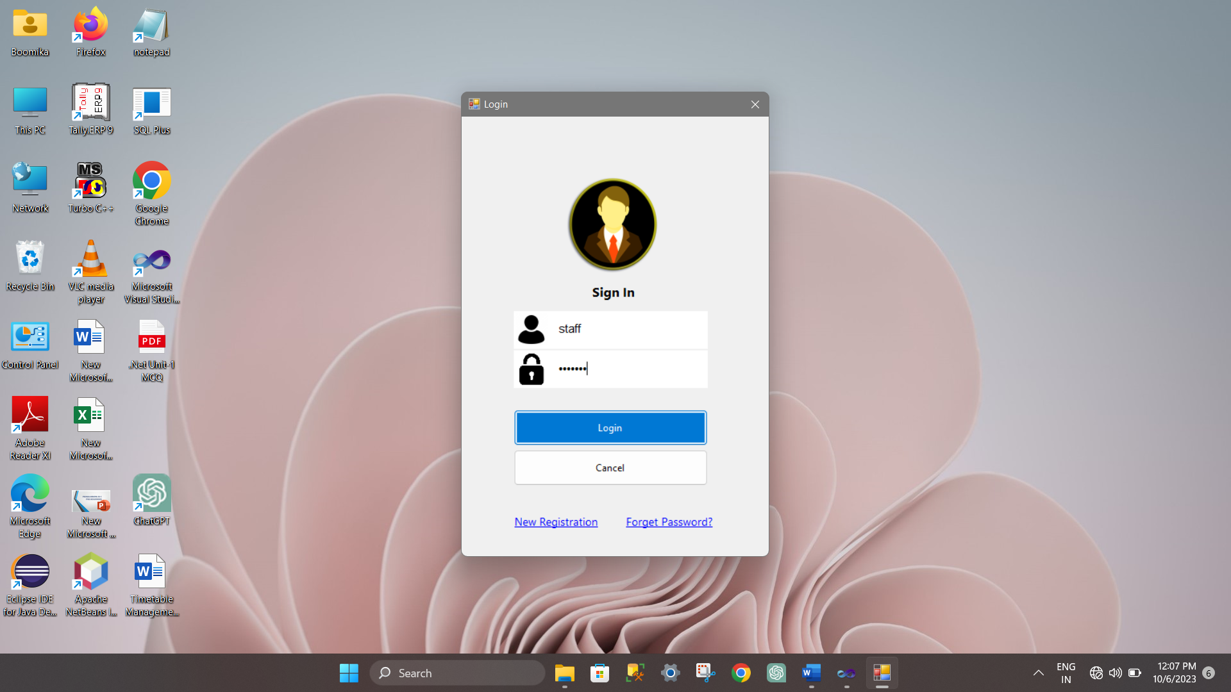

NEW USER REGISTRATION
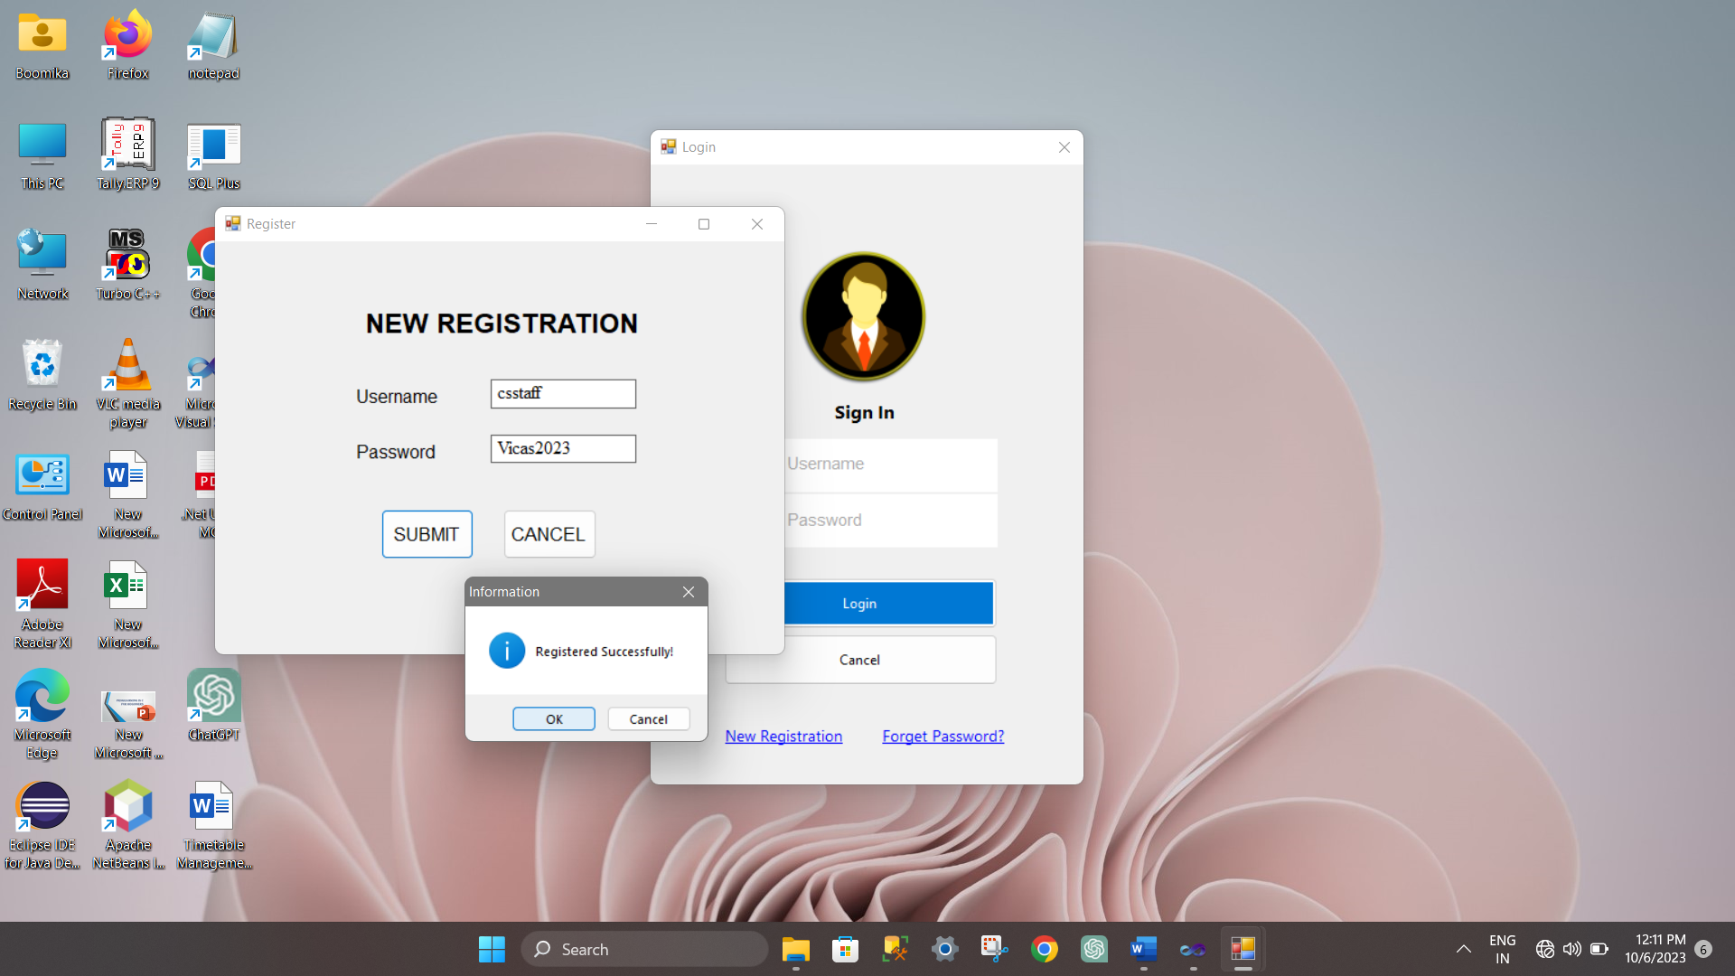

ADDING RECORDS
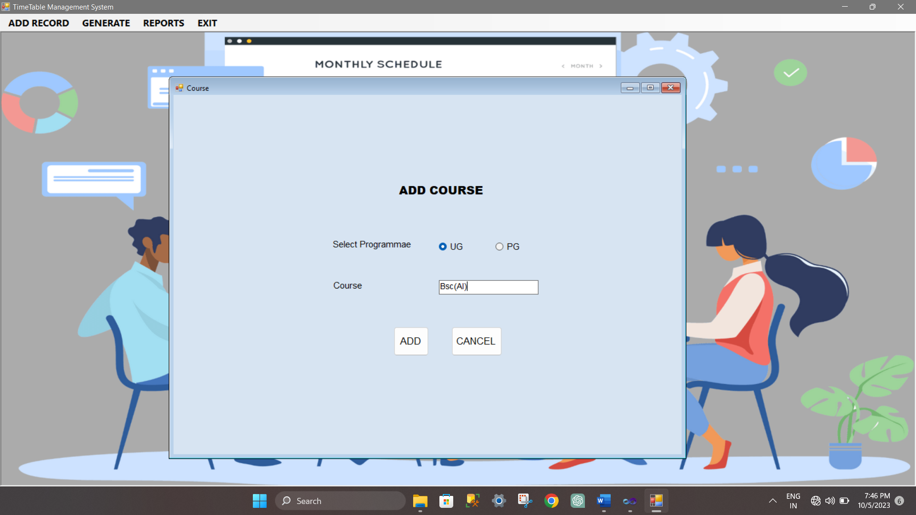

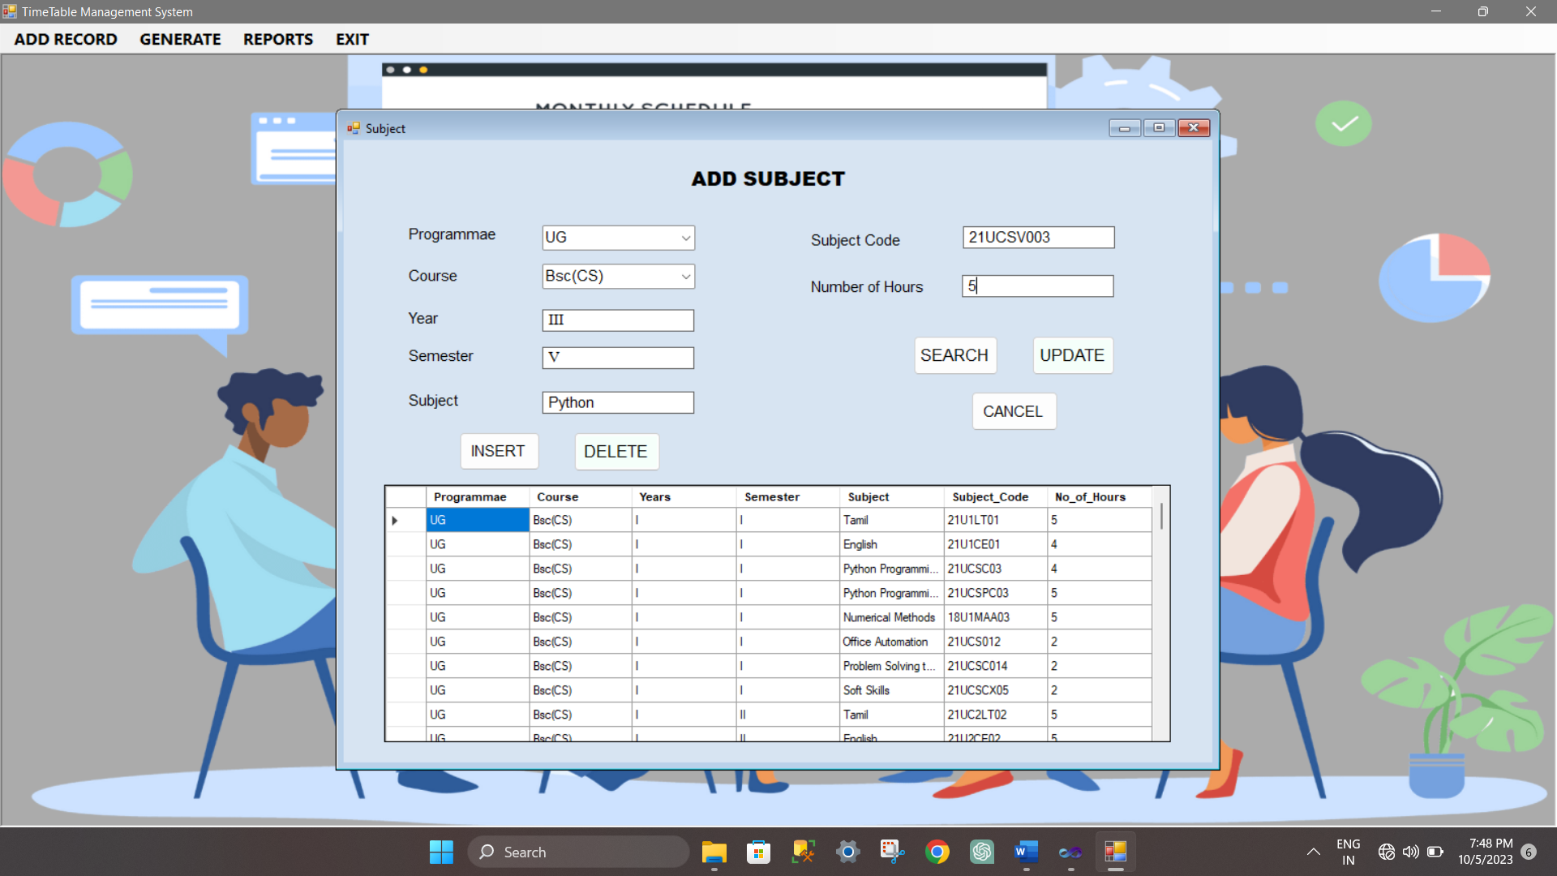

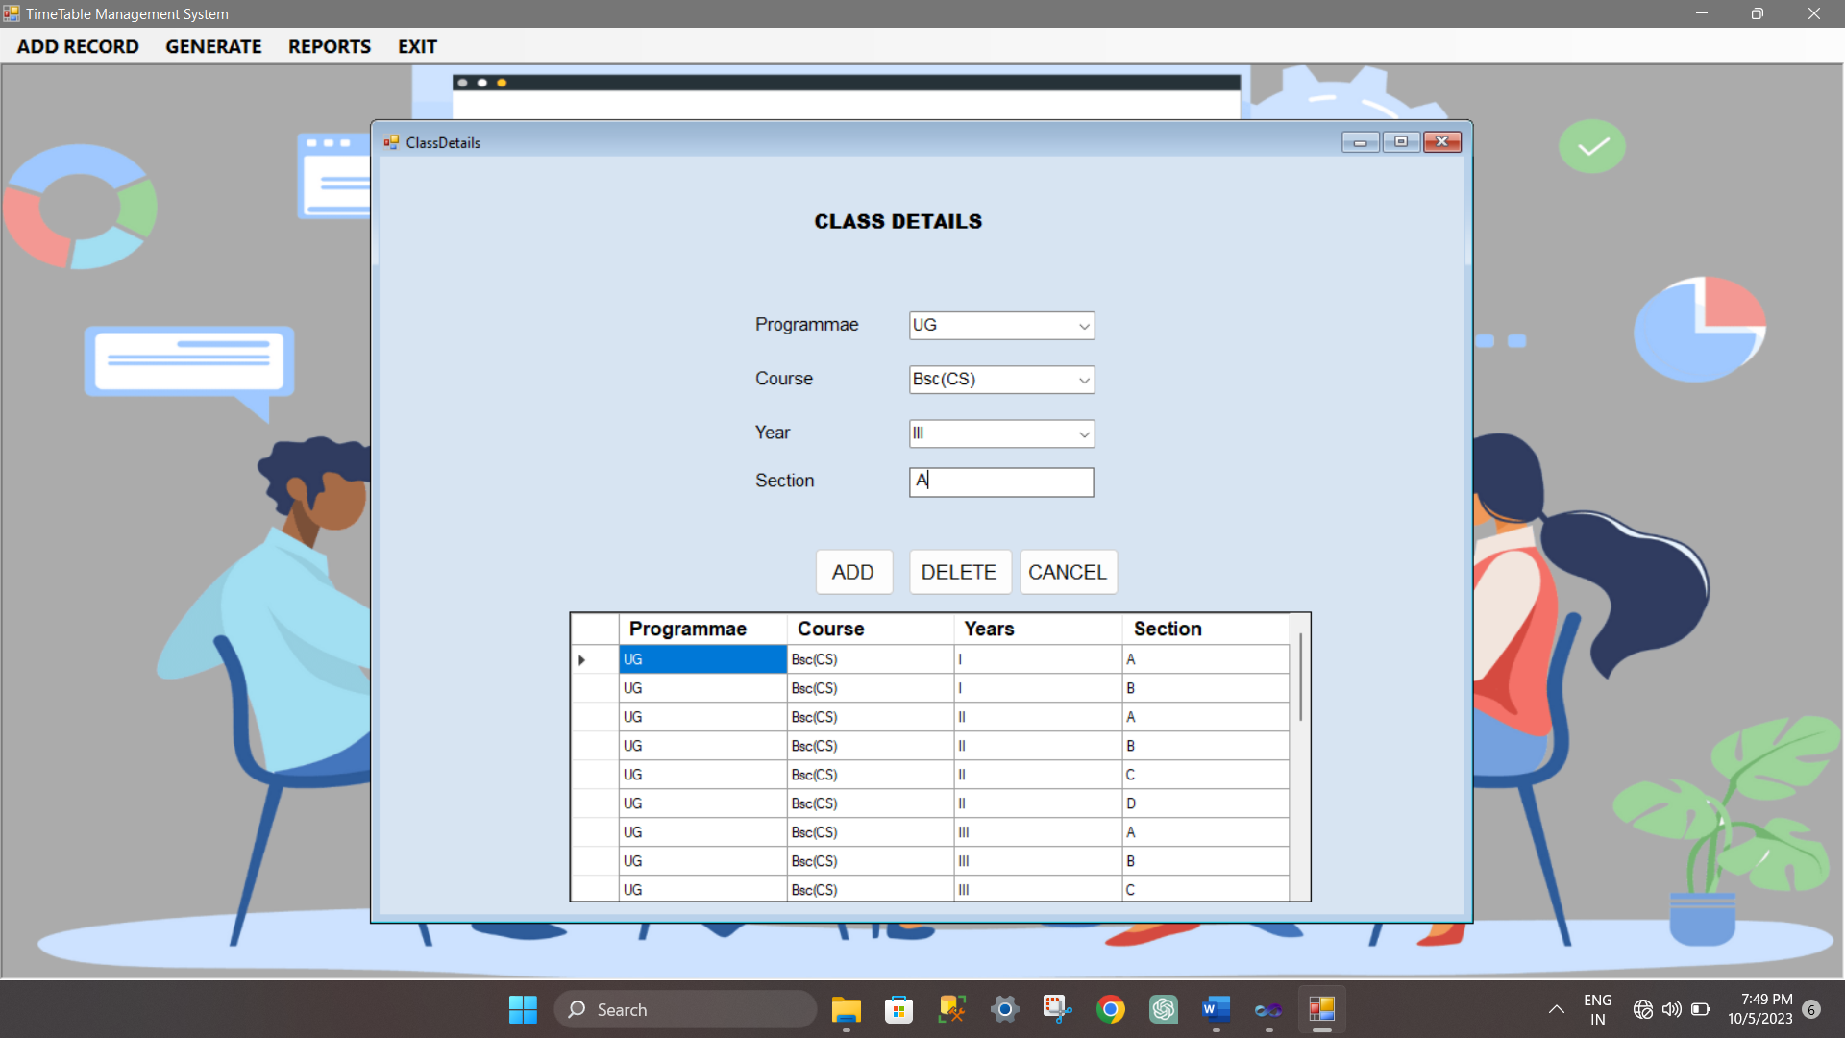

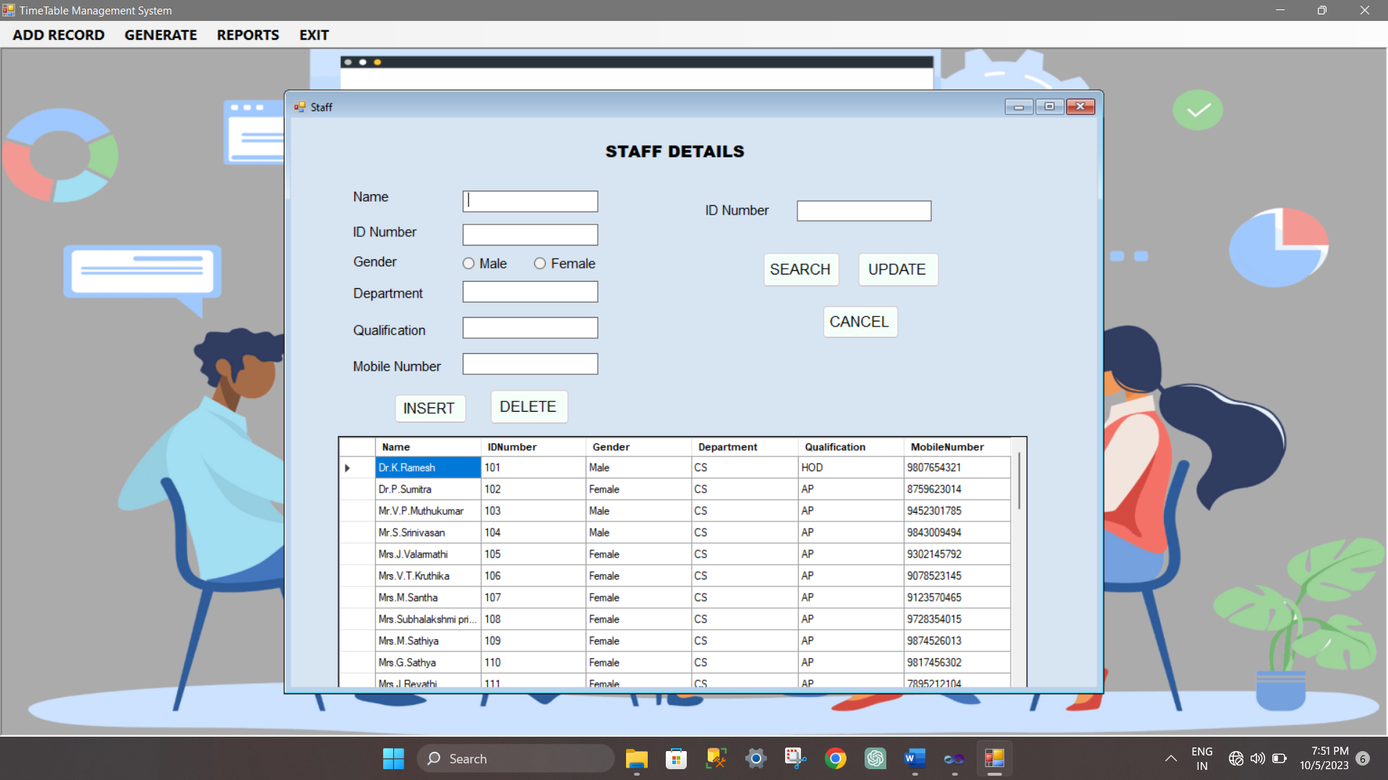

8.3 SAMPLE OUTPUT
GENERATE
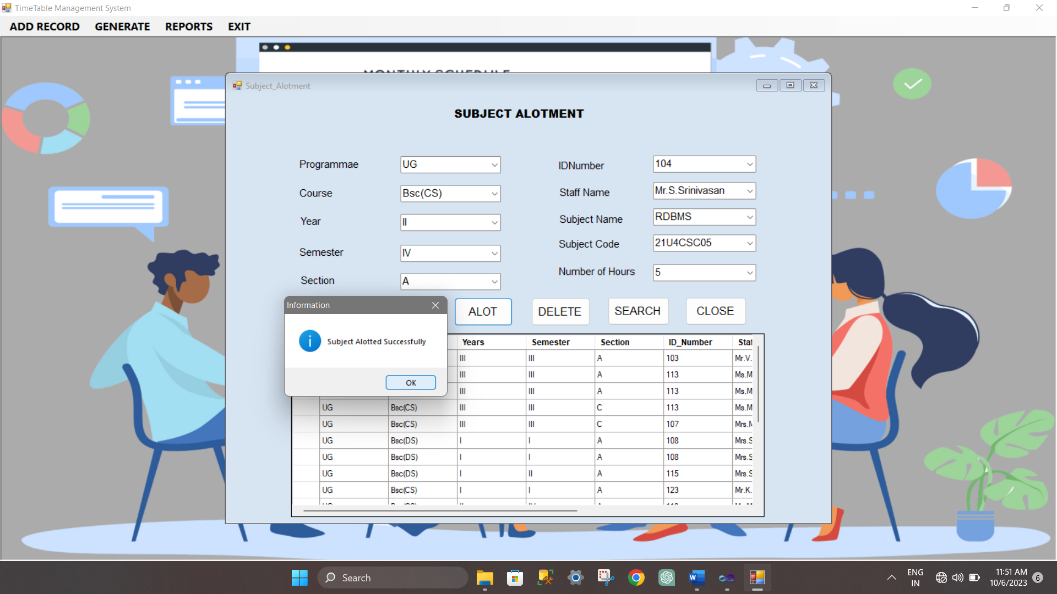

REPORT
