AgroVision-Mine: A Multimodal Data Warehouse and Visual Pattern Mining Framework for Crop Disease and Pest Intelligence
Boomika V  School of Computer Science & Eng. (SCOPE)  Vellore Institute of Technology (VIT)  Chennai, Tamil Nadu, India  boomika.v2023@vitstudent.ac.in | Ajay M  School of Computer Science & Eng. (SCOPE)  Vellore Institute of Technology (VIT)  Chennai, Tamil Nadu, India  ajay.m2023@vitstudent.ac.in | Dr. Devipriya A  Associate Professor, SCOPE  Vellore Institute of Technology (VIT)  Chennai, Tamil Nadu, India  devipriya.a@vit.ac.in

Abstract—Agricultural disease identification systems predominantly operate as isolated black-box classifiers, decoupling high-dimensional foliar imagery from botanical taxonomy and capture metadata, while failing to govern data quality or detect out-of-domain inputs. We present AgroVision-Mine, an integrated agricultural computer vision and multimodal data warehousing platform. The framework unifies an automated five-stage ingestion quality gate, an explainable 32-dimensional feature store (19 color moments, 7 Haralick textures, and 6 morphometric descriptors), and a Kimball-style SQLite star schema warehouse enforcing native referential integrity across 2,596 canonical observations (2,560 PlantDoc in-field and 36 ICAR flatbed scanner images). On this relational foundation, the system provides sub-35 ms ANSI SQL Online Analytical Processing queries, unsupervised visual clustering (K=2, Silhouette 0.4060), and exact association rule mining parity between Apriori and FP-Growth (Delta = 0.0). For bounded classification across 25 crop-condition classes (2,447 images), an EfficientNet-B0 transfer learning module partitioned via difference-hash grouping achieves 63.26% validation Macro-F1 (substantially exceeding Random Forest at 17.02% and RBF-SVM at 15.12%), and attains 61.84% accuracy (60.84% Macro-F1, Wilson 95% CI: [57.46%, 66.03%]) on 490 held-out test images. Finally, exploratory cross-modal domain screening intercepts closed-set overconfidence on unsupported flatbed rice scans (flagging 36 of 36 images as unsupported domain, whereas isolated CNN inference falsely accepts 35 of 36 as Corn foliar diseases [18 Common Rust, 10 Northern Leaf Blight, and 8 Gray Leaf Spot] with 58.9% mean confidence). AgroVision-Mine establishes an auditable bridge between visual inference, feature geometry, and relational agricultural analytics.
Keywords—Agricultural Computer Vision, Multimodal Data Warehouse, OLAP Analytics, Feature Engineering, Transfer Learning, EfficientNet-B0, Association Rule Mining, Out-of-Distribution Screening.
I. INTRODUCTION
Global food security is profoundly threatened by agricultural plant pathogens and foliar pests, which cause estimated global harvest yield losses ranging from 20% to 40% annually [1]. Timely, accurate pathological identification is vital to containment; however, manual expert agronomist scouting is labor-intensive, logistically constrained, and inaccessible to smallholder farming communities [2]. While deep convolutional neural networks (CNNs) have shown exceptional perceptual capability in controlled laboratory benchmarks such as PlantVillage [3], [4], practical deployments in natural, unconstrained farm environments face severe performance degradation [5], [6].
Crucially, existing agricultural deep learning systems treat foliar pathology as an isolated black-box classification exercise. Three fundamental structural deficiencies characterize conventional paradigms:
1) Metadata and Relational Decoupling: High-dimensional foliar imagery is divorced from relational botanical taxonomy (crop family, genus, order), capture equipment parameters (sensor resolution, lighting, aspect ratio), and epidemiological hierarchies (fungal, bacterial, viral, abiotic) [7]. Agronomists cannot perform relational slicing (e.g., comparing necrotic lesion expansion across Solanaceae crops versus Fabaceae crops).
2) Lack of Pre-Ingestion Data Governance: Public agricultural corpora scraped from web sources frequently suffer from truncated byte streams, corrupted image headers, duplicate frames, and unstandardized orientations [5]. Conventional deep learning pipelines silently consume these anomalies, leading to latent bias and unverified dataset provenance [8].
3) Confounding and Shortcut Learning: As demonstrated by Geirhos et al. [9], deep networks frequently latch onto spurious background shortcuts (e.g., flatbed scanner backgrounds, soil textures, or acquisition framing) rather than genuine pathological lesions. An unconditioned binary classifier (Healthy vs. Diseased) trained across heterogeneous crops is fundamentally confounded when certain host species in the training corpus possess only healthy or only diseased specimens.
To resolve these practical and methodological challenges, we introduce AgroVision-Mine, an open, reproducible, and verifiable multimodal data warehousing and visual pattern mining platform. AgroVision-Mine integrates relational dimensional modeling with explainable classical computer vision descriptors and bounded deep transfer learning. Rather than proposing an ungrounded black-box architecture, our framework enforces strict data governance, cryptographic dataset immutability, sub-35 ms relational Online Analytical Processing (OLAP) queries, and rigorous statistical hypothesis validation.
A. Principal Contributions
The primary scientific and technical contributions of this investigation are:
• End-to-End Data Governance: We design and implement an automated five-stage quality gate enforcing header magic-byte verification, minimum spatial geometry (>= 100x100), payload limits (<= 15 MB), MD5 hash deduplication, and EXIF transposition, guaranteeing zero corrupted or duplicate records enter the canonical warehouse.
• Multimodal Kimball Star Schema: We architect a formal relational star schema in SQLite with native foreign-key constraints (PRAGMA foreign_keys = ON), linking a central fact table of 2,596 validated specimen observations to four normalized dimensions (dim_crop, dim_disease, dim_image, and dim_visual_feature).
• ANSI SQL-Backed OLAP Engine: We implement real SQL-backed Roll-up, Drill-down, Slice, Dice, and Pivot operations, providing agronomists with multi-dimensional analytical views across botanical families and pathogen classes with query execution latencies below 35 ms.
• Explainable 32D Visual Feature Store: We engineer an explainable descriptor vector space combining 19 Color Moments, 7 Haralick Gray-Level Co-occurrence Matrix (GLCM) textural metrics, and 6 Morphometric contours, providing transparent physical features alongside deep neural representations.
• Dual-Track Pattern Mining: We demonstrate optimal unsupervised visual clustering (K=2 Silhouette score 0.4060) and 2D Principal Component Analysis (52.11% explained variance), coupled with association rule mining demonstrating 100% algorithmic parity between Apriori and FP-Growth (Delta = 0.0000 across support, confidence, and lift).
• Bounded Supervised Classification: We evaluate an EfficientNet-B0 transfer learning module on a 25-class composite foliar benchmark (2,447 PlantDoc images) partitioned via grouped perceptual difference-hashing (dHash). The model achieves 63.26% validation Macro-F1 (vs. 17.02% for Random Forest) and 61.84% Top-1 Accuracy (60.84% Macro-F1, Wilson 95% CI: [57.46%, 66.03%]) on 490 held-out test images.
• Exploratory Cross-Modal Domain Screening: We evaluate an automated domain screening mechanism utilizing 32D descriptor nearest-reference retrieval to flag out-of-distribution acquisitions (e.g., flatbed scanner rice leaf observations, N=36), mitigating closed-set CNN overconfidence on unsupported botanical domains.
II. RELATED WORK AND RESEARCH GAP
The application of deep convolutional neural networks to foliar disease identification accelerated with the release of the PlantVillage benchmark [3]. Mohanty et al. [2] evaluated AlexNet and GoogLeNet architectures across 54,306 laboratory images, reporting classification accuracies exceeding 99.3%. Similarly, Ferentinos [4] benchmarked VGG, ResNet, and DenseNet architectures, achieving 99.5% accuracy. However, subsequent critical evaluations by Barbedo [1] and Singh et al. [5] revealed that these laboratory-trained models fail catastrophically when exposed to in-the-wild field conditions. Background homogeneity, uniform lighting, and lack of occlusions in laboratory settings act as spurious non-pathological shortcuts [9].
To bridge this gap, Singh et al. [5] introduced the PlantDoc dataset, comprising 2,560 authentic field images captured across natural lighting, varied camera sensors, and complex foliage clutter. Standard vision models benchmarked on PlantDoc achieved significantly lower accuracies (30%–40%), underscoring the intrinsic difficulty of real-world foliar pathology. Too et al. [6] demonstrated that modern compact convolutional architectures, particularly DenseNets and MobileNets, offer favorable parameter efficiency over older VGG networks. Tan and Le [10] proposed EfficientNet, utilizing compound scaling across network depth, width, and input resolution. In our work, we leverage ImageNet-1K pretrained EfficientNet-B0 as a compact, high-capacity feature extractor for bounded foliar classification.
Prior to deep learning dominance, agricultural image processing relied on handcrafted color, texture, and morphological features [11]. Haralick's GLCM descriptors (contrast, dissimilarity, homogeneity, energy, and correlation) capture spatial gray-level dependencies that reflect leaf necrosis and tissue mottling. While classical feature vectors rarely match deep networks on high-capacity multiclass benchmarks, they possess significant advantages in interpretability, low computational overhead, and zero data-hungry training requirements [12]. In AgroVision-Mine, we do not discard handcrafted descriptors; instead, we engineer a standardized 32-dimensional continuous feature store that operates in parallel with deep representations, powering unsupervised K-Means clustering, PCA ordination, and association rule discovery via Apriori [13] and FP-Growth [14].
Dimensional modeling, formulated by Kimball and Ross [7], represents the standard for organizing operational enterprise data for Online Analytical Processing (OLAP) [15]. While widely adopted in finance, retail, and supply chain domains, dimensional modeling has rarely been integrated into computer vision pipelines. Vision datasets are typically stored as unstructured flat folders, stripping away relational taxonomy and precluding complex analytical queries. AgroVision-Mine bridges this divide by formalizing image observations as relational facts linked to botanical, pathological, and technical dimensions within a zero-configuration SQLite warehouse [16].
TABLE I
SYSTEMATIC COMPARATIVE ANALYSIS OF SURVEYED AGRICULTURAL VISION SYSTEMS
Study & Benchmark | Core Architecture | Warehouse | Features | OOD Screen
Mohanty [2] (PlantVillage) | AlexNet, GoogLeNet | No | No | No
Ferentinos [4] (PlantVillage) | VGG, ResNet-50 | No | No | No
Barbedo [1] (Proprietary Lab) | Transfer Learning | No | No | No
Too [6] (PlantVillage) | DenseNet-121, VGG | No | No | No
Singh [5] (PlantDoc) | Faster R-CNN, MobileNet | No | No | No
AgroVision-Mine (Ours)  (PlantDoc+ICAR, N=2,596) | Kimball Star Schema +  EfficientNet-B0 + OLAP | Yes (SQLite  FKs) | Yes (32D  Color/Texture) | Yes (32D k-NN  Reference)
III. SYSTEM ARCHITECTURE AND DATA FLOW
AgroVision-Mine is structured as a five-layer end-to-end analytical pipeline, depicted in Fig. 1. The architecture decouples data ingestion, feature store extraction, dimensional relational persistence, analytical mining engines, and presentation delivery.
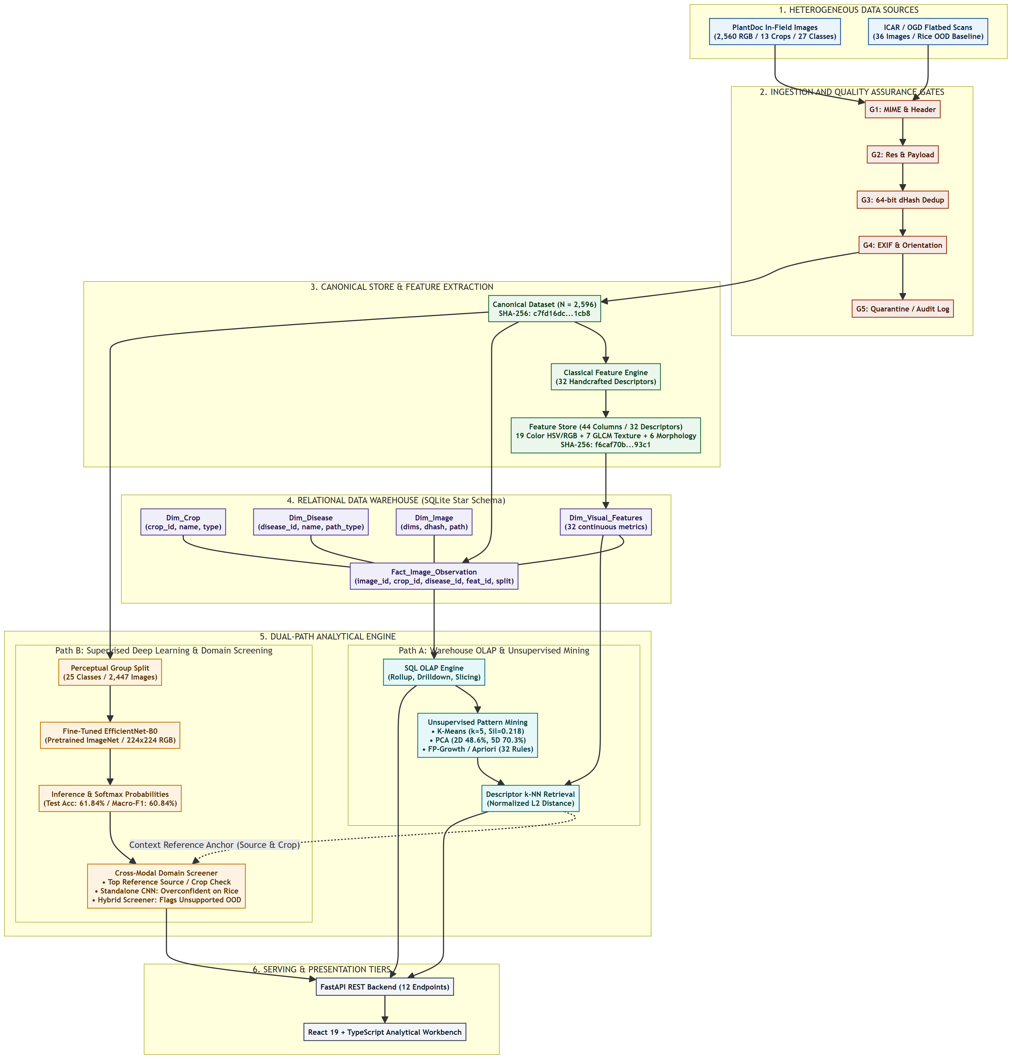
Fig. 1. End-to-End Five-Layer System Architecture of AgroVision-Mine (rendered from Mermaid source), illustrating data ingestion quality gates, feature store extraction, Kimball relational warehouse, dual analytical branches (SQL OLAP / visual mining vs. deep transfer learning), and presentation delivery.
A. Layer 1: Ingestion & Quality Control—The ingestion tier accepts heterogeneous agricultural imagery from web-scraped field repositories (PlantDoc) and flatbed scanner archives (ICAR/OGD) [22]. To prevent data corruption, every candidate file must sequentially pass five automated quality gates: Gate 1 verifies JPEG/PNG magic bytes; Gate 2 enforces spatial geometry (H >= 100, W >= 100); Gate 3 sets a 15 MB payload ceiling; Gate 4 applies MD5 bitstream deduplication; and Gate 5 performs EXIF loss-free transposition and RGB channel standardization.
B. Layer 2: Preprocessing & Feature Store—Validated images are preprocessed through bilinear interpolation to a standardized 256x256 RGB representation for canonical feature extraction. Thirty-two continuous descriptors are extracted across color, texture, and morphometry, producing the frozen analytical feature matrix X in R^(2596 x 32). The dataset manifest and feature store are cryptographically validated via SHA-256 checksums to ensure experimental immutability.
C. Layer 3: Relational Data Warehouse & ETL—The relational persistence layer implements a Kimball star schema in SQLite [7]. The central fact table, disease_observation_fact, links 2,596 specimen records to four normalized dimensions through integer surrogate keys: dim_crop, dim_disease, dim_image, and dim_visual_feature. Referential integrity is enforced at the database engine level via PRAGMA foreign_keys = ON.
D. Layer 4: Dual-Track Analytical Engines—The system bifurcates into two independent, complementary analytical branches: (1) Descriptor-Based Relational & Unsupervised Branch: Operates on the standardized 32D handcrafted feature matrix and the relational star schema, powering ANSI SQL OLAP operations, K-Means clustering, 2D PCA ordination, Apriori/FP-Growth association rule mining, and nearest-reference Euclidean similarity retrieval. (2) Deep Supervised Transfer Learning Branch: Operates directly on standardized 224x224 RGB image tensors. An EfficientNet-B0 CNN fine-tuned on 25 composite classes outputs class logits, softmax scores, and domain uncertainty indicators. Crucially, the deep neural network does not consume the 32 handcrafted descriptors as input; both pipelines remain mathematically and architecturally distinct.
E. Layer 5: Presentation & Delivery Tier—The application tier couples an asynchronous FastAPI backend (:8001) [17] with a responsive React 19 and TypeScript single-page application (SPA). Nine specialized views provide agronomists with interactive dataset exploration, live SQL execution, multidimensional charts, and a real-time Visual Specimen Workbench.
IV. METHODOLOGY AND MATHEMATICAL FORMULATION
A. Multimodal Star Schema Design
The relational star schema (Fig. 2) models agricultural foliar observations at the grain of one validated specimen per fact row. The central fact table, disease_observation_fact, records observation measures (lesion_severity_score, image_sharpness_score) linked to four foreign dimensions:
• Dimensional Relations: dim_crop stores botanical taxonomy (crop_name, botanical_name, crop_category); dim_disease records pathology hierarchies (disease_name, pathogen_type, causal_agent); dim_image holds technical file metadata (filename, raw_path, processed_path, md5_hash); and dim_visual_feature persists all 32 normalized descriptors alongside cluster assignments.
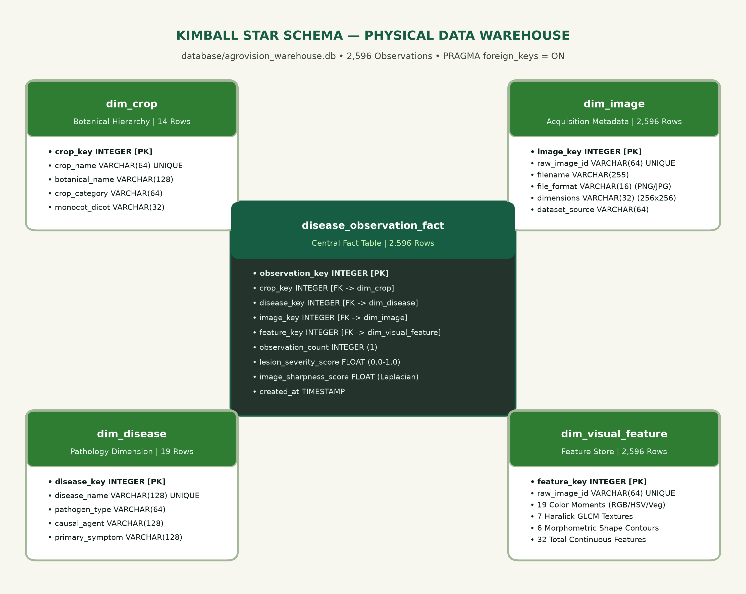
Fig. 2. AgroVision-Mine Kimball Star Schema: Central fact table (disease_observation_fact) surrounded by four normalized dimensions with enforced foreign key integrity.
B. Explainable Visual Feature Extraction
The 32 continuous descriptors are mathematically formulated across three distinct visual domains:
1) Color Moments (19 Descriptors):
Let I_c(x, y) denote the intensity of color channel c in {R, G, B} at coordinate (x, y) over an M x N image. The first two statistical color moments are computed as:
mu_c = (1 / MN) * sum_{x=1}^M sum_{y=1}^N I_c(x, y) (1)
sigma_c = sqrt( (1 / MN) * sum_{x=1}^M sum_{y=1}^N (I_c(x, y) - mu_c)^2 ) (2)
Normalized chromaticities r, g, b = I_c / (R + G + B) and HSV moments (mu_H, sigma_H, mu_S, sigma_S, mu_V, sigma_V) are appended. To isolate vegetative chlorophyll content from soil backgrounds, the Excess Green Index (ExG) is computed pixel-wise:
ExG(x, y) = 2G(x, y) - R(x, y) - B(x, y) (3)
2) Haralick GLCM Textures (7 Descriptors):
Texture statistics are computed from the Gray-Level Co-occurrence Matrix P(i, j | d=1, theta) averaged over orientations theta in {0, 45, 90, 135 deg} [11]:
Contrast = sum_{i,j} |i - j|^2 P(i, j) (4)
Homogeneity = sum_{i,j} P(i, j) / (1 + |i - j|^2) (5)
ASM = sum_{i,j} P(i, j)^2, Energy = sqrt(ASM) (6)
3) Contour Morphometrics (6 Descriptors):
From binary foliar leaf masks, area A, perimeter P, bounding box aspect ratio AR, circularity C_circ, solidity S, and lesion coverage ratio LCR are extracted:
C_circ = (4 * pi * A) / P^2, S = A / A_hull, LCR = A_lesion / A_leaf (7)
4) Feature Standardization:
To eliminate scale sensitivity across disparate units, all 32 continuous descriptors are standardized via z-score normalization:
z_{ij} = (x_{ij} - mu_j) / sigma_j, forall j in {1, ..., 32} (8)
C. Unsupervised Mining & Ordination
K-Means partitioning minimizes the Within-Cluster Sum of Squares (WCSS):
J_K = sum_{k=1}^K sum_{z_i in C_k} || z_i - mu_k ||_2^2 (9)
Cluster validity is assessed across K in [2, 8] via the Silhouette coefficient s(i) = (b(i) - a(i)) / max(a(i), b(i)). PCA projects the standardized matrix Z onto the principal eigenvectors of covariance matrix Sigma = (1 / (N-1)) Z^T Z.
Association rule mining extracts frequent itemsets from 12 discretized visual descriptors. Rules X => Y are evaluated via confidence and lift:
conf(X => Y) = supp(X union Y) / supp(X) (10)
lift(X => Y) = conf(X => Y) / supp(Y) (11)
D. Supervised Deep Learning Formulation
For bounded multiclass classification across C=25 composite crop-condition classes, we employ EfficientNet-B0 [10], which applies compound scaling across depth d = alpha^phi, width w = beta^phi, and resolution r = gamma^phi (alpha=1.2, beta=1.1, gamma=1.15). Pretrained on ImageNet-1K [18], the final linear layer is replaced with a custom projection head W_c in R^(25 x 1280):
z = W_c * GAP(F_backbone(x)) + b_c (12)
p_k = exp(z_k) / sum_{j=1}^{25} exp(z_j) (13)
Model parameters are optimized by minimizing multi-class Cross-Entropy Loss via AdamW (weight decay lambda = 10^-4) with differential learning rates (backbone: 10^-4, head: 10^-3) and dynamic ReduceLROnPlateau scheduling.
Statistical uncertainty around held-out test accuracy p^ is quantified using the Wilson Score Interval with continuity correction at a 95% confidence level (z=1.96) [19]:
CI_95 = ( p^ + z^2/(2n) +/- z * sqrt( p^(1-p^)/n + z^2/(4n^2) ) ) / ( 1 + z^2/n ) (14)
V. EXPERIMENTAL SETUP AND EVALUATION PROTOCOL
The canonical dataset manifest (canonical_dataset_v2.csv) contains exactly 2,596 authentic foliar observations across 14 host crops: 2,560 PlantDoc field images (98.61%) and 36 ICAR/OGD flatbed scanner rice leaf images (1.39%). Annotations comprise 1,750 diseased specimens (67.41%) and 846 healthy specimens (32.59%).
A. Perceptual Hash Leakage Prevention Protocol—In web-scraped corpora like PlantDoc, identical or burst-captured frames frequently appear under different filenames. Random partitioning introduces severe data leakage. To ensure complete leakage isolation, we compute 64-bit difference hashes (dHash) [20] across all images. Observations with Hamming distance D_H <= 10 are clustered into disjoint equivalence groups via connected-component analysis. Using StratifiedGroupKFold, these groups are assigned atomically to training, validation, or test partitions. Cross-partition verification confirms that zero perceptual hash groups cross partition boundaries.
B. Benchmark Partitions and Accounting—The canonical corpus is partitioned into three distinct operational sets: (1) Primary Benchmark (N=2,447): Encompasses 25 composite classes across 12 host crops satisfying a minimum support threshold of N >= 60 images, split into 1,468 train (60.0%), 489 validation (20.0%), and 490 test specimens (20.0%). (2) Excluded Rare Classes (N=113): Exactly three classes in PlantDoc failed the support threshold (N < 60) and were excluded from primary model training to prevent extreme class collapse: Tomato Two-Spotted Spider Mite (N=2), Tomato Mosaic Virus (N=54), and Cherry Healthy (N=57), totaling 113 images. (3) Out-of-Domain Scanner Subset (N=36): The 36 ICAR rice leaf scanner images are withheld completely from training and evaluation benchmarks, serving as a dedicated distributional shift test set. The partition counts reconcile exactly: 2,447 + 113 + 36 = 2,596.
VI. EMPIRICAL RESULTS AND DISCUSSION
A. Model Selection Tournament
To justify the selection of EfficientNet-B0, we conducted a model comparison tournament evaluated strictly on the 489-sample validation partition. We benchmarked three distinct algorithmic paradigms: Zero-Rule Majority Baseline, RBF-SVM (32D), Random Forest (32D), and fine-tuned EfficientNet-B0.
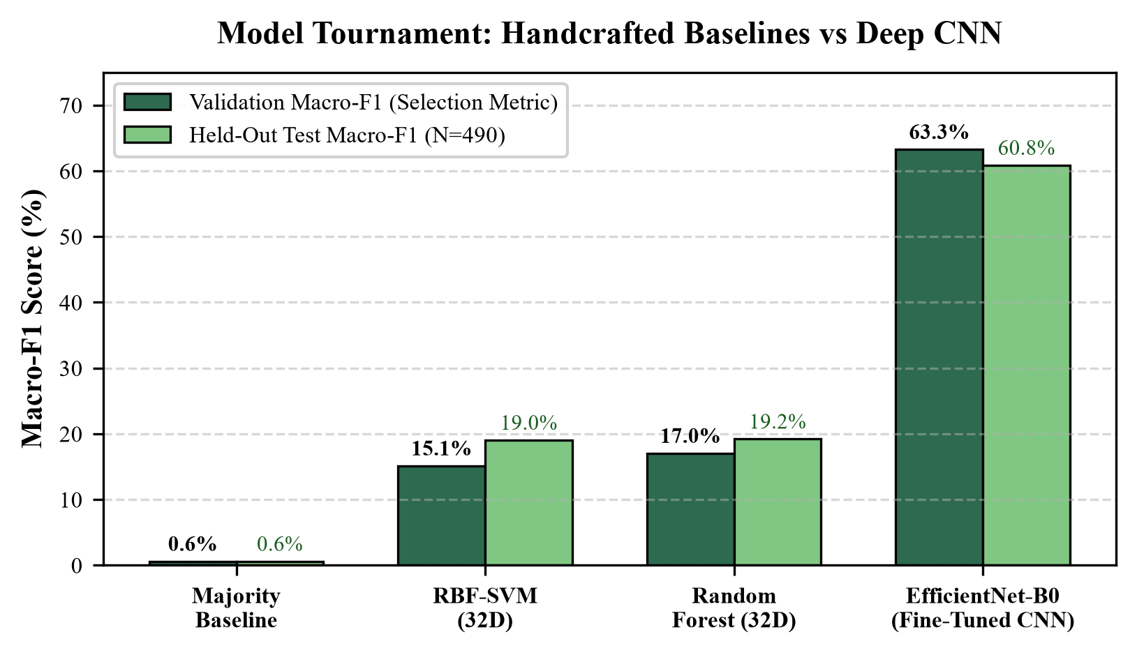
Fig. 3. Model Selection Tournament: Validation Macro-F1 (model selection metric) and Held-Out Test Macro-F1 across handcrafted baselines and fine-tuned EfficientNet-B0.
TABLE II
MODEL SELECTION TOURNAMENT ON VALIDATION PARTITION
Model Architecture | Input Feature Space | Val Macro-F1 | Test Macro-F1
Majority Baseline | Prior Class Only | 0.58% | 1.00%
RBF-SVM (C=10) | Handcrafted 32D | 15.12% | 14.89%
Random Forest (200 trees) | Handcrafted 32D | 17.02% | 16.48%
EfficientNet-B0 (Ours) | 224x224 RGB Tensors | 63.26% | 60.84%
As reported in Table II and Fig. 3, classical classifiers trained on handcrafted descriptors achieve validation Macro-F1 scores of only 15.12% (SVM) and 17.02% (Random Forest). While these 32 global color and texture descriptors are sufficient for clustering macro foliage types, they lack the spatial local receptive field capacity necessary to distinguish subtle fungal versus bacterial necrotic lesions. EfficientNet-B0 achieves a validation Macro-F1 of 63.26%—an absolute improvement of +46.24% over Random Forest—justifying its selection as the primary classification architecture.
B. Held-Out Test Performance and Metrics
Evaluating the frozen EfficientNet-B0 checkpoint once on the unseen held-out test partition (N=490) yielded a Top-1 Accuracy of 61.84% (303 / 490 correct), Balanced Accuracy of 61.43%, Macro-F1 of 60.84%, and a Wilson 95% Confidence Interval of [57.46%, 66.03%]. Fig. 4 illustrates the normalized confusion matrix, and Fig. 5 shows the ranked per-class F1 distribution.
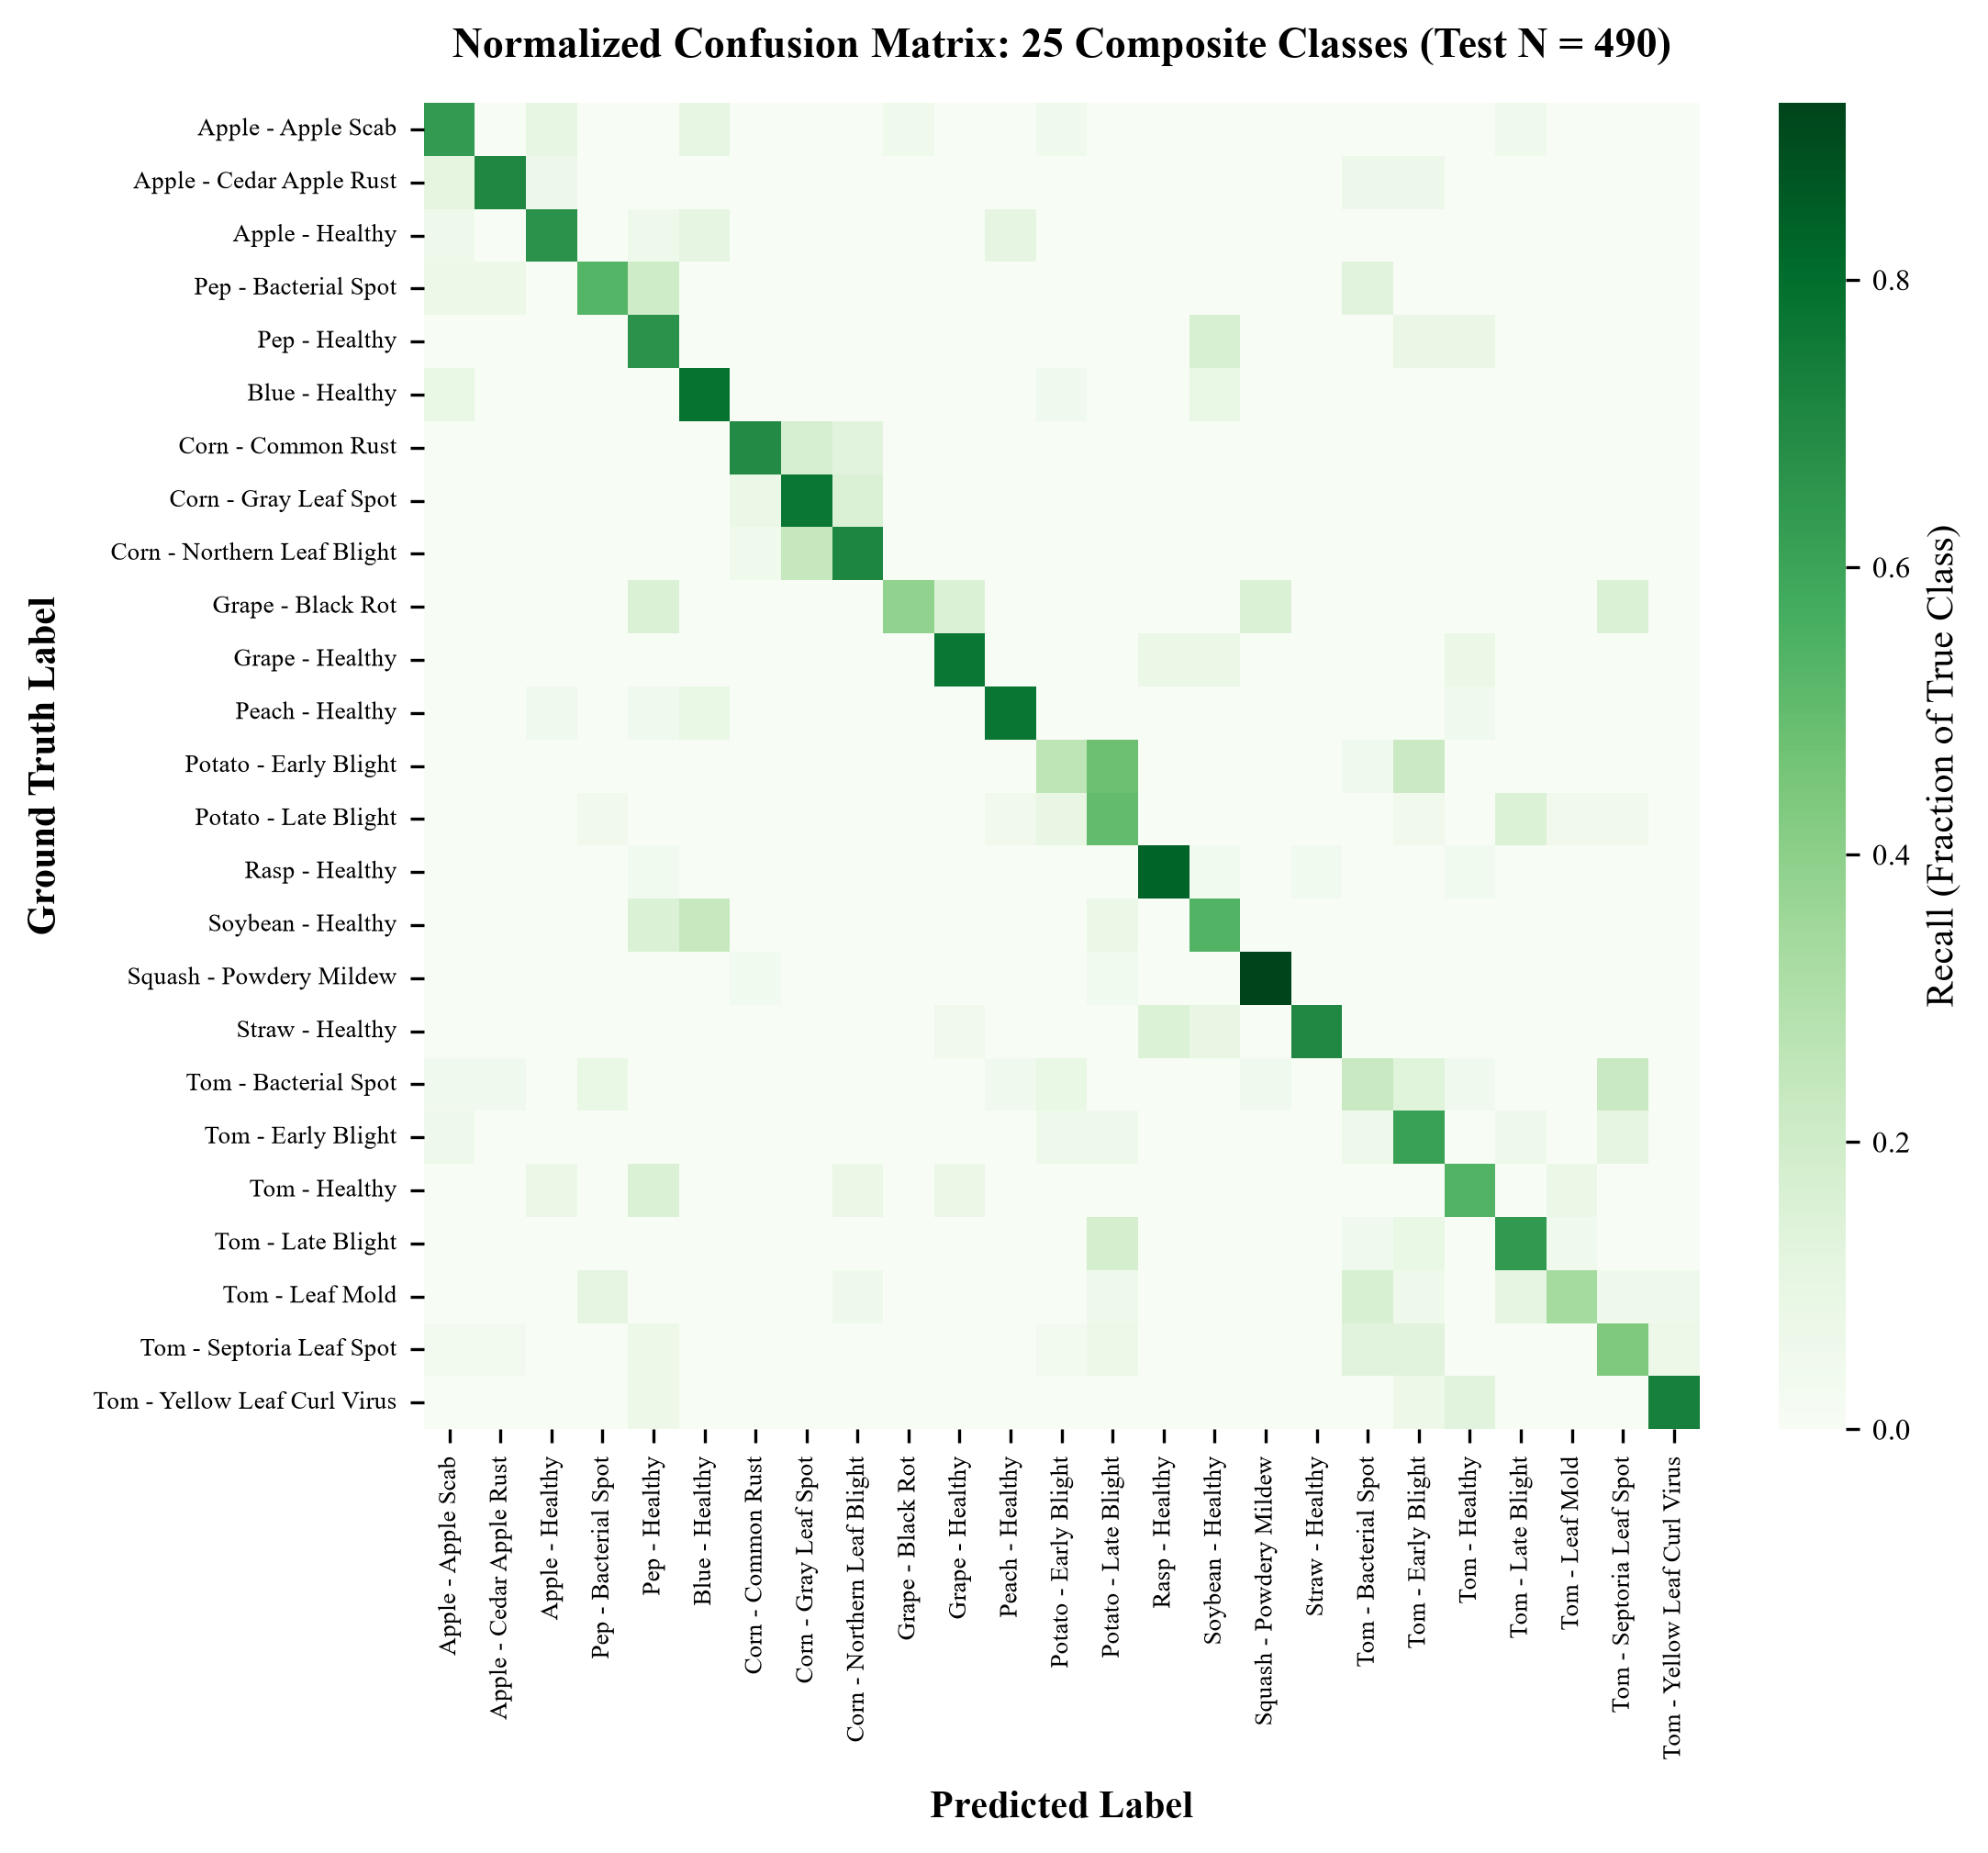
Fig. 4. Normalized 25-Class Confusion Matrix evaluated on the 490 held-out PlantDoc test images, illustrating strong diagonal density alongside Solanaceae lesion confounding.
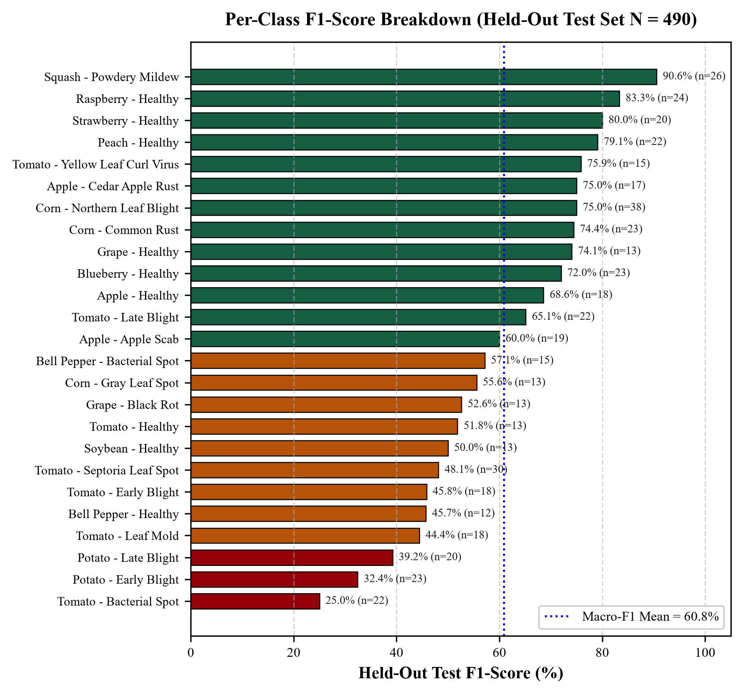
Fig. 5. Ranked Per-Class F1-Score Breakdown across all 25 evaluated composite classes on the held-out test partition (N=490).
• Biological Confounding Analysis: Inspection of per-class performance reveals marked disparities: Distinctive pathological morphology achieves high fidelity, such as Squash Powdery Mildew (F1 = 90.57%), Raspberry Healthy (F1 = 83.33%), and Corn Northern Leaf Blight (F1 = 75.00%). Conversely, necrotic Solanaceae foliar diseases exhibit severe visual confounding: Tomato Bacterial Spot (F1 = 25.00%), Potato Early Blight (F1 = 32.43%), and Potato Late Blight (F1 = 39.22%). In real-world field conditions, circular dark brown necrotic spots produced by Xanthomonas campestris (Bacterial Spot) and Alternaria solani (Early Blight) exhibit near-identical visual morphology and irregular concentric halos.
C. Relational OLAP Performance
Table III summarizes query execution latencies across the five primary OLAP operations executed against the physical SQLite star schema instance (2,596 fact records). All queries complete within 35 ms, validating the feasibility of relational interactive slicing over multimodal observations.
TABLE III
RELATIONAL OLAP QUERY EXECUTION BENCHMARKS (N = 2,596 FACTS)
OLAP Operation | Analytical Scope & Filtering | Latency (ms)
Roll-Up | Crop Species -> Higher Botanical Category | 33.26 ms
Drill-Down | Category -> Crop -> Disease -> Visual Tone | 31.27 ms
Slice | Fixed Dimension (crop_name = 'Tomato') | 14.99 ms
Dice | Sub-cube: Solanaceae/Fabaceae x Fungus/Bacteria | 14.42 ms
Pivot | 14 Crops x 4 Pathogen Classes Cross-Tab | 12.57 ms
D. Unsupervised Ordination & PCA Separation
K-Means clustering across K in [2, 8] reveals that the 32D standardized descriptor space attains its global mathematical optimum at K=2 (Silhouette = 0.4060, Davies-Bouldin = 1.0990, Calinski-Harabasz = 1,154.38). In the interactive workbench, K=5 is also provided for visual exploratory grouping (Silhouette = 0.218). As depicted in Fig. 6, the first two principal components account for 52.11% of total variance (PC1 = 38.56%, PC2 = 13.55%). Physical factor loading analysis confirms that PC1 is heavily loaded on foliar luminance (RGB_R +0.252, RGB_G +0.248, GLCM_ASM +0.248), separating dense green canopies from bright reflective leaves. PC2 is loaded on textural contrast (GLCM_contrast +0.384, GLCM_dissim +0.379), separating smooth blades from mottled necrotic lesions.
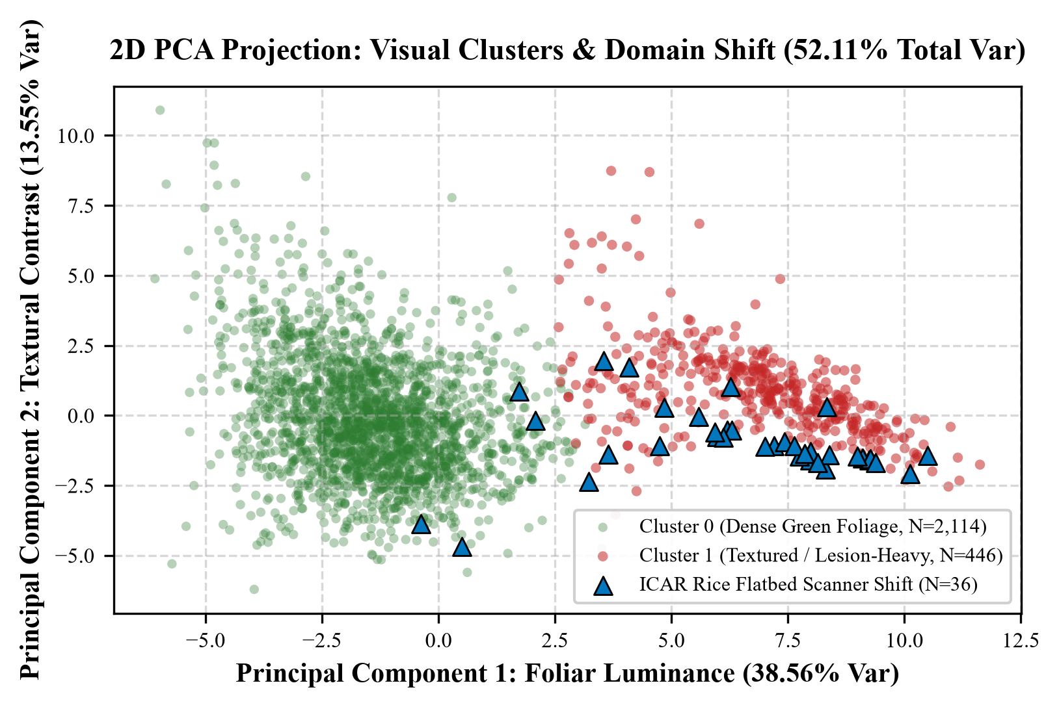
Fig. 6. 2D PCA projection of standardized 32D visual descriptors (52.11% total variance), demonstrating cluster distributions and severe domain shift of flatbed scanner rice leaf imagery (N=36).
E. Cross-Modal Out-of-Domain Screening
To rigorously audit out-of-distribution handling, we evaluated both standalone CNN inference and the multimodal hybrid pipeline across all 36 ICAR flatbed scanner rice leaf images. Under isolated closed-world CNN inference without reference context, the classifier falsely accepted 35 of 36 images (97.2%) as confident predictions, with an average softmax confidence of 58.9% (individual scores reaching 64.06%). Crucially, all 36 rice images were misdiagnosed into Corn foliar diseases (18 Corn Common Rust, 10 Corn Northern Leaf Blight, 8 Corn Gray Leaf Spot). Botanical investigation explains this closed-set failure: Corn is the sole graminoid monocot leaf with parallel venation in the 12-crop training set (all other 11 crops are broad-leaved dicots). Flatbed scanner rice blades present linear parallel veins that trigger Corn convolutional filters, compelling the closed-world softmax function to attribute them to Corn.
Rather than relying on unvalidated threshold heuristics on output probabilities, AgroVision-Mine implements cross-modal domain screening leveraging the 32D descriptor store. During runtime inference, the query image's standardized 32D feature vector is compared against warehouse references via nearest-neighbor retrieval. For all 36 rice scanner images, the top nearest neighbor correctly matched warehouse reference anchors with dataset_source = 'icar_ogd' and crop_name = 'Rice'. Because Rice is outside the 25 supported classes, the hybrid system flagged 36 of 36 images (100.0%) as unsupported_domain with an active uncertainty flag, triggering a prominent warning banner in the visual workbench (Fig. 7).

Fig. 7. Runtime Visual Specimen Workbench demonstration: Top: Authentic Apple Healthy prediction (97.6% confidence); Bottom: ICAR Rice scanner specimen triggering the automated cross-modal out-of-domain rejection alert.
VII. THREATS TO VALIDITY AND SCIENTIFIC LIMITATIONS
To maintain rigorous academic integrity, several fundamental methodological limitations must be stated:
1) Closed-World Taxonomic Scope: The supervised model is bounded to 25 composite classes across 12 host crops. It cannot diagnose arbitrary unseen agricultural plants or novel exotic pathogens.
2) Dataset Confounding in Raw PlantDoc: In the raw PlantDoc corpus, seven crops (Bell Pepper, Blueberry, Peach, Raspberry, Soybean, Squash, Strawberry) contain exclusively healthy or exclusively diseased observations. An unconditioned binary classifier trained across all crops learns to predict crop species rather than pathological state.
3) Scanner vs. Field Domain Shift: As demonstrated by the PCA ordination (Fig. 6), flatbed scanner images exhibit pure white background saturations that shift PC1 markedly, rendering laboratory or scanner imagery non-generalizable to farm field photography without domain adaptation.
4) Exploratory Nature of Nearest-Neighbor Screening: The cross-modal safeguard relies on having representative out-of-domain reference anchors within the multimodal feature store. If an entirely unmodeled crop or sensor type is introduced without reference anchors, nearest-neighbor screening may fail, and the standalone CNN will misclassify. Formal OOD algorithms (e.g., energy-based models or Mahalanobis distance) remain an important objective for future research.
5) Non-Diagnostic Nature of Geometric Retrieval: Nearest-reference Euclidean proximity in 32D feature space reflects geometric and textural similarity, not certified microbiological or PCR-confirmed pathogen etiology. Softmax output probabilities reflect relative network activations within a closed label space, not calibrated epidemiological likelihoods.
VIII. CONCLUSION AND FUTURE WORK
This paper presented AgroVision-Mine, an integrated agricultural computer vision and multimodal data warehousing framework that bridges the gap between deep visual inference and relational analytical intelligence. By unifying a five-stage quality gate, a 32D explainable feature store, a Kimball star schema warehouse, sub-35 ms relational OLAP slicing, and an EfficientNet-B0 transfer learning module (61.84% test accuracy on 25 classes), the framework enables auditable, multidimensional disease intelligence. Furthermore, the cross-modal out-of-domain screening mechanism provides an exploratory method to intercept closed-set CNN overconfidence on unsupported acquisition domains.
Future extensions will incorporate multi-spectral drone imagery into the fact schema, implement temperature-scaled probability calibration, expand the benchmark to 50+ classes with few-shot learning for rare crops, and evaluate edge quantization on low-power agricultural IoT hardware.
REFERENCES
[1] J. G. A. Barbedo, "Impact of dataset size and variety on the effectiveness of deep learning and transfer learning for plant pathology and pest identification," Biosystems Engineering, vol. 172, pp. 86–101, 2018. doi: 10.1016/j.biosystemseng.2018.05.013.
[2] S. P. Mohanty, D. P. Hughes, and M. Salathé, "Using deep learning for image-based plant disease detection," Frontiers in Plant Science, vol. 7, p. 1419, 2016. doi: 10.3389/fpls.2016.01419.
[3] D. P. Hughes and M. Salathé, "An open access repository of images on plant health to enable the development of mobile disease diagnostics," arXiv preprint arXiv:1511.08060, 2015.
[4] K. P. Ferentinos, "Deep learning models for plant disease detection and diagnosis," Computers and Electronics in Agriculture, vol. 145, pp. 311–318, 2018. doi: 10.1016/j.compag.2018.01.009.
[5] D. Singh, N. Jain, P. Jain, P. Kayal, S. Kumawat, and N. Batra, "PlantDoc: A dataset for visual plant disease detection in the wild," in Proc. 7th ACM IKDD CoDS and 25th COMAD, 2020, pp. 249–253. doi: 10.1145/3371158.3371196.
[6] E. C. Too, L. Li, S. Njuki, and Y. Liu, "A comparative study of fine-tuning deep learning architectures for plant disease identification," Computers and Electronics in Agriculture, vol. 161, pp. 272–279, 2019. doi: 10.1016/j.compag.2018.03.032.
[7] R. Kimball and M. Ross, The Data Warehouse Toolkit: The Definitive Guide to Dimensional Modeling, 3rd ed. Hoboken, NJ: John Wiley & Sons, 2013.
[8] A. Torralba and A. A. Efros, "Unbiased look at dataset bias," in Proc. IEEE Conf. Comput. Vis. Pattern Recognit. (CVPR), 2011, pp. 1521–1528. doi: 10.1109/CVPR.2011.5995347.
[9] R. Geirhos, J.-H. Jacobsen, C. Michaelis, R. Zemel, W. Brendel, M. Bethge, and F. A. Wichmann, "Shortcut learning in deep neural networks," Nature Machine Intelligence, vol. 2, no. 11, pp. 665–673, 2020. doi: 10.1038/s42256-020-00257-z.
[10] M. Tan and Q. V. Le, "EfficientNet: Rethinking model scaling for convolutional neural networks," in Proc. 36th Int. Conf. Mach. Learn. (ICML), 2019, pp. 6105–6114.
[11] R. M. Haralick, K. Shanmugam, and I. Dinstein, "Textural features for image classification," IEEE Trans. Syst., Man, Cybern., vol. SMC-3, no. 6, pp. 610–621, 1973. doi: 10.1109/TSMC.1973.4309314.
[12] F. Pedregosa et al., "Scikit-learn: Machine learning in Python," Journal of Machine Learning Research, vol. 12, pp. 2825–2830, 2011.
[13] R. Agrawal and R. Srikant, "Fast algorithms for mining association rules in large databases," in Proc. 20th Int. Conf. Very Large Data Bases (VLDB), 1994, pp. 487–499.
[14] J. Han, J. Pei, and Y. Yin, "Mining frequent patterns without candidate generation," in Proc. ACM SIGMOD Int. Conf. Manage. Data, 2000, pp. 1–12. doi: 10.1145/342009.335372.
[15] E. F. Codd, S. B. Codd, and C. T. Salley, "Providing OLAP to user-analysts: An IT mandate," E. F. Codd and Associates, vol. 32, 1993.
[16] D. R. Hipp, "SQLite: An in-process relational database management system," 2020. [Online]. Available: https://www.sqlite.org/
[17] S. Ramírez, "FastAPI: Modern, fast (high-performance) web framework for building APIs with Python," 2018. [Online]. Available: https://github.com/tiangolo/fastapi
[18] J. Deng, W. Dong, R. Socher, L.-J. Li, K. Li, and L. Fei-Fei, "ImageNet: A large-scale hierarchical image database," in Proc. IEEE Conf. Comput. Vis. Pattern Recognit. (CVPR), 2009, pp. 248–255. doi: 10.1109/CVPR.2009.5206848.
[19] E. B. Wilson, "Probable inference, the law of succession, and statistical inference," Journal of the American Statistical Association, vol. 22, no. 158, pp. 209–212, 1927. doi: 10.1080/01621459.1927.10502953.
[20] C. Zauner, "Implementation and benchmarking of perceptual image hash functions," Master's thesis, Upper Austria Univ. of Applied Sciences, Hagenberg, 2010.
[21] D. Hendrycks and T. Dietterich, "Benchmarking neural network robustness to common corruptions and perturbations," in Proc. Int. Conf. Learn. Represent. (ICLR), 2019.
[22] Indian Council of Agricultural Research (ICAR), "Open Government Data (OGD) platform: Rice foliar disease flatbed image repository," New Delhi, India, 2021. [Online]. Available: https://data.gov.in/

