Assignment_7

# CODE:

package Com.College;

/*

Name: Anurag Singh Prn: 21070126016

Problem Statetment:Write a Java application that will be able to add, subtract, multiply, divide, compare, convert to floating point, and find absolute value for rational

numbers, with exception handling

*/

import java.util.InputMismatchException; import java.util.Scanner;

class RationalNumber { private int numerator; private int denominator;

// Constructor for creating a Rational Number object public RationalNumber(int numerator, int denominator) {

if (denominator == 0) {

throw new IllegalArgumentException("Denominator cannot be zero.");

}

// Set the numerator and denominator of the object this.numerator = numerator; this.denominator = denominator;

// Simplify the rational number simplify();

}

// Method to add two Rational Numbers

public RationalNumber add(RationalNumber other) {

int resultNumerator = this.numerator * other.denominator + other.numerator * this.denominator; int resultDenominator = this.denominator * other.denominator;

return new RationalNumber(resultNumerator, resultDenominator);

}

// Method to subtract two Rational Numbers

public RationalNumber subtract(RationalNumber other) {

int resultNumerator = this.numerator * other.denominator - other.numerator * this.denominator; int resultDenominator = this.denominator * other.denominator;

return new RationalNumber(resultNumerator, resultDenominator);

}

// Method to multiply two Rational Numbers

public RationalNumber multiply(RationalNumber other) {

int resultNumerator = this.numerator * other.numerator;

int resultDenominator = this.denominator * other.denominator; return new RationalNumber(resultNumerator, resultDenominator);

}

// Method to divide two Rational Numbers

public RationalNumber divide(RationalNumber other) { if (other.numerator == 0) {

throw new ArithmeticException("Cannot divide by zero.");

}

int resultNumerator = this.numerator * other.denominator; int resultDenominator = this.denominator * other.numerator;

return new RationalNumber(resultNumerator, resultDenominator);

}

// Method to check if two Rational Numbers are equal public boolean equals(RationalNumber other) {

return this.numerator == other.numerator && this.denominator == other.denominator;

}

// Method to convert a Rational Number to a double value public double toDouble() {

return (double) this.numerator / this.denominator;

}

// Method to get the absolute value of a Rational Number public RationalNumber abs() {

int absNumerator = Math.abs(this.numerator); int absDenominator = Math.abs(this.denominator);

return new RationalNumber(absNumerator, absDenominator);

}

// Method to simplify a Rational Number private void simplify() {

int gcd = gcd(this.numerator, this.denominator); this.numerator /= gcd;

this.denominator /= gcd; if (this.denominator < 0) {

this.numerator = -this.numerator; this.denominator = -this.denominator;

}

}

// Method to get the greatest common divisor of two integers private int gcd(int a, int b) {

if (b == 0) {

return a;

}

return gcd(b, a % b);

}

// Override the toString() method to display a Rational Number as a String @Override

public String toString() {

return this.numerator + "/" + this.denominator;

}

}

public class Assignment_7 {

public static void main(String[] args) { try {

int numerator1 = Integer.parseInt(args[0]); int denominator1 = Integer.parseInt(args[1]);

RationalNumber rational1 = new RationalNumber(numerator1, denominator1);

int numerator2 = Integer.parseInt(args[2]); int denominator2 = Integer.parseInt(args[3]);

RationalNumber rational2 = new RationalNumber(numerator2, denominator2);

System.out.println("Rational 1 = " + rational1); System.out.println("Rational 2 = " + rational2);

// For executing a single function out of many, use the following code:

// if(args[4].equalsIgnoreCase("add")) {

// RationalNumber result = rational1.add(rational2);

// System.out.println("Addition: " + rational1 + " + " + rational2 + " = " + result);

// } else if(args[4].equalsIgnoreCase("subtract")){

// RationalNumber result = rational1.subtract(rational2);

// System.out.println("Subtraction: " + rational1 + " - " + rational2 + " = " + result);

// } else if(args[4].equalsIgnoreCase("multiply")){

// RationalNumber result = rational1.multiply(rational2);

// System.out.println("Multiplication: " + rational1 + " * " + rational2 + " = " + result);

// } else if(args[4].equalsIgnoreCase("divide")) {

// try {

// RationalNumber result = rational1.divide(rational2);

// System.out.println("Division: " + rational1 + " / " + rational2 + " = " + result);

// } catch (ArithmeticException e) {

// System.out.println("Division error: " + e.getMessage());

// }

// } else if(args[4].equalsIgnoreCase("equals")){

// boolean isEqual = rational1.equals(rational2);

// System.out.println("Equality check: " + rational1 + " = " + rational2 + " is " + isEqual);

// } else if(args[4].equalsIgnoreCase("toDouble")) {

// double doubleValue1 = rational1.toDouble();

// double doubleValue2 = rational2.toDouble();

// System.out.println("Floating point conversion: " + rational1 + " = " + doubleValue1 + ", " + rational2 + " = " + dou

// } else if(args[4].equalsIgnoreCase("abs")){

// RationalNumber result = rational1.abs();

// System.out.println("Absolute value: |" + rational1 + "| = " + result);

// } else {

// System.out.println("Invalid operation");

// }

// } catch (IllegalArgumentException e) {

// System.out.println("Invalid input: " + e.getMessage());

// }

//For executing all the functions, use the following code:

RationalNumber result = rational1.add(rational2);

System.out.println("Addition: " + rational1 + " + " + rational2 + " = " + result); result = rational1.subtract(rational2);

System.out.println("Subtraction: " + rational1 + " - " + rational2 + " = " + result); result = rational1.multiply(rational2);

System.out.println("Multiplication: " + rational1 + " * " + rational2 + " = " + result);

try {

result = rational1.divide(rational2);

System.out.println("Division: " + rational1 + " / " + rational2 + " = " + result);

} catch (ArithmeticException e) { System.out.println("Division error: " + e.getMessage());

}

boolean isEqual = rational1.equals(rational2);

System.out.println("Equality check: " + rational1 + " = " + rational2 + " is " + isEqual);

double doubleValue1 = rational1.toDouble(); double doubleValue2 = rational2.toDouble();

System.out.println("Floating point conversion: " + rational1 + " = " + doubleValue1 + ", " + rational2 + " = " + doubleValue2);

result = rational1.abs();

System.out.println("Absolute value: |" + rational1 + "| = " + result);

} catch (NumberFormatException e) {

System.out.println("Input error: " + e.getMessage() + ". Please enter integers as input.");

} catch (IllegalArgumentException e) { System.out.println("Input error: " + e.getMessage());

} catch (ArrayIndexOutOfBoundsException e) {

System.out.println("Usage: java As7 <numerator1> <denominator1> <numerator2> <denominator2>");

}

}

}

# OUTPUT:

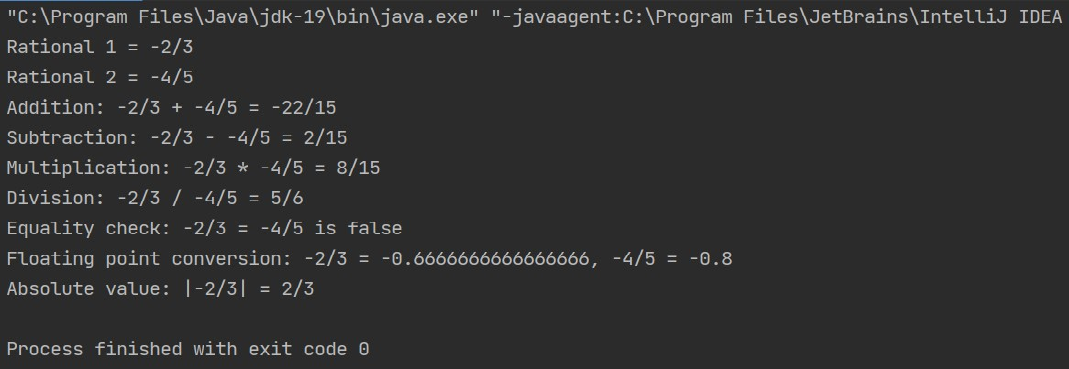

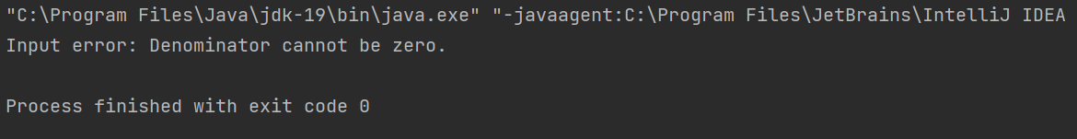

**GITHUB:**

[**https://github.com/Boomsnipa/Java_assignments**](https://github.com/Boomsnipa/Java_assignments)