Unified Marketing Agent - Project Documentation

Part 1: Unified API Documentation

1. Overview
The Unified API serves as the backend for the Marketing Agent application. It provides essential services for user authentication, session management, and interaction with the AI marketing agent.
- Base URL: http://localhost:8000 (Default)
- Framework: FastAPI
- Version: 1.0.0

2. Authentication API
Prefix: /api/auth
The Authentication module handles user registration, login, and security features.

Endpoints
1. Signup - Endpoint: POST /signup - Description: Registers a new user and triggers an email verification OTP. - Request Body: - email (string): User’s email address. - password (string): User’s password. - full_name (string): User’s full name. - Response: Returns success status and user data.
2. Verify Email - Endpoint: POST /verify-email - Description: Verifies the user’s email address using the OTP sent during signup. - Request Body: - email (string) - otp (string)
3. Login - Endpoint: POST /login - Description: Authenticates a user and returns an access token. - Request Body: - email (string) - password (string) - Response: Includes access_token (JWT) and user profile.
4. Forgot Password - Endpoint: POST /forgot-password - Description: Initiates the password recovery process by sending an OTP to the registered email.
5. Reset Password - Endpoint: POST /reset-password - Description: Resets the user’s password using a valid OTP.
6. Google OAuth - GET /google/login: Redirects to Google’s login page. - GET /google/callback: Handles the callback from Google, creates/retrieves the user, and redirects to the frontend with an authentication token.

3. AI Agent API
Prefix: /api/agent
The Agent API facilitates communication between the user and the LangGraph-based marketing AI.

Endpoints
1. Chat Interaction - Endpoint: POST /chat - Description: Sends a message to the AI agent and retrieves the response. It maintains conversational state via session_id. - Request Body: - message (string): The user’s input message. - session_id (string, optional): The ID of the current session. If omitted, a new session is created. - Response: - response (string): The AI’s reply. - session_id (string): The active session ID. - is_complete (boolean): Indicates if the current workflow is finished. - strategies (list, optional): Any marketing strategies generated during the session.
2. Get Sessions - Endpoint: GET /sessions - Description: Retrieves a list of all chat sessions for the authenticated user.
3. Get Chat History - Endpoint: GET /history - Parameters: session_id (optional). If not provided, fetches the last active session. - Description: Returns the full message history for a given session.

4. Agent Workflow Diagram
The following diagram illustrates the routing logic within the Orchestrator and the state transitions inside the Marketing Agent.
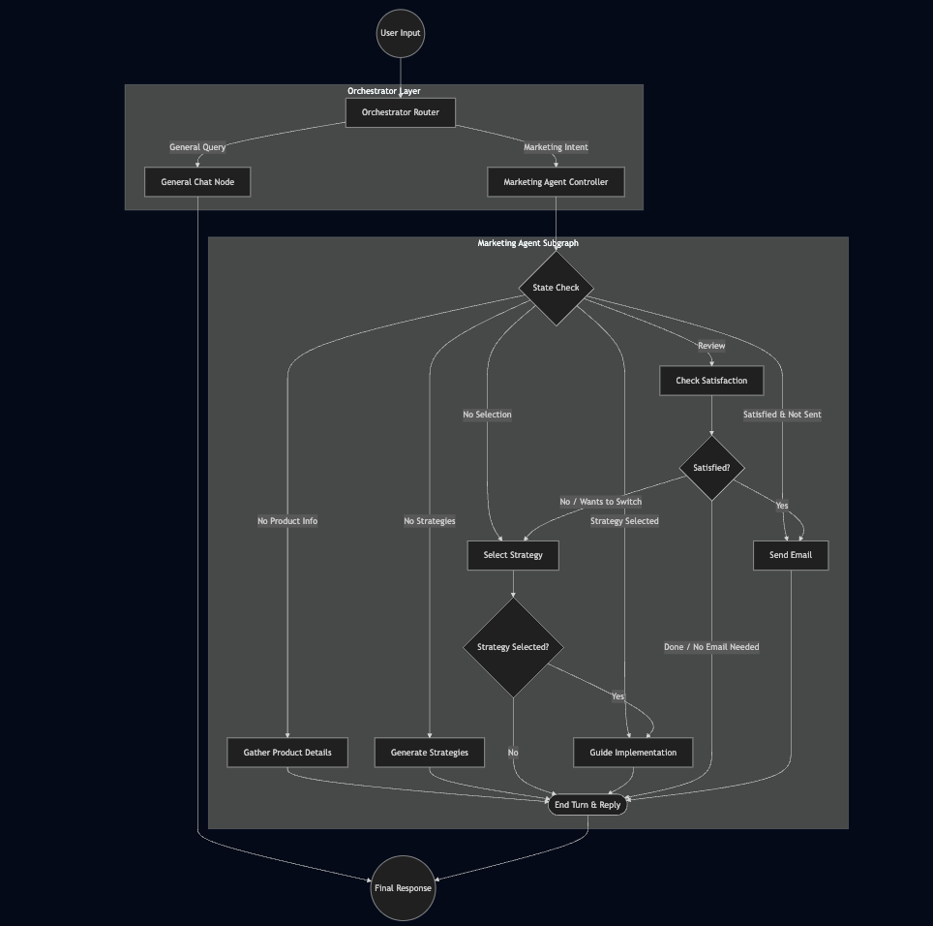
Agent Workflow Diagram

Part 2: UI Component Library Documentation
Location: unified_api_frontend_v2/src/components/ui
The frontend utilizes a set of reusable, accessible components built with React and Tailwind CSS. These components follow the “shadcn/ui” pattern, using cva (class-variance-authority) for styling variants.

1. Button (button.tsx)
A versatile button component with multiple visual styles and size options.
- Usage: <Button variant="default" size="sm">Click Me</Button>
- Variants:
  - default: Primary background color.
  - destructive: Red/Error background.
  - outline: Bordered with transparent background.
  - secondary: Secondary background color.
  - ghost: Transparent, hover effect only.
  - link: Looks like a hyperlink.
- Sizes: default, sm (small), lg (large), icon (square for icons).

2. Card (card.tsx)
A container component for grouping related content. It is composed of several sub-components for structured layout.
- Components:
  - Card: Main container with border, shadow, and rounded corners.
  - CardHeader: Wrapper for title and description.
  - CardTitle: Bold heading.
  - CardDescription: Muted text for subtitles.
  - CardContent: Main body area.
  - CardFooter: Bottom area (e.g., for action buttons).
- Usage:
- <Card>
<CardHeader>
<CardTitle>Title</CardTitle>
<CardDescription>Subtitle</CardDescription>
</CardHeader>
<CardContent>Content goes here</CardContent>
</Card>

3. Input (input.tsx)
A styled HTML input field.
- Usage: <Input type="text" placeholder="Enter text..." />
- Features:
  - Standardized border, padding, and focus states.
  - Supports all standard HTML input props (type, disabled, etc.).

4. Separator (separator.tsx)
A visual divider to separate content.
- Usage: <Separator orientation="horizontal" />
- Props:
  - orientation: "horizontal" (default) or "vertical".
  - decorative: boolean (default true). If true, it is skipped by screen readers.

5. Sonner (sonner.tsx)
A toast notification provider wrapping the sonner library.
- Usage: Place <Toaster /> at the root of your application.
- Functionality: Displays temporary notification messages (toasts) to the user.
- Styling: tailored to match the application’s theme (background, border, text colors).

