Preposition

USE of “ON”:
Surface:
- The book is on the table.
- The paper is on my desk.
Date / Day:
- He will come on Wednesday.
- They met me on Sunday.
- I was born on 26th January 1999.
Device / Machine:
- He is on the phone.
- The show will be telecasted on television.
- I was watching cricket match on television.
- He has been on the computer.
- He is solving the sum on calculator.
Body parts:

State:
- Ali was on fire last night.
- He has been on bed rest for past 2 days.
- Mango juice is on demand.


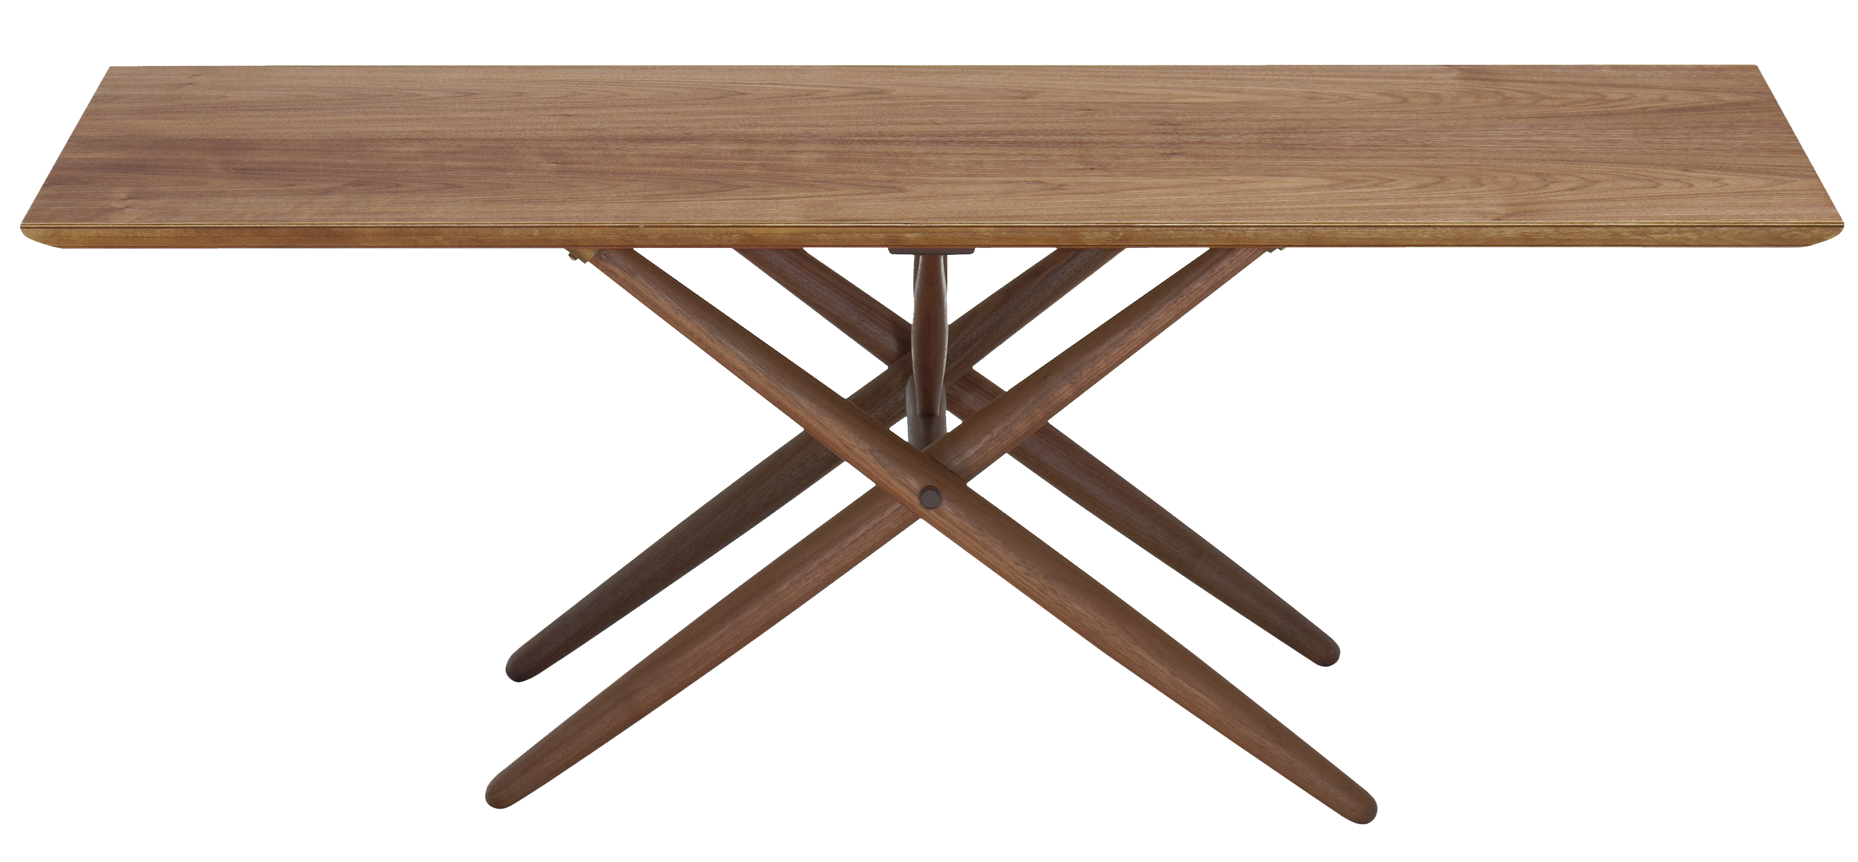
Use of “ONTO”:

Movement+surface:
- The cat jumped onto the table.
- Move the books into the shelf.
- She climed onto the roof.
- He stepped down from the train onto to the platform.
something walk or climb -–> “onto”

Use of “UPON”:
Immediately after doing something or something happens:
- Upon declaration of her result, she rushed towards her mother
- Ali got married immediately upon passing the college.
Something about to happen:
- Ramdan is almost upon us.
- Our exams will soon be upon us.
- His payment is going to be due upon us.
“Upon” is used instead of “ON” in more formal manner:
Upon is used with these verbs:
    - Depend
    - Congratulate
    - Experience
    - Happen
    - Insist
- My whole future is depended upon your decision.
- They congratulated him upon his success.
Between two nouns, one noun is more important:
- He has worked hard year upon year.
- We crossed further mile upon mile.
Movement+surface (But not walk or climb):
- He fell upon the ground.

Preposition of time:

Use of “AT”:
Clock time(Hours ,minutes, second):
- I go to school at 7o’clock.
- I will meet you at 2o’clock.
Use of “IN”:
Calander time:
- Years, months –> “IN”:
  - Pakistan got the Independence in 1947.
  - My exam in June month.
Use of “ON”:
- Days , Dates –> “ON”
  - I will meet you on Sunday.
  - My birthday is on 29th June.

Preposition of Place:

Use of “IN”:
Thing which is covered from all sides:
- I am in the class.
- I am in the home.
- I am in Lahore.
- He is sitting in the car.
Use of “AT”:
Telling exact location:
- We met at the coffee shop.
- The watchman is standing at the main gate.
- They are celebrating his birthday at Jinnah Park.
Use of “ON”:
Surface:
- What is on the table?
- He is on the roof.
- I live on 3rd floor of this building.

Use of “WITH”:
It is used with sensation(احساس) and feelings(جذ بات):
- My father is furious with me.
- I am very upset with my life.
Exceptions:
- “Rude” --> to
- “Polite” --> to
- “Kind” –> to
Tools:
- I wrote a letter with pen.
- He killed him with a knife.
Possession:
- I want a home with garden.
- We want a life with happiness.
- I want to pass with good marks.

Use of “BY”:

(کام کے کرنے کے طریقے کو بتانا۔ )
- I am talking by phone.
- Please send this letter by post.
Travel:
- I go to school by bus.
- He comes from Lahore by train.
Doer(کرنے والا):

Next to / beside(نزدیک) :
- My school is situated by my home.
- He is standing by me.
Deadline:
- You can submit your form by 31st August.
- I want this file by Monday.

