Fullname:Nguyen-Gia-Khiem
Student ID:22130080

Specialized Internship Report Questions – Module 2

Question 1:
Is the sol-gel method a chemical or physical film deposition technique? What are the advantages of sol-gel compared to other methods?
Answer: The sol-gel method belongs to the chemical deposition techniques. This method involves a chemical transformation from a solution (sol) into a solid gel phase, which eventually forms a thin film after drying and heat treatment.
Advantages of the sol-gel method compared to other methods:
- Low cost: It requires inexpensive equipment and uses chemical solutions instead of vacuum systems.
- Low processing temperature: It can be used on substrates that are sensitive to high temperatures.
- High purity and homogeneity: The precursor solutions are usually well-controlled, leading to uniform composition.
- Easy doping: Elements can be easily introduced into the solution phase to modify the film’s properties.
- Versatility: It can be applied to coat complex shapes and a variety of substrates (glass, metal, ceramics).
Question 2:
In the sol-gel method, what types of compounds are typically used as precursors? What factors affect the stability of the sol?
Answer: Precursors in the sol-gel method are typically metal alkoxides (e.g., tetraethyl orthosilicate – TEOS, zinc acetate) or metal salts (such as nitrates or chlorides).
Factors affecting the stability of the sol include:
- pH of the solution: Acidic or basic environments can accelerate hydrolysis and condensation.
- Concentration of precursors: High concentrations may lead to premature gelation.
- Temperature: Higher temperatures increase reaction rates but may destabilize the sol.
- Type of solvent: Polar solvents (e.g., ethanol, methanol) influence the rate of hydrolysis.
- Aging time: Over time, sols may aggregate or gel, depending on the composition.

Question 3:
What are the main stages in the sol-gel film deposition process? What does each stage correspond to in practice?
Answer: The main stages in the sol-gel process are:
- Hydrolysis and Condensation:
  - Metal alkoxides react with water (hydrolysis) and then undergo condensation to form a sol (a stable colloidal suspension).
  - In practice: This is done by mixing precursors, water, alcohol, and sometimes acids or bases under controlled conditions.
- Gelation:
  - The sol gradually transforms into a gel-like network due to continuous condensation reactions.
  - In practice: The sol is left undisturbed for a specific period to form a gel.
- Deposition:
  - The gel or sol is applied onto the substrate using techniques such as spin coating, dip coating, or spray coating.
  - In practice: The coated substrate is then dried at room temperature or slightly elevated temperatures.
- Drying and Aging:
  - The film is dried to remove solvents and further condense the network.
  - In practice: Carried out at 80–150°C depending on the material.
- Heat Treatment (Annealing):
  - The dried film is heated to eliminate organic residues and to crystallize or densify the film.
  - In practice: This step is crucial for enhancing film properties (optical, electrical, structural).

Question 4:
What is the role of the heat treatment (annealing) step in the film formation process?
Answer: The heat treatment or annealing step plays a critical role in:
- Removing organic residues: It eliminates remaining solvents and unreacted organics from the film.
- Densification: It helps compact the gel network, reducing porosity and increasing mechanical strength.
- Crystallization: For some materials like ZnO or TiO₂, annealing induces the formation of crystalline phases.
- Improving adhesion: It enhances the bonding between the film and the substrate.
- Tuning functional properties: Annealing can adjust optical, electrical, and surface characteristics of the film.
The specific temperature and duration of annealing depend on the material system, typically ranging from 300°C to 600°C for metal oxide films.

Quesion 5: Draw the absorption spectrum of the film.
Answer:
The absorption spectrum of the thin film was obtained using UV-Vis spectroscopy in the wavelength range from 200 nm to 700 nm. The measurement was conducted in absorbance mode, with a scan speed of 400 nm/min and a sampling interval of 0.5 nm.
Graph Description:
- The x-axis represents wavelength (nm).
- The y-axis represents absorbance (a.u.).
- Each curve in the spectrum corresponds to a different sample (Sample 1 to Sample 6).
- The graph shows how much light the thin film absorbs at different wavelengths in the ultraviolet and visible regions.
Observations:
- The absorbance is generally higher in the UV region (below 400 nm), indicating that the films strongly absorb UV light.
- As the wavelength increases beyond ~400 nm (visible range), the absorbance decreases, which is typical for semiconducting oxide films like ZnO or SnO₂.
- The absorption edge (sharp drop in absorbance) indicates the optical bandgap of the material, which will be used to calculate the bandgap in Question 6.
Conclusion:
The UV-Vis absorption spectrum confirms that the thin films absorb strongly in the UV range and have a well-defined absorption edge. This data is crucial for determining the optical bandgap and evaluating the film's suitability for optoelectronic applications such as UV detectors, solar cells, or transparent conductive oxides.

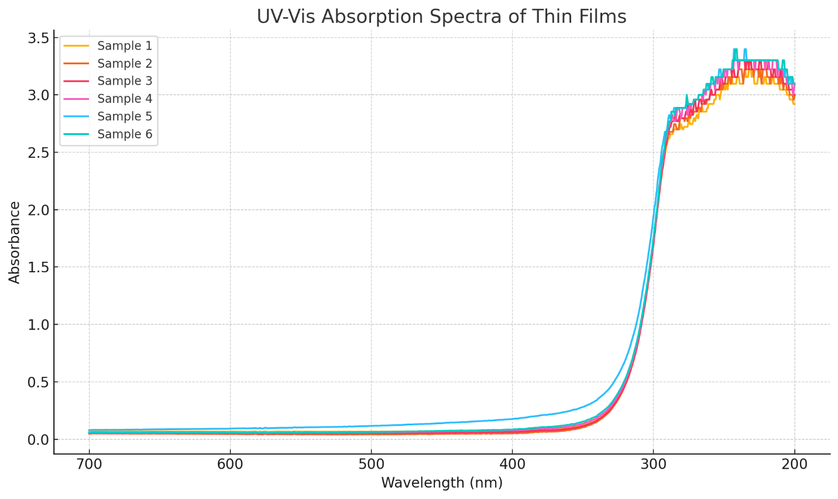
Question 6:
From the UV-Vis spectrum, determine the bandgap energy of the ZnO film.
Answer:
To determine the optical bandgap (EgE_gEg​) of the ZnO thin film, we use the Tauc plot method, which is suitable for direct bandgap semiconductors like ZnO.
Steps:
- Convert the wavelength (λ) to photon energy hνh\nuhν using the formula:
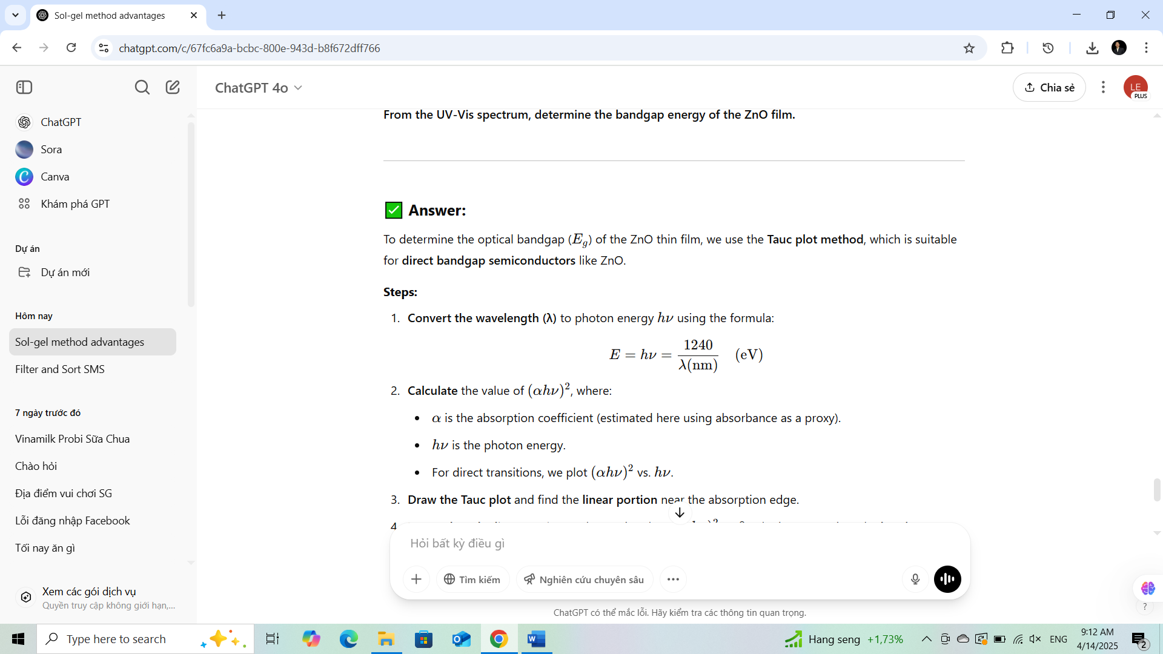

- Calculate the value of (αhν)², where:
  - α is the absorption coefficient (estimated here using absorbance as a proxy).
  - hν is the photon energy.
  - For direct transitions, we plot (αhν)² vs hv
- Draw the Tauc plot and find the linear portion near the absorption edge.
- Extrapolate the linear region to the x-axis (where (αhν)²=0). The intercept gives the bandgap energy EgE_gEg​.

Observation:
From the Tauc plot, the linear portion starts around 3.1 – 3.3 eV, and when extrapolated to the x-axis, the estimated bandgap energy of the ZnO thin film is approximately:


This value is consistent with typical bandgap values for ZnO, confirming the quality and optical properties of the deposited film.

Question 7:
Give a specific example of a thin-film fabrication process using the solution method to create one of the following films: SnO₂ or SiO₂. (Include chemicals used, deposition technique, and heat treatment conditions.)
Answer – Example: Sol-gel deposition of SiO₂ thin film
1. Chemicals used (precursors and solvents):
- Tetraethyl orthosilicate (TEOS) – Si(OC₂H₅)₄: main precursor for SiO₂
- Ethanol (C₂H₅OH) – used as a solvent to dissolve TEOS
- Deionized water (H₂O) – for hydrolysis reaction
- Hydrochloric acid (HCl) – catalyst to adjust pH and speed up the hydrolysis-condensation reaction
2. Chemical reaction in solution (simplified):
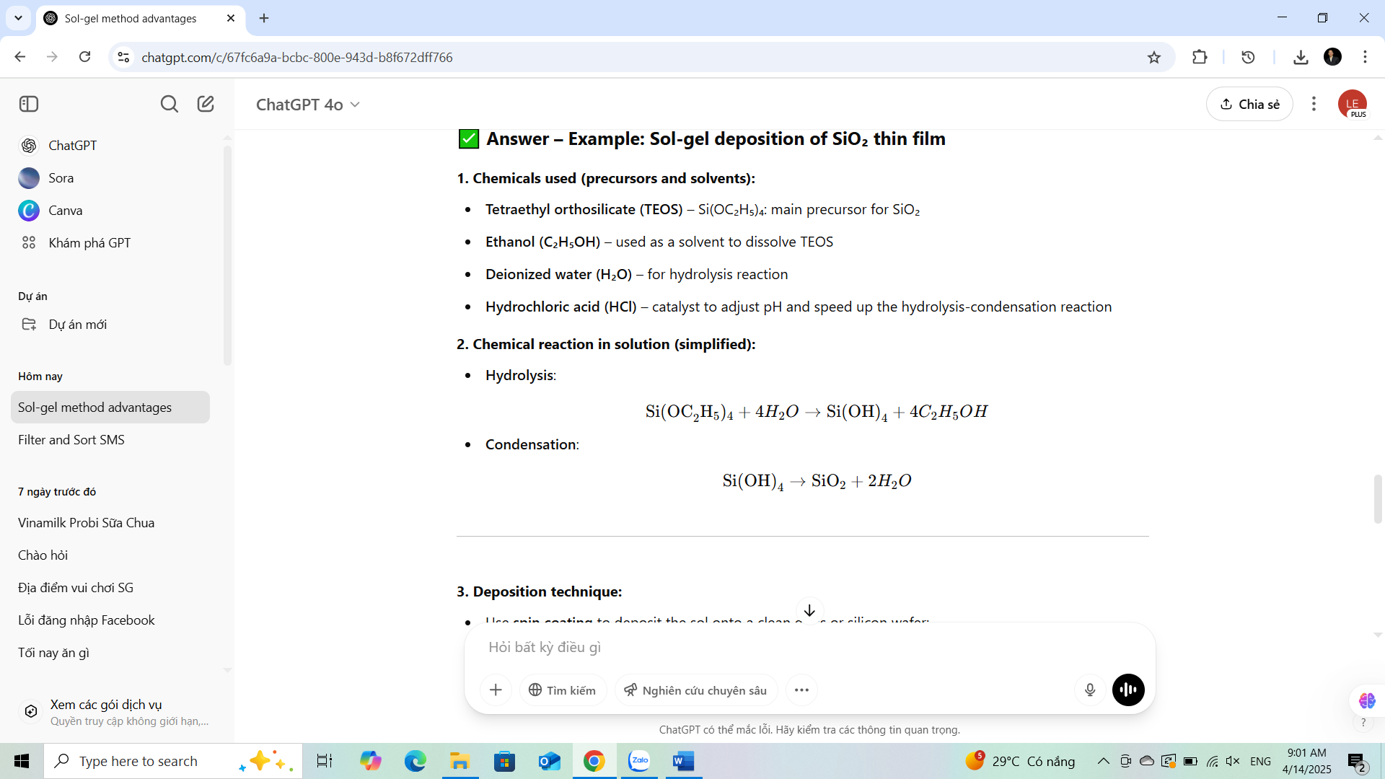
- Hydrolysis:

- Condensation:


3. Deposition technique:
- Use spin coating to deposit the sol onto a clean glass or silicon wafer:
  - Spin speed: 2000–3000 rpm
  - Spin time: 30–60 seconds
- Alternative methods include dip-coating or spray-coating depending on equipment and film thickness requirements.

4. Drying and aging:
- Let the coated substrate dry at room temperature for 10–30 minutes to allow evaporation of solvents.
- Optionally age at 100°C in an oven for 1–2 hours to remove residual solvent and promote further condensation.

5. Heat treatment (annealing):
- After drying, the film is annealed in a furnace:
  - Temperature: 400°C to 600°C
  - Duration: 1 to 2 hours
  - Atmosphere: Usually ambient air, but can also be done in nitrogen or oxygen for specific properties.

Outcome:
- A uniform, dense SiO₂ thin film with good optical and mechanical properties.
- Film thickness can range from tens to hundreds of nanometers depending on the number of coating layers.

