**Conversion Technical Design**

**FI001_Accounts Payable**

**TD_FI_IND_C_FI001_Accounts Payable**

**TABLE OF CONTENTS**

**1** **Document Information 3**

*1.1 General Data 3*

*1.2 Related Documents 3*

*1.3 Reference Documents 4*

**2** **Document History 4**

*2.1 Change History 4*

*2.2 RASCI 4*

*2.3 Approval Detail 4*

*2.4 Other Related Documents 5*

**3** **Development Overview 5**

*3.1 Purpose and Scope 5*

*3.2 Prerequisites and Dependencies / Constraints 5*

*Configuration of the target SAP environment prior to mapping activities: 5*

*Sources must be identified and read-only access configured to databases prior to mapping: 5*

*3.3 Non-functional constraints 6*

**4** **Technical Details 6**

*Steps for Data Flow: 7*

*4.1 JOB_FI_FI001_ACCOUNTS_PAYABLE_EXTRACT 7*

*4.1.1 Source fields 7*

*4.2 JOB_FI_FI001_ACCOUNTS_PAYABLE_MERGE 8*

*4.2.1 Source fields 8*

4.3 JOB_FI_FI001_ACCOUNTS_PAYABLE_TRANSFORM

4.3.1 Source Fields

*4.3.2 Default values 9*

* 1. *JOB_FI_FI001_ACCOUNTS_PAYABLE_VALIDATION 10*

*4.5 JOB_FI_FI001_ACCOUNTS_PAYABLE_SOURCE_UPDATE…****……………………………………. 66***

***4.6*** JOB_FI_FI001_ACCOUNTS_PAYABLE_FILE_GEN

*4.7 Enrichment 10*

*4.8 Load 10*

*Maintain Object Attributes: 10*

*Maintain Source Structures: 12*

*Maintain Source Fields: 12*

*Maintain Structure Relations: 12*

*Maintain Field Mapping and Conversion rules: 13*

*Maintain Fixed Values, Translations, User-Defined Routines: 13*

*Specify Files: 14*

*Assign Files: 14*

4.8.1 Target System for loading 14

4.8.2 SAP Load Method 14

4.8.3 Lookup Table Schema 15

**5** **Outstanding Issues 16**

**6** **Appendix 16**

*6.1 Cross team help required 16*

*6.2 Glossary of Terms 16*

**Document Information**

* 1. ***General Data***

|  |  |
| --- | --- |
| **Information** | **Detail** |
| **Design Team** | Data & Cutover – Design |
| **Design Owner** | **India Deployment Team** |
| **Process Area** | **FI** |
| **Object Name** | ACCOUNTS_PAYABLE |
| **Complexity** | Medium |
| **Technical Designer** | **Revathi Bharathi** |
| **Application Architect** | N/A |
| **Data Architect** | N/A |
| **Developer** | **Revathi Bharathi** |

* 1. ***Related Documents***

|  |  |
| --- | --- |
| **Document** | **Location** |
| MDS | [MDS link](https://rbcom.sharepoint.com/sites/turbo2020/_layouts/15/WopiFrame.aspx?sourcedoc=%7BF1941386-2C82-4085-9E05-F686848E0722%7D&file=MDS_FI001_Accounts_Payable.xlsm&action=default) |
| MRS | NA |
| FDS/TD |  |
| CRC | [CRC link](https://rbcom.sharepoint.com/sites/turbo2020/_layouts/15/WopiFrame.aspx?sourcedoc=%7B1D70913B-2F9D-4CDA-B2EE-8F6C3BCE52E8%7D&file=CRC_MEX_FI_FI001_Accounts%20Payable.xlsx&action=default) |
| UT | [UT link](https://rbcom.sharepoint.com/sites/turbo2020/_layouts/15/WopiFrame.aspx?sourcedoc=%7B3CAD67AE-E1A1-4229-AB93-763781BCC652%7D&file=UT_FI_MEX_C_FI001_Accounts%20Payable.docx&action=default) |

* 1. ***Reference Documents***

|  |  |
| --- | --- |
| **Document** | **Location** |
| Master Development Standards | BODS standard document |
| DS Development Standards | Naming checklist |
|  |  |

**Document History**

***Change History***

|  |  |  |  |  |
| --- | --- | --- | --- | --- |
| **Ver.** | **Date** | **Summary of Changes** | **Author** | **Transport Number** |
| 1 | 25/01/2017 | Initial version 1.0 | **Revathi Bharathi** | NA |
|  |  |  |  |  |
|  |  |  |  |  |

***RASCI***

|  |  |  |  |
| --- | --- | --- | --- |
| **RASCI** | **Role** | **Name** | **Phone** |
| R | ***Responsible*** for the creation of the TD and supporting documents (e.g. TMD’s) | **Revathi Bharathi** |  |
| A | ***Approver*** of the TD and supporting documents (e.g. TMD’s) | NA |  |
| S | ***Support*** in the creation of the TD and supporting documents (e.g. TMD’s) | NA |  |
| C | ***Consult*** in the creation of the TD and supporting documents (e.g. TMD’s) | **NA** |  |

R: Responsible; A: Accountable; S: Support; C: Contribute; I: Information;

***Approval Detail***

|  |  |  |  |
| --- | --- | --- | --- |
| **Review #** | **Date** | **Name & Position of Approver** | **Signature** |

|  |  |  |  |
| --- | --- | --- | --- |
| 1 | 25/01/2017 |  |  |
|  |  |  |  |
|  |  |  |  |

***Other Related Documents***

Please insert links/References to related Documents (issues, data entities, etc.)

|  |  |
| --- | --- |
| ***Related Document*** | ***Comment*** |

|  |  |
| --- | --- |
|  |  |
|  |  |

1. **Development Overview**
   1. ***Purpose and Scope***

This Document provides the technical approach taken for loading Accounts PAYABLE from legacy systems and construction data into SAP. Individual source mapping for a business unit is defined in Mapping documents.

The Document aims at explaining the architecture of the JOB and its various components and flow of the data along with metadata and framework details being captured to the granular level. The Document shall act as an input to the developer working on the job to help him to understand and follow the defined process.

* 1. ***Prerequisites and Dependencies / Constraints***

**Configuration of the target SAP environment prior to mapping activities:**

The mapping process requires visibility into the target configuration to allow proper mapping to Tier 0 data and configuration. Mapping cannot be completed unless the following configuration is completed in a development SAP environment.

* Company Code exists in relevant check table (T001)
* Currency exist in relevant check table (TCURC)
* Vendor Number Type exist in relevant check table (LFB1)
* Tax Code Type exist in relevant check table (T007A)
* Data Migration Contra Account exist in relevant check table (SKA1 or LFB1)
* Reconciliation account exist in relevant check table (SKB)
* Payment Terms usage exist in relevant check table (T052)
* Payment block key exist in relevant check table (T008)
* Payment Method exist in relevant check table (T042Z)
* Document Type exist in relevant check table (T003)
* Cost center exist in relevant check table (CSKS)
* Trading Partner exist in relevant check table (T880)
* GL Account exist in relevant check table (SKB1)

**Sources must be identified and read-only access configured to databases prior to mapping:**

Mapping activities cannot be completed without read-only ODBC access to each legacy table required to facilitate the conversion.

Legacy Tables Associated are:

1. GLOBAL.DBO.TEJ_FI001_AP
   1. ***Non-functional constraints***

No functional constraints exist for this object as of now.

1. **Technical Details**

**START**

DCT

Query Transform (Transform)

Query Transform (Merge)

MERGED TABLE

Query Transforms

(Import Check Tables)

TRANSFORMED TABLE

Validations

**FAIL**

View Dashboard

**PASS**

VALIDATED TABLE

FLAT FILE

IDOC/LSMW

**END**

SAP LOAD

***Steps for Data Flow:***

Step 1: **Merge Job** – Get the source data from DCT.

Step 2: **Transform Job**

Step 2 (a): Import all check tables from the required SAP system.

Step 2 (b): Apply transform logic, multiple lookups are used.

Step 2 (c): Apply validations, data that passes all validations goes to validated table.

Step 3: **Load Job** – Validated table is mapped in a query as per IDOC and LSMW structure.

* 1. ***JOB_FI_FI001_ACCOUNTS_PAYABLE_EXTRACT***

This section maps the JDE related source from the staging table into the relevant DCCT and LDCT tables in our process. Delta Extraction is got on Bi-Weekly Basis and the extraction process either inserts/updates the records and never deletes the records.

* + 1. ***Source Fields***

The Following Table contains all the extracted records and only inserts/updates the records as and when new extract is got. In this process, we never delete the already existing records, even if it does not come in from the source.

This table contains all the fields as is from the extraction table

|  |  |  |
| --- | --- | --- |
| Table Name | Field Name | Datatype |
| TEJ_FI001_AP | SOURCE | varchar(15) |
| TEJ_FI001_AP | COUNTRY | varchar(15) |
| TEJ_FI001_AP | RELEASE | varchar(30) |
| TEJ_FI001_AP | DATE_OF_EXTRACT | varchar(8) |
| TEJ_FI001_AP | UNIQUE_NO | varchar(1) |
| TEJ_FI001_AP | BELNR | varchar(10) |
| TEJ_FI001_AP | BKTXT | varchar(1) |
| TEJ_FI001_AP | BUKRS | varchar(1) |
| TEJ_FI001_AP | LEGACY_BUKRS | varchar(5) |
| TEJ_FI001_AP | GJAHR | varchar(4) |
| TEJ_FI001_AP | BLDAT | varchar(8) |
| TEJ_FI001_AP | BLART | varchar(2) |
| TEJ_FI001_AP | BUDAT | varchar(1) |
| TEJ_FI001_AP | WAERS | varchar(5) |
| TEJ_FI001_AP | XBLNR | varchar(1) |
| TEJ_FI001_AP | LEGACY_XBLNR | varchar(25) |
| TEJ_FI001_AP | BUZEI | varchar(3) |
| TEJ_FI001_AP | UMSKZ | varchar(1) |
| TEJ_FI001_AP | ZUONR | varchar(1) |
| TEJ_FI001_AP | LIFNR | varchar(10) |
| TEJ_FI001_AP | HKONT | varchar(1) |
| TEJ_FI001_AP | BSCHL | varchar(1) |
| TEJ_FI001_AP | SHKZG | varchar(1) |
| TEJ_FI001_AP | KOSTL | varchar(1) |
| TEJ_FI001_AP | ANLN1 | varchar(1) |
| TEJ_FI001_AP | SGTXT | varchar(50) |
| TEJ_FI001_AP | DMBTR | varchar(1) |
| TEJ_FI001_AP | LEGACY_DMBTR | decimal(15, 2) |
| TEJ_FI001_AP | WRBTR | varchar(1) |
| TEJ_FI001_AP | LEGACY_WRBTR | decimal(15, 2) |
| TEJ_FI001_AP | PRCTR | varchar(1) |
| TEJ_FI001_AP | SAKNR | varchar(1) |
| TEJ_FI001_AP | KURSF | varchar(1) |
| TEJ_FI001_AP | GSBER | varchar(1) |
| TEJ_FI001_AP | SEGMENT | varchar(1) |
| TEJ_FI001_AP | VBUND | varchar(1) |
| TEJ_FI001_AP | ZFBDT | varchar(8) |
| TEJ_FI001_AP | ZBD1T | varchar(1) |
| TEJ_FI001_AP | ZBD2T | varchar(1) |
| TEJ_FI001_AP | ZBD3T | varchar(1) |
| TEJ_FI001_AP | ZBD1P | varchar(1) |
| TEJ_FI001_AP | ZBD2P | varchar(1) |
| TEJ_FI001_AP | SKFBT | varchar(1) |
| TEJ_FI001_AP | MWSKZ | varchar(1) |
| TEJ_FI001_AP | LEGACY_MWSKZ | varchar(10) |
| TEJ_FI001_AP | ZTERM | varchar(4) |
| TEJ_FI001_AP | ZLSPR | varchar(1) |
| TEJ_FI001_AP | ZLSCH | varchar(1) |
| TEJ_FI001_AP | BUPLA | varchar(1) |
| TEJ_FI001_AP | XREF1 | varchar(1) |
| TEJ_FI001_AP | XREF3 | varchar(1) |
| TEJ_FI001_AP | WMWST | varchar(1) |
| TEJ_FI001_AP | WITHT | varchar(1) |
| TEJ_FI001_AP | WT_WITHCD | varchar(1) |
| TEJ_FI001_AP | WT_QSSHH | varchar(1) |
| TEJ_FI001_AP | WT_QSSHB | varchar(1) |
| TEJ_FI001_AP | YUUID | varchar(1) |
| TEJ_FI001_AP | YRFC | varchar(1) |
| TEJ_FI001_AP | YTEXT | varchar(1) |

The LDCT and DCT Tables are mentioned below:

1. LDCT TABLE

DISPLAY NAME: FI001_IND_BSIK_JDE_ACCOUNT_PAYABLE

|  |  |  |
| --- | --- | --- |
| Table Name | Field Name | Datatype |
| BSIK_FI001_JDE | SOURCE | varchar(20) |
| BSIK_FI001_JDE | RELEASE | varchar(30) |
| BSIK_FI001_JDE | SUPER_USER_ID | varchar(15) |
| BSIK_FI001_JDE | RECORD_STATUS | varchar(50) |
| BSIK_FI001_JDE | ERROR_COLUMNS | varchar(1000) |
| BSIK_FI001_JDE | LEGACY_BELNR | varchar(10) |
| BSIK_FI001_JDE | LEGACY_BUKRS | varchar(5) |
| BSIK_FI001_JDE | LEGACY_LIFNR | varchar(10) |
| BSIK_FI001_JDE | LEGACY_BLART | varchar(2) |
| BSIK_FI001_JDE | LEGACY_BUZEI | varchar(3) |
| BSIK_FI001_JDE | BELNR | varchar(10) |
| BSIK_FI001_JDE | BUKRS | varchar(5) |
| BSIK_FI001_JDE | GJAHR | varchar(4) |
| BSIK_FI001_JDE | BLDAT | varchar(8) |
| BSIK_FI001_JDE | BLART | varchar(2) |
| BSIK_FI001_JDE | WAERS | varchar(5) |
| BSIK_FI001_JDE | LEGACY_XBLNR | varchar(30) |
| BSIK_FI001_JDE | XBLNR | varchar(25) |
| BSIK_FI001_JDE | BUZEI | varchar(3) |
| BSIK_FI001_JDE | UMSKZ | varchar(1) |
| BSIK_FI001_JDE | LIFNR | varchar(10) |
| BSIK_FI001_JDE | HKONT | varchar(10) |
| BSIK_FI001_JDE | SHKZG | varchar(1) |
| BSIK_FI001_JDE | SGTXT | varchar(50) |
| BSIK_FI001_JDE | LEGACY_DMBTR | decimal(13, 2) |
| BSIK_FI001_JDE | DMBTR | decimal(13, 2) |
| BSIK_FI001_JDE | LEGACY_WRBTR | decimal(13, 2) |
| BSIK_FI001_JDE | WRBTR | decimal(13, 2) |
| BSIK_FI001_JDE | SEGMENT | varchar(10) |
| BSIK_FI001_JDE | ZFBDT | varchar(8) |
| BSIK_FI001_JDE | LEGACY_MWSKZ | varchar(10) |
| BSIK_FI001_JDE | MWSKZ | varchar(10) |
| BSIK_FI001_JDE | ZLSPR | varchar(1) |
| BSIK_FI001_JDE | ZLSCH | varchar(1) |
| BSIK_FI001_JDE | XREF3 | varchar(20) |
| BSIK_FI001_JDE | UNIQUE_ID | int |
| BSIK_FI001_JDE | CHECKED_OUT_BY | varchar(50) |
| BSIK_FI001_JDE | CHECKED_OUT_ON | varchar(50) |
| BSIK_FI001_JDE | CHECKED_OUT | varchar(1) |
| BSIK_FI001_JDE | MODIFIED_ON | varchar(50) |
| BSIK_FI001_JDE | MODIFIED_BY | varchar(50) |
| BSIK_FI001_JDE | ADDED_BY | varchar(50) |
| BSIK_FI001_JDE | ADDED_ON | varchar(50) |
| BSIK_FI001_JDE | BUKRS_CHECK | varchar(50) |
| BSIK_FI001_JDE | BLART_CHECK | varchar(50) |
| BSIK_FI001_JDE | WAERS_CHECK | varchar(50) |
| BSIK_FI001_JDE | LIFNR_CHECK | varchar(50) |
| BSIK_FI001_JDE | HKONT_CHECK | varchar(50) |
| BSIK_FI001_JDE | MWSKZ_CHECK | varchar(50) |
| BSIK_FI001_JDE | ZTERM_CHECK | varchar(50) |
| BSIK_FI001_JDE | ZLSPR_CHECK | varchar(50) |
| BSIK_FI001_JDE | ZLSCH_CHECK | varchar(50) |
| BSIK_FI001_JDE | GJAHR_CHECK | varchar(50) |
| BSIK_FI001_JDE | BLDAT_CHECK | varchar(50) |
| BSIK_FI001_JDE | SHKZG_CHECK | varchar(50) |
| BSIK_FI001_JDE | DMBTR_CHECK | varchar(50) |
| BSIK_FI001_JDE | WRBTR_CHECK | varchar(50) |
| BSIK_FI001_JDE | ZTERM | varchar(4) |

1. DCT TABLE

DISPLAY NAME: FI001_IND_BSIK_DCT_ACCOUNT_PAYABLE

|  |  |  |
| --- | --- | --- |
| Table Name | Field Name | Datatype |
| BSIK_FI001_DCT | SOURCE | varchar(20) |
| BSIK_FI001_DCT | RECORD_STATUS | varchar(50) |
| BSIK_FI001_DCT | ERROR_COLUMNS | varchar(1000) |
| BSIK_FI001_DCT | RELEASE | varchar(50) |
| BSIK_FI001_DCT | SUPER_USER_ID | varchar(50) |
| BSIK_FI001_DCT | UNIQUE_NO | varchar(10) |
| BSIK_FI001_DCT | UNIQUE_NO_CHECK | varchar(200) |
| BSIK_FI001_DCT | LEGACY_BELNR | varchar(10) |
| BSIK_FI001_DCT | LEGACY_BUKRS | varchar(5) |
| BSIK_FI001_DCT | LEGACY_LIFNR | varchar(10) |
| BSIK_FI001_DCT | LEGACY_BLART | varchar(2) |
| BSIK_FI001_DCT | LEGACY_BUZEI | varchar(3) |
| BSIK_FI001_DCT | GJAHR | varchar(4) |
| BSIK_FI001_DCT | KURSF | varchar(15) |
| BSIK_FI001_DCT | BUPLA | varchar(3) |
| BSIK_FI001_DCT | XREF1 | varchar(12) |
| BSIK_FI001_DCT | BKTXT | varchar(25) |
| BSIK_FI001_DCT | ZUONR | varchar(18) |
| BSIK_FI001_DCT | BSCHL | varchar(2) |
| BSIK_FI001_DCT | BELNR | varchar(10) |
| BSIK_FI001_DCT | BUDAT | varchar(8) |
| BSIK_FI001_DCT | KOSTL | varchar(10) |
| BSIK_FI001_DCT | ANLN1 | varchar(12) |
| BSIK_FI001_DCT | PRCTR | varchar(10) |
| BSIK_FI001_DCT | SAKNR | varchar(10) |
| BSIK_FI001_DCT | GSBER | varchar(4) |
| BSIK_FI001_DCT | VBUND | varchar(6) |
| BSIK_FI001_DCT | HKONT | varchar(10) |
| BSIK_FI001_DCT | ZBD1T | varchar(3) |
| BSIK_FI001_DCT | ZBD2T | varchar(3) |
| BSIK_FI001_DCT | ZBD3T | varchar(3) |
| BSIK_FI001_DCT | ZBD1P | varchar(5) |
| BSIK_FI001_DCT | ZBD2P | varchar(5) |
| BSIK_FI001_DCT | SKFBT | varchar(5) |
| BSIK_FI001_DCT | WMWST | varchar(16) |
| BSIK_FI001_DCT | WITHT | varchar(2) |
| BSIK_FI001_DCT | WT_WITHCD | varchar(2) |
| BSIK_FI001_DCT | WT_QSSHH | varchar(18) |
| BSIK_FI001_DCT | WT_QSSHB | varchar(18) |
| BSIK_FI001_DCT | YUUID | varchar(10) |
| BSIK_FI001_DCT | YRFC | varchar(10) |
| BSIK_FI001_DCT | YTEXT | varchar(10) |
| BSIK_FI001_DCT | UNIQUE_ID | int |
| BSIK_FI001_DCT | CHECKED_OUT_BY | varchar(50) |
| BSIK_FI001_DCT | CHECKED_OUT_ON | varchar(50) |
| BSIK_FI001_DCT | CHECKED_OUT | varchar(1) |
| BSIK_FI001_DCT | MODIFIED_ON | varchar(50) |
| BSIK_FI001_DCT | MODIFIED_BY | varchar(50) |
| BSIK_FI001_DCT | ADDED_BY | varchar(50) |
| BSIK_FI001_DCT | ADDED_ON | varchar(50) |
| BSIK_FI001_DCT | BUPLA_CHECK | varchar(50) |
| BSIK_FI001_DCT | ZUONR_CHECK | varchar(50) |
| BSIK_FI001_DCT | BSCHL_CHECK | varchar(50) |
| BSIK_FI001_DCT | BUDAT_CHECK | varchar(50) |
| BSIK_FI001_DCT | SAKNR_CHECK | varchar(50) |
| BSIK_FI001_DCT | KOSTL_CHECK | varchar(50) |
| BSIK_FI001_DCT | ANLN1_CHECK | varchar(50) |
| BSIK_FI001_DCT | PRCTR_CHECK | varchar(50) |
| BSIK_FI001_DCT | VBUND_CHECK | varchar(50) |
| BSIK_FI001_DCT | HKONT_CHECK | varchar(50) |

***4.2 JOB_FI_FI001_ACCOUNTS_PAYABLE_MERGE***

This section maps the records from various sources (in DCT) in scope for CURRENT PHASE for ECC.

The DCT and LDCT Tables in Scope for Accounts PAYABLE for Merging Purpose are “BSIK”.

Source table will have 4 Additional Fields “Source”,” Record_Status”, ”Error_Columns” and “Super_User_ID”

The fields LEGACY_XBLNR, LEGACY_LIFNR, LEGACY_ZLSPR,LEGACY_MWSKZ,LEGACY_BELNR are set as Primary Key.

* + 1. **Target Fields**

BSIK TABLE:

|  |  |  |
| --- | --- | --- |
| Table Name | Field Name | Datatype |
| BSIK_IND_FI001_MERGE | SOURCE | varchar(20) |
| BSIK_IND_FI001_MERGE | RECORD_STATUS | varchar(50) |
| BSIK_IND_FI001_MERGE | ERROR_COLUMNS | varchar(1000) |
| BSIK_IND_FI001_MERGE | LEGACY_BELNR | varchar(10) |
| BSIK_IND_FI001_MERGE | BELNR | varchar(10) |
| BSIK_IND_FI001_MERGE | LEGACY_BUKRS | varchar(5) |
| BSIK_IND_FI001_MERGE | BUKRS | varchar(5) |
| BSIK_IND_FI001_MERGE | BUKRS_CHECK | varchar(50) |
| BSIK_IND_FI001_MERGE | LEGACY_LIFNR | varchar(10) |
| BSIK_IND_FI001_MERGE | LIFNR | varchar(10) |
| BSIK_IND_FI001_MERGE | LIFNR_CHECK | varchar(50) |
| BSIK_IND_FI001_MERGE | LEGACY_BLART | varchar(2) |
| BSIK_IND_FI001_MERGE | BLART | varchar(2) |
| BSIK_IND_FI001_MERGE | BLART_CHECK | varchar(50) |
| BSIK_IND_FI001_MERGE | LEGACY_BUZEI | varchar(3) |
| BSIK_IND_FI001_MERGE | BUZEI | varchar(3) |
| BSIK_IND_FI001_MERGE | GJAHR | varchar(4) |
| BSIK_IND_FI001_MERGE | GJAHR_CHECK | varchar(50) |
| BSIK_IND_FI001_MERGE | BLDAT | varchar(8) |
| BSIK_IND_FI001_MERGE | BLDAT_CHECK | varchar(50) |
| BSIK_IND_FI001_MERGE | WAERS | varchar(5) |
| BSIK_IND_FI001_MERGE | WAERS_CHECK | varchar(50) |
| BSIK_IND_FI001_MERGE | LEGACY_XBLNR | varchar(30) |
| BSIK_IND_FI001_MERGE | XBLNR | varchar(25) |
| BSIK_IND_FI001_MERGE | XBLNR_CHECK | varchar(50) |
| BSIK_IND_FI001_MERGE | UMSKZ | varchar(1) |
| BSIK_IND_FI001_MERGE | SHKZG | varchar(1) |
| BSIK_IND_FI001_MERGE | SHKZG_CHECK | varchar(50) |
| BSIK_IND_FI001_MERGE | SGTXT | varchar(50) |
| BSIK_IND_FI001_MERGE | LEGACY_DMBTR | decimal(13, 2) |
| BSIK_IND_FI001_MERGE | DMBTR | decimal(13, 2) |
| BSIK_IND_FI001_MERGE | DMBTR_CHECK | varchar(50) |
| BSIK_IND_FI001_MERGE | LEGACY_WRBTR | decimal(13, 2) |
| BSIK_IND_FI001_MERGE | WRBTR | decimal(13, 2) |
| BSIK_IND_FI001_MERGE | WRBTR_CHECK | varchar(50) |
| BSIK_IND_FI001_MERGE | SEGMENT | varchar(10) |
| BSIK_IND_FI001_MERGE | ZFBDT | varchar(8) |
| BSIK_IND_FI001_MERGE | ZFBDT_CHECK | varchar(50) |
| BSIK_IND_FI001_MERGE | LEGACY_MWSKZ | varchar(10) |
| BSIK_IND_FI001_MERGE | MWSKZ | varchar(10) |
| BSIK_IND_FI001_MERGE | MWSKZ_CHECK | varchar(50) |
| BSIK_IND_FI001_MERGE | ZTERM | varchar(4) |
| BSIK_IND_FI001_MERGE | ZTERM_CHECK | varchar(50) |
| BSIK_IND_FI001_MERGE | LEGACY_ZLSPR | varchar(1) |
| BSIK_IND_FI001_MERGE | ZLSPR | varchar(1) |
| BSIK_IND_FI001_MERGE | ZLSPR_CHECK | varchar(50) |
| BSIK_IND_FI001_MERGE | ZLSCH | varchar(1) |
| BSIK_IND_FI001_MERGE | ZLSCH_CHECK | varchar(50) |
| BSIK_IND_FI001_MERGE | XREF3 | varchar(20) |
| BSIK_IND_FI001_MERGE | UNIQUE_NO | varchar(10) |
| BSIK_IND_FI001_MERGE | UNIQUE_NO_CHECK | varchar(200) |
| BSIK_IND_FI001_MERGE | KURSF | varchar(15) |
| BSIK_IND_FI001_MERGE | BUPLA | varchar(3) |
| BSIK_IND_FI001_MERGE | BUPLA_CHECK | varchar(50) |
| BSIK_IND_FI001_MERGE | XREF1 | varchar(12) |
| BSIK_IND_FI001_MERGE | BKTXT | varchar(25) |
| BSIK_IND_FI001_MERGE | ZUONR | varchar(18) |
| BSIK_IND_FI001_MERGE | ZUONR_CHECK | varchar(50) |
| BSIK_IND_FI001_MERGE | BSCHL | varchar(2) |
| BSIK_IND_FI001_MERGE | BSCHL_CHECK | varchar(50) |
| BSIK_IND_FI001_MERGE | BUDAT | varchar(8) |
| BSIK_IND_FI001_MERGE | BUDAT_CHECK | varchar(50) |
| BSIK_IND_FI001_MERGE | KOSTL | varchar(10) |
| BSIK_IND_FI001_MERGE | KOSTL_CHECK | varchar(50) |
| BSIK_IND_FI001_MERGE | ANLN1 | varchar(12) |
| BSIK_IND_FI001_MERGE | ANLN1_CHECK | varchar(50) |
| BSIK_IND_FI001_MERGE | PRCTR | varchar(10) |
| BSIK_IND_FI001_MERGE | PRCTR_CHECK | varchar(50) |
| BSIK_IND_FI001_MERGE | SAKNR | varchar(10) |
| BSIK_IND_FI001_MERGE | SAKNR_CHECK | varchar(50) |
| BSIK_IND_FI001_MERGE | GSBER | varchar(4) |
| BSIK_IND_FI001_MERGE | VBUND | varchar(6) |
| BSIK_IND_FI001_MERGE | VBUND_CHECK | varchar(50) |
| BSIK_IND_FI001_MERGE | HKONT | varchar(10) |
| BSIK_IND_FI001_MERGE | HKONT_CHECK | varchar(50) |
| BSIK_IND_FI001_MERGE | ZBD1T | varchar(3) |
| BSIK_IND_FI001_MERGE | ZBD2T | varchar(3) |
| BSIK_IND_FI001_MERGE | ZBD3T | varchar(3) |
| BSIK_IND_FI001_MERGE | ZBD1P | varchar(5) |
| BSIK_IND_FI001_MERGE | ZBD2P | varchar(5) |
| BSIK_IND_FI001_MERGE | SKFBT | varchar(5) |
| BSIK_IND_FI001_MERGE | WMWST | varchar(16) |
| BSIK_IND_FI001_MERGE | WITHT | varchar(2) |
| BSIK_IND_FI001_MERGE | WT_WITHCD | varchar(2) |
| BSIK_IND_FI001_MERGE | WT_QSSHH | varchar(18) |
| BSIK_IND_FI001_MERGE | WT_QSSHB | varchar(18) |
| BSIK_IND_FI001_MERGE | YUUID | varchar(10) |
| BSIK_IND_FI001_MERGE | YRFC | varchar(10) |
| BSIK_IND_FI001_MERGE | YTEXT | varchar(10) |
| BSIK_IND_FI001_MERGE | UNIQUE_ID_JDE | INT |
| BSIK_IND_FI001_MERGE | UNIQUE_ID_DCT | INT |

***4.3 JOB_FI_FI001_ACCOUNTS_PAYABLE_TRANSFORM***

In this job, transformation rules are applied on the data from the merged table; field structures are tuned to fit the IDOC/LSMW structure. SAP tables used for lookup are also imported in this job.

The fields LEGACY_BELNR, LEGACY_BUZEI, LEGACY_BLART, GJAHR, LEGACY_BUKRS, LEGACY_LIFNR are set as Primary Key.

Validations are applied to ensure only SAP ready records go into load file.

**4.3.1 Source fields**

BSIK Transformation Rules:

|  |  |  |  |
| --- | --- | --- | --- |
| Field Name | DataType | Field Label | Transformation Rule |
| SOURCE | varchar(20) | SOURCE | Direct Mapping |
| RECORD_STATUS | varchar(50) | RECORD_STATUS | Direct Mapping |
| ERROR_COLUMNS | varchar(1000) | ERROR_COLUMNS | Direct Mapping |
| LEGACY_BELNR | varchar(10) | LEGACY ACCOUNTING DOCUMENT NUMBER | Direct Mapping |
| BELNR | varchar(10) | ACCOUNTING DOCUMENT NUMBER | Direct Mapping |
| LEGACY_BUKRS | varchar(5) | LEGACY_COMPANY_CODE | Direct Mapping |
| BUKRS | varchar(4) | COMPANY CODE | Value Mapping (Unique_id ranging from 71734 to 71830 in MAP_TUR_TRASNFORM) |
| BUKRS_CHECK | varchar(50) | BUKRS_CHECK | Direct Mapping |
| LEGACY_LIFNR | varchar(10) | LEGACY_VENDOR_NUMBER | Direct Mapping |
| LIFNR | varchar(10) | VENDOR NUMBER | Direct Mapping (Looking up from SAP-LFB1) |
| LIFNR_CHECK | varchar(50) | LIFNR_CHECK | Direct Mapping |
| LEGACY_BLART | varchar(2) | LEGACY DOCUMENT TYPE | Direct Mapping |
| BLART | varchar(2) | DOCUMENT TYPE | Default to ‘Z2’ |
| BLART_CHECK | varchar(50) | BLART_CHECK | Direct Mapping |
| LEGACY_BUZEI | varchar(3) | LEGACY NUMBER OF LINE ITEM | Direct Mapping |
| BUZEI | varchar(3) | NUMBER OF LINE ITEM | Direct Mapping |
| GJAHR | varchar(4) | FISCAL YEAR | Concatenate RPCTRY + RPFY |
| GJAHR_CHECK | varchar(50) | GJAHR_CHECK | Direct Mapping |
| BLDAT | varchar(8) | DOCUMENT DATE | While extraction convert the date |
| format to DDMMYYY |
| BLDAT_CHECK | varchar(50) | BLDAT_CHECK | Direct Mapping |
| WAERS | varchar(5) | CURRENCY | Direct Mapping |
| WAERS_CHECK | varchar(50) | WAERS_CHECK | Direct Mapping |
| XBLNR | varchar(25) | REFERENCE_NUMBER | Mapping LEGACY BELNR to this field |
| UMSKZ | varchar(1) | SPECIAL G/L INDICATOR | Direct Mapping |
| HKONT | varchar(10) | GL ACC | Default to Blank |
| HKONT_CHECK | varchar(50) | HKONT_CHECK | Direct Mapping |
| SHKZG | varchar(1) | DR/CR_INDICATOR | if Posting Key = 21-S, 31-H,40-S,50-H |
| SHKZG_CHECK | varchar(50) | SHKZG_CHECK | Direct Mapping |
| SGTXT | varchar(50) | ITEM_TEXT | Direct Mapping |
| DMBTR | decimal(13, 2) | AMOUNT_IN_LOCAL_CURRENCY | Direct Mapping |
| DMBTR_CHECK | varchar(50) | DMBTR_CHECK | Direct Mapping |
| WRBTR | decimal(13, 2) | AMOUNT_IN_DOCUMENT_CURRENCY | Direct Mapping |
| If the amount is ‘0.00’ and currency is ‘INR”, |
| mapping the DMBTR to WRBTR |
| WRBTR_CHECK | varchar(50) | WRBTR_CHECK | Direct Mapping |
| SEGMENT | varchar(10) | SEGMENT | Default to BRANDED |
| ZFBDT | varchar(8) | BASELINE_DATE | While extraction convert the |
| date format to DDMMYYYY |
| This should be copied from the |
| Document date |
| MWSKZ | varchar(10) | Tax on sales/purchases code | Default to ‘80’ |
| MWSKZ_CHECK | varchar(50) | MWSKZ_CHECK | Direct Mapping |
| ZTERM | varchar(4) | PAYMENT_TERMS | Value mapping (Unique_id ranging from 6352 to 6399 in MAP_TUR_TRASNFORM) |
| ZTERM_CHECK | varchar(50) | ZTERM_CHECK | Direct Mapping |
| ZLSPR | varchar(1) | PAYMENT_BLOCK_KEY | Mapping JDE Payment block to |
| SAP Payment Block Key |
| ZLSPR_CHECK | varchar(50) | ZLSPR_CHECK | Direct Mapping |
| ZLSCH | varchar(1) | PAYMENT_METHOD | Mapping JDE Payment Method to |
|  |  |  | SAP Payment Method |
| ZLSCH_CHECK | varchar(50) | ZLSCH_CHECK | Direct Mapping |
| XREF3 | varchar(20) | Reference Key for Line Item | Mapping with Legacy LIFNR |
| UNIQUE_NO | varchar(10) | UNIQUE_NO | Direct Mapping |
| UNIQUE_NO_CHECK | varchar(200) | UNIQUE_NO_CHECK | Direct Mapping |
| KURSF | varchar(15) | EXCHANGE RATE | System will calculate the exchange |
|  |  |  | rate automatically |
| BUPLA | varchar(3) | BUSINESS_PLACE | Not required |
| BUPLA_CHECK | varchar(50) | BUPLA_CHECK | Direct Mapping |
| XREF1 | varchar(12) | REFERENCE_NUMBER | Direct Mapping |
| BKTXT | varchar(25) | HEADER TEXT | Mapping with Legacy_XBLNR |
| ZUONR | varchar(18) | Assignment Number | Based on Posting date convert the date |
|  |  |  | format to YYYYMMDD |
| ZUONR_CHECK | varchar(50) | ZUONR_CHECK | Direct Mapping |
| BSCHL | varchar(2) | POSTING_KEY | If Amount = '+' then 31 |
|  |  |  | Else 21 |
| BSCHL_CHECK | varchar(50) | BSCHL_CHECK | Direct Mapping |
| BUDAT | varchar(8) | POSTING_DATE | Default to go live date |
| BUDAT_CHECK | varchar(50) | BUDAT_CHECK | Direct Mapping |
| KOSTL | varchar(10) | Cost center | Direct Mapping |
| KOSTL_CHECK | varchar(50) | KOSTL_CHECK | Direct Mapping |
| ANLN1 | varchar(12) | Asset | Direct Mapping |
| ANLN1_CHECK | varchar(50) | ANLN1_CHECK | Direct Mapping |
| PRCTR | varchar(10) | Profit centre | Direct Mapping |
| PRCTR_CHECK | varchar(50) | PRCTR_CHECK | Direct Mapping |
| SAKNR | varchar(10) | DATA_MIGRATION_CONTRA_ACCOUNT | **If (BSCHL = 40 or 50)** |
| Set to 0021090000 |
| If(**BSCHL = 21 or 31 )** |
| BSCHL=ECC6 LIFNR |
| SAKNR_CHECK | varchar(50) | SAKNR_CHECK | Direct Mapping |
| GSBER | varchar(4) | BUSINESS_AREA | DCT and with business to assign |
| business area to each line item |
| VBUND | varchar(6) | TRADING_PARTNER_(INTERCOMPANY_ONLY) | Business User will be giving the |
| Trading partner |
| VBUND_CHECK | varchar(50) | VBUND_CHECK | Direct Mapping |
| ZBD1T | varchar(3) | CASH_DISCOUNT_DAYS_1 | Direct Mapping |
| ZBD2T | varchar(3) | CASH_DISCOUNT_DAYS_2 | Direct Mapping |
| ZBD3T | varchar(3) | NET_PAYMENT_TERMS_PERIOD | Direct Mapping |
| ZBD1P | varchar(5) | CASH_DISCOUNT_PERCENTAGE_1 | Direct Mapping |
| ZBD2P | varchar(5) | CASH_DISCOUNT_PERCENTAGE_2 | Direct Mapping |
| SKFBT | varchar(5) | Cash Discount in Document Currency | Direct Mapping |
| WMWST | varchar(16) | Tax Amount in Document Currency | Direct Mapping |
| WITHT | varchar(2) | Indicator for withholding tax type | Direct Mapping |
| WT_WITHCD | varchar(2) | Withholding tax code | Direct Mapping |
| WT_QSSHH | varchar(18) | Withholding tax base amount in document currency | Direct Mapping |
| WT_QSSHB | varchar(18) | Withholding tax base amount (local currency) | Direct Mapping |
| YUUID | varchar(10) | YUUID | Direct Mapping |
| YRFC | varchar(10) | YRFC | Direct Mapping |
| YTEXT | varchar(10) | YTEXT | Direct Mapping |

* 1. ***JOB_FI_FI001_ACCOUNTS_PAYABLE_VALIDATION***

The Output of the Transform Job is given as Input to the Validation Job. Here we perform 3 Types of Validation, the detailed summary of the same is provided below. After the validation two files are Generated, one is Valid File and the Other is Invalid File.

|  |  |  |
| --- | --- | --- |
| Table Name | Valid | Invalid |
| BSIK | BSIK_IND_FI001_PASS | BSIK_IND_FI001_FAIL |

**Accounts Payable Validation:**

There are three different configuration/Mandatory Validation done on field level in Accounts Payable Object.

**A: Mandatory Fields with Configuration/check tables (Should not be Null/Blank and Should have the Value Entered in the Configuration Table in the 060 Server). The Following Fields are mentioned below:**

|  |  |  |  |
| --- | --- | --- | --- |
| Object | Table | Field Name | Configuration Table |
| FI001 | BSIK | BUKRS | T001 |
| FI001 | BSIK | BLART | T003 |
| FI001 | BSIK | WAERS | TCURC |
| FI001 | BSIK | LIFNR | LFB1 |
| FI001 | BSIK | HKONT | SKB1 |
| FI001 | BSIK | KOSTL | CSKS |
| FI001 | BSIK | SAKNR | SKA1 |
| FI001 | BSIK | VBUND | T880 |
| FI001 | BSIK | MWSKZ | T007A |
| FI001 | BSIK | ZTERM | T052 |
| FI001 | BSIK | ZLSPR | T008 |
| FI001 | BSIK | ZLSCH | T042Z |

**B: Mandatory Fields with No Check/Configuration Table: (We do a Not Null/blank Check on the Fields)**

|  |  |  |  |
| --- | --- | --- | --- |
| Object | Table | Field Name | Configuration Table |
| FI001 | BSIK | GJAHR | N/A |
| FI001 | BSIK | BLDAT | N/A |
| FI001 | BSIK | ZUONR | N/A |
| FI001 | BSIK | SHKZG | N/A |
| FI001 | BSIK | BSCHL | N/A |
| FI001 | BSIK | DMBTR | N/A |
| FI001 | BSIK | WRBTR | N/A |
| FI001 | BSIK | BUDAT | N/A |

**C: Optional Fields with Configuration/Check Table (If these Records are Blank/Null then they Pass through as VALID, but if they are Having some Values then the Values are checked Against the Configuration/Check Tables):**

|  |  |  |  |  |
| --- | --- | --- | --- | --- |
| Object | Table | Field Name | Configuration Table | Comments |
| FI001 | BSIK | HKONT | SKB1 |  |
| FI001 | BSIK | KOSTL | CSKS |  |
| FI001 | BSIK | VBUND | T880 |  |
| FI001 | BSIK | MWSKZ | T007A |  |
| FI001 | BSIK | ZTERM | T052 |  |
| FI001 | BSIK | ZLSPR | T008 |  |
| FI001 | BSIK | ZLSCH | T042Z |  |

* 1. ***JOB_FI_FI001_ACCOUNTS_PAYABLE_SOURCE_UPDATE***

The following two fields are updated back to the DCT and LDCT tables. Lookup Function is Applied to Check for the “Record_Status” and Error_Columns” from the Merged Table Created. The Merged Table is Created by Merging the Valid and Invalid file from the Validation Job.

|  |  |
| --- | --- |
| Field Name | Description |
| Record_Status | "PASS" or "FAIL" records are updated back into the LDCT/DCT table |
| Error_Column | Error Column is Updated Based on the Field in which the Error Occurs. |

***4.6 JOB_FI_FI001_ACCOUNTS_PAYABLE_FILE_GEN***

The Valid Output Files from the validation job is passed on to the input of the sap load file creation job. We create load files based on the LSMW (Views) Created.

***4.7 Load***

The LSMW details are as follows:

**Project Name** : ZTURBO_DEVELOP

**Subproject Name** : ZFI_FI001_2

**Object Name**  : FI001_02

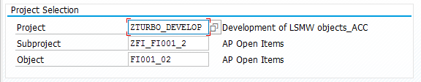

***Maintain Object Attributes:***

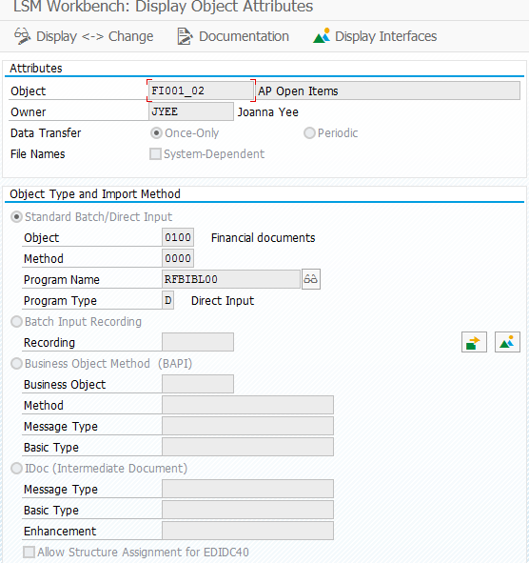

***Maintain Source Structures:***

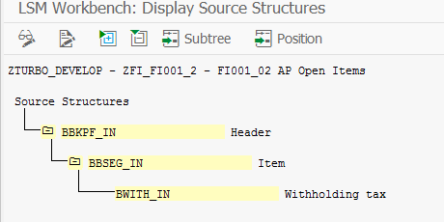

***Maintain Source Fields:***

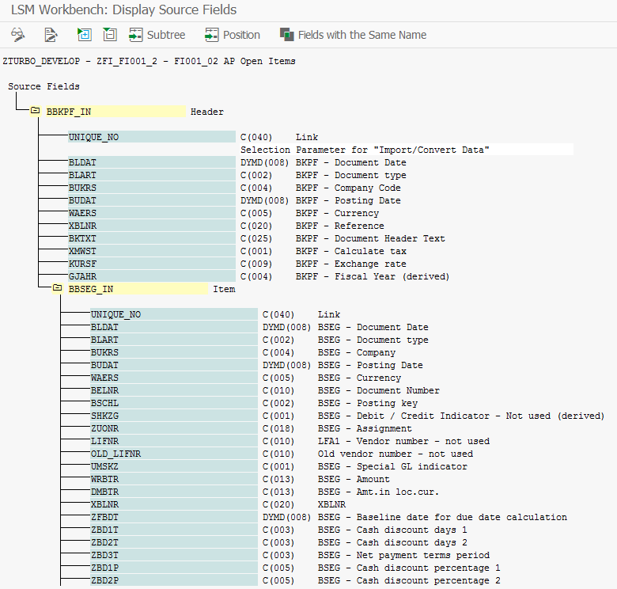

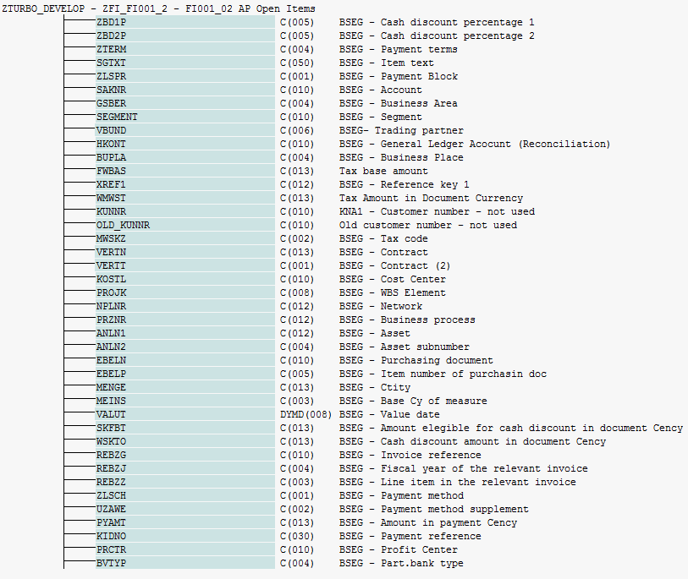

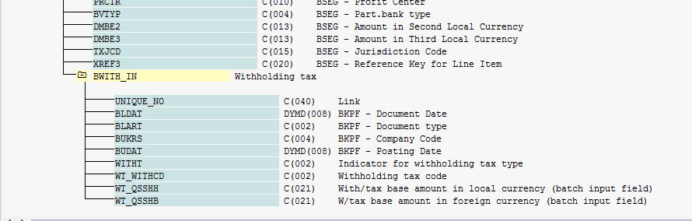

***Maintain Structure Relations:***

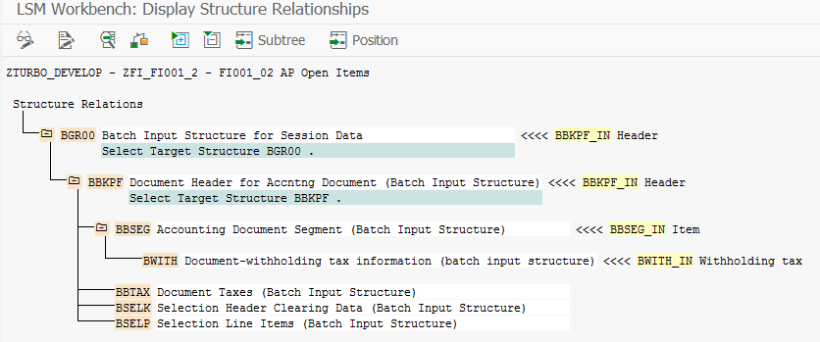

***Maintain Field Mapping and Conversion rules:***

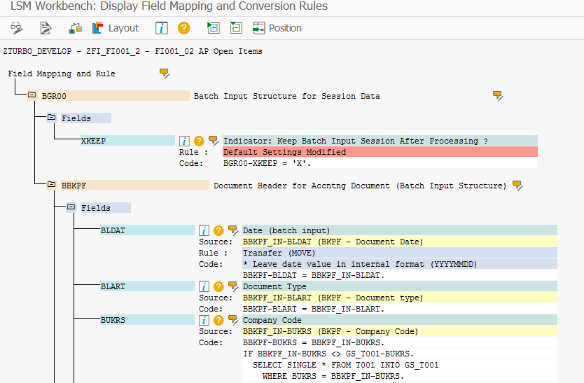

***Maintain Fixed Values, Translations, User-Defined Routines:***

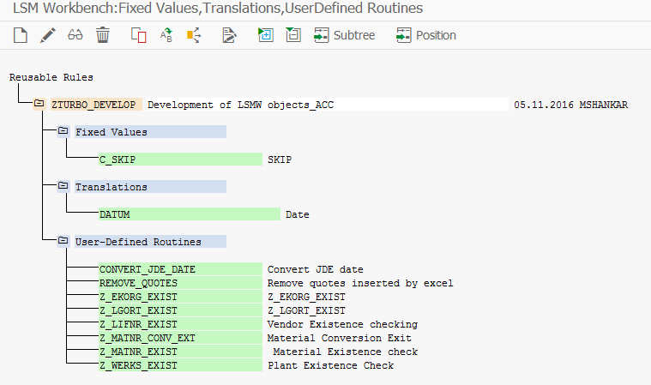

***Specify Files:***

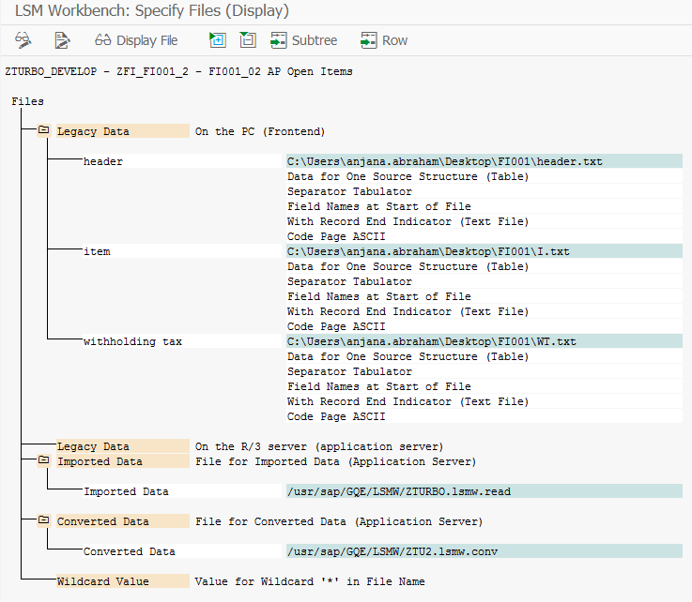

***Assign Files:***

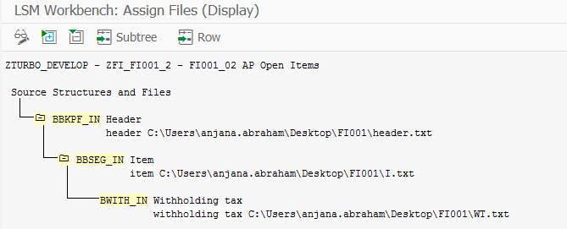

**4.6.1 Target System for loading**

**SAP System :**  ECC:  GTS:  APO:  TM:

**Non SAP System :**  TP:

**4.6.2 SAP Load Method**

**New Program:**  **Modification to Existing Program**:

BODS-IDOC/BAPI :

LSMW-BAPI/IDOC :  
LSMW Standard Program:-Direct input :  
LSMW Standard Program:-Batch input:

LSMW BDC Recording :

ABAP Program :

* + 1. **Lookup Table Schema**

|  |
| --- |
| **Attribute** |
| **Data source** DS_GDB_ETL_STG |
| **Type** Regular |
| **Lookup Table Name** CONSTRUCTION.MAP_TUR_TRANSFORM |

|  |  |  |  |
| --- | --- | --- | --- |
| **Field Name** | **Field Type** | **Length** | **Field Description** |
| BUKRS | VARCHAR | 4 | Company Code |
| ZTERM | VARCHAR | 4 | Payment Terms |
| ZLSCH | VARCHAR | 4 | Company Code | |

1. **Outstanding Issues**

| **Issue No** | **Description** | **Assigned To** | **Status** | **Impact** | **Resolution** |
| --- | --- | --- | --- | --- | --- |
|  |  |  |  |  |  |
|  |  |  |  |  |  |

1. **Appendix**
   1. ***Cross team help required***
   2. ***Glossary of Terms***

| **Term** | **Definition** |
| --- | --- |
| FDS | Functional Design |
| FMD | Functional Mapping Document |
| TD | Technical Design |
| TMD | Technical Mapping Document |
| TDDS | Technical Design Data Services |
| ECC | Enterprise Core Component |
| YYY | <Process Area> |
| CCM | Cost Center Master |
| DCT | Data Construction Tool |
| FF | Flat file |