PROJECT REPORT
Streamlining IT Procurement:
Automating Standard Laptop Orders with Flow Designer
ServiceNow Automation Project
Date | ____________________________
Team ID | ____________________________
Project Name | Streamlining IT Procurement: Automating Standard Laptop Orders with Flow Designer
Technology | ServiceNow Flow Designer
Maximum Marks | ____________________________

Prepared as an academic project report

1. Abstract
IT procurement teams frequently handle standard laptop requests for new employees, replacements, and approved upgrades. Manual processing can involve repeated data entry, approval follow-ups, procurement coordination, and status updates. This project proposes a ServiceNow Flow Designer solution that automates the standard laptop ordering workflow. The flow captures a request, validates required information, checks whether it follows the standard laptop policy, routes it for approval when required, creates procurement or fulfillment tasks, and communicates status to the requester. The objective is to reduce repetitive work, improve consistency, increase visibility, and create a traceable procurement process.

2. Introduction
Laptop procurement is a common IT service activity. A standard laptop request usually follows a predictable sequence: request submission, validation, approval, procurement, fulfillment, and closure. Because the sequence is repeatable, it is suitable for workflow automation. ServiceNow Flow Designer provides a low-code way to automate business processes using triggers, conditions, actions, approvals, tasks, notifications, and record updates.

3. Problem Statement
The standard laptop procurement process may depend on manual review and coordination between employees, IT support, managers, procurement teams, and asset teams. This can cause repeated data entry, approval delays, inconsistent handling, limited status visibility, manual follow-up, and difficulty maintaining a clear audit trail.

4. Project Objectives
The project aims to automate standard laptop requests, validate required information, route approval where required, create procurement/fulfillment tasks, update status automatically, notify relevant users, and maintain a consistent workflow.

5. Scope
In scope: standard laptop requests, request validation, approval routing, procurement task creation, status updates, notifications, and basic exception handling. Out of scope: vendor negotiation, physical warehouse operations, custom non-standard configurations, payment processing, and external supplier integration unless separately configured.

6. Ideation Phase – Brainstorming
The brainstorming phase identifies repeatable activities that can be automated before selecting the final solution.
No. | Idea | Description
1 | Automatic request validation | Check requester, laptop type/model, location, and required fields.
2 | Automatic approval routing | Send the request to the appropriate approver.
3 | Automatic procurement task | Create a task for procurement or IT asset fulfillment.
4 | Automatic status updates | Move the request through predefined stages automatically.
5 | Automatic notifications | Notify requester and responsible teams at important stages.
6 | Exception handling | Route incomplete or non-standard requests for manual review.

7. Idea Prioritization
Idea | Impact | Feasibility | Implementation | Selection
Request validation | High | High | Low | Selected
Approval routing | High | High | Medium | Selected
Procurement task | High | High | Medium | Selected
Status automation | High | High | Low | Selected
Notifications | Medium | High | Low | Selected
Advanced supplier integration | High | Medium | High | Future

8. Proposed Solution
A ServiceNow Flow Designer flow starts when a standard laptop request is created or submitted. It validates the request, identifies whether it is a standard laptop order, obtains approval when required, creates a procurement or fulfillment task, updates status, and sends notifications.
- Employee submits a standard laptop request.
- Flow is triggered.
- Required information is validated.
- Standard/non-standard condition is checked.
- Approval is requested when required.
- Procurement or fulfillment task is created.
- Status is updated.
- Requester and responsible teams receive notifications.
- Request is closed after fulfillment confirmation.

9. Flow Designer Design
Step | Flow Element | Purpose
1 | Trigger – Record Created/Updated | Starts the flow when the request is submitted.
2 | Validate Record | Reads and checks requester and laptop details.
3 | If – Required fields valid? | Routes incomplete requests for correction.
4 | If – Standard laptop? | Separates standard from non-standard requests.
5 | Approval | Routes the request to the required approver.
6 | Create Task | Creates procurement/asset fulfillment work.
7 | Update Record | Updates assignment, status, and progress.
8 | Notification | Communicates status to requester/team.

10. Detailed Workflow
REQUEST CREATED → VALIDATE DETAILS → STANDARD LAPTOP? → APPROVAL (IF REQUIRED) → CREATE PROCUREMENT TASK → UPDATE STATUS → NOTIFY REQUESTER → FULFILLMENT → CLOSE
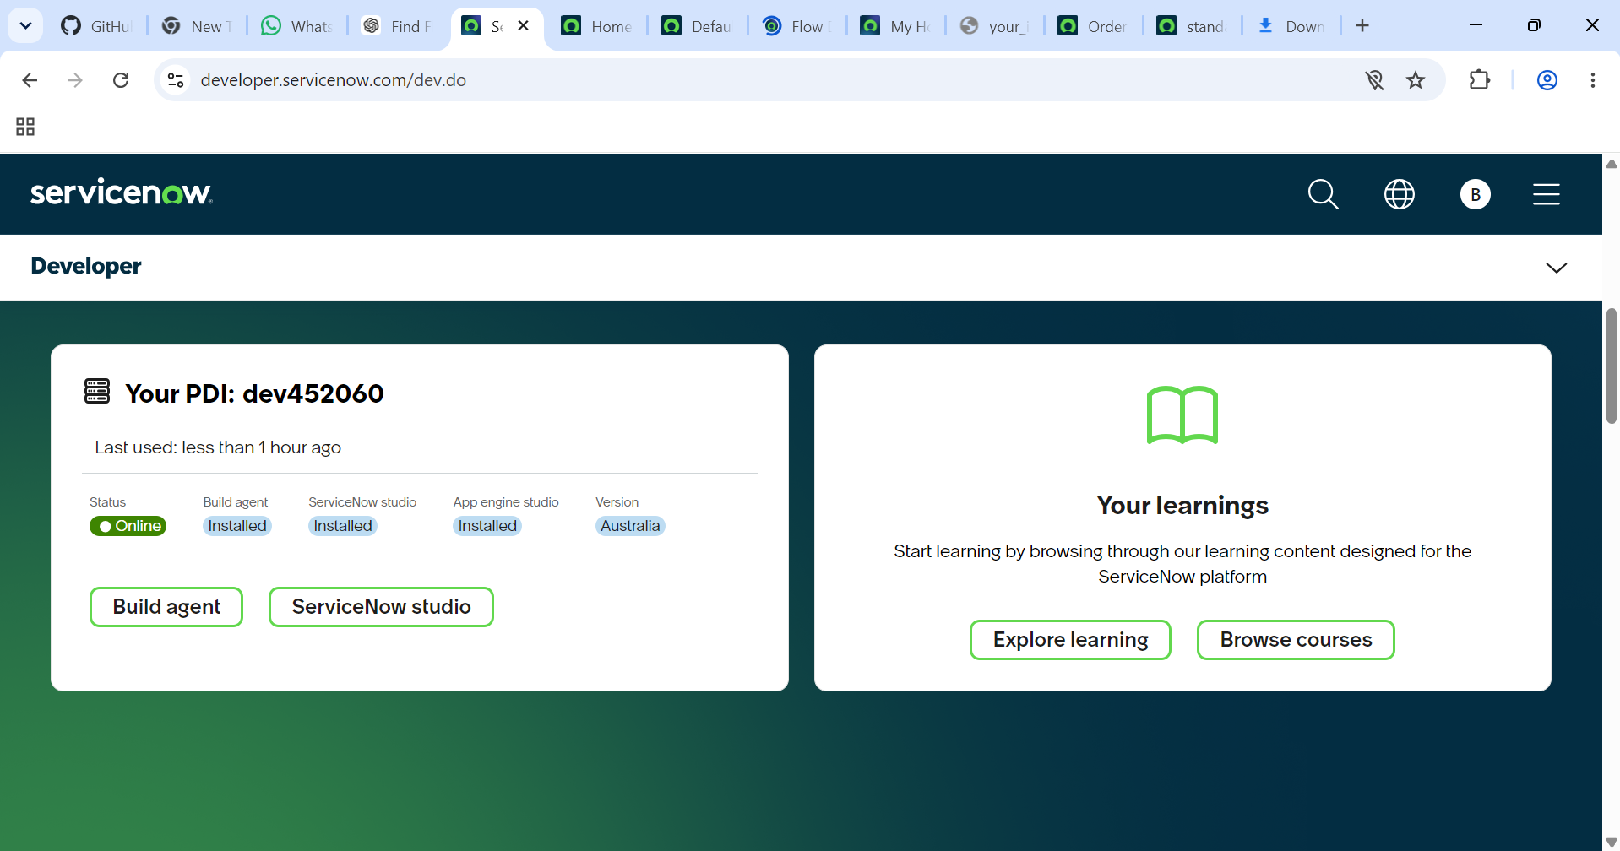
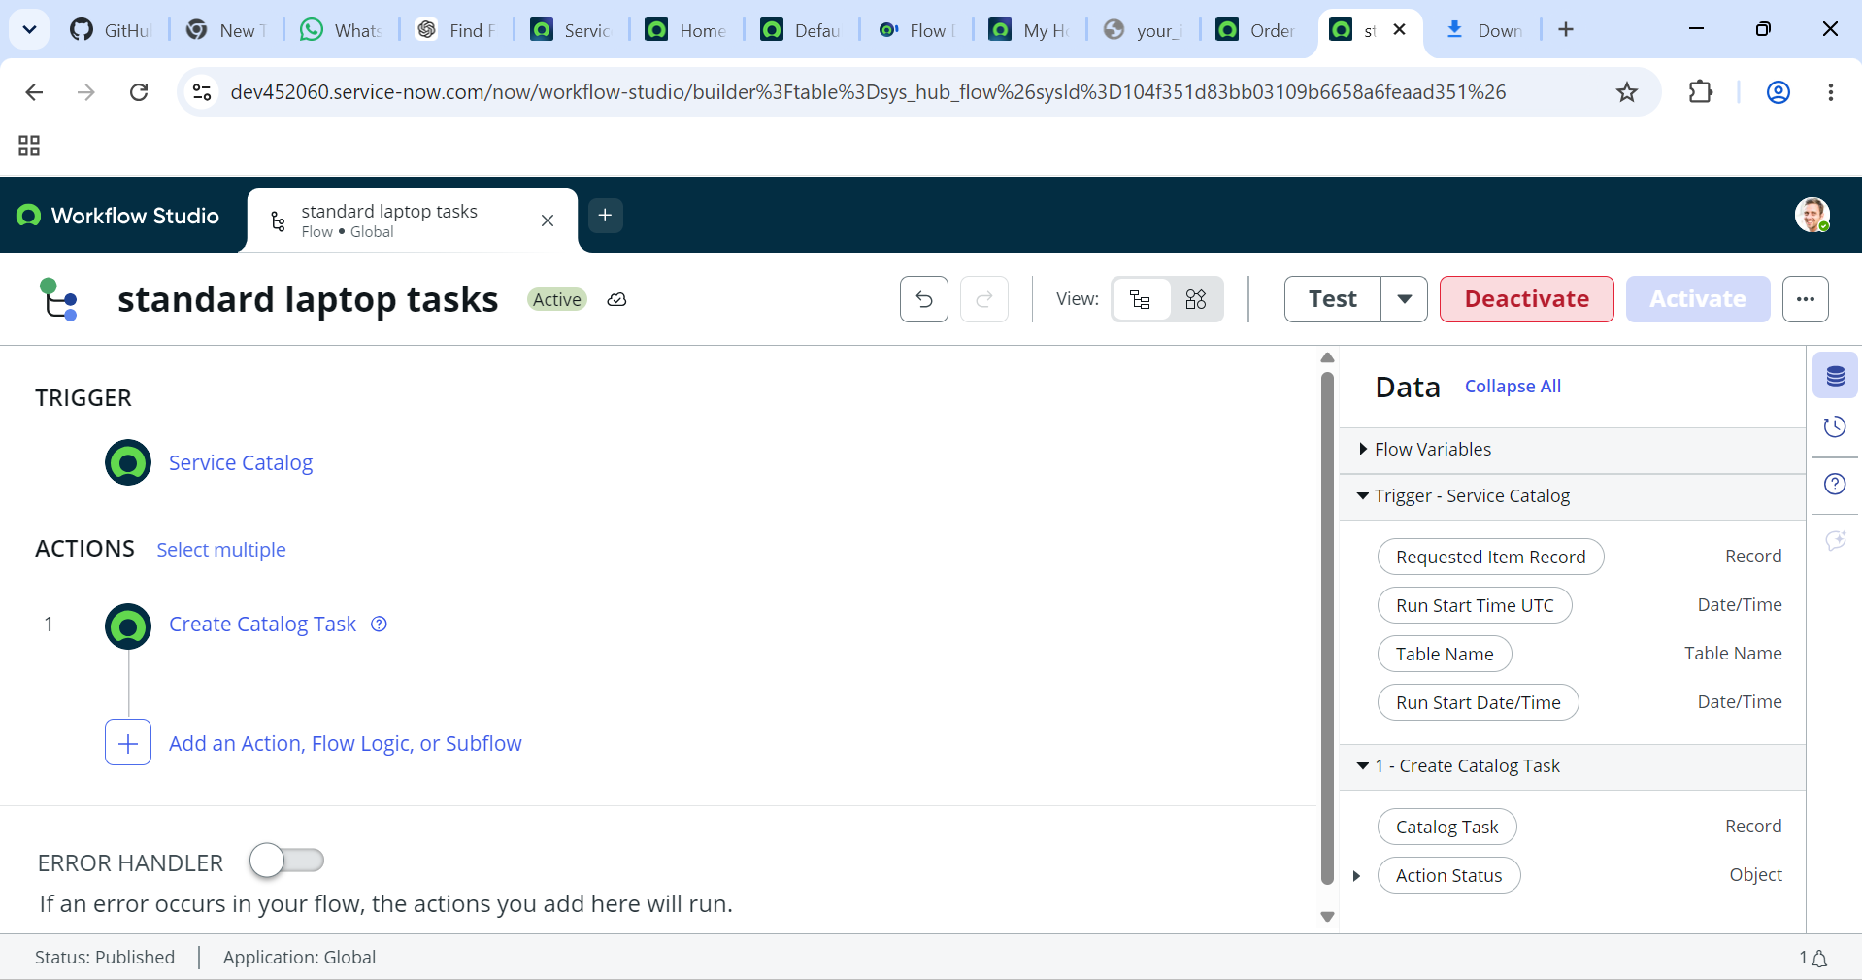

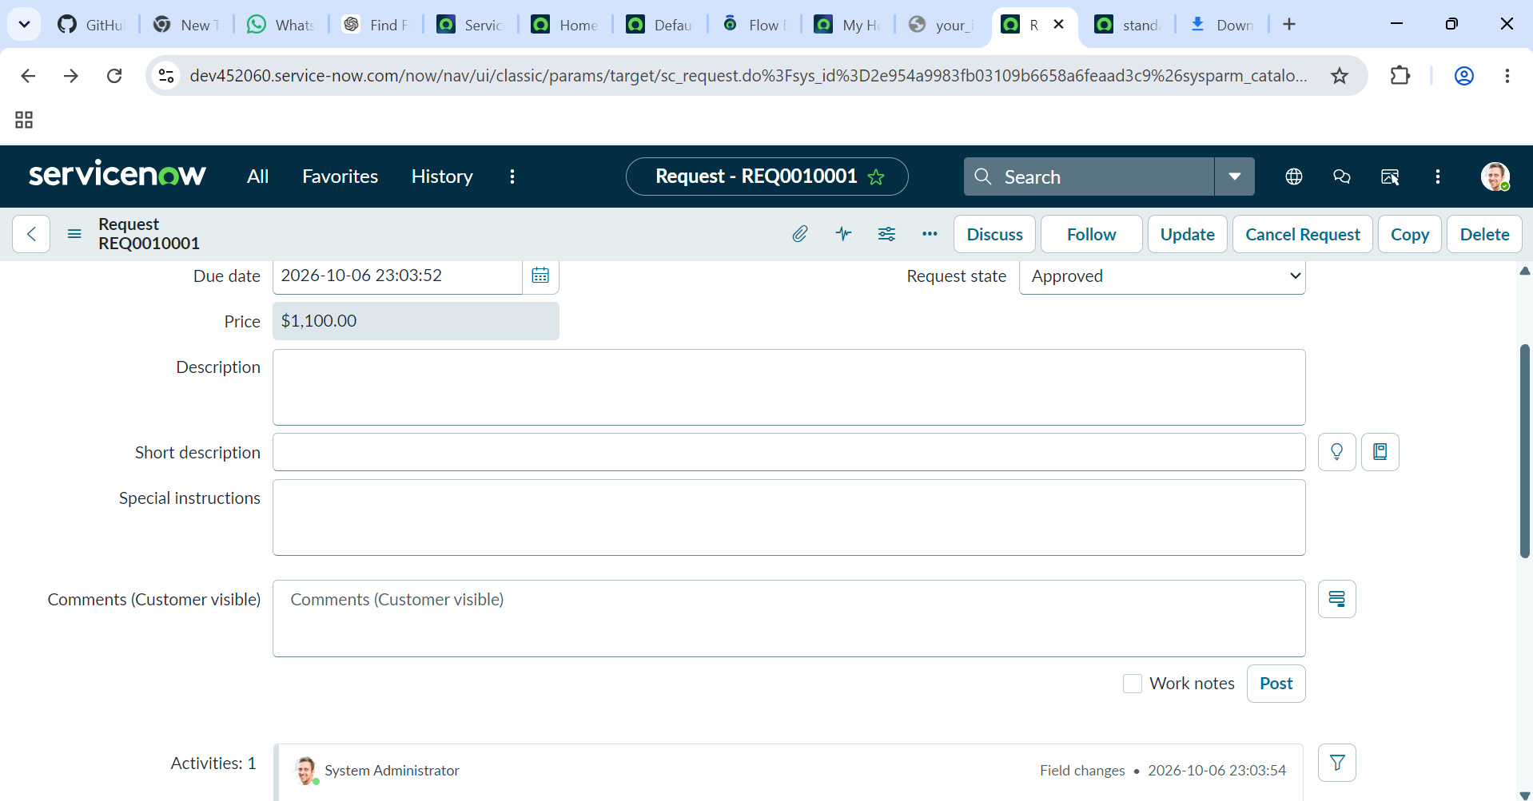

11. Sample Business Rules
Condition | Action | Assignment | Status
Standard laptop = Yes | Continue workflow | IT Procurement | In Progress
Required information missing | Return for correction | Requester | Incomplete
Approval required | Request approval | Approver/Manager | Awaiting Approval
Approved | Create procurement task | IT Procurement | Procurement
Rejected | Notify requester | Requester | Rejected

12. Implementation Steps in ServiceNow
- Open ServiceNow and navigate to Flow Designer.
- Create a new Flow named “Standard Laptop Order Automation”.
- Select the appropriate request/order record as the trigger.
- Configure the trigger for a newly submitted or created request.
- Add conditions to validate mandatory fields.
- Add an If/Else branch to identify standard laptop requests.
- Add an Approval action if policy requires approval.
- Add a Create Record/Task action for procurement or asset fulfillment.
- Add Update Record actions for assignment and status.
- Add Notification actions for requester and responsible teams.
- Save, test, and activate the flow.
- Create sample requests and verify each branch.

13. Testing Plan
# | Test Case | Expected Result | Status
1 | Valid standard laptop request | Flow starts and processes request | Pending
2 | Missing mandatory field | Request routed for correction | Pending
3 | Approval required | Approval task is generated | Pending
4 | Approval granted | Procurement task is created | Pending
5 | Approval rejected | Requester is notified | Pending
6 | Status update | Request status changes correctly | Pending

14. Expected Benefits
- Reduced manual effort for standard laptop requests.
- Faster and more consistent processing.
- Clear ownership of procurement tasks.
- Improved visibility into request status.
- Automated requester communication.
- Better auditability through workflow history and task records.
- Scalable foundation for future procurement automation.

15. Risks and Mitigation
Risk | Impact | Mitigation
Incorrect classification | Wrong workflow path | Use clear business rules and test cases.
Incomplete request data | Processing delay | Validate mandatory fields before approval.
Approval delays | Procurement delay | Use reminders/escalations where appropriate.
Incorrect assignment | Routing delay | Maintain clear assignment-group rules.

16. Future Enhancements
- Integrate with approved hardware catalogs.
- Connect with vendor/procurement systems through APIs.
- Add automatic inventory availability checks.
- Use approval rules based on department, cost center, or laptop model.
- Add SLA monitoring and escalation.
- Create procurement analytics dashboards.
- Explore AI-assisted classification for non-standard requests.

17. Conclusion
The proposed project demonstrates how ServiceNow Flow Designer can automate a repeatable IT procurement process. Standardizing validation, approval, task creation, status updates, and notifications can make laptop procurement more consistent and traceable. The design can later be extended to inventory checks, supplier integration, SLA management, and broader IT asset procurement.

18. References / Learning Resources
ServiceNow Flow Designer documentation and ServiceNow learning resources should be used during implementation. Exact table names, fields, approval policies, and procurement task configuration should be aligned with the ServiceNow instance used for the project.

19. Final Result

