

CCS ASSIGNMENT-1
NAME OF THE TECHNIQUE : PLAYFAIR CIPHER

TEAM MEMBERS:
Register Number :620123104014
Name : K.Boopathi
Year-sec : III-Year CSE-A

Source Code:
Index.html

<!DOCTYPE html>
<html lang="en">
<head>
<meta charset="UTF-8">
<title>Playfair Cipher</title>
<link rel="stylesheet" href="{{ url_for('static', filename='style.css') }}">
</head>
<body>
<div class="container">
<h2>Playfair Cipher Web App</h2>
<form method="post">
<label>Key:</label>
<input type="text" name="key" required value="{{ key }}">

<label>Text:</label>
<textarea name="text" rows="4" required>{{ text }}</textarea>

<div class="buttons">
<button type="submit" name="action" value="encrypt">Encrypt</button>
<button type="submit" name="action" value="decrypt">Decrypt</button>
</div>
</form>

{% if result %}
<h3>Result:</h3>
<div class="result">{{ result }}</div>
{% endif %}
</div>
</body>
</html>

Style.css
<!DOCTYPE html>
<html lang="en">
<head>
<meta charset="UTF-8">
<title>Playfair Cipher</title>
<link rel="stylesheet" href="{{ url_for('static', filename='style.css') }}">
</head>
<body>
<div class="container">
<h2>Playfair Cipher Web App</h2>
<form method="post">
<label>Key:</label>
<input type="text" name="key" required value="{{ key }}">

<label>Text:</label>
<textarea name="text" rows="4" required>{{ text }}</textarea>

<div class="buttons">
<button type="submit" name="action" value="encrypt">Encrypt</button>
<button type="submit" name="action" value="decrypt">Decrypt</button>
</div>
</form>

{% if result %}
<h3>Result:</h3>
<div class="result">{{ result }}</div>
{% endif %}
</div>
</body>
</html>

Main.py
from flask import Flask, render_template, request

app = Flask(__name__)

# ------------------ Playfair Cipher Core ------------------ #
def generate_key_square(key: str):
key = key.upper()
seen = set()
square = []
alphabet = "ABCDEFGHIKLMNOPQRSTUVWXYZ" # J omitted
for ch in key:
if not ch.isalpha():
continue
if ch == "J":
ch = "I"
if ch not in seen:
seen.add(ch)
square.append(ch)
for ch in alphabet:
if ch not in seen:
seen.add(ch)
square.append(ch)
return [square[i*5:(i+1)*5] for i in range(5)]

def find_position(square, ch):
if ch == "J":
ch = "I"
for r in range(5):
for c in range(5):
if square[r][c] == ch:
return r, c
raise ValueError(f"{ch} not in square")

def preprocess_plaintext(plaintext, filler="X"):
s = []
for ch in plaintext.upper():
if ch.isalpha():
s.append('I' if ch == 'J' else ch)
digraphs = []
i = 0
while i < len(s):
a = s[i]
if i+1 >= len(s):
b = filler
i += 1
else:
b = s[i+1]
if a == b:
b = filler
i += 1
else:
i += 2
digraphs.append((a, b))
return digraphs

def encrypt_pair(pair, square):
a, b = pair
ra, ca = find_position(square, a)
rb, cb = find_position(square, b)
if ra == rb:
return (square[ra][(ca+1)%5], square[rb][(cb+1)%5])
if ca == cb:
return (square[(ra+1)%5][ca], square[(rb+1)%5][cb])
return (square[ra][cb], square[rb][ca])

def decrypt_pair(pair, square):
a, b = pair
ra, ca = find_position(square, a)
rb, cb = find_position(square, b)
if ra == rb:
return (square[ra][(ca-1)%5], square[rb][(cb-1)%5])
if ca == cb:
return (square[(ra-1)%5][ca], square[(rb-1)%5][cb])
return (square[ra][cb], square[rb][ca])

def encrypt(plaintext, key):
square = generate_key_square(key)
digraphs = preprocess_plaintext(plaintext)
cipher_pairs = [encrypt_pair(p, square) for p in digraphs]
return "".join(a+b for a,b in cipher_pairs)

def decrypt(ciphertext, key):
square = generate_key_square(key)
s = [ch for ch in ciphertext.upper() if ch.isalpha()]
digraphs = [(s[i], s[i+1]) for i in range(0, len(s), 2)]
plain_pairs = [decrypt_pair(p, square) for p in digraphs]
return "".join(a+b for a,b in plain_pairs)

# ------------------ Flask Routes ------------------ #
@app.route("/", methods=["GET", "POST"])
def index():
result, text, key = None, "", ""
if request.method == "POST":
key = request.form.get("key", "")
text = request.form.get("text", "")
action = request.form.get("action")
if action == "encrypt":
result = encrypt(text, key)
elif action == "decrypt":
result = decrypt(text, key)
return render_template("index.html", result=result, text=text, key=key)

if __name__ == "__main__":
app.run(debug=True)

Encrption:

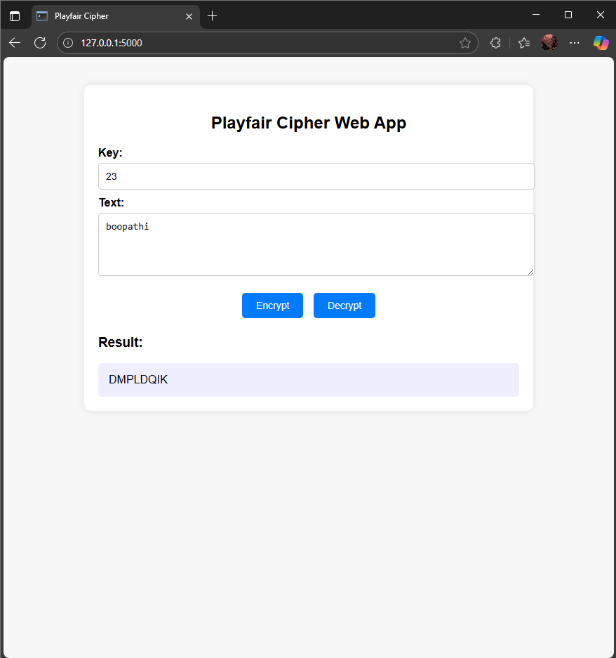
Decryption:

