Installing Strapi Using NPX
Strapi is a powerful open-source Headless CMS that enables developers to create flexible and scalable content APIs quickly. This guide walks you through installing Strapi using npx, explains each setup prompt, and prepares the document for adding screenshots.

Prerequisites
Ensure you have the following installed:
- Node.js ≥ 18.x
- npm ≥ 6.x
Verify your versions by running:
node -v
npm -v
If Node.js is not installed, download it from nodejs.org.

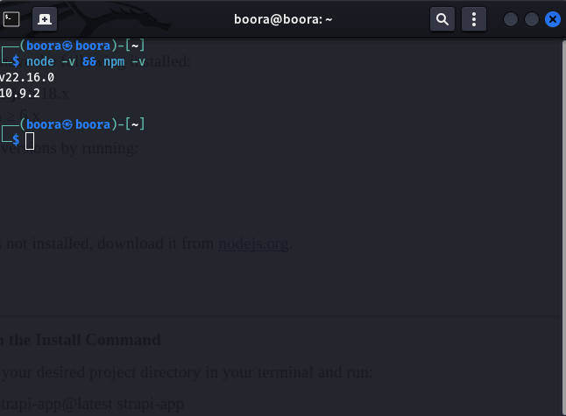

Step 1: Run the Install Command
Navigate to your desired project directory in your terminal and run:
npx create-strapi-app@latest strapi-app
This command:
- Creates a new folder named strapi-app.
- Initiates Strapi’s interactive setup process.
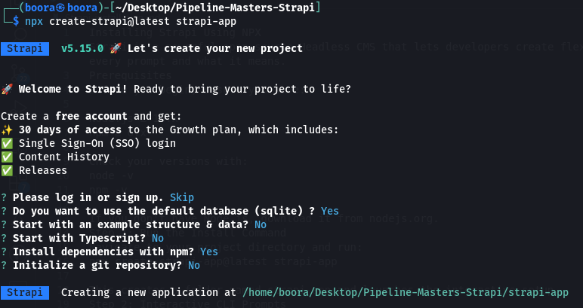

Step 2: Interactive CLI Prompts
Strapi’s setup process will prompt you with several questions. Below are the prompts, their meanings, and recommended responses:

1. Login or Sign Up
? Please log in or sign up.
❯ Skip
- Skip: Recommended for local development. Signing up provides access to premium features like SSO and Content History for 30 days.

2. Default Database Selection
? Do you want to use the default database (sqlite)?
❯ Yes
- ✅ Yes: Uses SQLite, perfect for quick setup and development.
- No: Allows connection to PostgreSQL, MySQL, or MongoDB later.

3. Starter Template Option
? Start with an example structure & data?
❯ No
- 🧱 No: Start with a blank project to design your own content types.
- Yes: Includes pre-filled content for testing and exploration.

4. Use TypeScript?
? Start with TypeScript?
❯ Yes
- ✅ Yes: Recommended for TypeScript users or production-grade applications.
- No: Uses plain JavaScript for simpler setups.

5. Install Dependencies
? Install dependencies with npm?
❯ Yes
- ✅ Yes: Automatically installs required dependencies.
- No: Choose this if you prefer manual installation later.

6. Initialize Git Repository
? Initialize a git repository?
❯ No
- 📁 No: Skip if you plan to initialize Git manually or integrate later.
- Yes: Automatically sets up a Git repository.

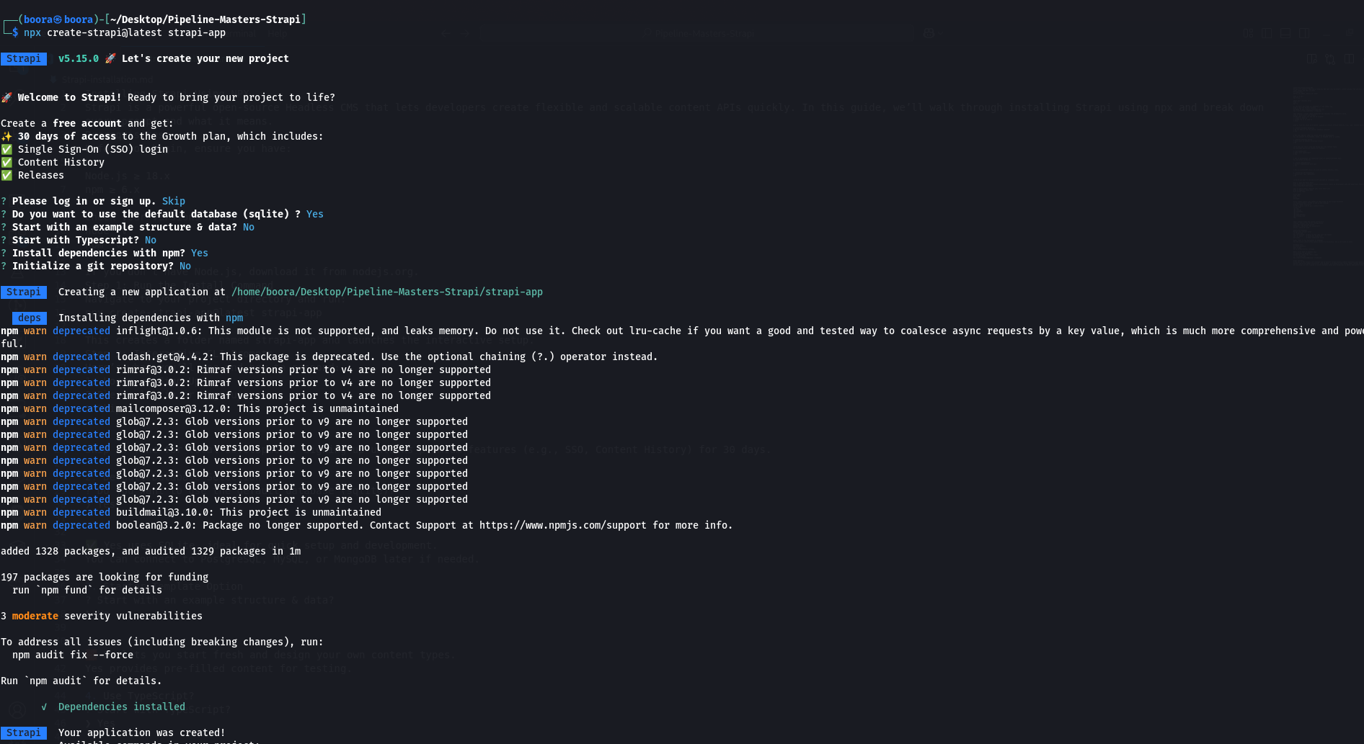

Step 3: Installation Completion
Once the setup process is complete, Strapi will display a confirmation message in the terminal, indicating that your application has been created and listing the available commands to manage your project.
The terminal output will look like this:
Dependencies installed

Your application was created!
To get started:
cd /home/boora/Desktop/PIPELINE-MASTERS-Strapi/strapi-app
npm run develop
This message confirms that the installation was successful and provides the next steps to start working with Strapi.

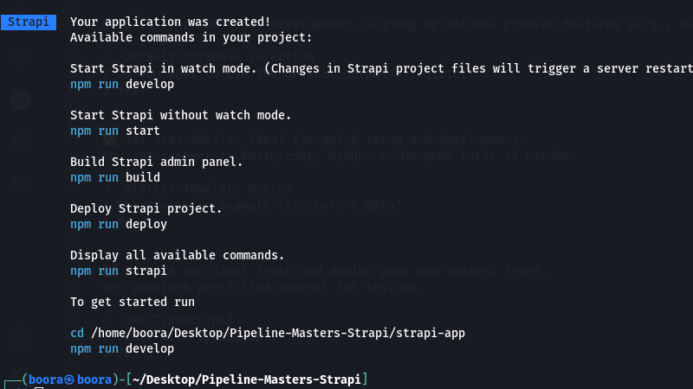

Step 4: Open the Admin Panel
After installation, Strapi starts in development mode and opens your browser to:
http://localhost:1337/admin
This is where you’ll register your first admin user.

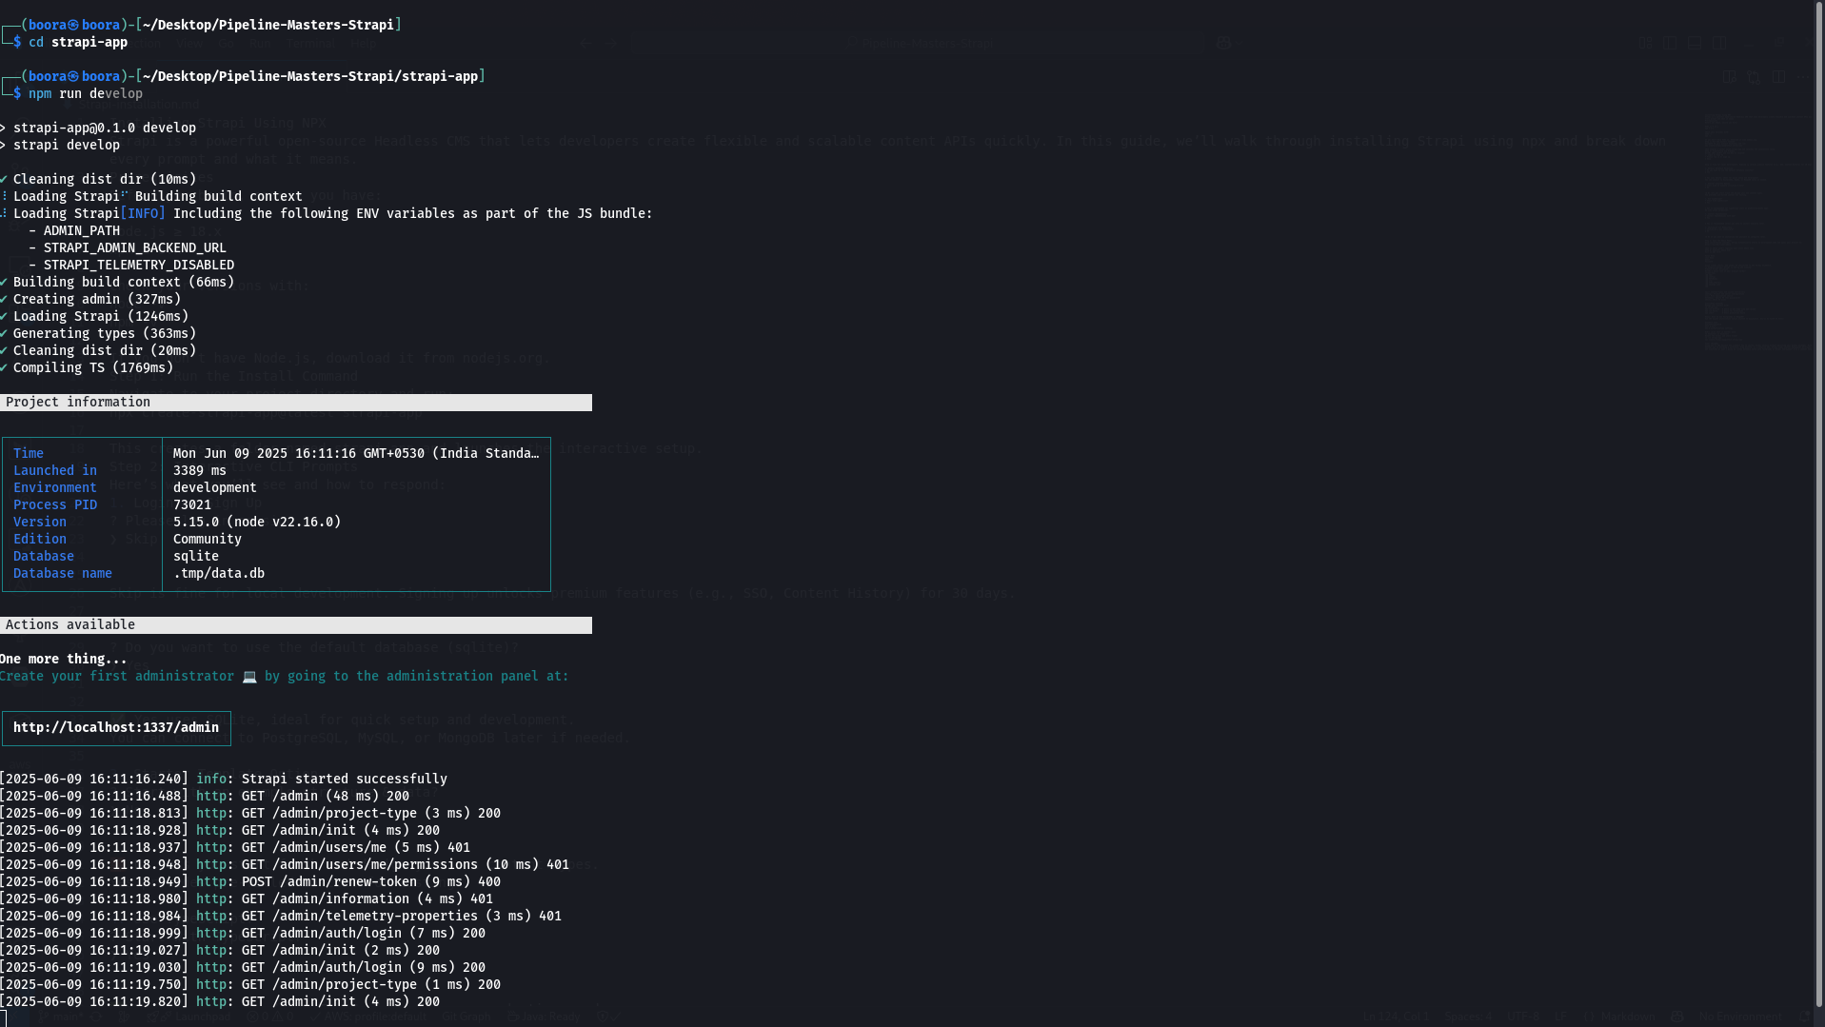
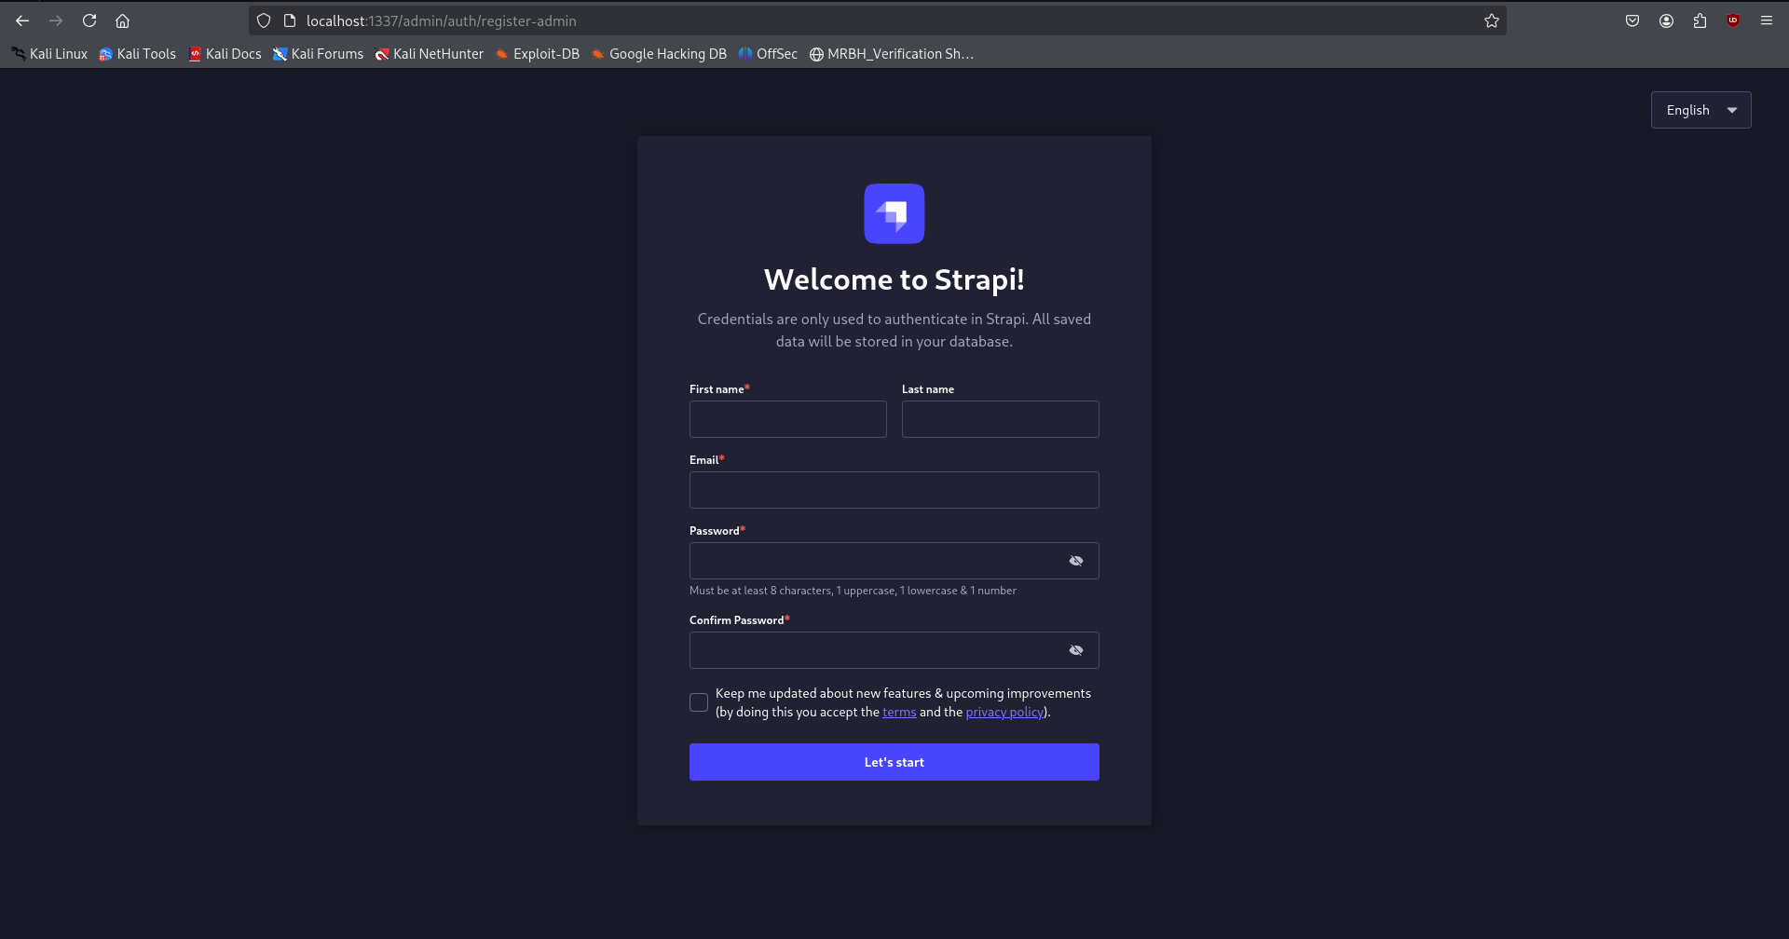

Step 5: Register Admin User
Complete the admin registration form:
- First Name
- Last Name
- Email
- Password
Click “Let’s Start” to access the Strapi dashboard.
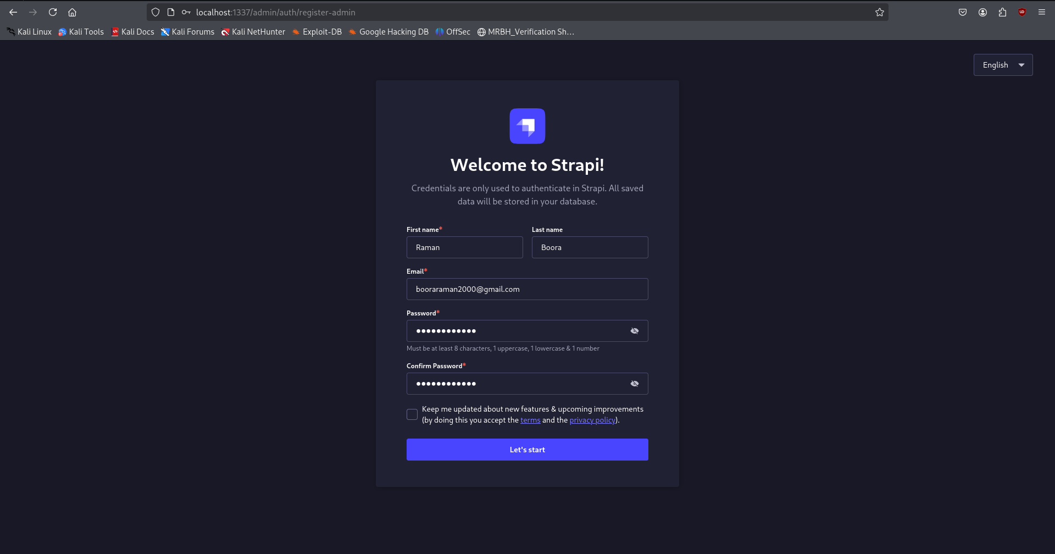
🎉 Congratulations! Your Strapi instance is now running!
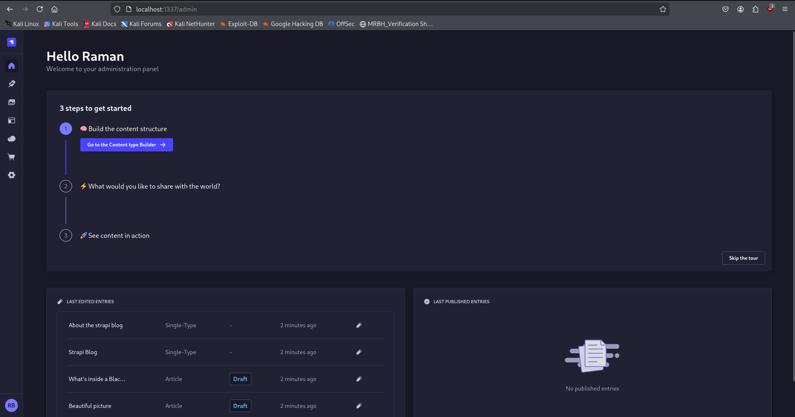

Project Folder Structure
Your project directory will look like this:
strapi-app/
├── api/ # Content-types and custom controllers
├── config/ # Project and server configurations
├── database/ # SQLite database (for quickstart)
├── src/ # Main application source
├── admin/ # Admin UI files
├── node_modules/ # Project dependencies
├── package.json # Project metadata and scripts
└── ...
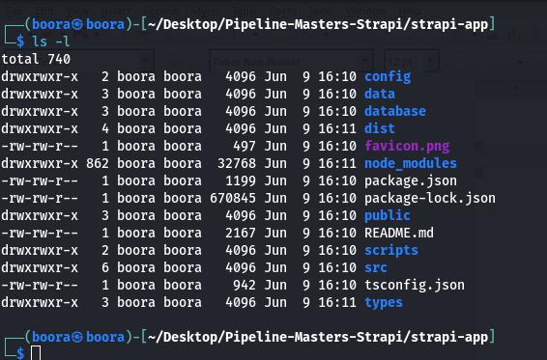

Start/Stop Commands
Manage your Strapi project with these commands:
cd strapi-app
npm run develop # Start in development mode with hot-reload
npm run build # Build for production
npm start # Start production build
