**Python to R spatial script conversion**

GitHub Repository: <https://github.com/bcgov/SSGBM-VRI-BEM>

1. Creation of the Ecosystem Spatial Product (VRI-BEM)

To assess habitat a wildlife species of interest, an ecosystem spatial (map) product is required. For this project, the main data sources used to build the map product are described in Table 1. The resultant map product is referred to as ‘VRI-BEM’ and covers the Southern portion of the Skeena region.

**Note:**

**For this Code-With-Us project, the data is provided and clipped to a sample area-of-interest.**

TABLE 1: Data sources used to create the VRI-BEM spatial product:

|  |  |  |  |  |
| --- | --- | --- | --- | --- |
| **Feature** | **Data Source** | **Uses in VRI-BEM product** | **Scale** | **Public Data** |
| Vegetation Resource Inventory (VRI) 2020[1] | DataBC | * Attain polygon linework * Assign forest cover attributes (e.g., crown closure, stand composition, forest age to structural stage, etc.) * Assign Biogeoclimatic Ecosystem Classifications (BEC) * Correct BEM labels | 1:20 000 | Yes |
| Consolidated Cutblocks (CCL) 2020[2] | DataBC | * Delineate harvested areas | 1:20 000 | Yes |
| Fire disturbance | BC LDW | * Delineate burn severity | 1:20,000 | Yes |
| Digital Elevation Model (DEM) | n/a | * Assign slope, aspect, elevation | 25 m | No |
| Broad Ecosystem Mapping (BEM) | DataBC | * Assign ecosystem labels | 1:250,000 | Yes |
| Freshwater Atlas (FWA) | DataBC | * Identify floodplain areas * Correct ecosystem labels related to large and small lakes, riparian, and open water features. | 1:20,000 | Yes |
| BEC Data | VRI | * BEC Data from VRI for Zone/ Subzone/ Variant | 1:20 000 | Yes |

* 1. Processing Overview

The following is an overview of the main processing steps applied to create the VRI-BEM:

* Download and prepare data layers used as inputs to the spatial mapping product.
* Assign DEM data (slope, aspect, elevation) to each VRI polygon based on majority area of 25 m by 25 m grid cells (pixels) that overlap with each VRI polygon.
* Assign Broad Ecosystem Units (BEU) from BEM to each VRI polygon.
* Conduct quality assurance (QA) and corrections of assigned ecosystem labels to new scale (VRI polygon scale) (refer to Appendix B).
* Create rules (logic) to assign structural stage and stand composition (current conditions) to broad ecosystem units based on VRI tree species and age data.

Figure 2 depicts some of these steps. GIS processing methods are described in detail in Appendices A.

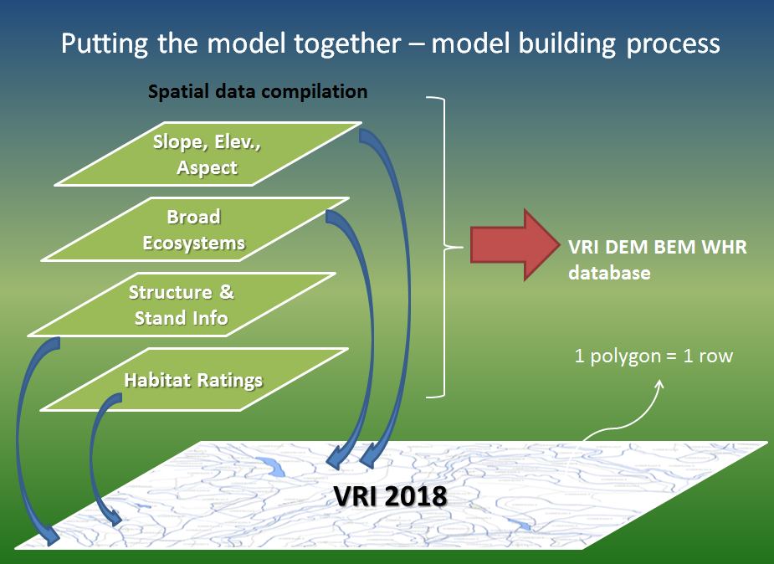

**VRI**

FIGURE 2: Overview of inputs and process of building the VRI-BEM ecosystem interpretation spatial coverage for the South Skeena.

1. <https://catalogue.data.gov.bc.ca/dataset/vri-forest-vegetation-composite-polygons-and-layer-1>
2. <https://catalogue.data.gov.bc.ca/dataset/harvested-areas-of-bc-consolidated-cutblocks->