H05D4A: Computer Architectures

Exercise sessions 1-2-3

Goal of these exercise sessions
These exercise sessions aim to help you build a good understanding of the basic RISC-V CPU architecture and the typical digital ASIC design flow. In the sessions, you will develop a complete processor in Verilog, going through simulation, synthesis, and place & route steps till eventually generating the GDSII file.
- You start by completing the necessary components of a single-cycle processor and simulating it with a simple program. Then add a new instruction support for multiplication (MULT).
- Next, you will increase its performance by pipelining the processor, based on which you will learn how to run the full digital backend flow.
- Afterwards, you will update your CPU architecture to handle different hazard situations.
- In the end, you will use the knowledge you learned from the course to optimize the latency of running a matrix-matrix multiplication program.

Information about the tools
To complete the assignment, you will work with two kinds of tools:
One kind is for the functional correctness check, using Cadence Xcelium.
Another kind is for the digital backend flow, for which we adopt the OpenLane flow, as shown below. The tools used in each separate step are highlighted with red boxes.
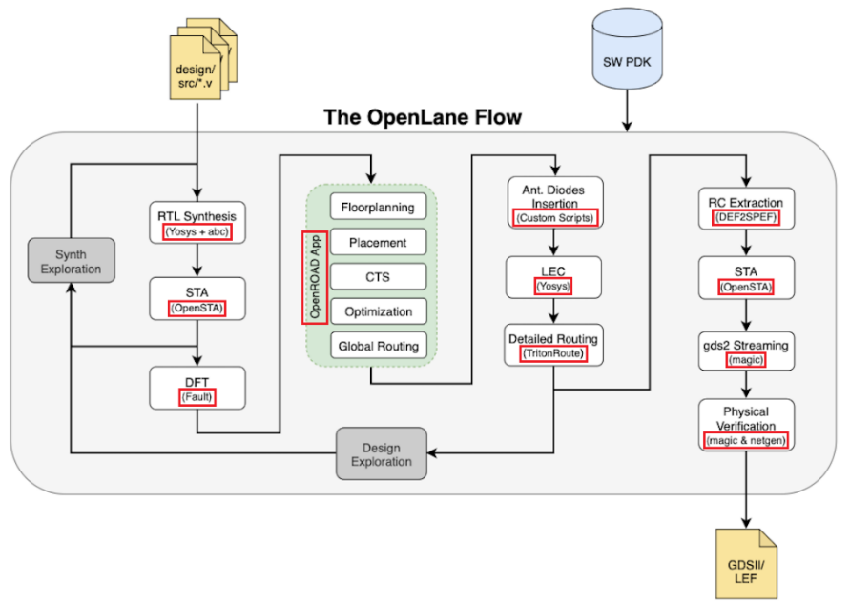
Xcelium helps you to perform cycle-accurate simulation based on your testbench and HDL codes. OpenLane helps you to automated RTL to GDSII flow based on several components including OpenROAD, Yosys, Magic, Netgen, CVC, SPEF-Extractor, KLayout and several custom scripts for design exploration and optimization. You can find more information here: link. The 130nm SkyWater open-source PDK, SKY130, is used in the backend flow for this exercise.
These tools are set up for you.

Project workspace
- To create your workspace, you have to download from Toledo the file CA_Exercise_2026_release.zip. Extract it to some location of your system.
The folders that compose our project workspace are:
- Verilog: All the Verilog files that define the logic of the processor.
- SIM: Files for running the simulation of the HDL code.
  - SIM/data: Subfolder that contains the assembly code to run.
- Backend: Files for running the backend flow for the processor.

For using the tools and completing the exercise sessions, it is recommended to have access to ESAT servers. You can either come to the ESAT computer room or connect remotely through SSH connection.
If you are not familiar with SSH connections and/or git versioning tool and want to use them, please check out the documents and guides provided for you in the course material.

Run CYCLE-Accurate Simulation (for Functional Correctness check):
To run the simulation of the processor:
- Switch to the simulation folder /SIM. Run the command source xcelium_23.03.rc
- Run the command make sim_gui through a terminal (Optionally run the command make sim to use the tool without a graphical interface which checks the correctness of the program). This command will call all the HDL files declared in SIM/files_verilog.f and will execute the testbench RTL/cpu_tb.v. This testbench
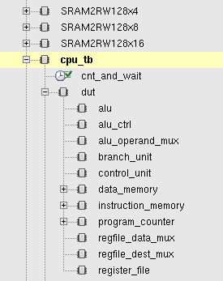
  - declares an instance of the cpu
  - loads the instruction memory from the file SIM/data/imem_content.txt
  - loads the data memory from the file SIM/data/dmem_content.txt
  - starts the execution of the instructions.
- After running the command, the Xcelium graphical interface will open. In the left part of the window the whole hierarchy of the design can be found.
- With the objective of displaying the internal signals for debugging, go to the target submodule and select it. Afterwards do right-click over the signals to display and select “Send to Waveform Window.” Finally run the simulation with the button:
- To change the current executed program (to change instruction and data memory content) modify the hexadecimal files imem_content.txt and dmem_content.txt (contained in the folder SIM/data) with the instruction memory and data memory, respectively. Several example programs can be found in the folder SIM/data/testcode. The files with the format NAME_OF_PROGRAM_imem_content.txt and NAME_OF_PROGRAM_dmem_content.txt, which contain the data for the instruction memory as well as the data for the data memory respectively, must be copied into the files SIM/data/imem_content.txt and SIM/data/dmem_content.txt. These last-mentioned files are the files effectively loaded by the simulation.

Run Backend Flow (for Timing and Area check):
You can prepare the backend environment using the following steps:
- Go to the “Backend” folder, run the command: source setup.sh.
- In the terminal, type the command jupyter-lab. This should introduce you to the website of Jupyter notebook.
- The Jupyter notebook is divided into 3 parts. The first part is the prerequisite of the scripts, like environment variables’ settings, function definition etc. The second part is about the synthesis. You need to run synthesis with every implementation. The last part first leads you to the floorplanning step with visualization, and then goes through the whole backend flow. You will be able to see the layout of the chip.

Tasks to be done by you in these exercise sessions:
The datapath as well as its submodules have already been implemented for you in Verilog. However, the functionality of the processor must be completed by carrying out the tasks described underneath (1,2,3,4,5).

1. Single Cycle processor with adder
Complete the internals of the control unit to handle the following instructions: (BEQ, JUMP, LW, SW, ADDI as well as R-type ALU instructions called ‘ ALU_R’). Set the outputs of the control unit correctly depending on the fetched instruction, ensure the correct datapath behavior.
==> For debugging purposes, you can use the test code simple_program in the folder SIM/data. Next, the code “MULT1” executes the multiplication of 5 integers and sums all the results. Test this code to ensure that your design is correctly implemented. Then, fill the cycle counts into the report table.
==> At this step, you are also required to run the synthesis. You need to set up the backend tools and open the Jupyter Lab, then follow the instruction in synthesis stage. Fill in the timing and area info after synthesis into the report table.

2. Single Cycle processor with multiplier
The processor completed in the last exercise can execute multiplications through sums and shifting since there is no hardware support to carry out the multiplication in one cycle. With the purpose of boosting performance, your task will be to add hardware support for multiplication and evaluating its impact on performance (number of cycles to finish the run). The processor must be able to process the multiplication instruction MULT. The format of the instruction is the following:
0000001 | XXXXX | XXXXX | 000 | XXXXX | 0110011
[31:25] funct7 | [24:20] rs2 | [19:15] rs1 | [14:12] funct3 | [11:7] rd | [6:0] opcode
Three files might need to be modified for this purpose: control.unit.v, alu_control.v and alu.v. To test the performance and correctness of your design, load the assembly test code “MULT2” which now uses the implemented MULT instruction to carry out the same 5 multiplications and sums of the testcode “MULT1”. After updating your design, run the simulation and synthesis.
- (For you to think) Is it necessary to modify the control unit for the insertion of the MULT instruction?

3. PIPELINED processor
In this part of the session, we will modify our processor to convert it to a pipelined implementation. For now, assume data and control hazards are solved by inserting NOP instructions.
For a processor with 5 pipelined stages (Instruction Fetch (IF), Instruction Decode (ID), Execute (EXE), Memory (MEM) and Write Back (WB)), identify which hardware resources belong to each of the mentioned stages, and which signals should go from stage to stage. Using Figure 4.31 of the book, try to match the HDL code with the Architecture and complete the tables underneath.
 | IF | ID | EXE | MEM | WB
Datapath Resources

 | IF > ID | ID > EXE | EXE > MEM | MEM > WB
Signals

Insert the pipelined registers where necessary, using the module reg_arstn_en. This module implements a register with variable width, which is set through the parameter DATA_W. See the inset on the right for an example for such a pipelined register between the Fetching (signals signal_IF) and Decode stage (signal_ID). Connect the enable signal of the pipelined registers to the global enable signal called enable. After updating your design, run the test code MULT2 again and ensure the correct functionality.
reg_arstn_en#(
.DATA_W(16)
) signal_pipe_ID_EX(
.clk (clk ),
.arst_n(arst_n ),
.din (signal_IF ),
.en (enable ),
.dout (signal_ID )
);
Afterwards, open the Jupyter Notebook to run through the complete backend flow. Try to understand the general idea of the flow. Note down the timing and area info after Logic Synthesis step. Then track the change of timing and area in the reports of subsequent steps, and reason for this change. Also, in the notebook, we provide you with the script to visualize the chip formation step-by-step.
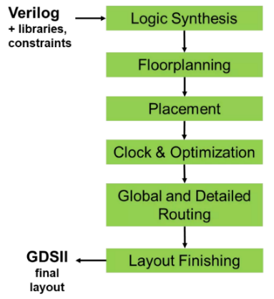
The general digital backend flow steps

4. PIPELINED processor with Data-hazard resolution
Since the pipelined processor implemented does not have support for handling data hazards, the execution of more complex code containing branches or data dependencies would not work properly.
Add hardware support for forwarding and stalling to achieve this functionality. After updating your design, run the test code MULT3 to ensure the correct functionality.
Finally, open the Jupyter Notebook to run through synthesis steps and compare the results with the previous implementations. If you are interested, you can also run through the entire backend flow for better comparison (not required).

5. Advanced acceleration
This last exercise aims at demonstrating how an architecture can leverage the structure of a program to speed up its execution. To do so, your will accelerate the execution of the following matrix-matrix multiplication:
$$\left(\begin{matrix}\begin{matrix}1 & 2 & 3 \\ 6 & 7 & 8\end{matrix} & \begin{matrix}4 & 5 \\ 9 & 10\end{matrix} \\ \begin{matrix}11 & 12 & 13 \\ 16 & 17 & 18\end{matrix} & \begin{matrix}14 & 15 \\ 19 & 20\end{matrix}\end{matrix}\right). \left(\begin{matrix}\begin{matrix}21 & 26 & 31 \\ 22 & 27 & 32\end{matrix} & \begin{matrix}36 & \begin{matrix}41 & 46\end{matrix} \\ 37 & \begin{matrix}42 & 47\end{matrix}\end{matrix} \\ \begin{matrix}23 & 28 & 33 \\ \begin{matrix}24 \\ 25\end{matrix} & \begin{matrix}29 \\ 30\end{matrix} & \begin{matrix}34 \\ 35\end{matrix}\end{matrix} & \begin{matrix}38 & \begin{matrix}43 & 48\end{matrix} \\ \begin{matrix}39 \\ 40\end{matrix} & \begin{matrix}\begin{matrix}44 & 49\end{matrix} \\ \begin{matrix}45 & 50\end{matrix}\end{matrix}\end{matrix}\end{matrix}\right)=\left(\begin{matrix}\begin{matrix}355 & 430 & 505 \\ 930 & 1130 & 1330\end{matrix} & \begin{matrix}580 & \begin{matrix}655 & 730\end{matrix} \\ 1530 & \begin{matrix}1730 & 1930\end{matrix}\end{matrix} \\ \begin{matrix}1505 & 1830 & 2155 \\ 2080 & 2530 & 2980\end{matrix} & \begin{matrix}2480 & \begin{matrix}2805 & 3130\end{matrix} \\ 3430 & \begin{matrix}3880 & 4330\end{matrix}\end{matrix}\end{matrix}\right)$$
For this exercise, a baseline program (MULT4) is provided to execute this matrix multiplication. This program operates on two matrices I and W stored in row-major order and column-major order, respectively, and appends the result O in row-major order after the operand matrices in the data memory space.
Using your pipelined implementation as a basis, elaborate a solution to accelerate the executions of matrix multiplications (hints: Patterson-Hennessy Section 4.8 to 4.10, RISC-V specification chapter 17). Simulate your design to ensure correctness and check the latency (number of cycles to complete MULT4). Then, run the backend flow (synthesis required, floorplan & signoff optional) to get the timing and area information. In the end, you can visualize the generated GDSII file.

Other useful info
- The deadline of the project is at the beginning of May 2026.
- The assignments must be completed in groups of no more than 2 people.
- After completing each exercise, the results must be shown to the TAs for its correspondent evaluation.
- Also, you will hand in a small report which includes the performance of your processor after each step and some questions to answer.
- This project counts for 4 points in the final grade. The report and your final processor design need to be submitted to Toledo. The deadline will be set and communicated to you.

