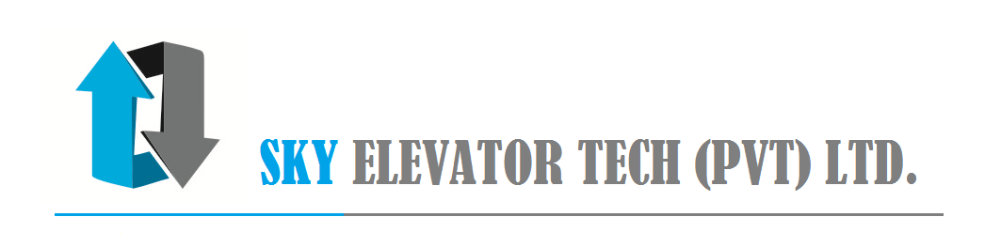

Our Ref: <our_ref>

Date: 5<start_date_format1>

<name>,

<address_no_and_road>,

<address_city>

Dear <sir_or_madam>,

**Subject: Job Completion and Handing Over of Elevator.**

**Agreement No.: <agreement_no>**

With reference to the above subject, we wish to inform you that we have successfully completed installation and the lift is ready for commissioning.

Kindly find the attached inspection sheet, sign with stamp and return a copy to us,

Upon receiving of the signed copy, we will send you the original warranty certificate.

The free maintenance and warranty period would be commencing from <start_date_format2> to <end_date_format2>.

Also, kindly arrange the payment on delivery of the original document and Invoice.

For Emergencies please contact following numbers;

Office hours: Office – 0113-069079

Off peak hours: 0766 722 000

Note: The continuation of the Annual Maintenance will be subject to the release of retention payment in line with the terms and conditions.

Thanking you and assuring you of our best attention and services at all times.

Handed over by, Received by,

…………………… ....................................

Sky Elevator Tech pvt ltd <received_by_name>

Mobile 077-0515005

City Office: Off Alfred House Avenue, Level 2, #03, Dharmaraja Mawatha, Colombo-3, Sri Lanka.

<Tel:+94> 113 069 079, Fax: +94 112 553 919, Mobile: + 94770515005, Email: [info@set-lift.com](mailto:info@set-lift.com), Web: www.set-lift.com