**\***

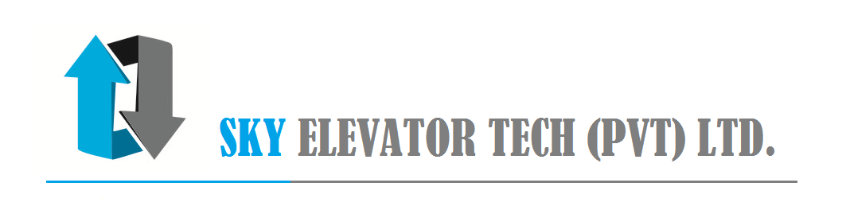

**Warranty Certification**

Our Ref: <ref_no>

Date: <start_date_format3>

***Project Name:*** <project_name>

Contact Person: <contact_person>

Location: <location>

**Agreement No.: <agreement_no>**

SKY Elevator Tech (Pvt) Ltd. hereby warrants each new product of the <supplier_name> at above project which supplied and installed by SKY Elevator Tech (Pvt) Ltd to be free from defects in material for a period of five (05) years from the date of handing over (<start_date_format2>). SKY Elevator Tech will repair/ replace without charge any part or component thereof which is defective.

This warranty shall not apply and shall be void for any damages or loses arises out of causes beyond its reasonable control (a "Force Major Event"), including, but not limited to, acts of God or public enemy, acts of other parties, acts of civil and military authority, unusually severe weather and cause of water and lightning and rodent attacks. And also, any alteration or modernizations are not covered if required by government bodies or landlord or any others.

Note:

1. This certificate will not be valid in case of unpaid of the any payments and due exceeding 60 days from the date of invoice.
2. This certificate is invalid if the Retention payment in not paid upon completion of One year and within 2 months of the invoice date or Annual maintenance contract is not renewed or any unauthorized bodies involved in any repairs.
3. Please not the elevator Shaft and the machine room to be protected from water and Rodent. Further the building to be protected from lightning attacks which are not covered in the warranty.

Thank you,

……………………………………….

Yours faithfully

**SKY Elevator Tech (Pvt) Ltd**

City Office: Off Alfred House Avenue, Level 2, #03, Dharmaraja Mawatha, Colombo-3, Sri Lanka.

<Tel:+94> 113 069 079, Fax: +94 112 553 919, Mobile: + 94770515005, Email: [info@set-lift.com](mailto:info@set-lift.com), Web: www.set-lift.com

**Monthly Maintenance Check Lift**

|  |  |
| --- | --- |
| **1.** | **Machine Room** |
| 1.1 | Machine Room Cleaning |
| 1.2 | Machine Room Light |
| 1.3 | Machine Room Ventilation/Air Condition. |
| 1.4 | Machine oil level |
| 1.5 | Machine oil leak |
| 1.6 | Break operation |
| 1.7 | Machine baring Noise |
| 1.8 | Break Operation |
| 1.9 | Rope condition |
| 1.10 | panel Cleaning |
| 1.11 | Speed governor |
| 1.12 | Speed governor rope condition |
| 1.13 | ARD Operation |
| **2.** | **Hoist Way** |
| 2.1. | Rails and rail bracket cleaning |
| 2.2. | Entrance sill cleaning |
| 2.3. | Entrance header cleaning |
| 2.4. | Header track and contact cleaning |
| 2.5. | Push button and indicators |
| 2.6. | Pit cleaning |
| 2.7. | Pit light |
| 2.8. | Final limit switch Operation |
| 2.9. | Door contact check |
| 2.10. | Emergency Intercom/ Bell |
| **3.** | **Elevator Car** |
| 3.1. | Inspection Operation |
| 3.2. | Car Top Cleaning |
| 3.3. | Car top light |
| 3.4. | Car ceiling Light |
| 3.5. | Fan |
| 3.6. | Rail oil |
| 3.7. | Car door operator Service |
| 3.8. | Door detectors |
| 3.9. | Push button and indicators |
| 3.10. | Flooring Condition |