# HW : 4 PyCity Schools Analysis

For this assignment two CSV files are given, one with school name, type, size and budget, and other one with students and their reading and math score.

The average passing data for both the type of schools, charter and district, is as shown below :



From the data give it can be concluded that

1. Charter schools has higher percent passing in math and reading. Also, of 15 schools under study all eight Charter schools ranked first followed by district schools.

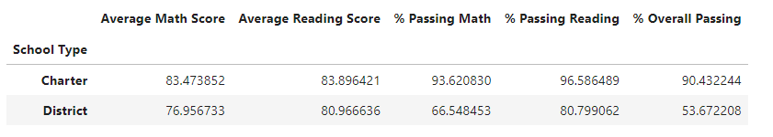

1. Schools with number of students greater than 2000 had less overall passing percentage

1. Charter Schools has less students along with less per student budget, but with higher % overall passing rate.

1. More information on the teacher to student ratio, private funding, school grade, extra curriculum activities and location of schools will help in analyzing the data further.