Point-of-Sale
- Email quotations and invoices directly from your system
- Full vehicle history by registration number
- Locate stock item availability by tyre size, description, supplier code or greatest profitability
- View GP per line item or entire transaction
- Set specific pricing/discounts for customers by product
- Electronic interface with Bosal catalogue
- Cash sale docket printing
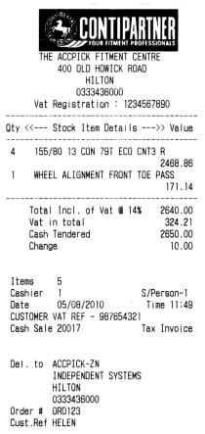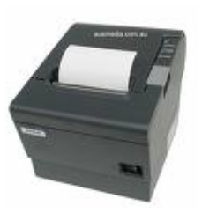
- Cashier control
- Analyse daily Cash to Account Sales, with GP and average spend per transaction
- Retrieve copy Invoices from current or previous months or years
- Maintain customer database for Customer Relationship Management
- Quotations with sms facility
- Convert Quotation to Job Card
- Job card control with options for serial number tracking
- Job Card labels – adhesive labels identifying job number, date and customer details
- Repair controls – manage customer stock sent to third party for repair
Stock Control
- Stock labels – generate bar coded, adhesive labels at stock receiving
- Automated stock take procedures with hand held stock scanner: count and verify stock while continuing to trade
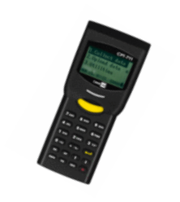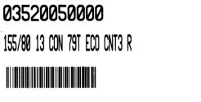
- Stock adjustments report on quantity and cost price changes
- Price overrides report
- Electronic download of supplier price updates
- Maintain maximum allowable discounts per department
- GP warnings
- Promotional Messaging facility linked to specific stock items/departments
- Key value item management
- Serial number tracking facility
- Enquiries per stock item: average & current costs, gross margins, purchases & sales trends, stock on purchase order, back order and sales order
- Track stock movement - top sellers - slow movers - sales trends
- Stock contribution enquiry: sales analysis relative to stock holding
- Supplier contribution enquiry: sales value analysis by supplier within a selected department with analysis of stock holding
- Reorder by supplier / department with option for recommended re-order based on purchases and sales stats for the last 3/4/12 months and average thereof
Debtors
- Email invoices and statements directly from the system
- Credit limits and terms warnings, automatic blocking where required
- Debtor Notes for managing customers
- Sales & gross profit performance reporting per account & analysis of items sold
- In depth management of Salesmen performance

Creditors
- Purchase history per supplier
- Return for Credit controls – manage stock items returned for credit/exchange to suppliers
- Remittance advice enquiries over a selected period
- Record and manage expenses

Cash book
- Control your bank account
- Income and Expense analysis
- Integrate Debtor direct deposits and payments to Creditors
- Bank reconciliation

Purchase Orders (optional)
- Create and email orders to suppliers
- Receipt stock against purchase order with back order option
- Bar coded, adhesive labels on stock receiving

General Ledger (optional)
- Month-end integration transfer from Accpick Point-of-Sale system
- Trial balance
- Income statement
- Balance sheet
- Export facilities to spreadsheet

Management Reporting,
Multiple Store and
Remote Access
- Link home / admin office/ laptop to your store
- Messaging: communication facility for Accpick users on the network
- Link two or more stores for Branch and Group reporting
- At each branch, view stock availability across the group
- For a selected Supplier: generate a consolidated group order for all branches from group and branch stock and sales analysis; facility to email order
- Export of enquiry or report data to spreadsheet format
