**Manufacturing Case Study**



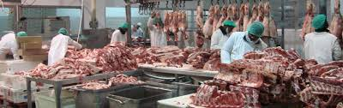

* Bill Of Materials
* Shrink packs
* Orders By Packer
* Order lists
* Manufacturing Reports
* Despatch advice
* Tracking barcodes for meat parcel
* Reports to track stock movements, manufactured, sell by dates
* Display batch controls for a specific BarCode
* Print Labels
* Manufacture
* Multiply Mass by Contract price
* Display batch controls for a specific BarCode
* Prompt for Barcode - if found in Trackbatch and it has a batch number - Display details of ALL items that were in the same batch
* Deli Shop Invoice
* Orders By Packer
* Order lists
* Manufacturing Reports

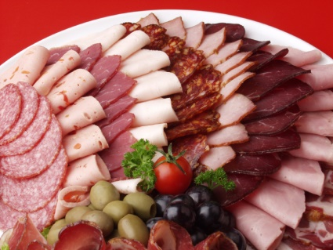



**Oscars Authentic Deli Meats**

**Requirement**

**Manufacturing**

Application that places manufactured items into stock and prints small (serial number) label per item. Application must display a lookup table of all items on the Stock file, allowing user to select: the item manufactured and the number of units.

Update the stock master file Quantity on Hand with number of units manufactured, print a label per unit and update a batch control file with Item Code, Item Details, Date manufactured and serial number.

Label layout to be discussed. Contents of label – Serial number (as a barcode), Date of Manufacture (do they need this encrypted in some way?)

**Stock holding room**

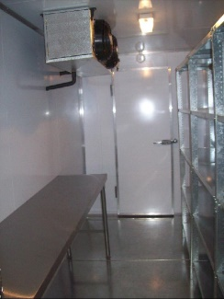

Application to extract items from Stock to packing room – Simply scan the barcode and the system will update: the batch control file (with date + time item was removed from stock for packing) and the Stock master file Quantity on Hand (this will be diminished by the unit removed for packing)

**Reports for Manufacturing / Stock holding**

1. Items manufactured for specific date range
2. Specific item movement – Date manufactured, Date removed for packing
3. Sell By date warnings – Select period (Eg 3weeks) and system will report on any items that have been in Stock Holding for period or longer
4. Quantities in Stock Holding – various options on display / report option

**Sales / Tele Sales Ordering**

Much the same as current ordering system – Prompt for Customer, add line items required.

Customer has date required / delivery day settings which need to be considered

Ability to over-ride standard system pricing for “Special Orders” – Password control and report to management on any items sold @ non-standard pricing

**Packing / executing Sales Order**

Display order on screen and allow scanning of items on order.

Must allow then to scan ANY item on the order (not the top line only as is currently the case) and to store the order for later completion.

*On completion*

Post to Accpick files – update Debtors. Do NOT update stock holding as that will have been updated when removed from Stock and taken to be packed

Print a label with order details. Label size and contents to be discussed. Contents could include, Customer Name, Date for delivery, Order number

S**ales orders + packing plus driver sheets**

Need to check what reports are in use and make sure that these are available on upgraded system

Complete access to all Accpick operations

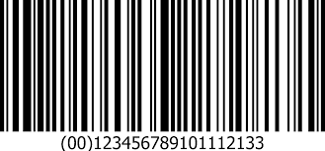

**Oscars Authentic Deli Meats**

**A phased-in approach**

The intention is not to disturb the current operation (particularly over the forthcoming busy period) until such time as the new development has been thoroughly tested.

This approach will actually provide total serial number tracking of each item manufactured as well as stock controls.

The intention is to provide the server plus two terminals in locations that do not have terminals / control systems currently, ie. Manufacturing and Despatch

**Manufacturing application**

Places manufactured items into stock and prints small (serial number) label per item.

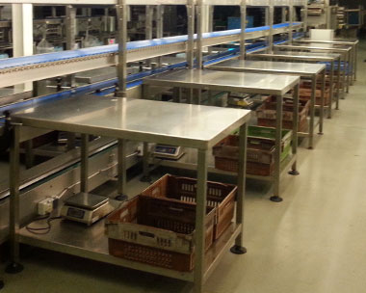

A stock lookup table of all items on the Stock file will be displayed, allowing user to select: the item and the number of units manufactured, day/night shift, table sliced. A label per unit will print as follows:

**36314013145** << Bar Code with this number below

36 – Week of the year

3 – The number of day in the week

1 – Being the (unique) label counter printed that day

1 – Day Shift (could be 2= Night Shift)

3 – Table # where sliced + packed

40 – Being the expiry date- 4 week from the week of the year

145 – PLU (Price Lookup Code)

Label size to be agreed, labels will be thermal transfer

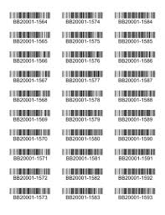

For each label printed a unit will be placed in stock holding fridge

This application must have a Label re-print facility. The label re-print must contact the same details as original label.

**Reports for Manufacturing / Stock holding**

1. Items manufactured for specific date range
2. Specific item movement – Date manufactured, Date moved into Despatch - see Despatch controls below
3. Sell By date warnings – Select period (Eg 3weeks) and system will report on any items that have been in Stock Holding for period or longer
4. Quantities in Stock Holding – various options on display / report option

**Sales / Tele Sales Ordering**

**Keep the Accpick version running as-is – So no disruption to the current operation whilst**

**Despatch controls**

As each order enters despatch – Simply scan the ‘manufactured label’ – System will update Date despatched (well this is actually date the parcel arrived in dispatch)

This will enable you to control the cycle of stock movement per item manufactured without impacting on the current Ordering, Packing, Invoicing system in anyway

We will continue with the development of the TeleSales, Packing, Invoicing and Exporting to Pastel functionality. We can run side-by-side test runs and when satisfied we implement this functionality.

**Manufacturing application**

Places manufactured items into stock and prints small (serial number) label per item.

A stock lookup table of all items on the Stock file will be displayed, allowing user to select: the item and the number of units manufactured, day/night shift, table sliced. A label per unit will print as follows:

**36314013145** << Bar Code with this number below

36 – Week of the year

3 – The number of day in the week

1 – Being the (unique) label counter printed that day

1 – Day Shift (could be 2= Night Shift) **Day = 06h30 – 16h00, rest it Night**

3 – Table # where sliced + packed

40 – Being the expiry date- 4 week from the week of the year

145 – PLU (Price Lookup Code)

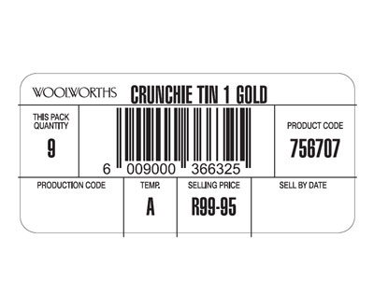

Label size to be agreed, labels will be thermal transfer

For each label printed a unit will be placed in stock holding fridge

This application must have a Label re-print facility. The label re-print must contact the same details as original label.

**Reports for Manufacturing / Stock holding**

1. Items manufactured for specific date range
2. Specific item movement – Date manufactured, Date moved into Despatch - see Despatch controls below
3. Sell By date warnings – Select period (Eg 3weeks) and system will report on any items that have been in Stock Holding for period or longer
4. Quantities in Stock Holding – various options on display / report option

Change of plan - New coding convention

3600145001

36 – **Week of year**

00145 – **Stock Code** – we need to decide the longest code that they have and zero fill before the code, that way the length of the code will always be constant

0001 – **Unique counter** for that Stock code for the day

Save the following to batch_controls.dbf

Code, Description, Date + Time manufactured, Counter.

Include following field in the dbf - Date Packed

When updating the batch_controls.dbf – have the file indexed on Code. Search for the code manufactured, if found check if any entries for current date – scroll through + get the last counter number, to update the counter field

**Reporting facility – as specified above**

1 – Simply prompt for Date Range in Start Date + End date format, temporary index on date manufactured – filter the file for date range requested, display fields in a browse with option to sort on Code / Description + print option

2 – Prompt for Code – Display fields as in report 1 above but only for the Code requested

3 – Prompt for expiry date – defaulting it to Date() – 28 days. Temp conditional index on Date Manufactured – for dates < date entered @ run time. Display results in browse table as mentioned for report 1 above.

4 – Prompt for report to be Detailed / Totals. Temporary index on items that have blank Date Packed field (ie. have not yet left the storage fridge) – If report type = ‘Detailed’ – list each and every item as mentioned in report 1 above. If report type = ‘Totals’ we need to load Code, Description, Qoh into an array and simply cumulate Qty’s in Qoh

**Add ons**

* Telesales to send an email of order to client
* Once order is dispatched a copy of the invoice is to be emailed to the customer as well as the rep
* Set delivery dates for certain areas

Packing must be done 2 days before dispatch