**Point of Sale**

**Point of Sale Invoice** 

**Gross Profit**

Before updating a completed invoice, pressing the [←] will display the Gross Profit in Rand and % value per line item.



To restore to original view press the [←] again.

**Note:** There is NO prompt for this on the screen; facility maybe password protected.

**Sub Total Discount/Selling Price/ Gross Profit/Header Details**

At the Update Transaction prompt, substitute the **Y** with **S/P/G/H**

**Subtotal Discount Facility (S):** This option allows a % discount to automatically be applied to all line items on the invoice. A minus (-) discount will automatically increase the unit price of all line items.

**Set Selling Price Facility (P)** allows the revised inclusive Total Amount of the Invoice to be entered. The system automatically adjusts the prices of individual items in proportion to the new total price.

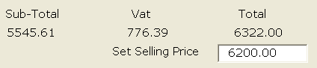

This facility maybe password controlled

**Display Gross Profit Facility (G)** displays the displays the gross profit value and gross profit percentage for the total invoice.

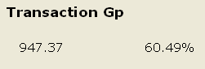

**Header Adjustments Facility (H)** re-displays the Invoice Header details. with options to amend Delivery Details, Order Number, Customer Reference/Job Card Number and Salesman details.

**Debtors**

**Debtor Transactions** 

**4. Batch Receipt Posting**

On completion of a batch, the option exists to print the batch before updating.

**Debtor Enquiry** 

**1. Individual Account**

To edit payment reference select:

1. 
2. Highlight Payment
3. Click on order # to edit payment reference.

**2. Total Debtors Summary**

**2. Monthly**

The Debtor’s Age Analysis has the option to view all debtor account balances or only those debtor accounts with account balances overdue.

Toggle options to re-order age analysis.

Output to Printer or Spreadsheet

**4. Transactions**

**1. Date Selection**

The  facility enables the transaction data to be sorted by:

Transaction Type Transaction Details

Transaction Date Transaction Value

Transaction Number

Note: The selected option is displayed in the bottom left hand corner of the screen.

Once selection has been made, this may be printed or exported to a spreadsheet.

To view Transaction Totals select, 

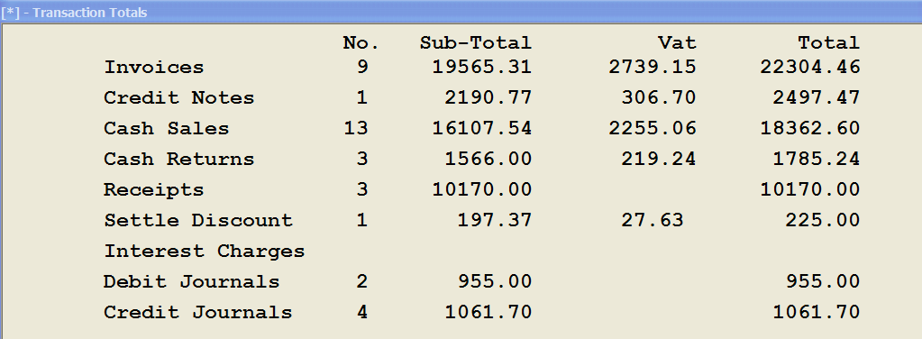

**2. Gross Profit**

This facility displays GP value and % details for all or selected month to date transactions, for all or selected salesmen with the options to:  
 - exclude cash sale transactions  
 - view transaction details

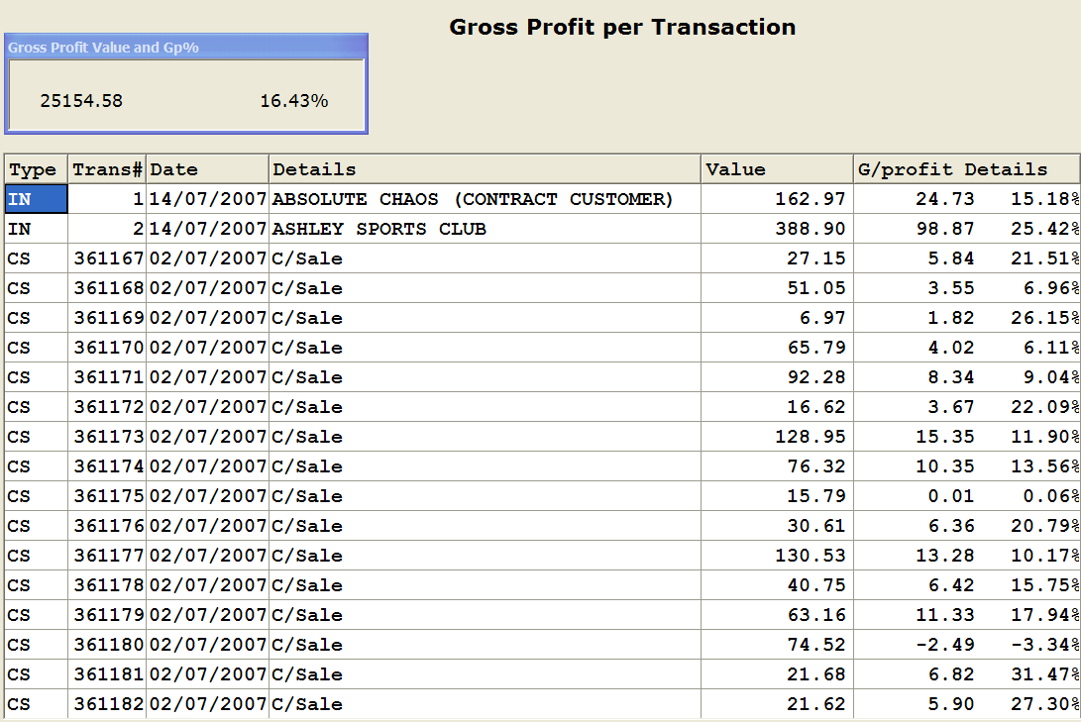

**4. Daily Totals**

The Daily Totals option displays the daily sales values for the current period with the options to:



View the daily gross profit values and daily gross profit as a percentage of daily sales.

View the daily cash sales vs daily account sales as a total value and as a %

View the average sales value for the day

View a listing of the transactions for selected day

Output to Printer or File

**5. Cashup Details**

The Cashup Details displays a listing of the Day End summary regardless of the number of day ends initiated.

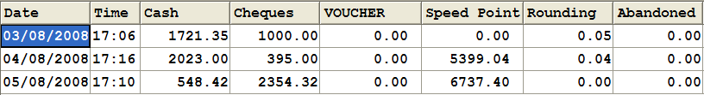

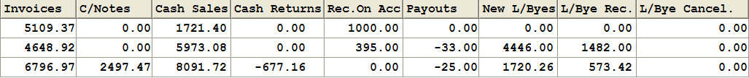

**6. Salesman**

**2. Items Sold per S/Man**

Lists the total number of items sold per salesman.

**8. Account Sales History**

Displays sales history for a selected Debtor by line item.

**Debtors Reports** 

**F. Area/Salesman Report**

This report provides a detailed analysis of each salesman’s total sales value, GP details and total quantity of items sold for a selected period and for selected transactions.

A summary report shows the average sales and gross profit values for each salesman fro a selected period.

**I. Account Performance Report**

This report provides a sales analysis  
 - for MTD and YTD sales values and GP%’s for all or selected Debtors  
 - for the past 12 months

**K. Items Sold Report**

This report is an analysis of the stock items sold to a selected debtor for either the month to date or for an historical period of 3 or 12 months.

**Stock Control**

**Stock Control Maintenance** 

**1. Stock Item/s**

Stock items maintenance includes the following options:

* **Key Value Items   
  (e.g Top Seller/Promotional/Cost Sensitive Items)**  
  If a stock item has been identified as a key value item, a report can be extracted showing the total sales value of all key value items for the period. To view and print this report select Stock Control Enquiries, Top Sellers, Key Value Items.
* **Pack Detail** – text field describing pack detail/number of items in this pack… for information purposes only.
* **Gross Profit Display** - The Gross Profit percentage on the stock item is displayed for all three price options.

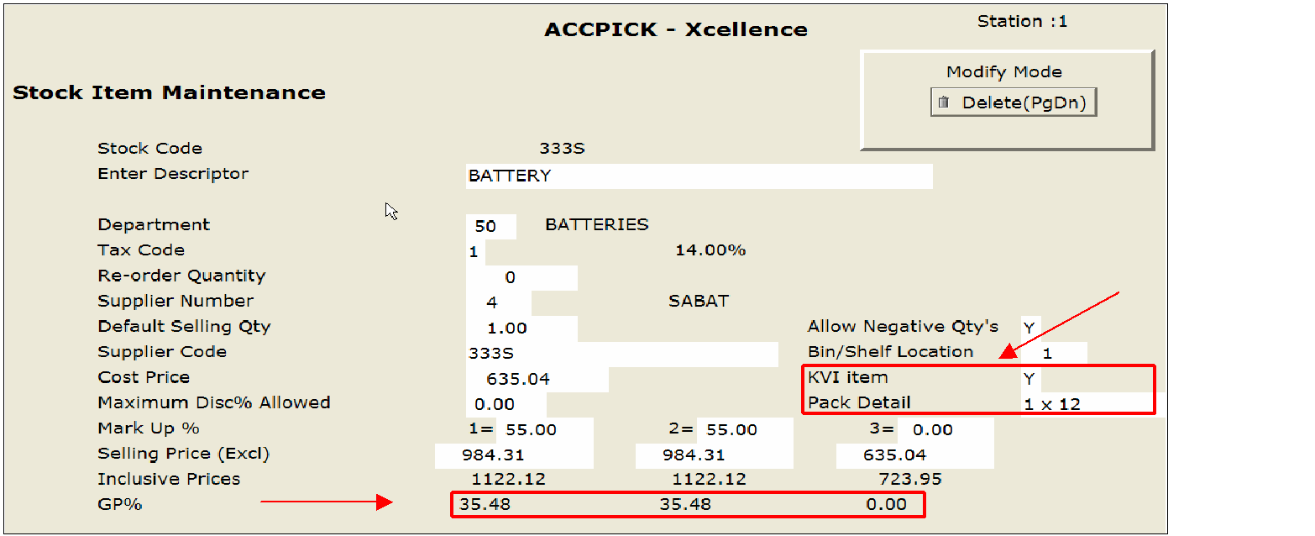

**Stock Control Enquiry** 

**2. Stock Item History**

The stock item history enquiry provides a breakdown of a selected stock item’s sales or purchase history.

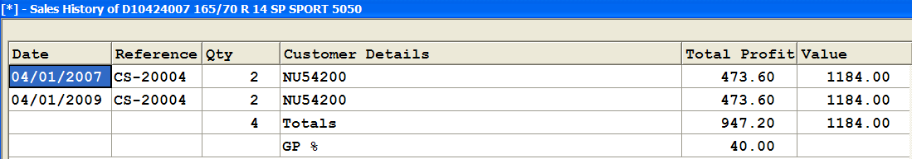

**3. Stock Valuation**

The Quantity on Hand enquiry displays all stock items with a negative quantity on hand

Note: Only items for Labour should be reflected on this report. All other items with negative quantities on hand should be counted back to zero prior to month end processing.

**4. Stock Movement Enquiry**

This option displays the stock movement as per quantity received, quantity sold and quantity on hand for a specified stock item for either the current period or historical periods.

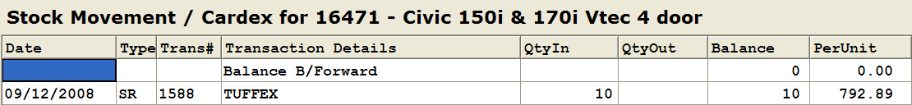

**5. Stock Contribution Enquiry**

**Supplier Contribution**

The Stock Contribution Enquiry is an analyse of the sales for a selected department by supplier.

**Check Stock**

The Check Stock facility enables the analysis of the stock holding for a selected supplier for all stock or only active stock.

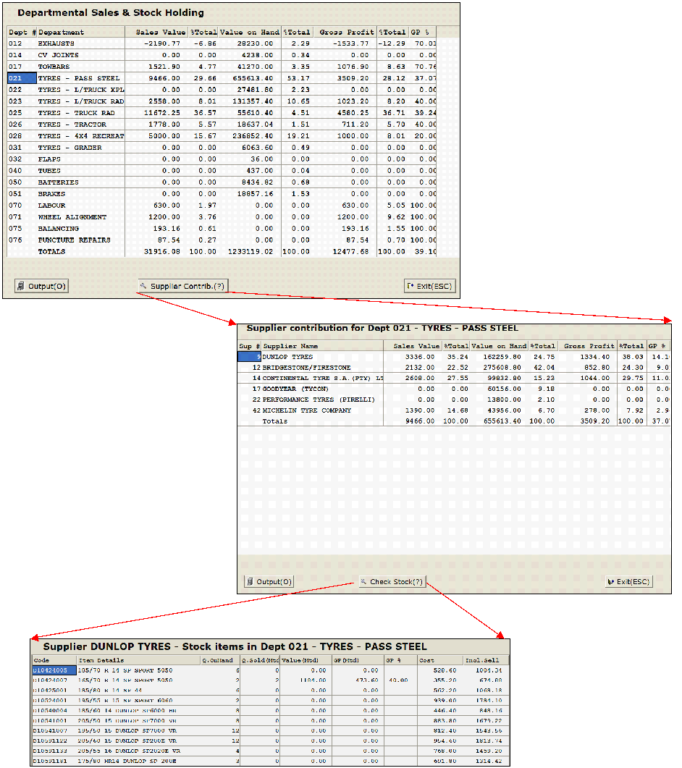

**7. Sales Department Enquiry**

Graphical representation of monthly department sales.

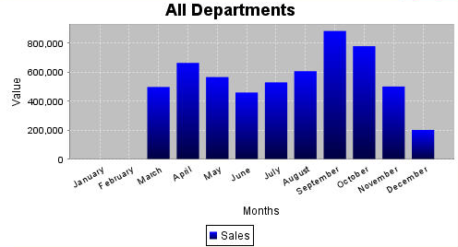

**8. Salesman/Area**

Value or graphical representation of Monthly Salesman/Area Sales

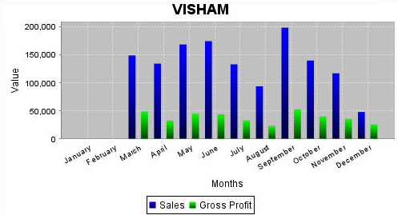

**9. Hourly Analysis**

The Hourly Analysis enquiry provides an analysis of sales by the hour for current or historical periods.

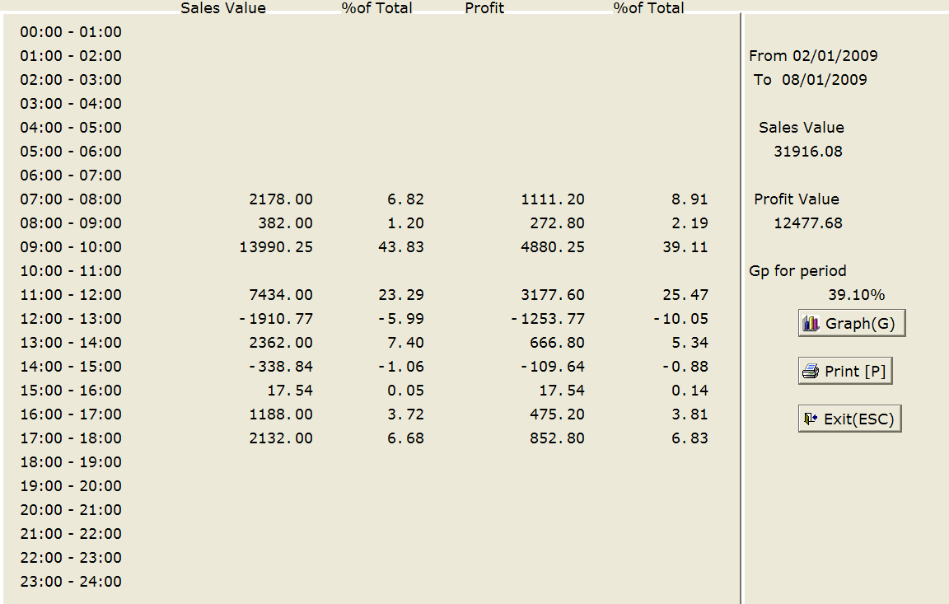

**B Top Sellers**

An analysis of monthly and YTD sales by Value, Quantity Sold and GP for all stock items, specified departments, specified suppliers or key value items.

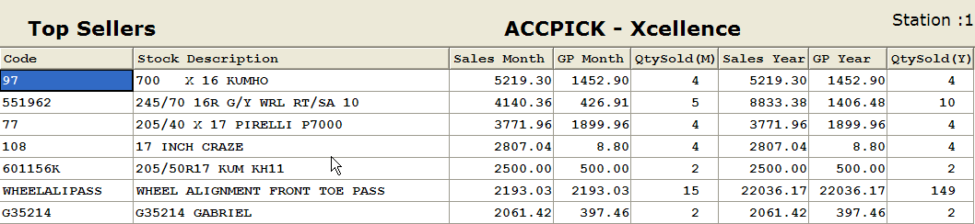

**E. GP Warnings**

Option to view:

- static GP details, by Department or Supplier, for all stock priced at less than a specified GP%

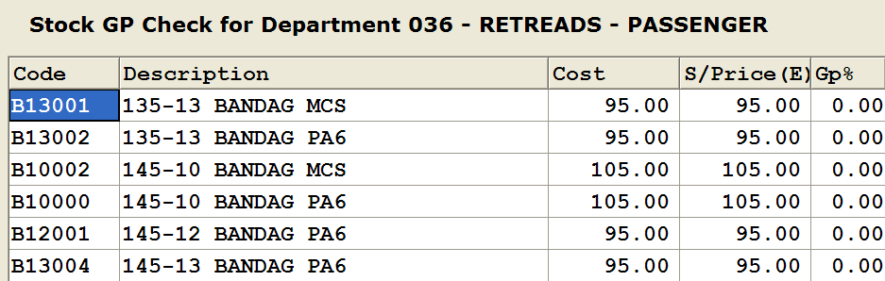

- actual sales GP detail, by Department or Supplier, for all items sold below a specified GP% for a specified period

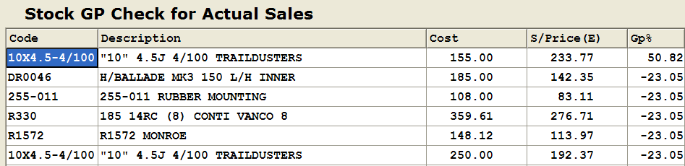

**Stock Control Report** 



**C. Stock Transactions**

**2. Total quantities**

Sorts stock item sales value, quantity and GP% by department or supplier with details or total values only.

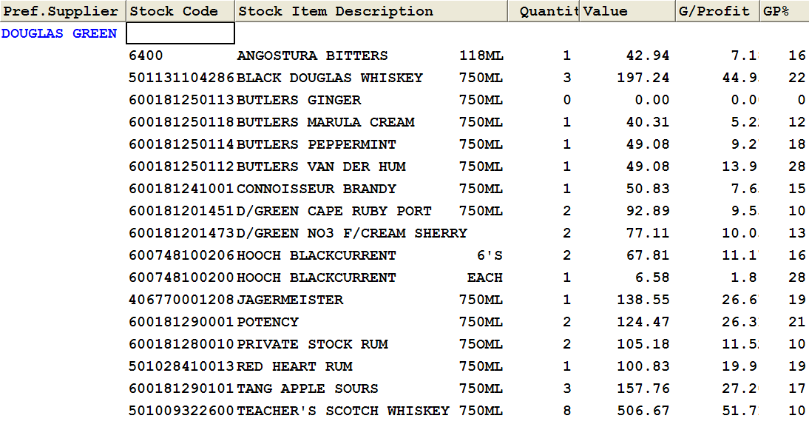

**4. Adjustments –**

The Adjustments report lists all manual adjustments which were made to stock prices, stock quantities and stock descriptions for a specified period.

**6. Price Overrides**

The Price Overrides Report lists all standard and actual selling price variances for all or selected sales with salesperson details.

**7. Serial Numbers**

**D. Stock Valuation**

The stock valuation report provides an analysis of the value of the actual stock quantity on hand, stock quantity counted at Average Cost or Last Cost value.

**G. Re-Order**

This Historical Statistics report details stock quantities purchased and sold over the last 3 or 12 months by Supplier or Department as well as quantities on hand and recommended re-order quantities.

Output to printer or spreadsheet.

**H. Gross Profit**

This report shows an analysis of gross profit details per department for a selected period.

**I. Stock Received/Stock Returned**

The ‘By Supplier and Department’ option on this report provides an analysis of all stock received/returned by Supplier and Department for a specific period. Use this report to calculate franchise fees.

Output to printer or spreadsheet.

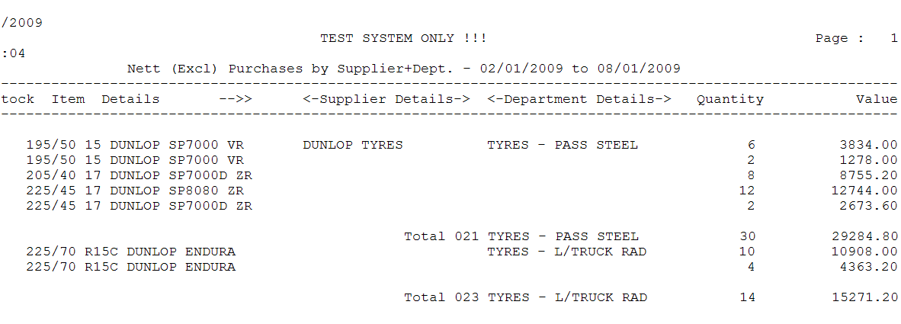

**Creditors**

**Creditors Enquiry** 

**2. Total Creditors Summary**

The Creditor’s Age Analysis has the option to view all creditor account balances or only those creditor accounts with account balances equal or greater than the terms value.

**6. Purchase History**

Displays monthly net stock purchases, exclusive of vat.



**Utilities**

1. **System Parameters**

**2. Password Maintenance**

Listing of recommended passwords:

* Global – This is the masterkey and allows access whenever the system prompts for a password.
* POS Credit Notes, Cash Returns, Cash Control, Receipts on Account
* Quotations @ Cost
* Job Cards Cancel Jobs
* Debtors - Maintenance, Journal Entries
* Stock Control Maintenance, Transactions, GP and Stock Take, Contract Maintenance, Stock Returns
* Creditors Journal Entries
* Cash Book Entry Level
* Utilities Parameters, Period end, File Clearance
* General Ledger Entry Level

**Export Enquiry or Report Data to Spreadsheets**

The facility exists for a number of reports to be exported to a spreadsheet.

At the required output prompt select the file option. The data will be saved in a file with a .csv extention in your data folder. E.g. \test\debtrans.csv.

To view the data, open the file in Excel and edit as required. Save in Excel format.

**Printing Enhancements**

Extended multi user printing facilities exist with options to print enquiries and reports to approved Accpick compatible laser, dotmatrix, label and cash sale printers within the network.

**Special Facilities on Request**

**Weight of items**

Facility to capture weight of stock item in stock maintenance. Weight is printed on individual items on invoice and total weight value.

**Serial Numbers**

If a serial number is required for stock items in a selected department, an automatic prompt can be enforced at POS.

**Promotions**

**Consolidated Debtors and Creditors**

For wider area network

Shops may share common Debtors and Creditors

**PDF format for statements, invoices quotes and purchase orders**

Email facility for above.

**Online BSA Catalogues**

For Supa Quick and Speedy stores only

**AP Credit Check facility**

While processing an invoice, a credit limit warning will appear when the total transaction value is greater than the credit limit value for that particular debtor.

**Contacting Support.**

The Accpick Support team is available to assist you with your queries - regardless of how small or large they may seem.

**Telephonic Support**

The Support Team can be contacted on the following numbers at the following times:

|  |  |
| --- | --- |
| Telephone | +27 (0)33 343 6000 |
|  |  |
| Email | sales@accpick.co.za |
| Business Hours, Mon - Fri | 8.00 – 13.00, 13.30 – 16.30 |
| On the last working day of the Month, the office remains open until 5pm and opens at 7.30 am the following working morning to assist with Month End queries. | |

**Secure Online Access**

An additional support facility exists which allows our support consultants to work remotely via ADSL on your Accpick system.

**Website Information**

Visit out website, [www.accpick.co.za](http://www.accpick.co.za/), for periodic updates, news tips and tricks – all designed to enhance your Accpick experience.