**All modules in your Accpick data for all branches must be month ended before proceeding with consolidated general ledger integration of the relevant month i.e. Debtors, Creditors, Stock & Cash Book.**

**STEP 1:**

**To check your System Status i.e. what month & year ending date:**

**In the Accpick Consolidated General Ledger Menu:**

Go to ***Enquiry/Reports; System Status***. Make sure that the “Current Month” is the month that you are preparing to integrate from, if not, you have not yet done your previous month’s period end.

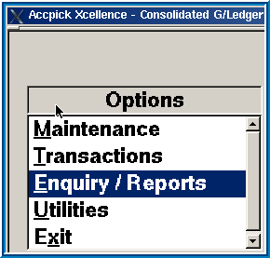 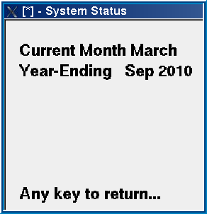

**STEP 2:**

**In your Accpick Consolidated General Ledger Menu**

**Check that the Integration Links to the Branch Data Directories are in place for each module i.e. Debtors, Creditors, Stock, Cash Book.**

***Maintenance; Integration; Debtors, Stock Control, Creditors, Cash Book***

Check each of the modules in each of the branches and ensure that everything has a DR and a CR in place, as well as the narration details.

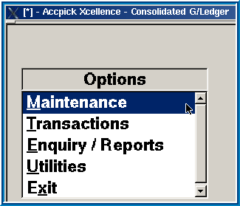 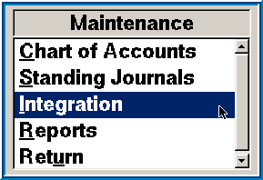

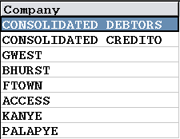 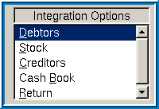

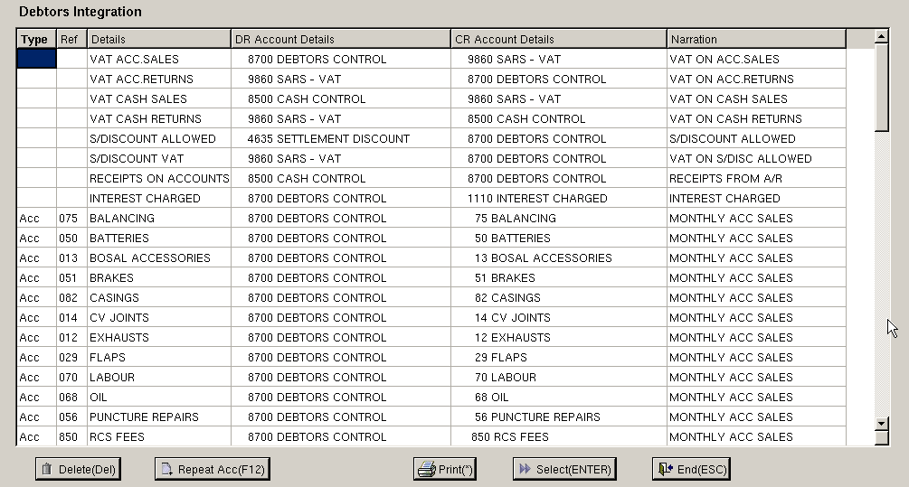

**STEP 3:**

**Consolidated General Ledger Integration Transfer:**

***Transactions; Integration Transfer***

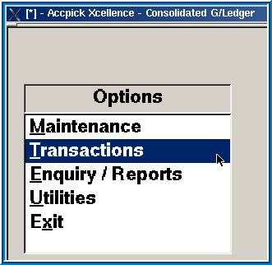 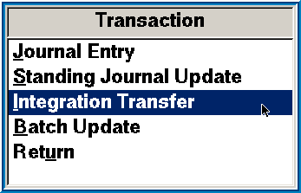 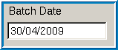

Batch Date: Use last day of the month that you are integrating

Select Month: Month you are integrating

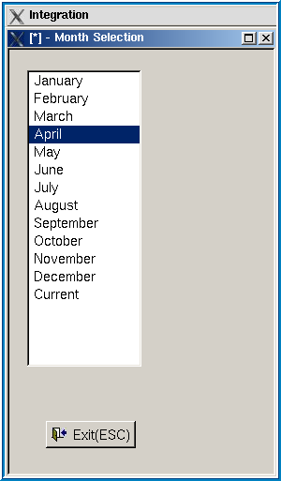 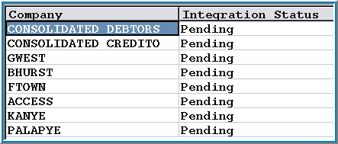

**STEP 4:**

**Debtors Journals from Consolidated Debtors**:

If you have processed Debit / Credit Journals in the Accpick Debtors Module you will now be prompted to enter your Debtors Control Account Number. (**18000** – Debtors Control Account) This completes the one leg of the journal correctly. You need to complete the opposite side of the journal by selecting the relevant General Ledger Account Code. Once you have completed the allocations, press ***F7*** to update. Use ***Control+F12*** to copy the selected account to all blanks in debit or credit only if required.

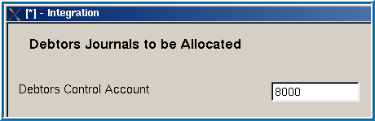

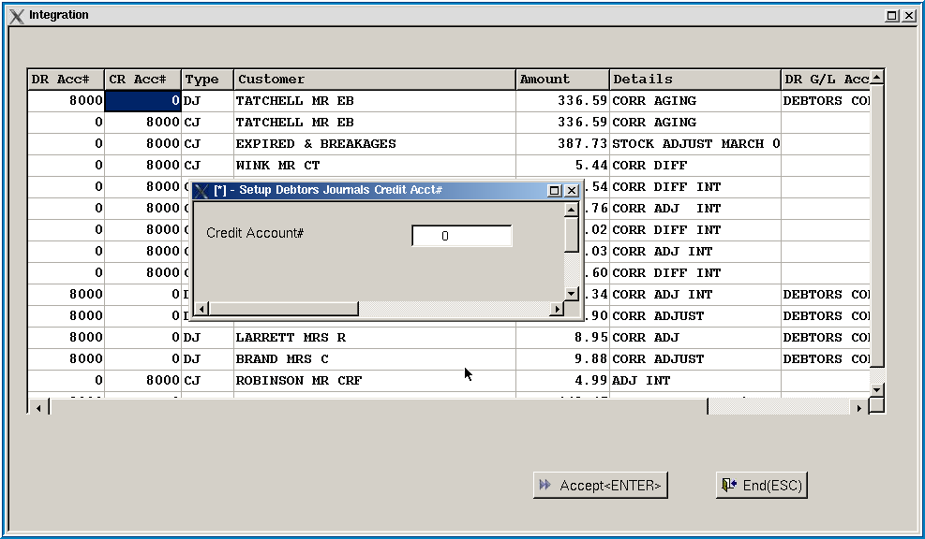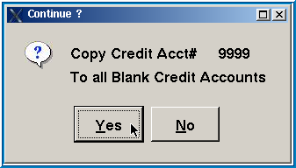

Press **Esc** to update and select **Yes** to post the batch.

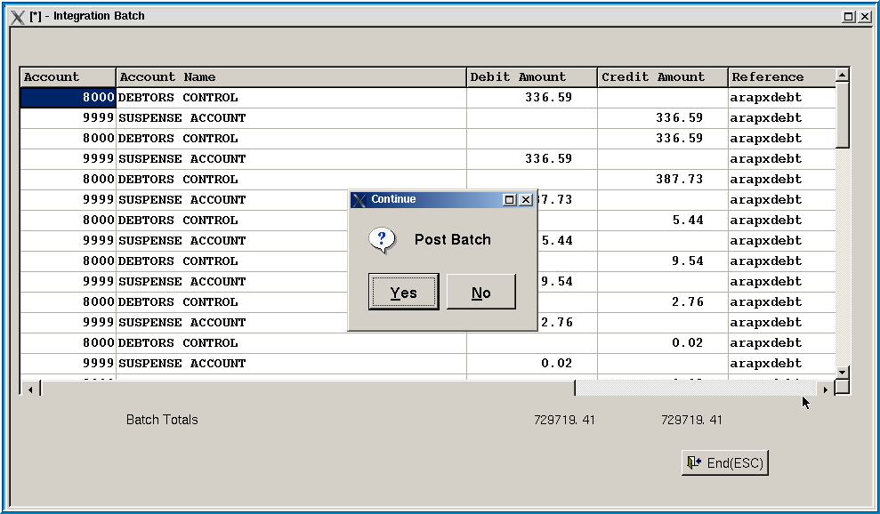

Printing of the Integration Batch is optional.

**Creditors Journals from the other branches**:

If you have processed Debit / Credit Journals in Accpick Creditors Module you will now be prompted to enter your Creditors Control Account Number. (**19000** – Creditors Control Account) This completes the one leg of the journal correctly. You need to complete the opposite side of the journal by selecting the relevant General Ledger Account Code. Once you have completed the allocations, press ***F7*** to update. Use ***Control+F12*** to copy the selected account to all blanks in debit or credit only if required.

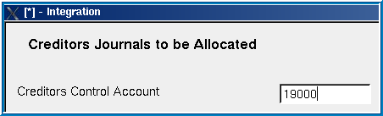

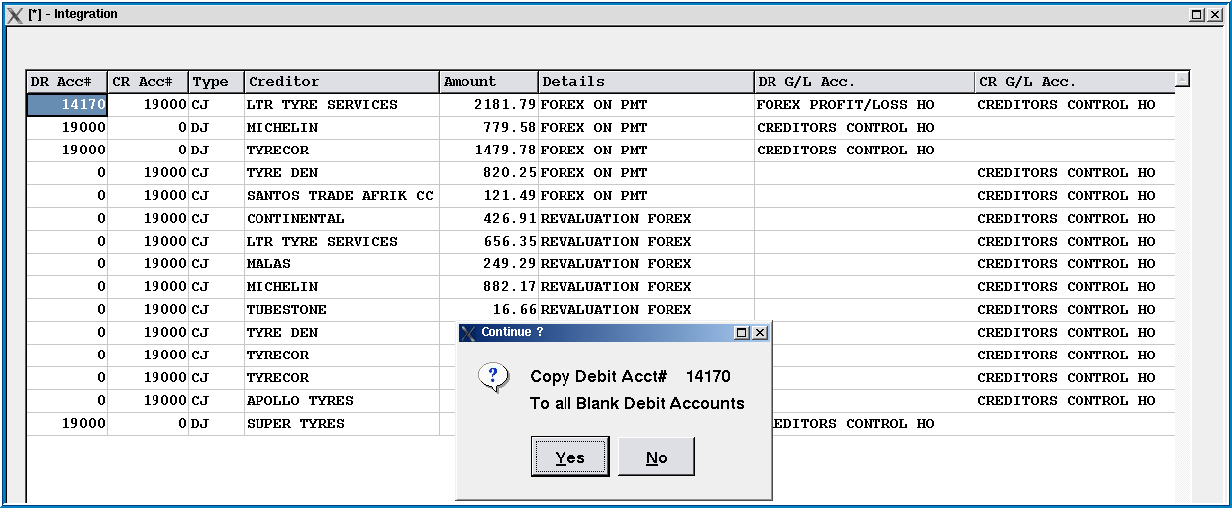

Repeat for all branches until all show completed.

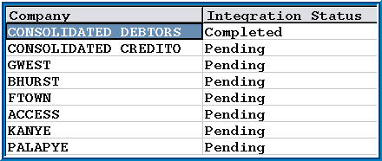

**STEP 5:**

**CHECKING CONTROL ACCOUNT BALANCES - General Ledger vs Accpick data i.e. Debtors, Creditors, Stock Control, Cash Book Modules**

***Enquiry/Reports; Ledger Account***

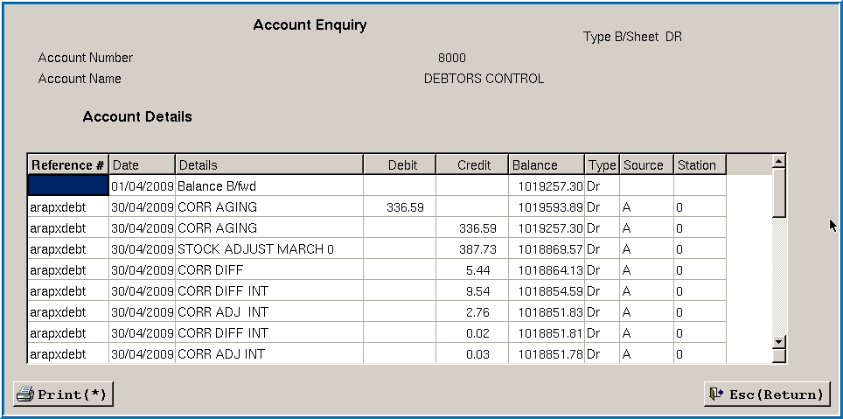

**Compare each of the control accounts in the ledger with the reports printed in Accpick.**

The few cents difference as a result of VAT rounding can be ignored, anything greater than that should be investigated.

**Cash Control Account** should balance back to zero.

Reasons why Cash Control may not balance back to zero:

1. Where the Month End for All Modules *excluding* the Cash Book has been processed, there should be no further entries processed in the Cash Book relating to Payments to Creditors and/or Receipts from Debtors prior to month ending the Cash Book i.e. only Other Income or Expenses ought to be processed.
2. Cash not banked for cash sales and not recorded as Payouts or Pay & Update transactions.
3. Cash sale monies received on the last day of the month and only banked on the 1st day of the new month that were not reflected as deposits in the Cash Book for the last trading day.

The few cents difference as a result of VAT rounding can be ignored, anything greater than that should be investigated.

|  |  |  |  |  |
| --- | --- | --- | --- | --- |
| **CASH CONTROL ACCOUNT** | | | | |
| **Debits integrated into the Cash Control Account** | |  | **Credits integrated into the Cash Control Account** | |
| MONTHLY CASH SALES  Department Cash Sales from POS  This amount is the net cash sales taken from **Debtors-Reports-D-4** | 110,400.00 |  | VAT ON CASH RETURNS  Taken from **Debtors-Reports-E** | 1,400.00 |
| VAT ON CASH SALES  This amount is the net VAT on cash sales taken from **Debtors-Reports-E** | 15,400.00 |  | PAYOUTS TO CREDITORS  Pay & Updates + POS Pay-outs taken from **Creditors-Reports-6** | 24,000.00 |
| RECEIPTS FROM DEBTORS  Taken from **Debtors-Reports-E** | 200,000.00 |  | DEBTORS RECEIPTS  Direct deposits taken from **Cash Book-Reports-2** | 25,000.00 |
|  |  |  | MONTHLY C/BOOK INCOME  Other Income i.e. Daily banking of Speedpoint & cash/cheques from **Cash Control POS** | 275,400.00 |
|  | **325,800.00** |  |  | **325,800.00** |

**STEP 6:**

**Gross Profit Journal**

***General Ledger Enquiries & Report, Income Statement***

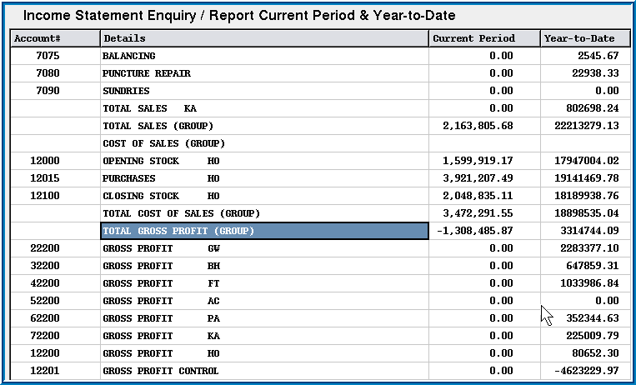

Note the amount for the Total Gross Profit & update the Journals.xls from the Gross Profit reports for each branch & the difference to be posted to A/C 12200 for Head Office.

Update the Journals.xls with the amounts for VAT on Cash Sales for each branch from the reports printed earlier.

These journals now need to be captured into the ledger. See notes on Journal Entry below.

**To process Journal Entries**

***Transactions; Journal Entry; New Batch***

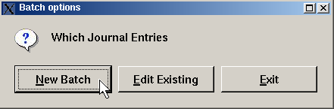

Select **Current** for journals affecting current month & **Past** for previous months within the current financial year.

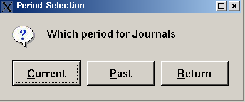

**Insert (+)** to enter the journal information – account code, narration, amount, journal reference number, debit or credit. Deletion & editing of line items is allowed.

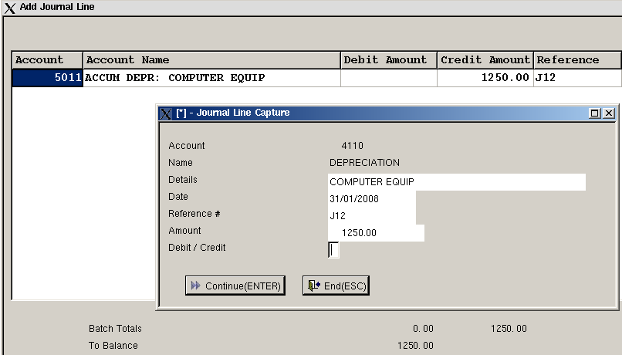

To edit a journal batch: ***Transactions; Journal Entry; Edit***

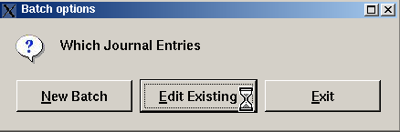

To update the journal batch:***Transactions; Batch Update; F2 to tag; Esc to update***

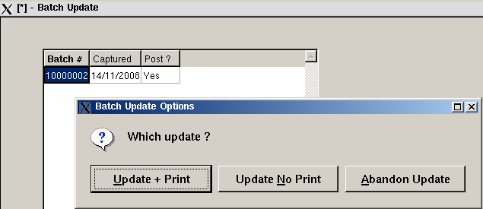

**Standing Journal Update**

***Transactions; Standing Journal Update***

**Create or edit a Standing Journal**

***Maintenance; Standing Journals; Insert(+) for new standing journal***

1. At the Descriptor prompt, enter an identifying reference

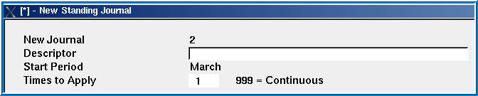

1. At the Times to Apply prompt, enter the frequency – Monthly(12), Quarterly(4), Bi-Annually(2), Annually(1) or (999) for Continuous.

**Note : Standing Journals require two entries in order to comply with the double entry system of accounting – one a debit entry and the other a credit entry.**

1. Click on  to insert the Journal details.
2. Enter the Account number or use the select facility to view and select from the current Chart of Accounts.
3. Enter the Journal Details, Amount and indicate whether the journal is a Debit or a Credit value.
4. Click on  to save.
5. Click on  to insert the Contra Account details.

**Note: Only Journals which are in balance will be saved. Total Debits must equal Total Credits.**

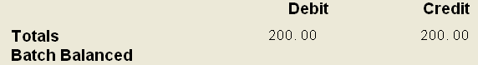

Journal adjustments can be made by clicking on: , , 

1. to print journal entry.
2. Click on  and click on  to save.
3. Click on  to return to the Maintenance Menu.

**STEP 7:**

**General Ledger Enquiries & Reports** (Optional to print & export to CSV facility once Trial Balance has been satisfactorily cross-checked & all journals processed.)

 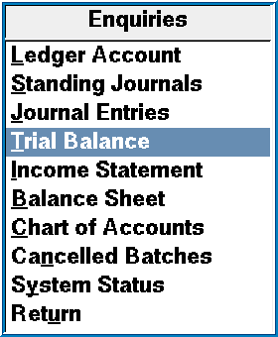

When printing or exporting each of these reports, change the date to the last day of the month you are reporting on.

**Trial Balance: *Enquiries/Reports; Trial Balance; P to print or * to export;***

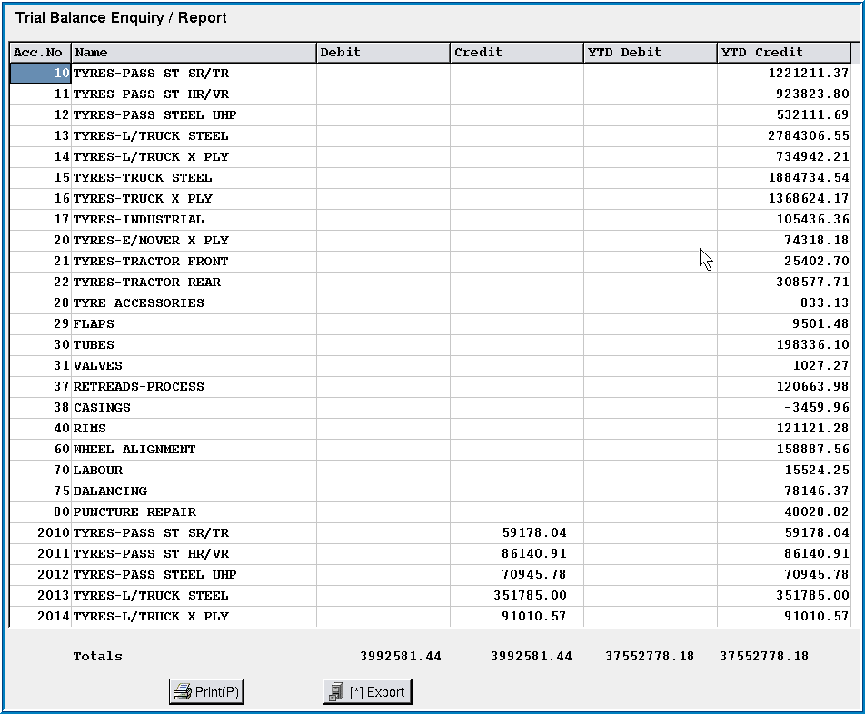

**Income Statement: *Enquiries/Reports; Income Statement; P to print or * to export***

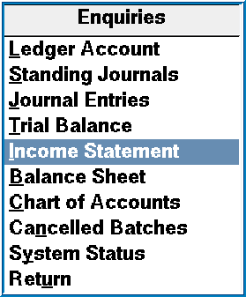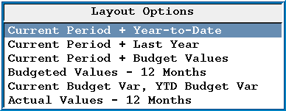

**Balance Sheet: *Enquiries/Reports; Balance Sheet; P to print or * to export***

**STEP 8:**

**Indexing data files is processed in the General Ledger Menu**

***Utilities; Index Files; Choose Current (because you have not run a month ended yet!)***

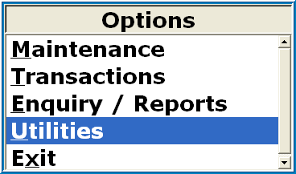 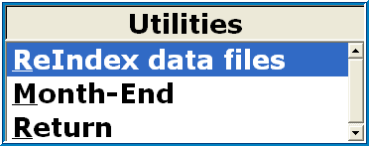

**STEP 9:**

**BACKUP !**

Use a new disk for this period & label it GL Month end e.g. MAY 2009

**STEP 10:**

**GENERAL LEDGER Period End is processed in the General Ledger Menu**

Ensure that all entries have been processed before proceeding. The period end is required before integrating the next month.

***Utilities; Month-End***

 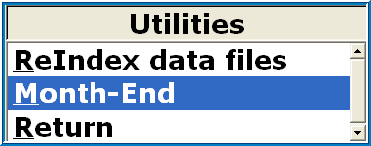

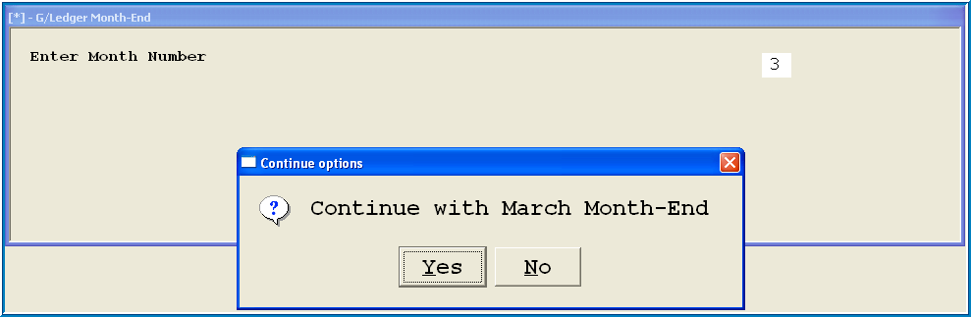

**N.B. ENSURE THAT YOU MONTH END INTO THE CORRECT MONTH!!!**

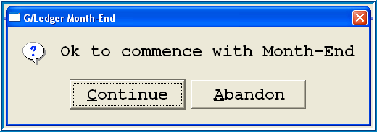

**STEP 11:**

**Check your System Status:**

**In General Ledger Menu:** ***Enquiry/Reports; System Status. Make sure that you are now in the following month.***

 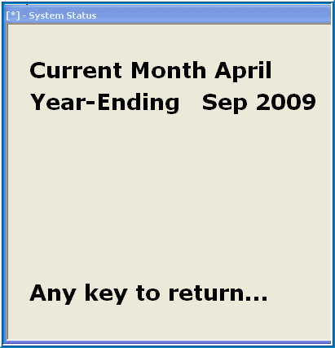

**Check your archived data to confirm that you have month-ended into the correct month:**

**In General Ledger Menu:** Go to ***Enquiry/Reports; F6 into the previous month; Ledger Account.*** Type in account no. 9000 & confirm that the month you have just integrated has the correct transactions.

 