Introduction & Background

Over 35 years of company experience in Point of Sale and IT, and combined staff experience in Point of Sale, Internet and IT of 100 years, the software continues to reflect our expertise in the Point-of-Sale market in Southern Africa, in particular our specialist knowledge in all areas

Accpick is vital to the management and control of any successful business operation, with ease of use, stability, reliability, system controls, inventory

**￼Accpick Service In point Form**:

* Accpick use a stack of online cloud based services:
* Accpick has partnered with Google Cloud Platform for Cloud Infrastructure:
* 99% of the servers in the world use Linux it open source and constantly updated.
* Support is done via Teamviewer Accpick have purchased unlimited license with a customised version of Teamviewer which can be downloaded for support
* Whatsapp is a alternate and Free support option where customers can take photos and chat with our support Staff

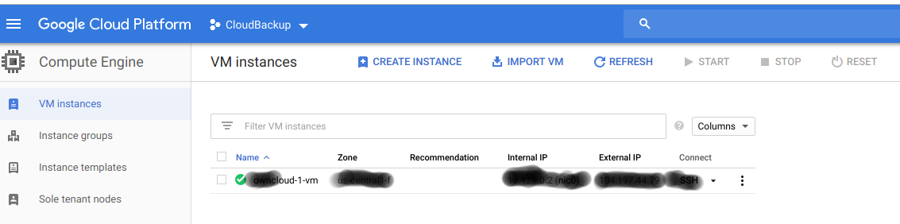

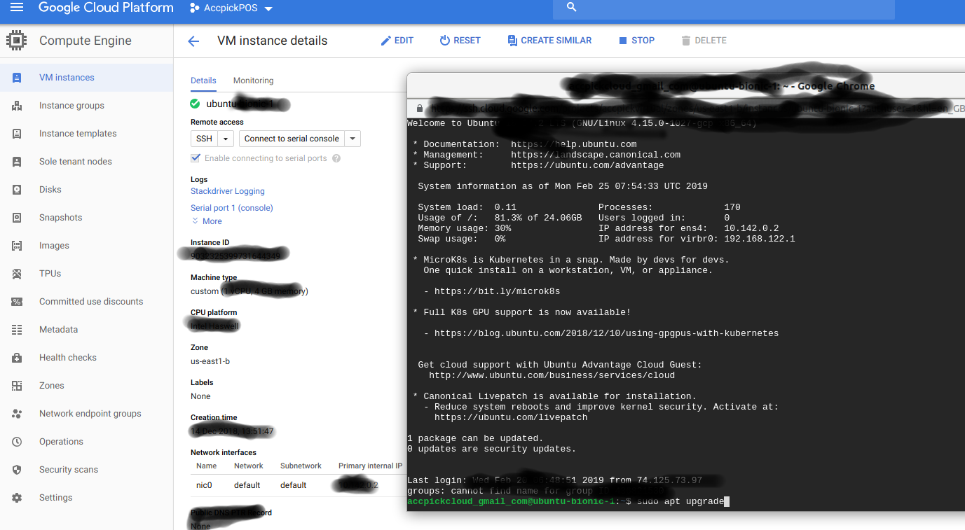

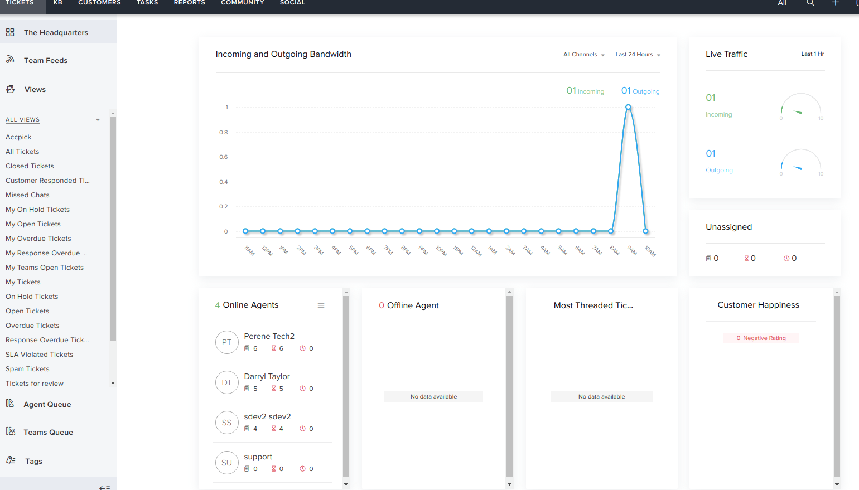

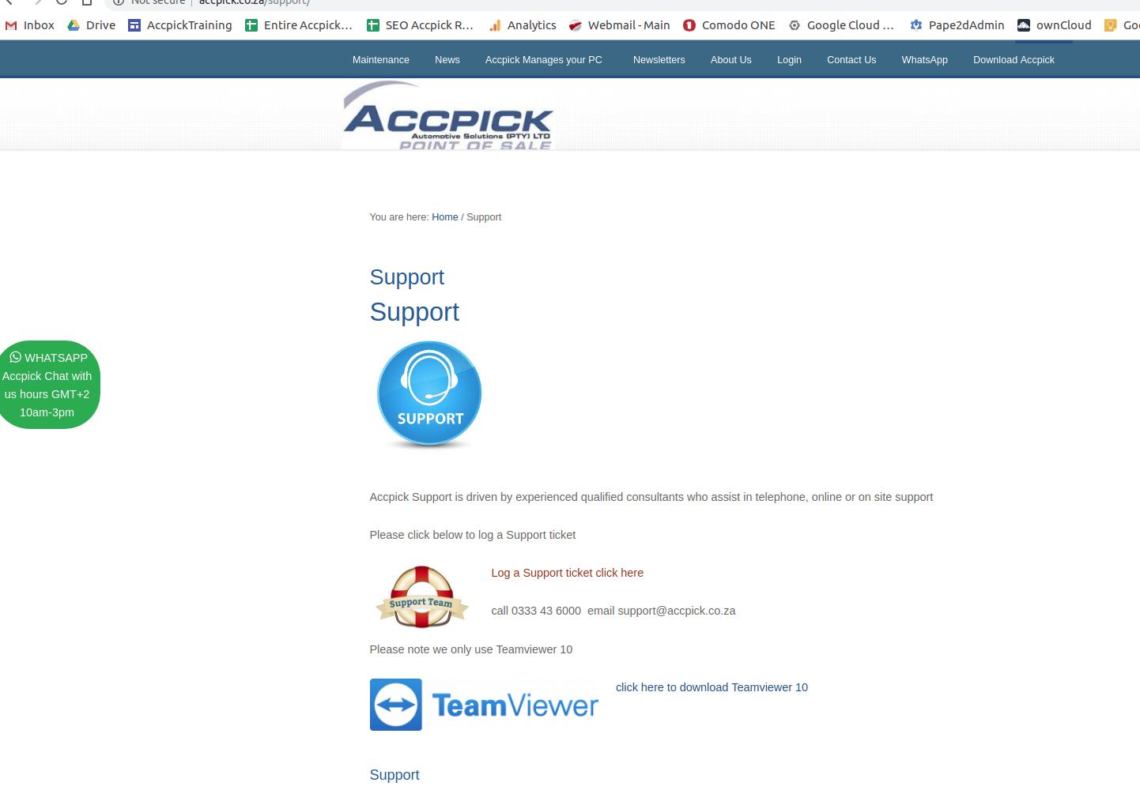

**Knowledge Base Online / Training**

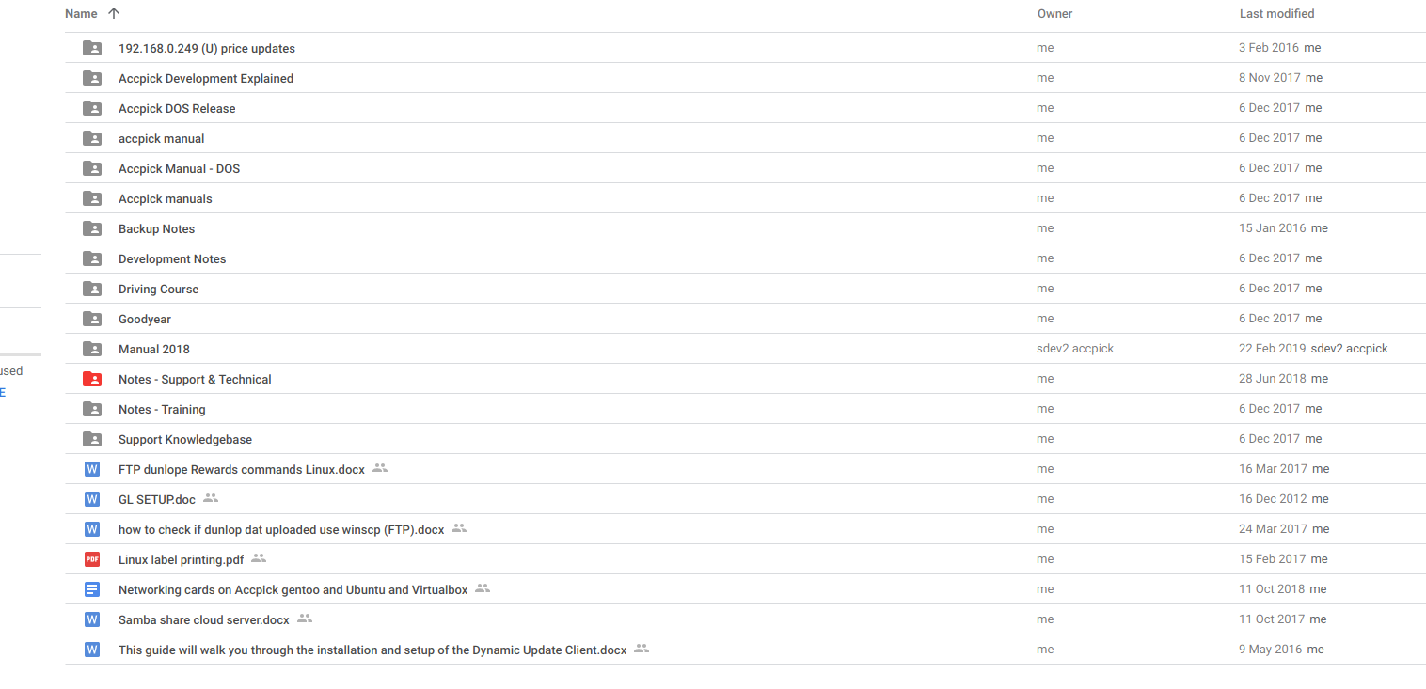

**Backups hosted on GCP (Google Cloud Platform)**

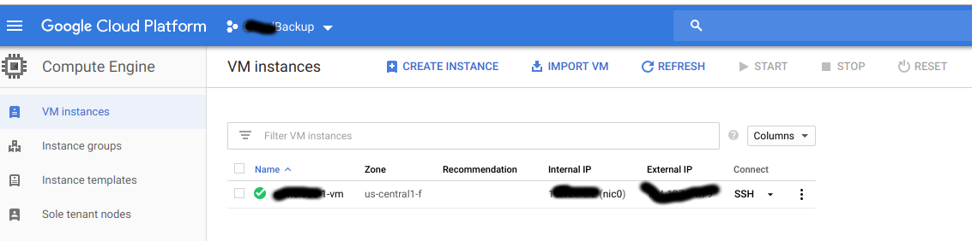

**Customer Computer Patch Management**

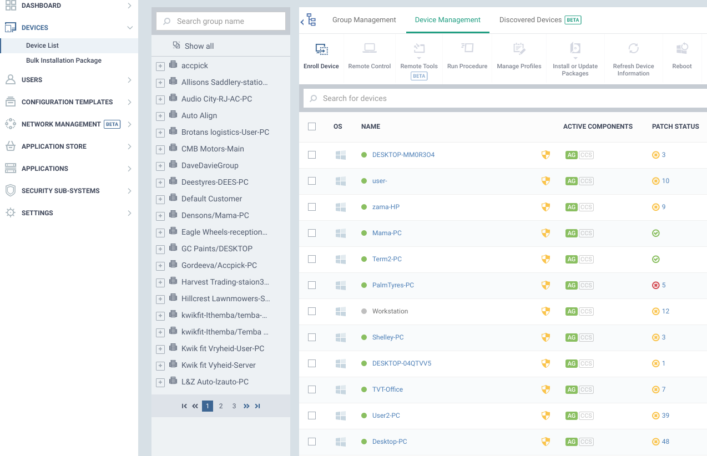

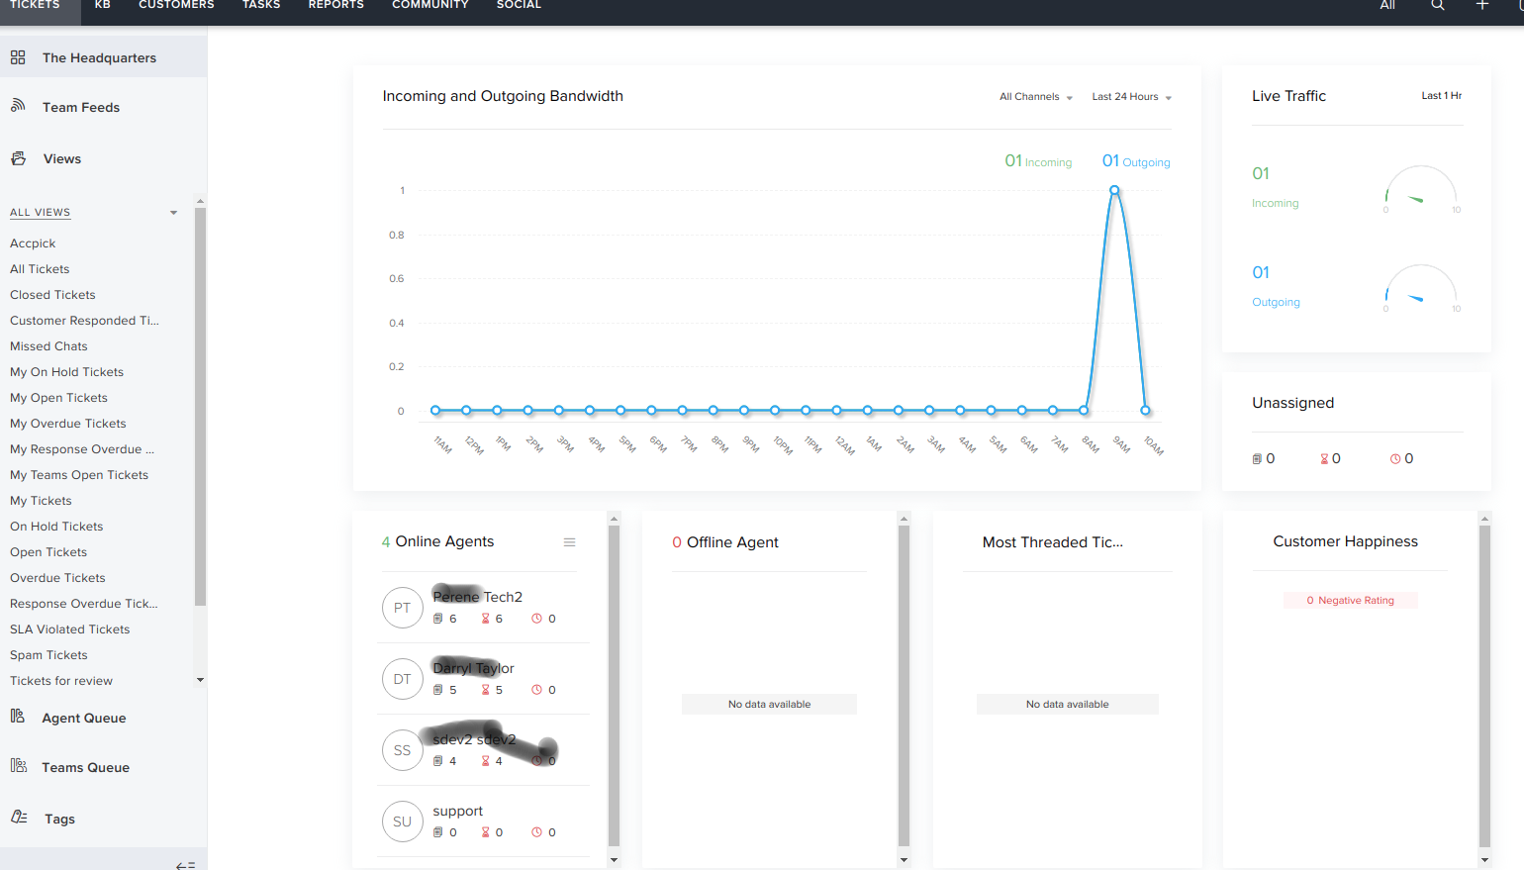

**Source Code**

**Written in Flagship and recently reporting in C#**

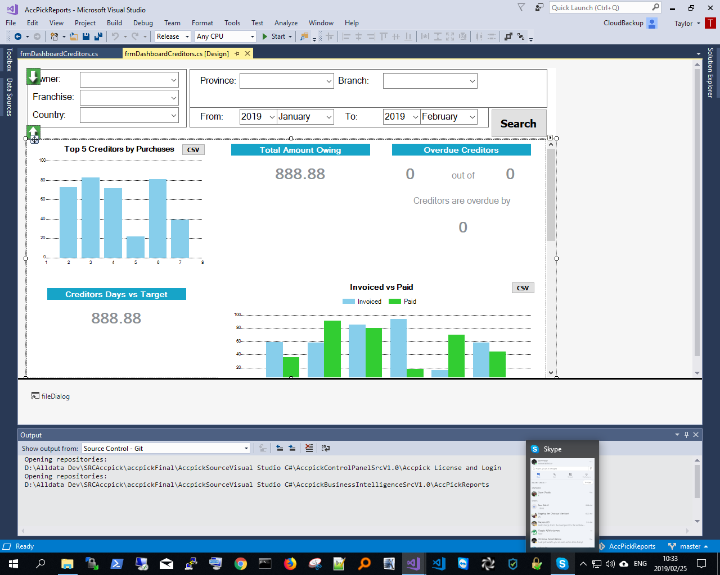



**Accpick Deployment Cross Platform:**

**Deployment can be carried out on a variety of platforms as below: This depends on the hardware our clients use, In order to save on Expensive Hardware upgrades we can install Accpick on older or newer hardware:**

**Accpick has many versions:**

* **DOS**
* **Windows XP**
* **Windows 32 bit ie 7**
* **Windows 64bi ie 10**
* **Linux Gentoo**
* **Linux Ubuntu 18**
* **Virtualbox**
* **Cloud Virtualization GCP**

**The choice of deployment depends on the clients location, internet and other requirements ie Physical on premise or cloud,**

**Access via Remote Terminal Emulators:**

**NoMachine (Fastest)**

* **X2Go**
* **Windows Remote Desktop**
* **Teamviewer**
* **VPN**

**Client A 1 x Linux Server 11 remote stores all connecting via ADSL.**

**Client B 5 x Linux Servers all on premise 5 remote stores independent of each other then consolidate after hours.**

**FAQ Questions**

=====================================================================

**QUESTION:**

System must be written in a language which is both modern and widely utilized internationally and in South Africa. Same for underlying database which must be able to be accessed by commercially  available  report writing  tool.

=====================================================================

## Accpick Answer

## 

* Accpick is written in a Multi-Platform Database Development and Porting System, available for Linux, MS-Windows and commercial Unices.
* is easy to use,
* is a highly optimized 4GL language, syntactically compatible to other XBase dialects.
* is object oriented
* supports the same code (FlagShip is 100% backwards compatible to Clipper '87 to 5.3, and to the most of dBase, Foxbase, FoxPro 2.5-2.6) in modern 32/64bit operating systems like Linux, Unix and MS-Windows using backward compatible source and .dbf databases.
* allows you to add C sources externally or inline into the prg source; but does not require any C knowledge.
* Accpick use Visual Studio and C# and SQL as the reporting Frontend

=====================================================================

**QUESTION:**

National call Centre (Monday to Saturday) i.e. vendor must be able to demonstrate an ability to support on a day to day basis a network of users nationally.

=====================================================================

## Accpick Answer

Accpick Support is driven by experienced qualified consultants who assist in telephone,online or on-site support. We also have a Whatsapp line where all your queries can be attended to. Accpick uses an effective customer dashboard system where clients can log their tickets. Our call center is open daily from 8 am till 4: pm Monday to Friday, After hours and weekends we have an after hours support number, Proven Support has been non going with a single telephone number and multiple lines for 35 years.

=====================================================================

**QUESTION:**

Must be able to adapt software requirements timeously.

=====================================================================**Accpick Answer**

Accpick employ a team of professional developers and Linux Engineers, work will be done according to a pre agreed schedule with milestones. using the Agile Framework

=====================================================================

**QUESTION:**

The application should have an architecture which enables FNB specific changes without affecting the core system and enable FNB  to  accept  and  deploy updates  without extensive code work.

=====================================================================

**Accpick Answer**

Accpick has 17 customized versions from Time Freight to Gas applications and more any customization will be considered and weighed before implementation. See the attached list of environment variables 700 variations. Accpick is developed over a lightweight fast flexible database with 10 core modules so independent changes will not affect the system.

=====================================================================

**QUESTION:**

The application must utilize or allow for all the modern Technology, i.e. cloud computing, mobile access etc.

=====================================================================

**Accpick Answer**

Accpick has a new cloud based server which runs on any platform over the internet.

=====================================================================

**QUESTION:** The system must not  utilize any bespoke  hardware  or components  which hinder or preclude an easy migration.

**QUESTION:**

Operating  systems  and  hardware  utilized  must  be  commercially  acceptable and  freely available  country wide.

=====================================================================

**Accpick Answer both questions**

Accpick Deployment Cross Platform:

Deployment can be carried out on a variety of platforms as below: This depends on the hardware our clients use, In order to save on Expensive Hardware upgrades we can install Accpick on older or newer hardware:

**Accpick has many versions:**

* DOS
* Windows XP
* Windows 32 bit ie 7
* Windows 64bi ie 10
* Linux Gentoo
* Linux Ubuntu 18
* Virtualbox
* Cloud Virtualization GCP
* The choice of deployment depends on the clients location, internet and other requirements ie Physical on premise or cloud,
* Access via Remote Terminal Emulators:
* NoMachine (Fastest)
* X2Go
* Windows Remote Desktop
* Teamviewer
* VPN

**Client A** 1 x Linux Server 11 remote stores all connecting via ADSL.

**Client B**  5 x Linux Servers all on premise 5 remote stores independant of each other then consolidate after hours.

We currently have a company who has stores from PMB all the way to Ballito , each store is connected via an Icon on each PC /Station which links all stores and branches. Accpick can run UNLIMITED WORKSTATIONS (eg. 11 branches 50 workstation 35 printers 25 scanners). Link two or more stores for Branch and Group reporting

At each branch, view stock availability across the group options you have to update, For a selected Supplier: generate a consolidated group and branch stock

[**Stock Reports**](https://us11.campaign-archive.com/?u=348ed09257a92e56be4192149&id=8d6a70a4ba)(Click here)

=====================================================================

**QUESTION:**

The application must provide for easily utilizable two way EDI. - is the electronic interchange of business information using a standardized format; a process which allows one company to send information to another company electronically rather than with paper. Business entities conducting business electronically are called trading partners.

=====================================================================

**Accpick Answer**

**Data interchange options:**

* CSV
* SQL
* email
* Compatible with MS and Libre Office suites
* Statements emailed
* Statements no longer need to be printed can be digitally stored
* Services:
* FTP, SFTP
* Rewards programs import our data
* Electronic Group Ordering for a selected Supplier: generate a consolidated group and branch stock
* Email order to Supplier
* Export of enquiry or report data to spreadsheet format

=====================================================================

**QUESTION:** Must have adequate resources to support and continually develop the software and ability to deploy to sites nationally in both urban and rural sites.

=====================================================================

**Accpick Answer**

We can deploy and support Accpick to rural areas which we strongly suggest that the should have Internet connection.

Accpick data files are so small and reliable and extremely fast to read and write to with an average daily backup can be 2mb! This is why Accpick perfect to run via the internet

This is why Accpick can run UNLIMITED WORKSTATIONS (eg. 11 branches 50 workstation 35 printers 25 scanners).

We have permanent Developers and will development with an Agiles Framework

=====================================================================

**QUESTION:**

Application will cover POS, supply chain management inclusive of stock management, and full functionality accounting which is GAAP and SARS compliant.

=====================================================================

**Accpick Answer**

Complete POS and Accounting Solutions for your business. In line with GAAP requirements. Accpick addresses all Accounting and SARS requirements as well as producing VAT numbers in invoices and VAT reports on a one/two month cycle which are submitted to SARS.

=====================================================================

System Operational Requirements

  GAAP compliant

**Accounting System**

=====================================================================

**Accpick Answer**

Vital to the management and control of any successful business operation, are ease of use, stability, reliability, system controls, inventory management and online sales, marketing and management information, in line with [GAAP r](https://www.investopedia.com/terms/g/gaap.asp)equirement

=====================================================================

**QUESTION:**

Fully integrated with  POS system.

=====================================================================

**Accpick Answer**

Complete POS and Accounting Solutions for your business. Point of Sale comprises of transactions which will pertain to the client (eg. Invoices, cash sales, credit notes, payments, job cards, quotations, etc). There are other functions available like transaction reprint, cash control (which shows the value of cash flow for the day), and lay byes.

Under Debtors, Creditors and Stock Control, you can manage your accounts, departments, and stock, and you can pull high-level reports (eg. Age analysis, and current and historical statements, etc). Transactions, such as Debit and Credit Journals can be processed through these modules.

Inter branch transfers can be done via the Accpick package.

=====================================================================

**QUESTION:**

Budget facility

=====================================================================

**Accpick Answer**

The Budget facility can be implemented for stock and creditors control which are managed via Head Office.

=====================================================================

**QUESTION:**

Year on year comparisons.

=====================================================================

**Accpick Answer**

We offer our clients access through Head Office to our Business Intelligence System where you can view all your progress.

Owner Company, Province Branch we can Customise this for you.

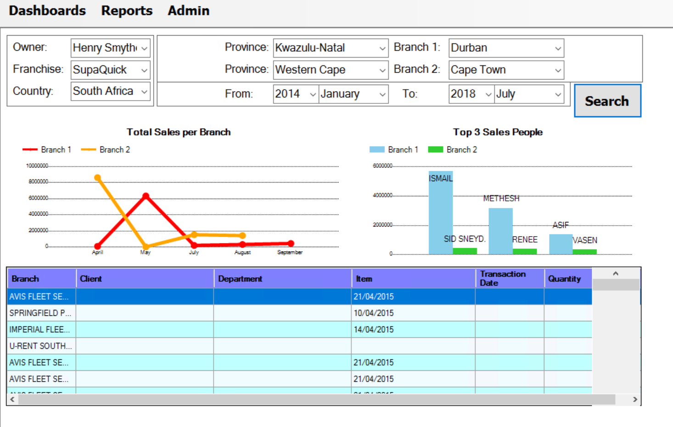

=====================================================================

**QUESTION:**

Buffer stock, reports and alerts.

=====================================================================

**Accpick Answer**

By considering certain inventory information, such as previous sales history and expected demand, you can determine the necessary amount of buffer or safety stock for each specific item.

=====================================================================

**QUESTION:**

Consignment stock.

=====================================================================

**Accpick Answer**

Accpick Support consignment stock as well as Laybyes

=====================================================================

**QUESTION:**

Add images to inventory.

=====================================================================

**Accpick Answer**

No, since most catalogues are online however addition we can add links using html, in addition for speed over internet it was considered a slower option but can be added at development stage

=====================================================================

**QUESTION:**

Easy and simple cash up and day end procedure .

=====================================================================

**Accpick Answer**

=====================================================================

Accipick has an easy to use page format with simple steps to do day ends ,month ends as well as year ends. The Accpick ECO System is extremely customizable and flexible it’s designed to run with 100's of variables from setting up customized actions --: an example would be enabling the software to email the business owner at day end cash up time, a report.It is also integrated with the cloud so that all your data is saved.You will never lose your work.

[**Cash up and Management Report System**](http://accpick.co.za/management-reporting/) (Click here)

=====================================================================

**QUESTION:**

Dashboard views per customer, accountant (customizable)

=====================================================================

**Accpick Answer**

Accpick has a standalone CRM will need some adjustments

or we can integrate Sugar CRM with Mail Chimp hosted TBD

=====================================================================

**QUESTION:**

National database with limited information shared between all stores

=====================================================================

**Accpick Answer**

i=====================================================================

Accpick manage National Franchise (GoodYear) Dunlope etc price updates from time to time. Each individual branch can be configured to access certain data with price lists , and be locked out of data that doesn’t pertain to them.

====================================================================

**Point of Sale System**

=====================================================================

**QUESTION:**

All transactions processed through POS system (loan items, repairs services, delivery notes, consignment stock, inter branch stock transfers etc.)

=====================================================================

**Accpick Answer**

Point of Sale comprises of transactions which will pertain to the client (eg. Invoices, cash sales, credit notes, payments, job cards, quotations, etc). There are other functions available like transaction reprint, cash control (which shows the value of cash flow for the day), and lay byes. Item repairs or charging can be managed under job cards.

Under Debtors, Creditors and Stock Control, you can manage your accounts, departments, and stock, and you can pull high-level reports (eg. Age analysis, and current and historical statements, etc). Transactions, such as Debit and Credit Journals can be processed through these modules.Inter branch transfers can be done via the Accpick package.

=====================================================================

**QUESTION:**

Paperless (ability to email , sms, documents to clients)

=====================================================================

**Accpick Answer**

The server or Computer will need internet access to allow you to email customers.

Using your suggested email address and SMTP settings we enable you to send Statements ,Quotations ,Cash Invoices as well as Credit Notes and Transactions all via our Accpick System.

Accpick suggest documents that are NOT essential are NOT Printed as they are available for reprint or electronic retrieval later on.

Accpick can export to CSV or PDF for EDI

=====================================================================

**QUESTION:** Workflow e.g. set account customer to print delivery note and email invoice to HQ.

=====================================================================

**Accpick Answer**

Our settings are available for emailing and printing through to Head Office. Our current chain of Tyre Dealerships find this to be very useful .We also have an awards program for best salesmen as we have records of all transactions per salesmen. this is then FTP automatically the the relevant file server.

In addition Cash up reports can be emailed or sms to managers depending on requirements.

=====================================================================

**QUESTION:**

Modern system e.g. sign delivery note on tablet, create transactions on mobile device, scan barcodes, touch screen interface etc.

=====================================================================

**Accpick Answer**

It is available via the Windows 10 Tablet, although we will incorporate a new feature for portable signature devices.

Accpick is touchscreen ready

=====================================================================

**QUESTION:**

Ability to create barcode label (QR code, Data Matrix) when invoicing with all customer,

vehicle and product  details to stick onto the product for warranty purposes.

=====================================================================

**Accpick Answer**

Barcode and stock and pricing labels are available, QR codes are in the pipeline.

=====================================================================

**QUESTION:**

Tracking of cash customer historical purchases with all details of client or  vehicle and product sold

=====================================================================

**Accpick Answer**

Yes we use serial number tracking and this is available through the Debtors module which is accessed easily.

=====================================================================

**QUESTION:**

National database with limited information shared between all  regional stores.

=====================================================================

**Accpick Answer**

Yes, one main server will be responsible for holding all data, and will be backed up to the cloud The drives will be RAID.

Each individual branch can be configured to access individual data, and be kept out of data that doesn’t pertain to them.

Each branch has many stations which are accessed by other branches using the Accpick icon on their desktop where you can switch between different stations. A national price list can be managed and installed on each branch.

We believe each store must have an independant database which is cloned across the branches, then consolidate for Group reporting. This maintains store independence from a centralised register at the same time is fully reportable

Accpick separate months, years and Archives according to the GAAP principle.

However one can change access to varying periods.

We insist in month and years ends and stock take in order to discipline the accounting procedure. This forces GAAP accounting discipline onto Franchisees to be SARS compliant and not leave outstanding matters which become much more difficult to resolve if left for months.

=====================================================================

**QUESTION:**

Custom fields that can be marked mandatory / optional per transaction type or customer.

=====================================================================**Accpick Answer**

Yes, to a certain degree, in addition comments fields can be used This is setup through System Utilities or commands in the run scripts.Training modules are available freely to all the necessary staff. ie You can switch a environment variable on or off

=====================================================================

**QUESTION:**

Ability to change certain fields after invoice was processed e.g. order number.

=====================================================================**Accpick Answer**

Security of data is key so depending on password control and customise setting various settings can be changed

[Customization Click Here](http://accpick.co.za/set-customization/)

=====================================================================

**QUESTION:**

Transactions logged per user (enter password, pin, fingerprint etc. when creating transaction)

=====================================================================**Accpick Answer**

Passwords can be setup for each transaction. Our system keeps information on who is recording the transaction per station. In addition certain modules can be excluded from usage depending on the users Hirecachly status. Fingerprint reader may be required

=====================================================================

**QUESTION:**

Pricing set per item, item group, customer, customer group or mix there of Rounding rules.

=====================================================================**Accpick Answer**

Yes. Pricing is set per item, and each item can be set to 3 different prices ranges .Contract pricing is a feature as well, Vat is customisable according to product type.

=====================================================================

**QUESTION:**

Rules per customer or customer group Debtors

=====================================================================**Accpick Answer**

Yes, ie Credit Limits, Cash or not VAT

How to print invoice or where?

Accept cash to a Drop safe.

Weigh bulk coinage received credit a transaction.

[Customization Click Here](http://accpick.co.za/set-customization/)

[Group Ordering Click here](http://accpick.co.za/accpick-group-ordering/)

=====================================================================

**QUESTION:**

Mandatory fields to be captured, scrap or faulty products  returned allowed, branding for account etc.

=====================================================================**Accpick Answer**

Yes, This is managed through the System utility window of Accpick.

=====================================================================

**QUESTION:**

System to pick up details of repeat cash customers e.g. when typing cell phone number name, address, Vat number auto populates

=====================================================================**Accpick Answer**

Yes, This is available through the Debtors module and customer fields setup

=====================================================================

**QUESTION:** Additional details for scrap return - product size, make (possibly use custom field),

=====================================================================

**Accpick Answer**

Yes, we have customised this option for the tyre companies so and since we have serial number tracking and job cards it can be managed plus in credits in returns of stock.

=====================================================================

**QUESTION:**

Loan item tracking - alert after x days (possible integration with workflow module)

=====================================================================

**Accpick Answer**

Items / products can be invoiced out commented as a loan it will be removed from stock and credited upon return.

Report On outstanding stock or jobs can be run.

=====================================================================

**QUESTION:**

 Sales orders for job cards, quotes etc. Create invoice from job card (part of workshop module)

=====================================================================

**Accpick Answer**

Yes, once a job card or quotation is made, it can be either edited for further items, converted into an invoice , stock can be order then A daily job Sales order can be reported.

Remote Salesman Ordering is also available for Sale Reps

Customers can receive SMS when job completed

[Sales Orders Remote for Salesman Click here](http://accpick.co.za/remote-ordering-salesman/)

=====================================================================

**QUESTION:** Display debtor information while creating transaction e.g. credit limit info, scrap return allowed etc.

=====================================================================

**Accpick Answer**

Yes, depending on security requirements ie credit available will be displayed on the screen while the invoice is being created

=====================================================================

**QUESTION:**

Display stock information while creating transaction,

=====================================================================

**Accpick Answer**

Yes,including national stock levels. This can be done either through stock lookup under quick functions, or is visible when you adding a line item.

[**Accpick Quick Guide Click Here**](http://accpick.co.za/accpick-shortcut-keys/)

=====================================================================

**QUESTION:**

Easy control of till, payments received (EFT, credit card, deposit) and petty cash.

=====================================================================

**Accpick Answer**

Payouts can be made through the POS module, or through the Cash Book Module, or a separate facility can be made up to manage petty cash. A window requested what payment type is being received will appear once the transaction is about to be complete, and the user must enter this in the correct field.

This is security related depending on requirements

=====================================================================

**QUESTION:**

Payment methods integrated into POS (PayFast, SnapScan, PayU, PayGate)

=====================================================================

**Accpick Answer**

All national bank facilities using debit or credit cards are required. currently manual is pipeline. WIP.



Tel:  +27 33 343 6000 Web: [www.accpick.co.za](http://www.accpick.co.za) email [sales@accpick.co.za](mailto:sales@accpick.co.za)