**Creditors Module**

**Enquiry**

**and**

**Reports**

Contents

**Enquiries**

**Total Creditors Summary** 3

Age Analysis 3

Control Enquiry 4

**Expense Category and Tax Analysis** 5

Details 6

**Purchase History** 7

# Total Creditors Summary

## Age Analysis

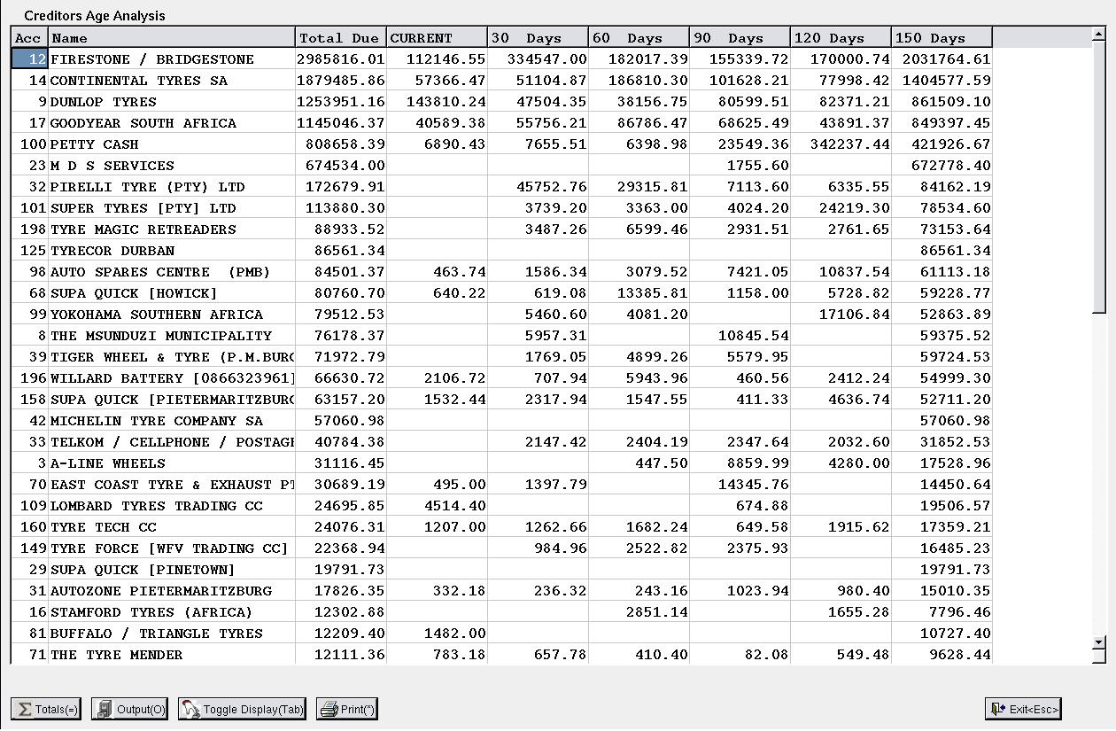

## Control Enquiry

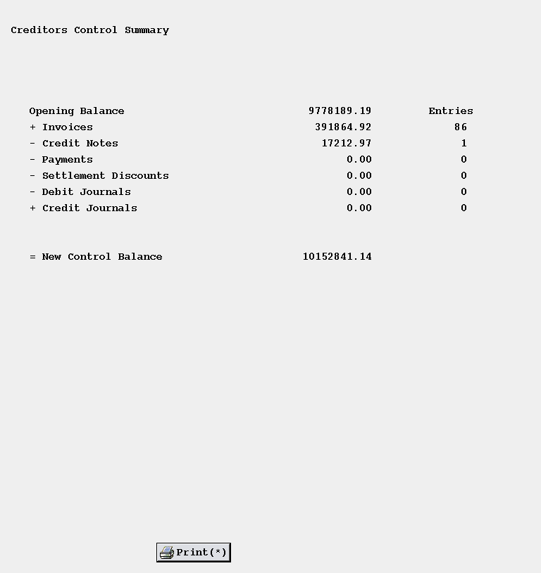

# Expense Category and Tax Analysis

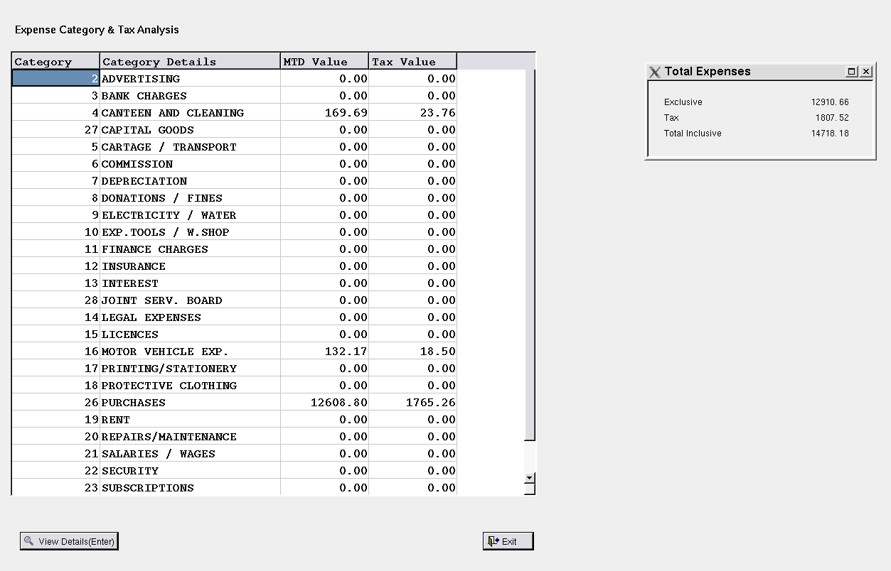

## Details

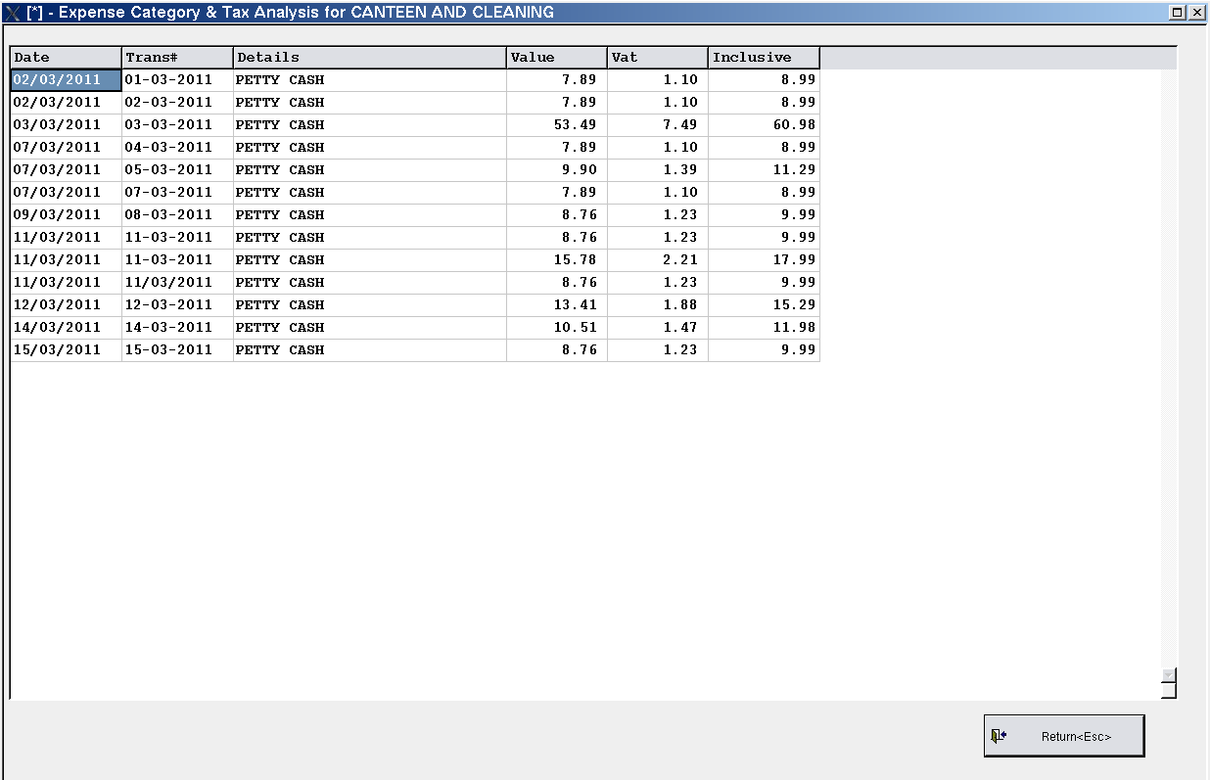

# Purchase History

