# Solution Extraction Using PIG

1.**Loadig Data to a variable:**

Crime = Load ‘user/input/CRIME3.csv’ USING PigStorage(‘,’) as (inc_no:int,offense:int,offense_code:chararray,off_descript:chararray,district:int,reporting_area:int,occurance_date:datetime,year:int,month:int,day:chararray, hour:int,street:chararray);

From this we can load the dataset to a particular variable by giving the correct path of the input file location and after finding the file location we save the data based on the structure we provide.

2.**Describing the dataset loaded:(Structure)**

a = describe crime;

From this query we can able to see the structure of the dataset and their respective datatypes.

3.**Setting limit to print or to display the dataset:**

a = LIMIT crime 5;

From this we can able to print the first 5 rows of the dataset by providing the limit.

4. **Displaying the dataset:**

dump a;

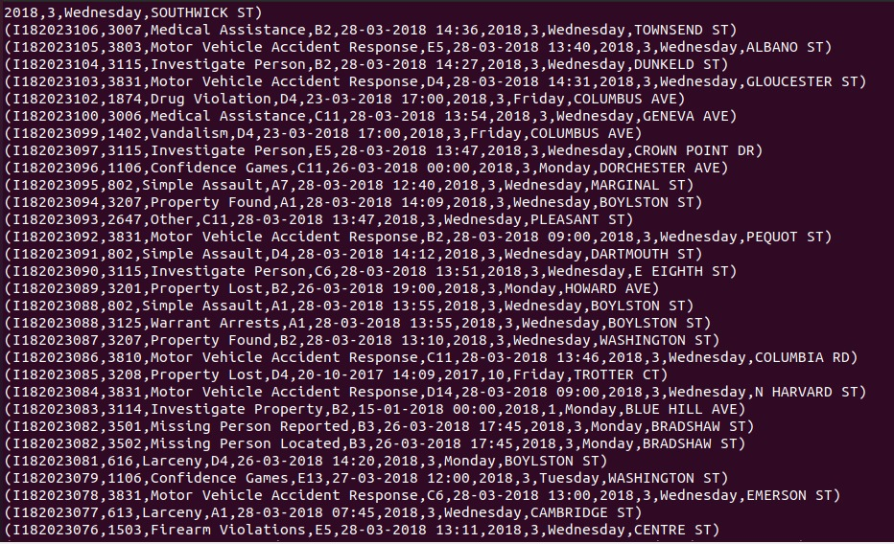

This query is able to provide or to display the data.

5. **Displaying the Offences:**



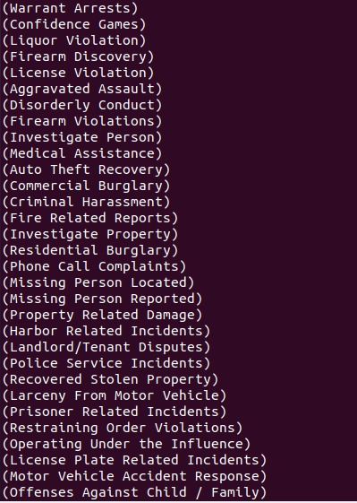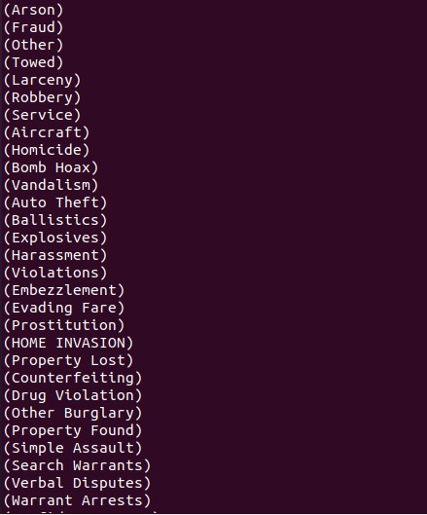

6.Displaying the occurrence of offences

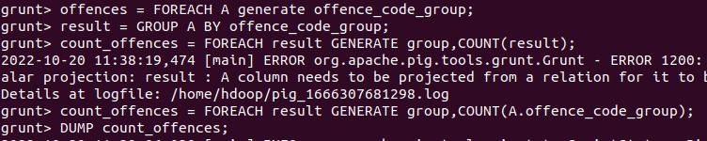

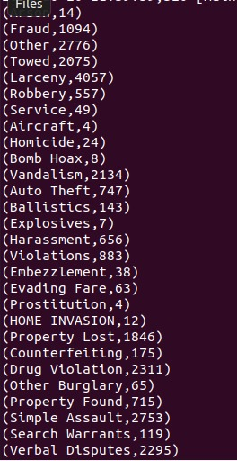

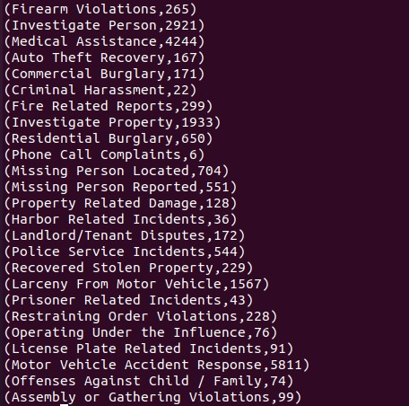

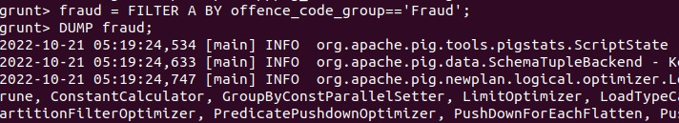**7. Displaying the Occurrence of crime-fraud**

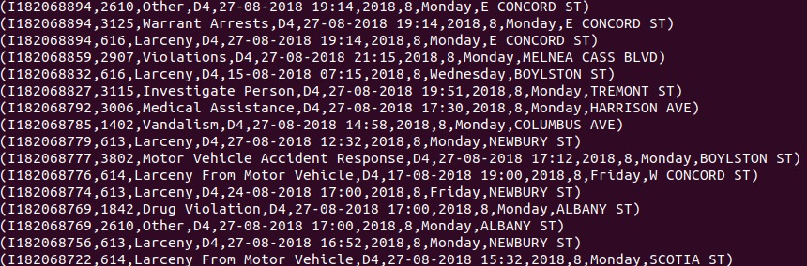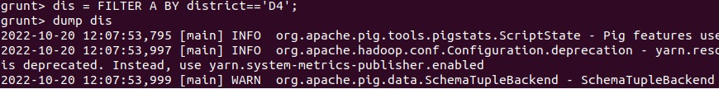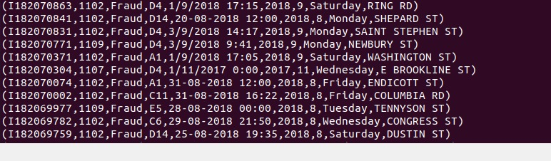**8.Displaying the crimes in D4 district**

**9. Illustrate command**

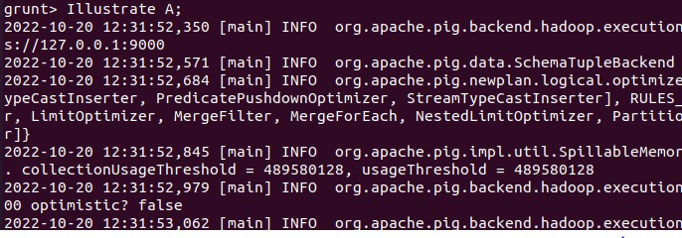

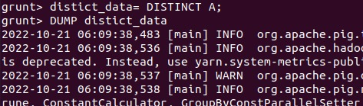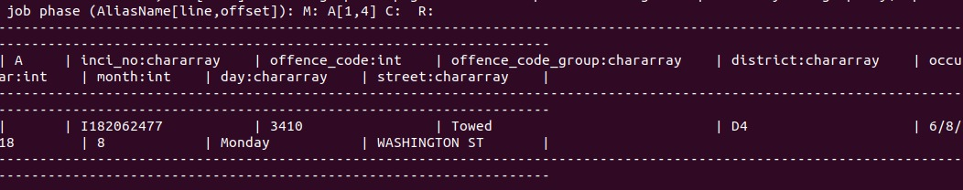**10.Distinct**

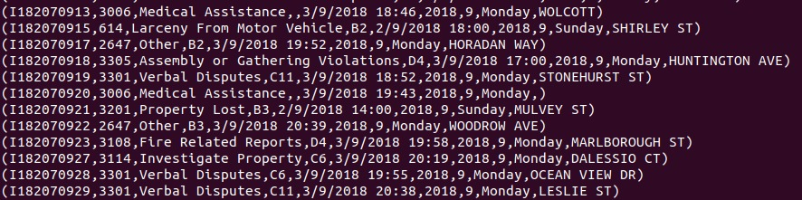

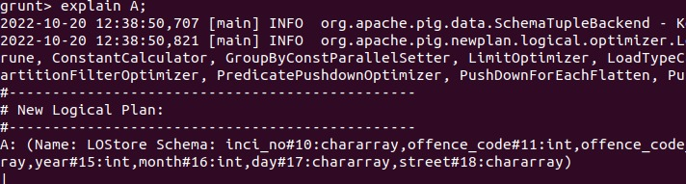**11.Explain**

