1to1 : A booking system for my sister’s business
For this project I will be taking a TDD approach utilizing the scrum for one framework.
Product backlog
As a | I need | So that
Business owner | The app to be secure | My data is safe
Business owner | To be able to CRUD clients to a database | I can manage my bookings

Daily scrum 18/01/2020
Today I will plan my first sprint, then start on developing it
Sprint planning 18/01/2020
Sprint duration 1 week to end 25/01/2020
- The system needs an authentication system.
- It will be private, so signup is not necessary
- I will generated some sort of encrypted key and use it for logging in
Wireframe of the auth screen Mobile wireframe

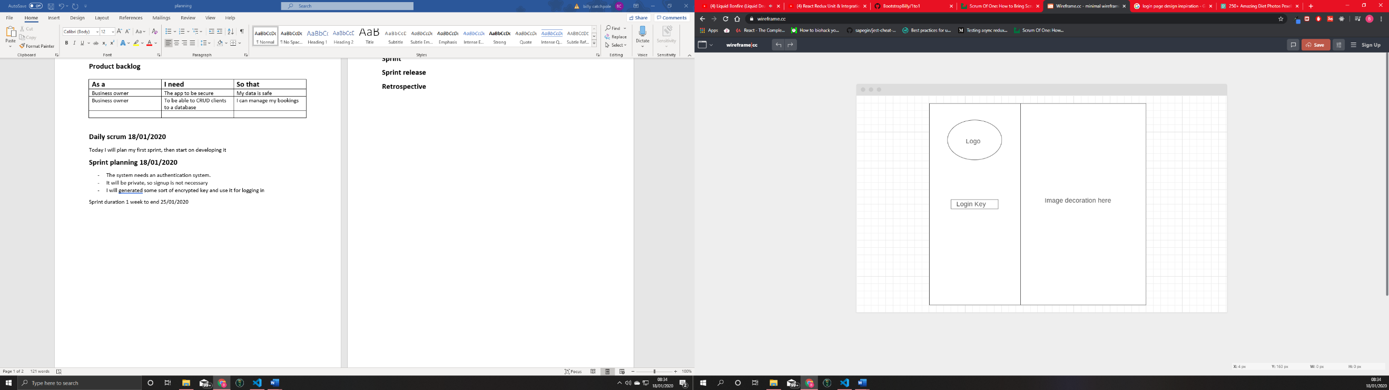

Component planning
Logo – Has a logo image and nothing else
Login Input box – An input field which dispatches a login action to the api
-props enterKeyHandler : a function
Image Decoration – An image and nothing else
Authentication screen – A container for all the above
Sprint
Part 1a – Write unit tests for components
Part 1b – Write enough code to make the unit tests pass
Sprint release
Retrospective

