

# EXERCISE 2 – Relative paths

Here is a website folder structure.

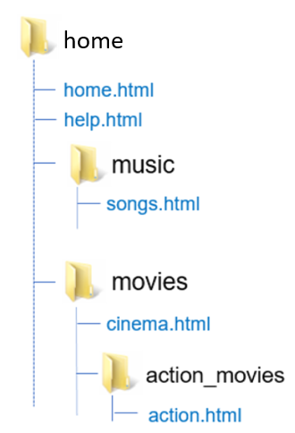

**YOU JOB:** Fill the table with the **missing hyperlinks**, so that we **can create a link** from the source page to the destination page.

|  |  |  |
| --- | --- | --- |
| ***SOURCE PAGE*** | ***DESTINATION PAGE*** | ***HYPERLINK*** |
| action.html | cinema.html | <a href="../cinema.html"> |
| home.html | songs.html | <a href= "./music/songs.html"> |
| help.html | action.html | <a href="./movies/action_movies/action.html"> |
| cinema.html | help.html | <a href= "../help.html"> |
| action.html | home.html | <a href= "../../home.html"> |
| cinema.html | action.html | <a href= "./action_movie/action.html"> |
| songs.html | action.html | <a href= "../movie/action_movies/action.html"> |
| action.html | songs.html | <a href= "../../music/songs.html"> |