Boppana Bharat Satya   
 *Department of CSE-AI*   
*Sathyabama Institute of Science and Technology   
(deemed to be university)*Chennai, India  
boppanabharatsatya@gmail.com

Rohit Sai Kalyan Kopalli  
 *Department of CSE*   
*Sathyabama Institute of Science and Technology   
(deemed to be university)* Chennai, India  
rohitkopalli90@gmail.com

**ABSTRACT**

A bacterial infection in the lungs results in an illness known as pneumonia. The effectiveness of treatment depends in large part on early diagnosis. For a variety of reasons, including the disease's appearance being ambiguous in chest X-ray images or being mistaken for another illness, the diagnosis may be arbitrary. Thus, in order to assist clinicians, computer-aided diagnosis systems are required. AI algorithms can automatically diagnose pneumonia or other lung-related diseases in patients by analyzing their chest X-ray scans. Because lives are at stake, the algorithm needs to be extremely accurate. In this project, we employ transfer learning (TL), a machine learning (ML) technique that allows knowledge from one task to be applied to another, improving performance on related tasks. Utilizing a custom deep CNN and images of X-ray to retrain the pre-trained model, pneumonia was identified from chest X-ray images. Freeze the first few layers and fine-tune the model for two new label classes in order to retrain the removed output layers (Pneumonia and Normal).

**Keywords** — machine learning, deep learning, CNN, transfer learning.

**I. INTRODUCTION**

Acute pulmonary infections, such as pneumonia, could be brought on by viruses, bacteria, or fungi and infect the lungs, leading to

The pleural effusion, a situation in that fluid fills the lung, and inflammation of the air sacs. It is the cause of over 15percent of deaths in children under five yrs of age. Pneumonia is more common in developing and underdeveloped nations due to factors like poor environmental situations, pollution, and overcrowding, as well as a lack of access to healthcare. Therefore, keeping the disease from becoming fatal could be highly aided by early diagnosis along with treatment. A diagnosis of lung disease is often made by lung radiological examination by utilizing the computed tomography (CT), magnetic resonance imaging (MRI), or radiography (X-rays). An examination of the lungs that is non-invasive and reasonably priced is X-ray imaging.

In this article, we have outlined our method for diagnosing pneumonia and explained how the model's performance is significantly impacted by the lung image size. We discovered that the difference between images showing pneumonia and those showing it is fairly subtle; large images can provide more detailed information. However, when working with large images, the computation cost also increases exponentially.

"Machine learning" is a branch of computer science along with AI which focuses on the simulating human learning procedures as well as enhancing their accuracy over time with data & algorithms. Put differently, "Transfer learning" refers to an ML method in which a formerly trained model has been utilized as the foundation for the new model on a various task. Using a popular technique called ensemble learning, the final prediction for a test sample has been obtained by fusing the decisions of multiple classifiers.

One useful artificial intelligence tool that is essential to the resolution of many challenging computer vision issues is deep learning. Convolutional neural networks (CNNs), in particular, are DL (Deep Learning)models that are broadly utilized for a range of image classification tasks. But these models only function at their best while they have access to a lot of data. Such large labeled data sets are hard to come by in biomedical image classification problems because each image must be classified by a specialist doctor, a costly and time-consuming process. There is a workaround for this problem: transfer learning. This technique solves problems involving small datasets by reusing a model that was “trained on a large dataset and applying its network weights. Since CNN models were trained on massive datasets like ImageNet, which has over 14 million images”, they have been frequently utilized for the biomedical image classification tasks.

The WHO estimates that it kills 1.4 million children under the five yrs of age annually, making up 18percent of all child deaths under five yrs of age worldwide. Pneumonia is a global health concern that primarily impacts children along with families in South Asia along with the sub-Saharan Africa. It is possible to prevent childhood pneumonia. It can be treated with lower-tech, lower-cost care, and medication, and it could be inhibited with the simple interventions. Thus, research along with the development of computer-aided diagnosis is desperately required to decrease the mortality rate associated with pneumonia, particularly in children.

This paper presents a model which automatically classifies a patient as having pneumonia or not utilizing CNNs and DL applications. Using a deep transfer learning algorithm, the suggested methodology automatically identifies the features of the image of X-ray which indicate the existence of disease & determines if the patient is suffering from pneumonia.

**II. RELATED WORKS**

1. Wang et al. made available a database called Chest x-ray 14, which included 32,717 distinct patients and 112, 120 frontal view x-ray images that were labelled with eight labels. The data set was later extended to include 14 diseases, from the original 8 that were suggested. This dataset's limitation in the context of pneumonia is the small number of labelled images that have the illness, which causes a very uneven classification. In order to classify the abnormalities in the images of chest X-ray, Wang et al. proposed a 2D ConvNet that predicts the labels using a simple binary relevance. Wang and colleagues employed AlexNet, GoogleNet, ResNet, and VGG16 architecture for image classification. ResNet had also achieved the highest accuracy.

2. Rajpurkar et al. used a 121-layer CNN to create CheXNet. Utilizing the F1 metric, the paper evaluated CheXNet's performance against a radiologist's. Pneumonia is among the 14 diseases that this network could identify. As it works on an X-ray image, the model displays the localised areas in the image as well as the probability of a pathology. Using seventy percent of the images for the training, twenty percent for validation, and ten percent for testing, the model has been capable to achieve a f1 score of 0.435, higher as compared to the radiologist's(0.387).  
3. In order to classify the images into viral pneumonia, bacterial pneumonia, and no pneumonia, Acharya et al. proposed a deep Siamese network (DSN) that used 5328 and 300 images for training and testing, respectively, to achieve a ROC AUC of 0.9500. Following their development, several deep CNNs were assessed by Yu-Xing Tang and colleagues.

4. In order to relieve patients with a normal chest X-ray, Ken Wong et al. classified the images into normal and disease states. They did not believe that sick patients should be sent home. Their network made use of a dilated ResNet block and Inception-ResNet-v2, which was pre-trained on ImageNet. In order for half of the patients to be diagnosed as disease-free, they set the recall rate at 50%. They also used 3217 images of the Chest X-ray 14 dataset to train this network, running it for 50 epochs in order to reach a maximum ROC AUC of 0.9300.

5. The Adam algorithm was combined with logistic regression, Amores-Falconi, and K-means clustering to train the network. However, due to limited resources, they only looked at 5606 randomly selected images. They also conclude that because of the complexity of the data set, logistic regression is not a reliable method of result prediction and that a DenseNet, with an accuracy (AUC) of 0.60, would be a better choice.

6. Li et al. combined lung field segmentation and rib suppression with a CNN-based methodology. Three CNNs have been trained on various resolution images for the lung area pixel patches, and feature fusion was used to combine all the data. For pediatric pneumonia, Liang et al. created a unique network having a residual structure that consists of two dense connection layers, one worldwide average pooling layer, and 49 convolutional layers.  
7. A 3D full CNN was proposed by Pezeshk et al. for quick screening and the creation of candidate suspicious regions. After that, a large set of data augmentations from the positive along with the negative patches have been used to train an ensemble of 3-D CNNs. The classifiers were trained with various thresholds and types of data augmentation on false positive patches. Ultimately, the final prediction was generated by averaging the outputs of the 2nd stage networks.

8. For the localization of pneumonia, “Sirazitdinov et al. proposed an ensemble of RetinaNet along with Mask R-CNN networks”. Networks 1st identified the areas impacted by pneumonia, and after that non-max suppression was implemented in the regions of the lung that were anticipated.

9. Two 3D-customized mixed link network (CMixNet) architectures were used by Nasrullah et al. Faster R-CNN was utilized for lung nodule recognition using features acquired from CMixNet along with the U-Net, such as encoder-decoders; a gradient boosting machine (GBM) has been employed for the classification.

10. The custom neural network proposed by Pasa et al. contains 5 convolutional blocks, a worldwide “average pooling layer, a completely connected softmax layer having 2 outputs, and each convolutional block having two 3×3 convolutions having Rectified Linear Units (ReLUs) followed by the max-pooling operation”.

**III. PROPOSED SYSTEM**

This paper proposes an optimal approach for the pneumonia diagnosis from X-rays of chest. After addressing the issue of the small dataset through data augmentation, cutting-edge DL models—deliberated in Section 3—have been optimized for the pneumonia classification. The final estimate has been after then computed by combining the “predictions from these models having a weighted classifier (explained later in this section)”.

The deep transfer learning framework has served as the foundation for the working methods of the proposed model. In recent times, researchers have been using CNN models based on transfer learning to solve a range of computer vision issues. Over the past fewer decades, these models have found widespread application in medical disorders, diagnostics, industries, along agriculture. Here, a deep TL model based on CNN is created and applied to the image classification of an X-ray.

Szegedy et al proposed that GoogLeNet architecture is a 22-layer deep network made up of "inception modules" as opposed to layers that are progressively more advanced one after the other. Through the hosting of parallel convolution and pooling layers, an inception block can support a huge number of units at the each and every stage; however, this leads to an uncontrollably high computational complexity due to the raised number of parameters. The GoogLeNet model utilizes blocks of inception having a dimension decrease to manage the computational complexity. An ideal “sparse architecture constructed from the available dense blocks of the building enhances the performance of ANNs for the computer vision tasks, as demonstrated by the performance of GoogLeNet”, in which the inception block was first introduced.

He et al.'s ResNet-18 model boosts the effectiveness of deep network training by using a residual learning framework. In contrast to the initial unreferenced mapping in monotonically progressive convolutions, the ResNet models' residual blocks aid in network optimization, enhancing model accuracy. Identity mapping is carried out by the residuals, also known as "skip connections," which don't add parameters or raise computational complexity.

Huangl.' s proposed DenseNet architectures are computationally efficient and offer a rich feature representation. The main explanation for this is DenseNet model's feature maps have been concatenated with those from all earlier layers in each layer. This decreases the number of trainable parameters in the convolutional layers, which makes the model more computationally efficient. Moreover, the feature illustration is enhanced by concatenating the feature maps from the earlier layers with present layer.

**IV. SYSTEM ARCHITECTURE**

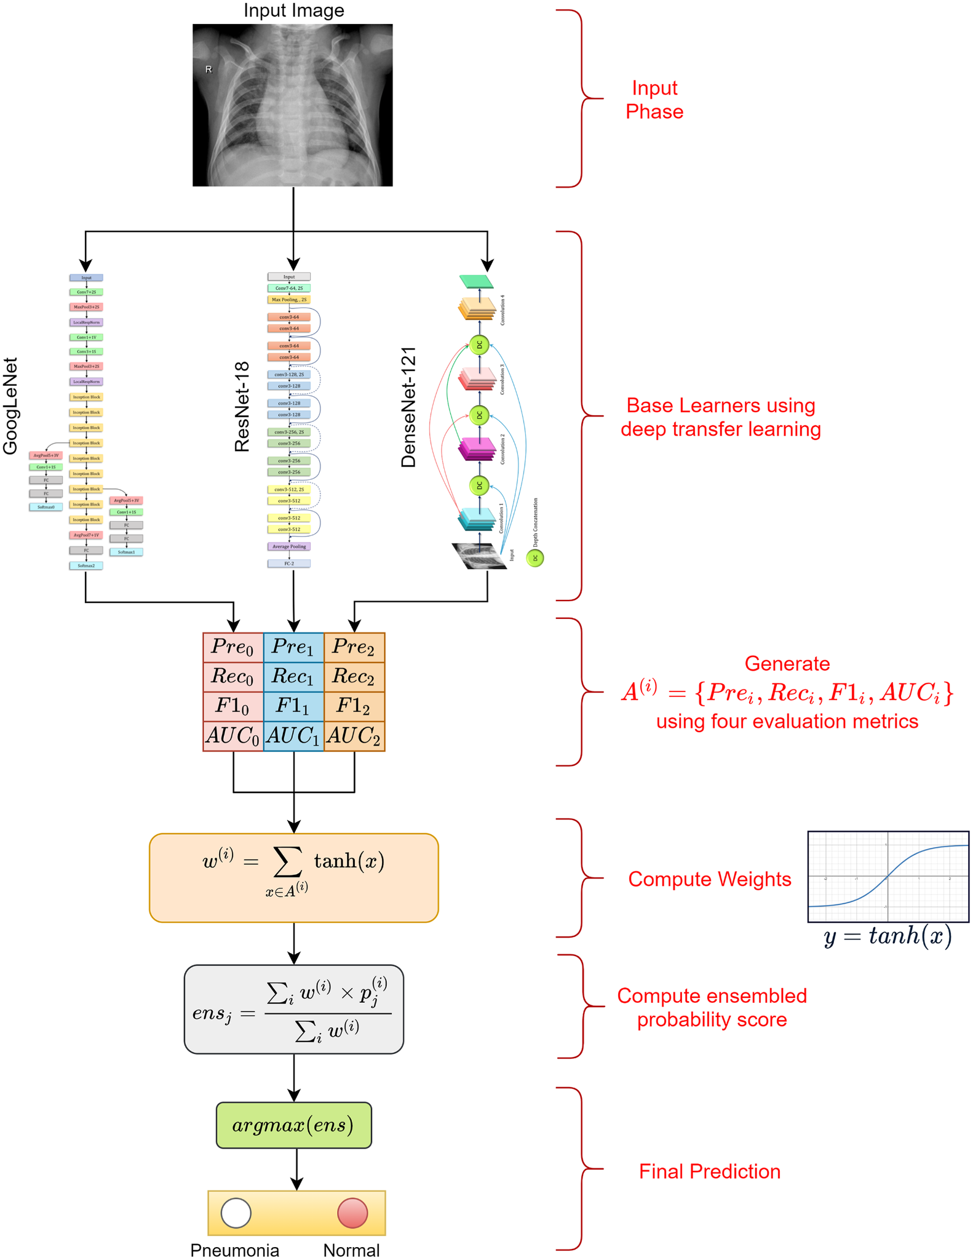

Fig. 1. System Architecture

**V. RESULT**

The model's robustness has been shown by the several scores—like “recall, accuracy, precision, and AUC score—obtained during the experiments. A higher F1 score of 99.002 along with an AUC score of the” 99.809 established the proposed model's efficacy, and it has been capable of attaining an accuracy of the 98.857 percent. Despite the fact that several approaches were developed to work with this given dataset, the suggested methodology produced superior outcomes. It would be fascinating to see methods in the future for much more efficiently calculating the weights corresponding to several models, as well as a model that makes predictions based on the patient's medical history.

**VI. CONCLUSION**

One major cause of morbidity along with mortality is the pneumonia. It is responsible for adult hospital admissions sizeable portion, and a sizeable portion of those patients who has been passed away (mortality rate for patients over 75 yrs is 24.8%). The World Health Organization states that early diagnosis and treatment, along with a straightforward intervention, can prevent pneumonia. However, most people on the planet do not have access to radiology diagnostics. In spite of the imaging equipment availability, there has been a dearth of specialists qualified to analyze X-rays. This paper proposed the utilization of deep transfer learning techniques for pneumonia automatic detection in images of the chest X-ray. The deep networks that we employed in our methodology produced higher accuracy due to they had much more complex structures with few parameters, which intended that they required lesser processing power. Overfitting is a phenomenon that occurs while there is not enough training data, as in the medical image processing case. It was addressed through the utilization of transfer learning along with data augmentation.

**VII. REFERENCES**

1. Liu, N.; Wan, L.; Zhang, Y.; Zhou, T.; Huo, H.; Fang, T. Exploiting convolutional neural networks with deeply local description for remote sensing image classification. IEEE Access 2018, 6, 11215–11228. [CrossRef]
2. Hosny, A.; Parmar, C.; Quackenbush, J.; Schwartz, L.H.; Aerts, H.J. Artificial intelligence in radiology. Nat. Rev. Cancer 2018, 18, 500–510. [CrossRef] [PubMed]
3. Kallianos, K.; Mongan, J.; Antani, S.; Henry, T.; Taylor, A.; Abuya, J.; Kohli, M. How far have we come? Artificial intelligence for chest radiograph interpretation. Clin. Radiol. 2019, 74, 338–345. [CrossRef] [PubMed]
4. Douarre, C.; Schielein, R.; Frindel, C.; Gerth, S.; Rousseau, D. Transfer learning from synthetic data applied to soil–root segmentation in x-ray tomography images. J. Imaging 2018, 4, 65. [CrossRef]
5. Sun, C.; Yang, Y.; Wen, C.; Xie, K.; Wen, F. Voiceprint identification for limited dataset using the deep migration hybrid model based on transfer learning. Sensors 2018, 18, 2399. [CrossRef] [PubMed]
6. Esteva, A.; Kuprel, B.; Novoa, R.A.; Ko, J.; Swetter, S.M.; Blau, H.M.; Thrun, S. Dermatologist-level classification of skin cancer with deep neural networks. Nature 2017, 542, 115–118. [CrossRef]
7. Shen, D.; Wu, G.; Suk, H.I. Deep learning in medical image analysis. Annu. Rev. Biomed. Eng. 2017, 19, 221–248.
8. Grewal, M.; Srivastava, M.M.; Kumar, P.; Varadarajan, S. Radnet: Radiologist level accuracy using deep learning for hemorrhage detection in ct scans. In Proceedings of the 2018 IEEE 15th International Symposium on Biomedical Imaging, Washington, DC, USA, 4–7 April 2018; pp. 281–284.