NAME: B Venkata Balaji

EMAIL: 208x1a4207@gmail.com

PHONENO.:6303612803

ROLL NO.:208x1a4207(AIML)

COLLEGE: Kallam Haranadhareddy Institue of Technology

HTML CODE:

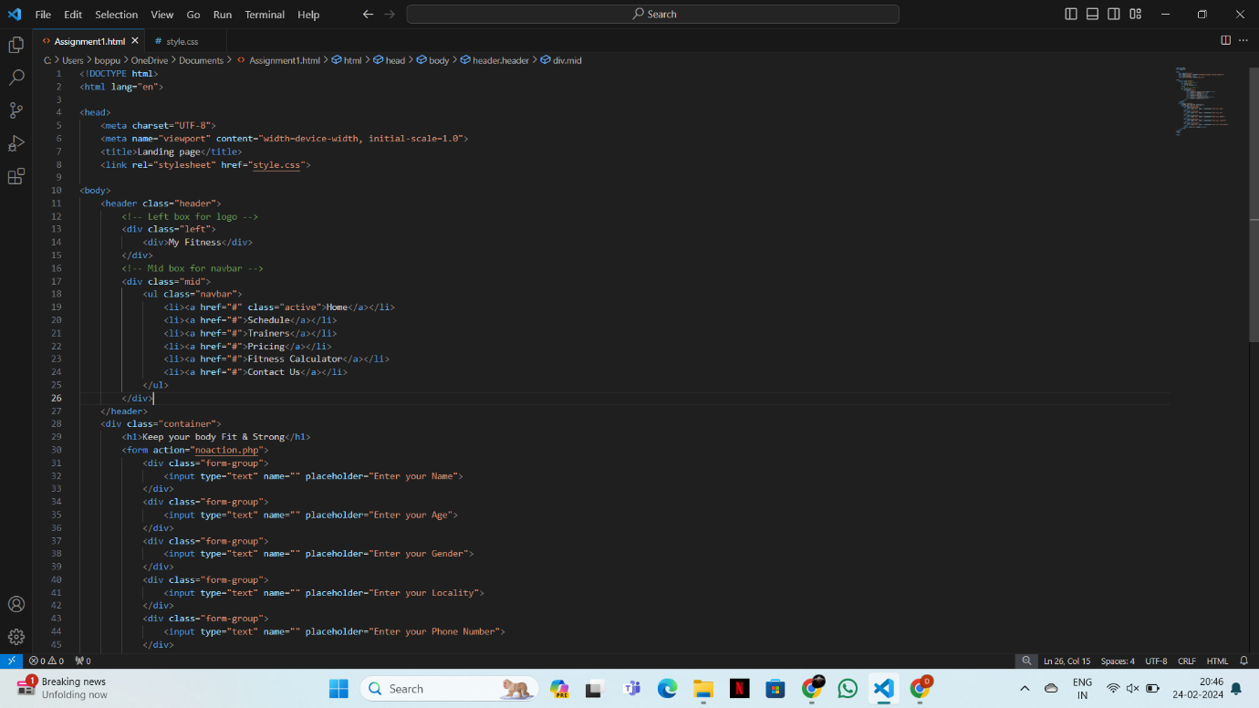

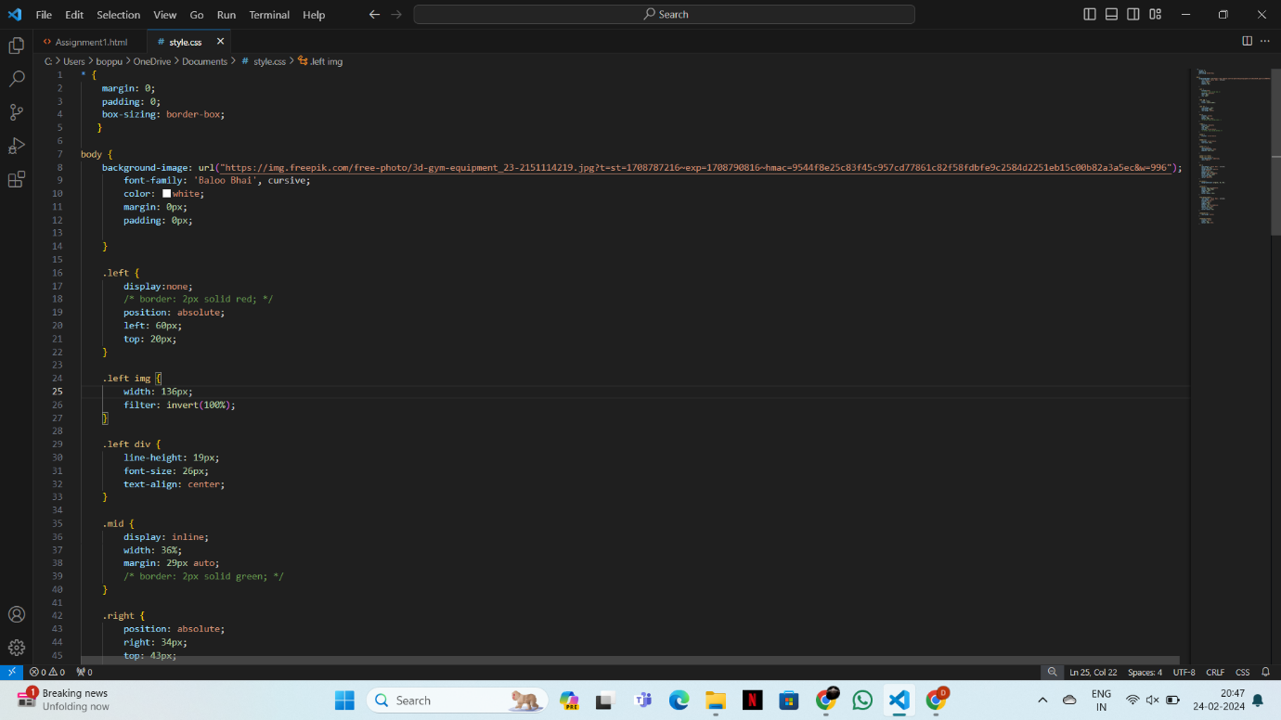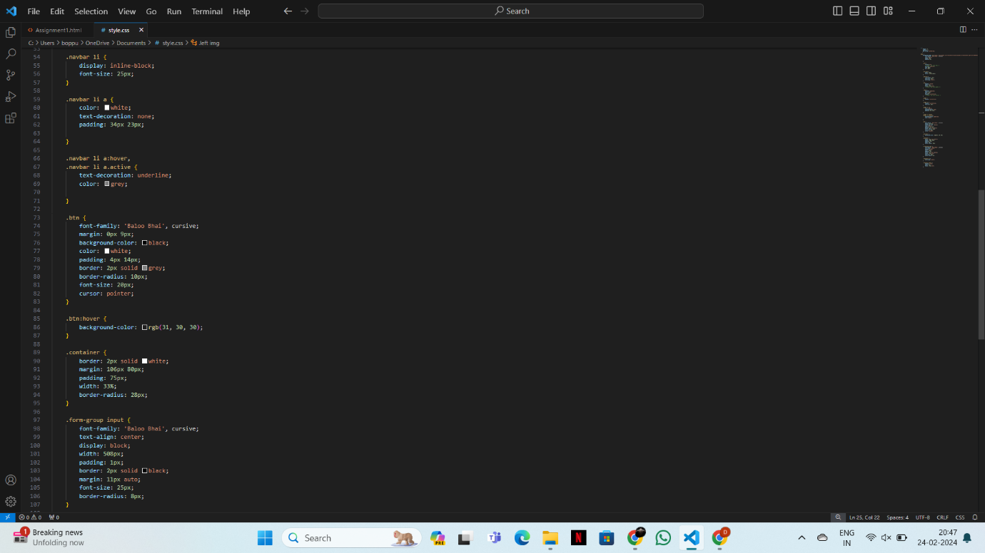

FINAL OUTPUT:

