NAME: B VENKATA BALAJI

ROLL NO: 208X1A4207

EMAIL ID: [208x1a4207@khitguntur.ac.in](mailto:208x1a4207@khitguntur.ac.in)

COLLEGE NAME: KALLAM HARANADHAREDDY INSTITUTE OF TECHNOLOGY

PHONE NO: 6303612803

THEME: Card components

SOURCE CODE

Card.jsx:

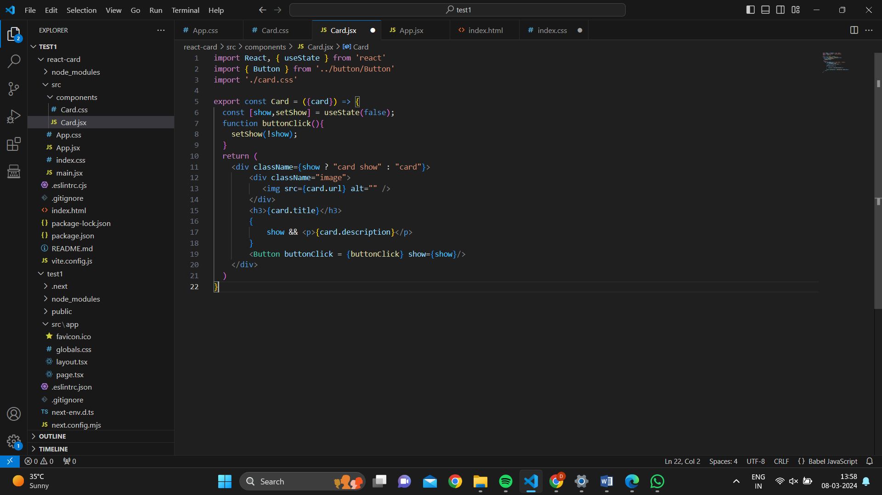

Card.css:

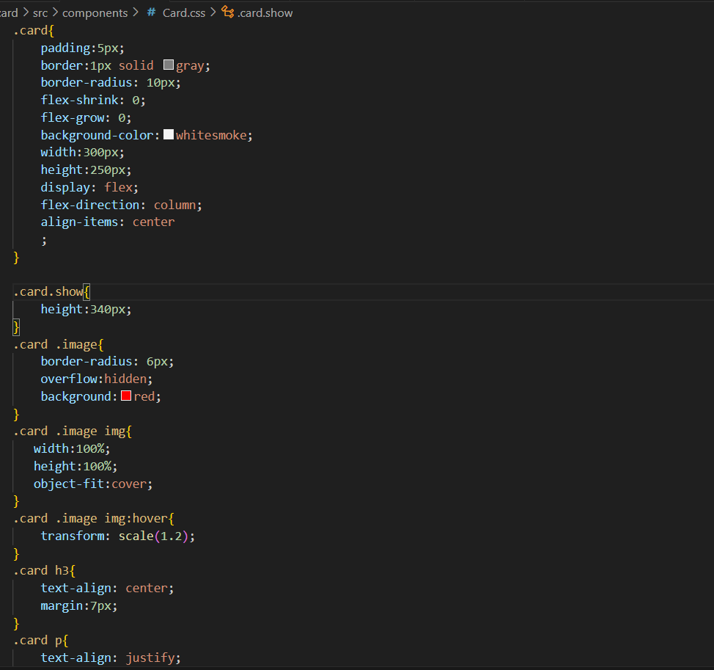

Button.jsx

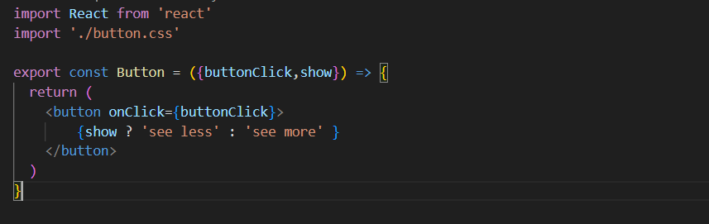

Button.css

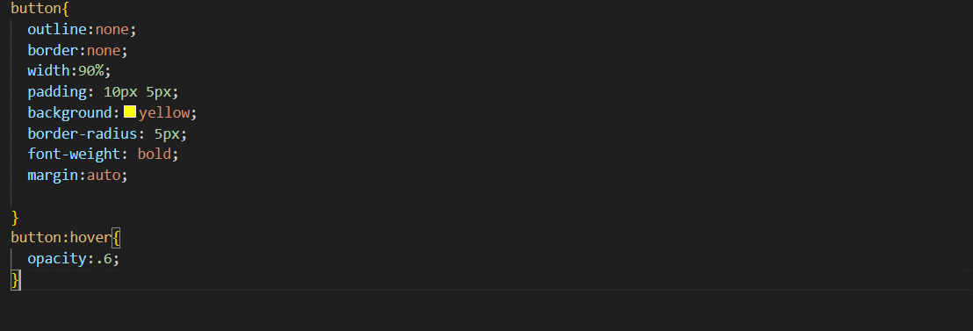

App.jsx

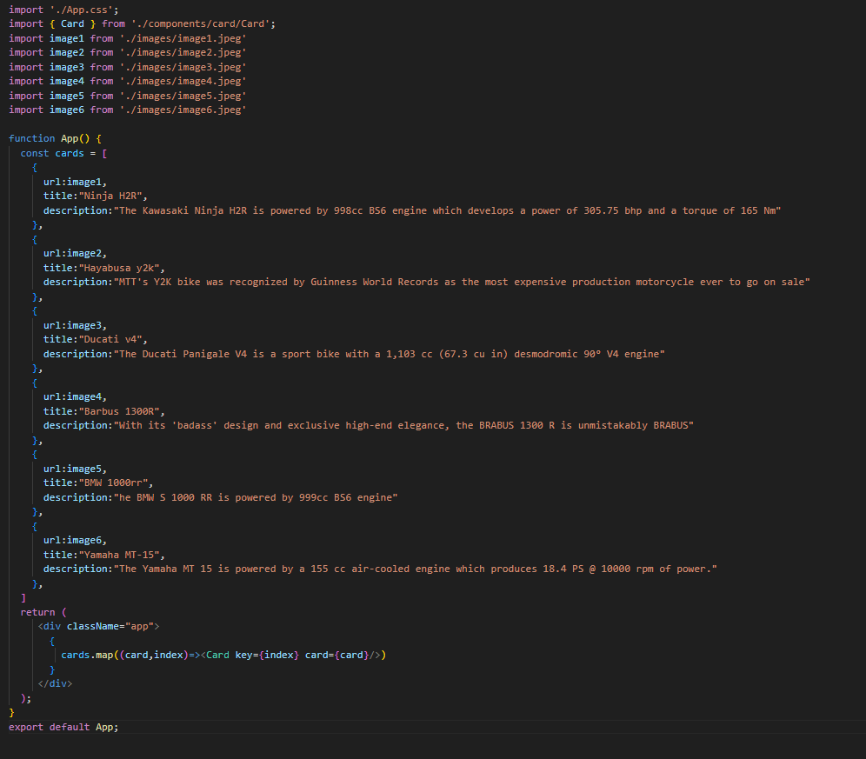

App.css

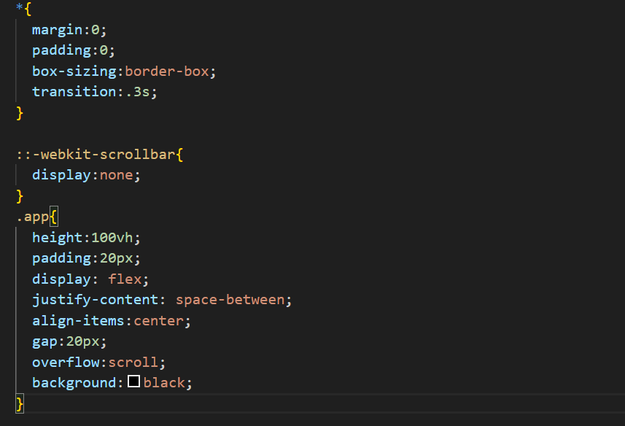

OUTPUT

