Interpreting Macroeconomic Indicators Using 10 Year Treasury Yields
The objective of this analysis is to evaluate how macroeconomic indicators reflect structural changes in monetary policy regimes and market expectations across distinct historical periods. By examining the United States GDP data between 1971 and 1979, this analysis aims to distinguish the extent to which observed increases in measured output are attributable to inflationary pressures following the transition away from gold convertibility, rather than purely real economic expansion. Complementing this, the study analyzes movements in 10-year United States Treasury yields across the 1977–1984 and 2018–2024 periods to identify how financial markets incorporate expectations regarding inflation, recession risk, and monetary policy adjustments, particularly during episodes of economic disruption such as the late-1970s inflation crisis and the COVID-19 recession. Additionally, trading volume patterns between 2004 and 2009 are considered to assess how financial conditions and technological changes influence market participation and risk-taking behaviour. Together, these time series are used to illustrate how nominal indicators, yield dynamics, and market activity reflect broader institutional and macroeconomic environments rather than serving as direct measures of real economic performance alone.
Data preparation/cleaning methods
The bond yield data was cleaned through a series of procedures. The first and simplest step was to drop the “NaN” values from the dataset. Because these entries contain missing information, they cannot be used in calculations or analysis. Another step involved standardizing the naming of the date variable. Across different datasets, the date column appeared in both lowercase (“date”) and uppercase (“DATE”). In order to ensure consistency when applying data-processing functions, all instances of the variable were standardized to “DATE”. This standardization enabled the creation of reusable scripts that could be applied uniformly across datasets by invoking the relevant function.

The first function created converts the data into monthly averages. This function, named monthly, takes the parameter “df”, allowing any dataset to be passed into it. The data is indexed using the date column and resampled on a monthly frequency, after which the mean is calculated. This allows the data to be observed on a monthly average basis, reducing short-term volatility and improving comparability across time periods.
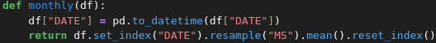
Another function was created to section data into specific date ranges, enabling easier data management and reducing the likelihood of errors. This function allows a data frame to be provided along with a specified start and end date. When executed, the dataset is filtered so that only observations within the selected time period remain, producing a more manageable subset of the data. Complementing this, a smoothing function was implemented to reduce short-term fluctuations and highlight longer-term trends within the data.
Lastly, a function was created to smooth the data for a specific numeric column. Although this procedure functions more as a preset transformation than a strict cleaning step, it allows a data frame, a target column, and a window size to be specified. The function then applies smoothing over the defined window, helping to reduce noise and clarify underlying trends in the data.

Stagflation and Recovery
The United States was under significant stagflation pressures during the 70s after the oil shocks, however the figure below demonstrates the attempts of the United States recovering from the stagflation and oil shocks. .diff() is used to compute the difference of 10 year US Treasury Yields and detect 3 month long changes. 3 months resemble a quarter and is useful because it can be used to determine short term economic shocks, while not generating too much noise. The rapid changes in treasury yields reflect the US administration attempting to curb stagflation and put the economy of the United States in a stable position after the oil shocks of 1973 and 1979. Bond Yields crashed significantly twice, which reflected massive interest rate cuts and economic stimulation. The results of these however, not shown in the graph were a successful economic recovery from stagflation, which allowed the economy to grow in a functional manner again.

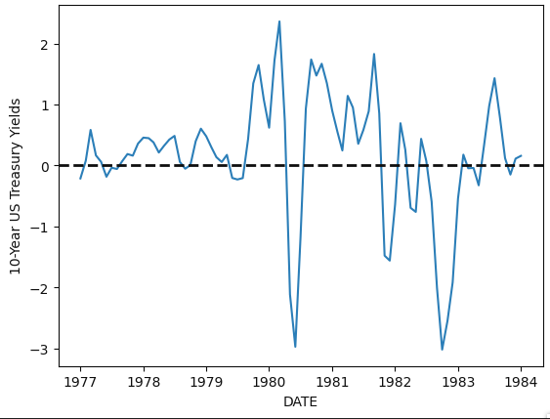

Legacy of the 2020 Pandemic
The COVID 19 pandemic led to a significant slowdown in economic activity, the greatest downturn since the great recession of 2008, governments knowing how the situation could turn out, began implementing policies which the 10 year US treasury yields reflected. After the worst parts of the pandemic, the economy required significant stimulation to function properly, which made the United States cut interest rates significantly mid 2020 combined with stimulus checks to keep households and livelihoods functional. once the central bank determined that the economy could function on its own without significant interest rate cuts, the United States tried to reduce inflationary pressure by increasing interest rates, again reflected by the treasury yields being above zero for the majority of 2021 up until 2024, then being cut again due to an economic slowdown from a cooling job market and consumer sentiment.
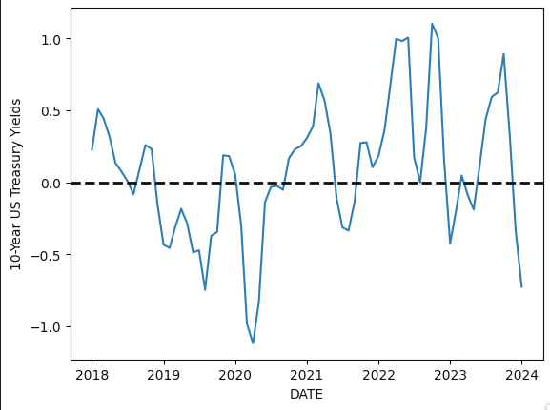

Conclusion
The empirical patterns examined in this analysis suggest that macroeconomic indicators should be interpreted within the broader institutional and monetary policy frameworks that influence them, rather than treated as direct measures of real economic performance alone. The increase in the United States GDP between 1971 and 1979 illustrates how nominal output growth can partly reflect inflationary pressures following the end of gold convertibility, emphasizing the need to distinguish between genuine real expansion and monetary effects. In a similar manner, movements in 10-year United States Treasury yields during both the late-1970s inflation crisis and the 2018–2024 period demonstrate how financial markets continually adjust expectations regarding inflation, policy tightening, and recession risk in response to macroeconomic disruptions, reinforcing the view that market indicators primarily reflect evolving expectations about policy credibility and economic stability.

